Which of the following declares a variable that can store an integer?

1. **int quantity = 0;**
2. integer quantity = 0;
3. quantity = 0;
4. Int quantity = 0;

A C++ statement must end with a _____________________ .

1. colon
2. comma
3. period
4. semicolon

Which of the following prompts the user to enter an hourly pay rate?

1. cout >> "Pay rate per hour? ";
2. cout << "Pay rate per hour? ";
3. cout >> "Pay rate per hour? ":
4. cout << "Pay rate per hour? ":

Which of the following sends keyboard input to a variable named **payRate**?

1. cin >> payRate;
2. cin << payRate;
3. cin <> payRate;
4. cin > payRate;

Which of the following is a valid if clause? (The **average** variable has the **double** data type.)

1. if (average > 70.5 && average < 80.5)
2. if (average < 70.5 && average > 80.5)
3. if (average < 70.5 || > 80.5) X
4. if (average > 70.5 && < 80.5)X

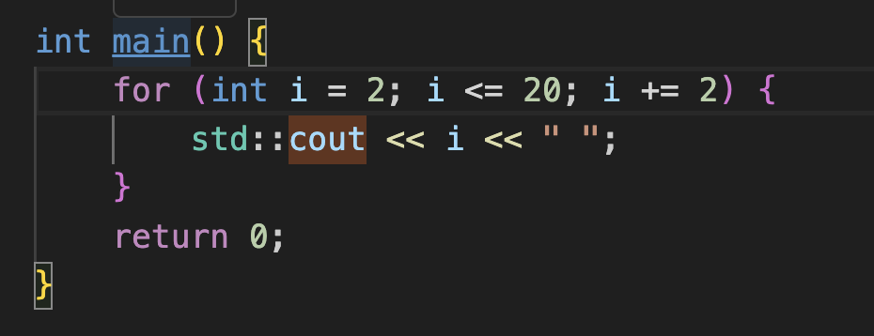

1. Prints any number from 1 till 20
2. Prints any number from 2 till 20
3. Prints even numbers from 2 till 20
4. Prints odd numbers from 2 till 20  
     
   Console:  
   2 4 6 . . . . 20

What is the correct way to declare an array of integers in C++ with 5 elements?  
A. int arr[5];

B. int arr[5] = {};

C. int arr() = {5};

D. int arr[] = {5};  
  
  
Which loop is suitable when the number of iterations is known beforehand?

A. for loop

B. while loop

C. do-while loop

D. All can be used interchangeably

Which keyword is used to define a function that doesn’t return any value?

A. null

B. void

C. empty

D. none

Which type of loop is executed at least once even if the condition is false?

A. for loop

B. while loop

C. do-while loop

D. if statement

Which data type in C++ is used to store decimal numbers?

A. int

B. double

C. char

D. float

Which header file should be included to work with input/output operations in C++?

A. <math.h>

B. <stdio.h>

C. <iostream>

D. <string>

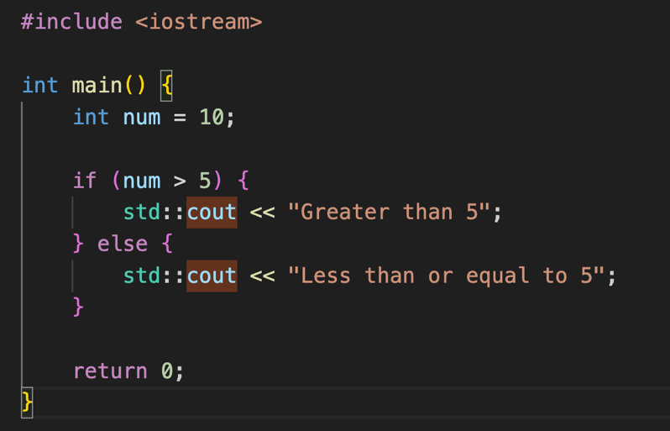

What will be the output of this code?

A. Greater than 5

B. Less than or equal to 5

C. 10

D. This code will result in an error.

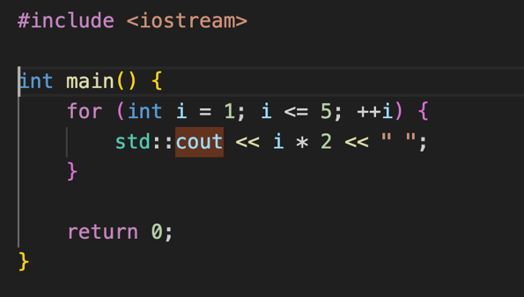

A. 2 4 6 8 10

B. 1 2 3 4 5

C. 1 3 5 7 9

D. 2 4 8 16 32

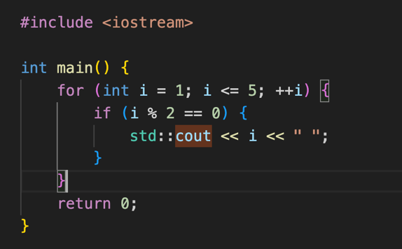

What will be the output of this code?

A. 2 4

B. 1 3 5

C. 1 2 3 4 5

D. 2 4 6

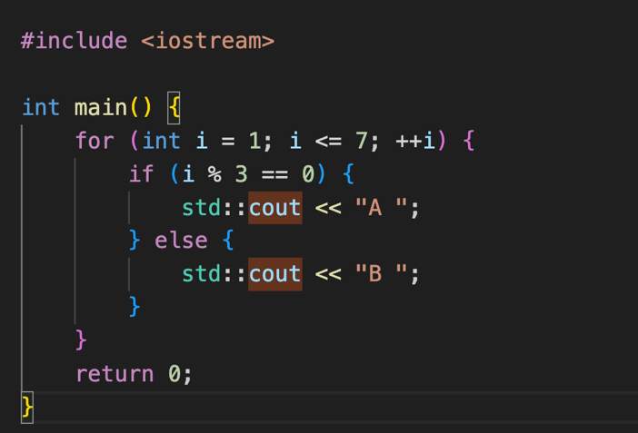

What will be the output of this code?

A. B B A B B A B

B. B A B B A B A

C. B B B A B B B

D. A B B A B B A