PBControl, the scenario paintball score system

By Team F.U.B.A.R. (The Netherlands)

http://www.pbcontrol.net/
http://www.team-fubar.nl/


PBControl is a score system developed by and for scenarion players who want a simple to use and reliable system.
About PBControl
PBControl is a score system developed for scenario paintball players, you can compare the system with the Capture the Flag or Domination modes found in todays video games.
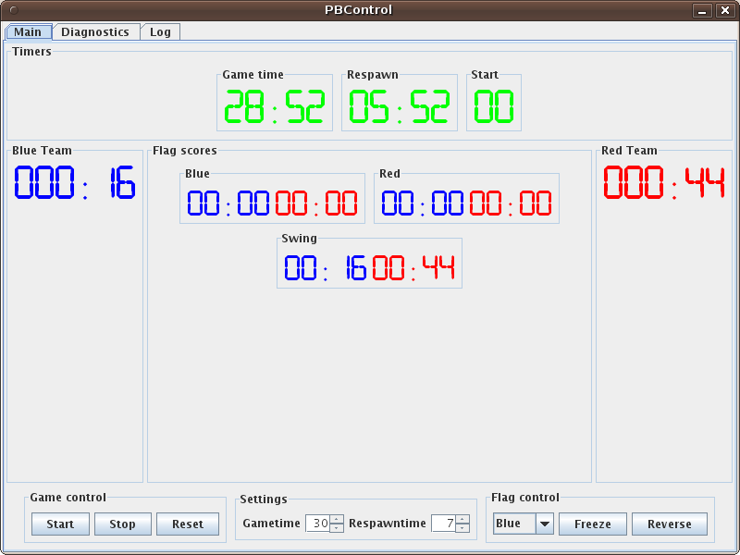
The system is build around three flags (which can be build out to a maximum of 16 upon request), a blue, red and swing flag.

Two teams (Blue and Red) have to battle around these three flags, they will have to clock as much minutes as they can on all three flags during a game.

The three flags can be controlled from a central computer, via a wireless system all flags receive the game settings and the start/stop signal.

On all the flags its possible to add horns which will sound when the game starts and stops, this way players will always have a fair start, which makes playing much more fun.

The central computer
PBControl uses a central computer for controlling the games, the software used is free to use and Open Source (Available on http://www.pbcontrol.net/).

The software supports a lot of features, a summation:
- Variable game/respawn time
- Remotely freeze or reverse (change color) a flag
- View realtime game scores
- Generate a game report (PDF) with scores and two signature lines

For more features and/or screenshots, visit http://www.pbcontrol.net/

Buying PBControl
PBControl is sold as a package consisting of:
- Three bases/flags
- A wireless controller for the central computer
- A CD-Rom with the PC software (Windows, Linux and Mac OSX)

A flag consists of:
- One box with two 4-digit displays (Heavy duty, paintball proof)
- One small box with two buttons (and a cable to connect it to the display box)
- Optionally a horn can be purchased which will sound when a game starts or stops.

The complete system (3 flags, central computer software and hardware) is available starting at EUR 2200,00

For more information, visit www.pbcontrol.net or e-mail to wido@team-fubar.nl

