**SPRAWOZDANIE**

Zajęcia: Grafika komputerowa

Prowadzący: prof. dr hab. Vasyl Martsenyuk

**Laboratorium 9**

**Data: 10.05.2022**

**Temat: "Konstruowanie obiektów z użyciem Three.js"**

**Wariant: 10**

Michał Wielopolski

Informatyka I stopień,

stacjonarne,

4 semestr,

Gr. 4

1. **Polecenie:**

Celem jest konstruowanie modelu figury szachowej zgodnie z wariantem zadania (patrz rysunek) używając three.js

w oparciu na omówione na zajęcie metody konstruowania obiektów

1. **Wykorzystane komendy:**

1. kod źródłowy

var material = new THREE.MeshPhongMaterial(

    {

        color: 0xffffff,

    });

    white_rook = new THREE.Group();

    var white_rook_part1 =  new THREE.Mesh(

        new THREE.SphereGeometry( 1, 32, 16, 0, Math.PI ), material);

    white_rook_part1.rotation.x=-8;

    white_rook.add( white_rook_part1 );

    var white_rook_part2 =  new THREE.Mesh(

        new THREE.TorusGeometry( 1.5, 1, 16, 100 ), material);

    white_rook_part2.rotation.x=-8;

    white_rook_part2.position.y=-0.8;

    white_rook.add( white_rook_part2 );

    var white_rook_part3 =  new THREE.Mesh(

        new THREE.CylinderGeometry( 2.5, 1.5, 3, 64 ), material);

    //white_rook_part3.rotation.x=-8;

    white_rook_part3.position.y=-2.42;

    white_rook.add( white_rook_part3 );

    var white_rook_part4 =  new THREE.Mesh(

        new THREE.CylinderGeometry( 2.6, 2.6, 0.4, 64 ), material);

    //white_rook_part3.rotation.x=-8;

    white_rook_part4.position.y=-4;

    white_rook.add( white_rook_part4 );

    var white_rook_part5 =  new THREE.Mesh(

        new THREE.CylinderGeometry( 3, 3, 0.4, 64 ), material);

    //white_rook_part3.rotation.x=-8;

    white_rook_part5.position.y=-4.4;

    white_rook.add( white_rook_part5 );

    var white_rook_part6 =  new THREE.Mesh(

        new THREE.CylinderGeometry( 1.5, 2, 5, 64 ), material);

    //white_rook_part3.rotation.x=-8;

    white_rook_part6.position.y=-7.1;

    white_rook.add( white_rook_part6 );

    var white_rook_part7 =  new THREE.Mesh(

        new THREE.CylinderGeometry( 2, 3, 5, 64 ), material);

    //white_rook_part3.rotation.x=-8;

    white_rook_part7.position.y=-12.1;

    white_rook.add( white_rook_part7 );

    var white_rook_part8 =  new THREE.Mesh(

        new THREE.CylinderGeometry( 3, 3.8, 3, 64 ), material);

    //white_rook_part3.rotation.x=-8;

    white_rook_part8.position.y=-16.1;

    white_rook.add( white_rook_part8 );

    var white_rook_part9 =  new THREE.Mesh(

        new THREE.CylinderGeometry( 3.8, 4.4, 2, 64 ), material);

    //white_rook_part3.rotation.x=-8;

    white_rook_part9.position.y=-18.6;

    white_rook.add( white_rook_part9 );

    var white_rook_part10 =  new THREE.Mesh(

        new THREE.CylinderGeometry( 4.6, 4.6, 1, 64 ), material);

    //white_rook_part3.rotation.x=-8;

    white_rook_part10.position.y=-20.1;

    white_rook.add( white_rook_part10 );

    scene.add(white_rook);

<https://github.com/wielopolski/GrafikKomputerowa>

1. **Wynik działania:**

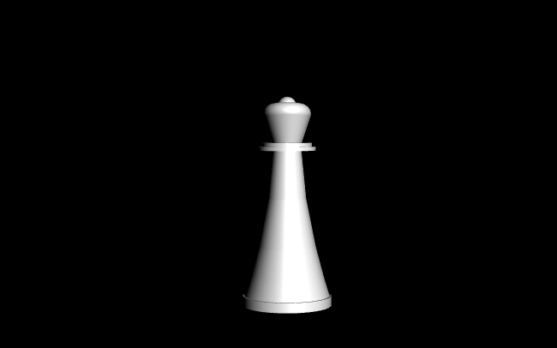

1. **Wnioski:**​

Za pomocą three.js możemy skonstruować różne obiekty w 3D.