BatchEncoder Manual
Revision 1.0.0.0 (01/07/2017)
Contents
1 Introduction 3
1.1 What is BatchEncoder 3
1.2 Supported OS's 3
1.3 System requirements 4
1.4 Screen resolution 4
1.5 Program version numbering 4
1.6 Configuration files extensions 5
1.7 Support 5
1.8 Developers 5
2 License 7
3 Basic usage 8
3.1 Adding input audio files to the File List 8
3.2 Selecting output file format and preset. 9
4 Advanced options 10
5 Contact 11

Introduction
This document is intended as short and compact manual for the BatchEncoder users. Main goal is to describe program features and how to use them. At this chapter are presented the requirements of the program to run correctly in any supported operating system.

What is BatchEncoder
BatchEncoder is an audio files conversion software. It supports most of popular audio file formats including lossy and lossless compression. The main program window is simple in usage and design. BatchEncoder is basically GUI front-end for command-line tools. All it does is creating background processes and passing arguments to it with options you select from presets/format menu and additionally adding input and output file paths. This help file describes very basic futures and usage of the application. For specific options for each format use help available for command-line tools.
In short terms BatchEncoder is:
- new generation of audio conversion utility for Win32 GUI,
- supporting many lossy and lossless audio formats,
- easy configurable for newbies,
- having advanced options for experienced users,
- an open-source, fast and simple software,
- constantly developed as requirements are changing.

Supported OS's
The program is build by default as UNICODE enabled using UnicoWS for older ANSI systems.
Currently are supported the following operating systems:
- Microsoft Windows Vista SP1 (http://www.microsoft.com/)
- Microsoft Windows Vista (http://www.microsoft.com/)
- Microsoft Windows XP SP2 (http://www.microsoft.com/)
- Microsoft Windows 2000 SP4 (http://www.microsoft.com/)
- Microsoft Windows Mev (http://www.microsoft.com/)
- Microsoft Windows 98 SE (http://www.microsoft.com/)
- Microsoft Windows 95 OSR2 with IE 5.0 (http://www.microsoft.com/)
- Unix/Linux using Wine (http://www.winehq.org/)
It is possible to run the program in other versions of Windows or in other operating systems, but the authors are testing program only on this versions of OS's. If you have successfully tested and used this program without any trouble in other OS then send an e-mail or post this on the program forums.

System requirements
It depends on encoders/decoders requirements. Standalone program works with few megabytes of system memory and do not need fast CPU. Check the dependencies of used command-line encoders and decoders for specific information about hardware requirements. The better hardware you have the better it goes. With older hardware you may experience some troubles with highly optimized tools. Specially when they are using assembly optimizations like MMX, SSE, SSE2, SSE3 or any other CPU specific. So please check all the details about your hardware and used tools before complaining to the authors of BatchEncoder in forums or via the e-mail.

Screen resolution
The minimum supported resolution is 640x480 with 256 colors.

Program version numbering
Program has his own version numbering philosophy. As this topic is some times controversial and may be less understandable by some users here is short description how to read program versions.
BatchEncoder A.B.C.D <release>
if (B == 0) && (C == 0) && (D == 0) <release> == Stable
if (B > 0) && (C == 0) && (D == 0) <release> == Stable (patch/fix)
if (C != 0) && (D == 0) <release> == Beta
if (C == 0) && (D != 0) <release> == Alpha
Simplifying all the science we get:
- A for a major stable release (C and D are equal to zero).
- B for a minor stable patch/fix release (C and D are equal to zero).
- C for a beta release.
- D for an alpha release.
For example 1.0.0.5 is alpha release, 1.0.5.0 is a beta release, 1.0.0.0 is stable release and 1.1.0.0 is stable release with minor patch/fix.

Configuration files extensions
Program configuration files are used to store all settings. No other solutions are used, such as system registry. Only XML text files with UTF-8 encoding are supported.
Configuration files extensions:
- .xml - valid for all types of configurations,
- .config - main program configuration,
- .list - the file-list file entry's,
- .presets - preset names and options for selected format,
- .formats - formats specifications for encoders and decoders.
Please use only UTF-8 text editors to edit any configuration files. There is no description of format of configuration files. The file format is self explaining and most of time it is automatically generated by the program. If you really need to know more check the program sources to find how the things are done.

Support
There is no direct support for this software. This is free, open-source software and authors are not paid for developing the software (only user donations are accepted).
The project is developed in free time as hobby and authors are normally working at jobs that are not related to BatchEncoder project. You can go to BatchEncoder website and check the project forums for help or write an e-mail to the authors. Please check the contact chapter for more details.

Developers
To build program from sources you will need the following components:
- Microsoft Visual C++ 9.0
Check Microsoft(R) website http://www.microsoft.com/ for more informations about Visual C++.
- TinyXml Library
Required for compiling the program. Download latest stable release from http://www.sourceforge.net/projects/tinyxml/. Unpack source package to 'TinyXml\src' dir is the program source directory.
- UnicoWS.lib
Required for program compilation (unicode builds only). The Microsoft Platform SDK contains the UnicoWS.lib library (included in MSVC++ 9.0).
To run program on non unicode systems you will need the Microsoft Layer for Unicode dynamic library (UnicoWS.dll).
The Microsoft Layer for Unicode is available as a redistributable from http://www.microsoft.com/msdownload/platformsdk/sdkupdate/psdkredist.htm download it and install in your system.

License
This program is free software; you can redistribute it and/or modify it under the terms of the GNU General Public License as published by the Free Software Foundation; version 2 of the License.
This program is distributed in the hope that it will be useful, but WITHOUT ANY WARRANTY; without even the implied warranty of MERCHANTABILITY or FITNESS FOR A PARTICULAR PURPOSE. See the GNU General Public License for more details.
You should have received a copy of the GNU General Public License along with this program; if not, write to the Free Software Foundation, Inc., 59 Temple Place, Suite 330, Boston, MA 02111-1307 USA

Basic usage

Adding input audio files to the File List
The input files will be converted to the selected output format using chosen preset. For each file you can select different output format and preset. Only checked files are processed.
Method 1 using pop up menu:
Step 1. Right click on the list (pop up menu will display, same as in Edit menu).
Step 2. Select Add Files or Add Directory option.
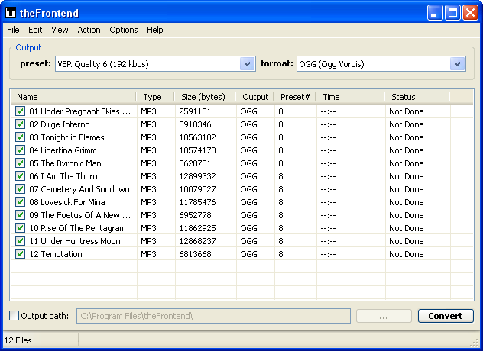
Picture 1: Main program window.
Method 2 using Edit menu from main window:
Step 1. Select form main window menu Edit sub menu.
Step 2. Select Add Files or Add Directory option.
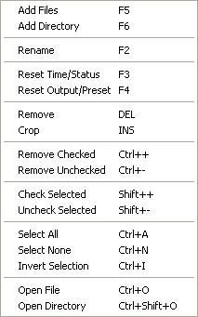
Picture 2: Edit menu and File List pop up menu (this menus are the same).
You can Load and Save file list form/to a file using File menu.
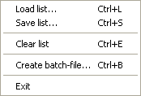
Picture 3: File menu options.

Selecting output file format and preset.
To be done.

Advanced options
To be done.

Contact
Website: https://github.com/wieslawsoltes/BatchEncoder
E-mail: wieslaw.soltes@gmail.com

