

Title of the Abstract

Presenting Authora, Second B. Authorb, Third C.

Authorb

aDepartment of Ecochemistry, University, City, Country

bDepartment of Analytical Chemistry, Institution, City, Country

**Young scientists are strongly encouraged to submit their work and participate in the conference. A prize will be offered to the best presentation (250€).**

INTRODUCTION

This document has been prepared to assist authors submitting abstracts for the SWS- Europe Annual Meeting. It has been prepared with the specified page layout, general formatting and styles for papers to be published in the conference proceedings.

Paper size is A4 (21x29.7cm); margins are 2.54 cm all around. Font is Times New Roman size 12 for the main text except article title (size 16) and Authors’ names (size 14). Text is justified (except for title and Authors’ names: centred).

The division in sections should suit most Authors. However, Authors should not feel constrained to the suggested sections. Text styles (such as headings, captions and tables) have been defined for ready application. Please apply these styles to the appropriate text.

METHODS

Under the following format, many authors will be able to replace the existing text in the document. This will ensure the correct style is used throughout the document. For instance, the above heading is in the style of a first-level heading.

The beginning of a new paragraph is indented and there are no lines between paragraphs.

Second heading style

The styles of different level headings are defined as part of this document. Simply apply the desired style to the heading in the text.

*Third heading style*

The above is an example of the third-level heading style.

RESULTS and DISCUSSION

Results and Discussion should be here.

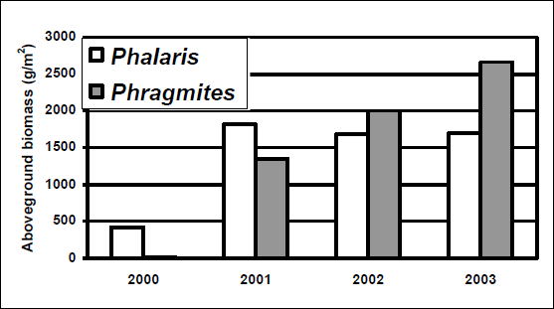

**Fig. 1**. Centre figures on the page. The style for figure captions (“Caption”) is the same as that for tables. Place the caption below the figure. Font size is 10 point.

Figures

Figures should be preferably in black and white. If you submit a colour figures, make sure they are legible in black and white printing because the book of abstracts will be printed in black and white. Where possible, insert electronic versions of figures in your document.

Tables

It is important to follow the format and style for tables carefully. An example is given below. Apply the style “Table” to the text in the table before applying other text formatting such as tabs, indents etc. As a minimum, please use Times New Roman 10 point font.

**Table 1. Table captions are placed above the table to which it refers. Tables are centred on the page. Font size is 10 point.**

|  |  |  |  |  |  |
| --- | --- | --- | --- | --- | --- |
| Row 1 | Row 2  (days) | Row 3  (mg kg-1) | Row 4  (min) | Row 5  (mg L-1) | Row 5  (%) |
| A1 | 1 | 10.0 | 15 - 6 | 8.06 | 4 |
| A2 | 2 | 6.1 | 65 - 32 | 4.7 | 27 |
| B1 | 3 | 485.8 | 45 - 6 | 3.4 | 98 |
| B2 | 4 | 36.4 | 1 - 0.5 | 12.02 | 47 |
| C1 | 5 | 8.1 | 53 - 1.5 | 64.1 | 6 |
| C2 | 6 | 2.3 | 1.5 - 0.2 | 2.2 | 12 |

CONCLUSIONS

Conclusions of the study to be placed here.

ACKNOWLEDGEMENTS

Acknowledgements to be placed here.

REFERENCES

Kadlec, R.H. and Knight, R.L. 1996. *Treatment Wetlands.* CRC Press Lewis Publishers, Boca Raton, New York, 893 p.

Kersten, M. 2002. Speciation of trace metals in sediments. In: Ure, A.M. and Davidson, C.M., (Eds.) *Chemical Speciation in the Environment*. Blackwell Science Ltd Oxford., UK, pp. 301-321.

Vymazal, J. 2007. Removal of nutrients in various types of constructed wetlands. *Science of the Total Environment* 380 (1-3): 48-65.

2