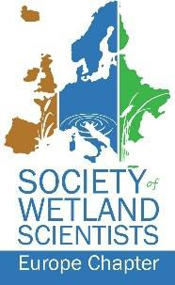

**Thank you Biebrza !**

Martin Wassen

Environmental Sciences, Copernicus Institute of Sustainable Development, Utrecht University

What started almost 40 years ago, when I visited Biebrza for the first time in 1985 has enriched my life in many ways. The landscape, the ecosystems, the hydrology, the people, the friends and all the adventures I experienced during these almost 4 decades. Doing field work together, gaining insight into how this extraordinary ecosystem works, experiencing the darkness at night, the quietness, the wildlife, the cultural heritage, how people can live in harmony with nature, the history with its bright but also dark sides, the happiness we shared at a bonfire or being on my own for a day in the marshes. All this I cherish with gratitude. I have, not only as scientist, but also as a person benefitted enormously from Biebrza.

Today in my presentation I will take you on a tour. I will travel through time over the past 40 years of Polish – Dutch cooperation. On the way I will highlight projects in which various consortia of researchers have worked together in unraveling the secrets of Biebrza leading to a deeper insight into the processes and the functioning of the system and how these have contributed to protection and management. On behalf of all Dutchmen that worked in Biebrza I would like to express our sincere gratitude.

Thank you Biebrza !