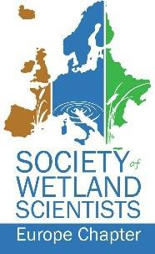

Time to restore. What can science do to bring power to the peatlands?

Rudy van Diggelen

University of Antwerp, Department of Biology

Peatlands have declined worldwide, especially in Europe, particularly in Western Europe, where many have simply vanished. Almost all remaining peatlands are so severely degraded that they have become environmental problem areas. To reach a sustainable future peatland restoration is therefore essential. The European Commission has recognized this and included peatland restoration as a priority target in an ongoing legislation attempt to reverse further nature degradation in Europe. This proposed Nature Restoration Law formulates binding targets for nature restoration throughout the EU and has the final goal that all European ecosystems are in need of restoration by 2050. Note that the proposal does not say that the restoration has finished by 2050 but instead that it is in progress by then. The Commission sees restoration as a process, not necessarily an endpoint.

Despite this—according to some relatively modest—target, the NRL proposal has led to much agitation in interest groups. The agricultural lobby has campaigned massively against the proposal. That lobby was rather successful. At the moment of writing (spring 2024), even a significantly watered-down version of the original proposal has still not been accepted by the member states.

In my contribution, I will describe how the process has developed and analyze the role of scientists therein. I will assess the positions of the different interest groups and discuss opportunities to cooperate with crucial stakeholders in order to bring back the power to the peatlands. I will discuss possible restoration pathways outside the NRL and identify areas where scientists can play an important role.