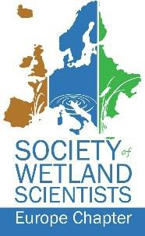

Wetland restoration in the National park “Bielaviežskaja pušča” – the Belarusian part of the Bialowieza forest. Summary of the two decades of work.

Viktar Fenchuk

Frankfurt zoological society, Frankfurt, Germany

National park “Bielaviežskaja pušča” covers an area of over 150 thousand hectares of which 82,5 thousand hectares constitute the Belarusian part of the cross-border belarus-polish UNESCO World Heritage Site Bialowieza forest.

Forests of Bielaviežskaja/Bialowieza were developing in the conditions of stable hydrological regime and high waterlogging with up to 30% of the area covered in wetlands and mires. Drainage and land improvement activities started on the territory of Bielaviežskaja/Bialowieza in the 19th century, continued in 1920-1930’s and peaked during soviet times in 1950-1960’s. As the result, over 50% of mires were drained, the majority of rivers canalized and an extensive system of drainage canals created. Such large scale drainage caused a general drop in the ground water level on the larger part of Bielaviežskaja pušča by 0,5-1,5 meters leading to cascade effects in forest ecosystems. (Grummo et al., 2021).

First wetland restoration activities on the territory of the National park were conducted at Dzikaje mire in 2006 under coordination of APB-BirdLife Belarus as part of implementation of the site management plans for three key breeding sites for the globally threatened Aquatic warbler *Acrocephalus paludicola* developed in 1998. Following this work, the need for wetland restoration appeared in the Park’s Management plan in 2008 (Management plan…, 2008).

The first complex inventory of potential wetland restoration sites was implemented in 2010. The inventory focused on melioration systems – drained mires and screened the state of 14 sites, of which 10 sites were identified as requiring restoration (Kozulin et al., 2010). In 2012-2013 the second inventory focused on small and seasonal watercourses in the central part of Bielaviežskaja pušča and reviewed the state of 30 linear objects (channels, streams, rives), of which of which only 8 were of natural origin. Subsequent and prioritization selected 8 objects grouped in 3 sites (Arnolbik et al., 2013) for priority restoration.

In December 2013 a Memorandum of Understanding outlining key priorities for joint work was concluded between the National park “Bielaviežskaja pušča”, APB-BirdLife Belarus and Frankfurt zoological society. This cooperation gave an impetus to wetland restoration activities. Basing on the results of the inventories, planning of restoration works started in 2014 and by 2023 the restoration works were implemented on 10 sites with the total area of 3’664 hectares. The smallest restoration site was 36 ha (canal in the upper course of Salomienka river) and the largest – 1’238 ha (Zarkauščyna forest drainage network) (Table 1., Figure 1).

**Table 1. Wetland restoration sites in the National park “Bielaviežskaja pušča”**

|  |  |  |  |  |
| --- | --- | --- | --- | --- |
| # | Site name | Year of completion of restoration works | Area, ha | Site type |
|  |  |  |  |  |
| 1 | Dzikaje mire | 2006 | n/a* | Natural fen mire |
| 2 | Baruščyčy | 2016 | 37 | Drained fen mire |
| 3 | Plianta | 2016 | 91 | Drained fen/meadow |
| 4 | Upper Salomienka river | 2016 | 36 | Forest drainage channel |
| 5 | Dziki Nikar | 2017 | 1164 | Drained fen mire |
| 6 | Papialiova | 2018 | 300 | Drained fen mire |
| 7 | Dzikaje - Kliepačy | 2019 | 330 | Drained fen mire |
| 8 | Salomienka river | 2019 | 138 | Canalized river |
| 9 | Zarkauščyna drainage network | 2021 | 1238 | Forest drainage channel network |
| 10 | Zubryca | 2023 | 92 | Drained fen mire |
| 11 | Halieva balota | 2023 | 239 | Drained fen mire |
|  |  |  |  |  |
|  | Total |  | 3664 |  |

* Impact area estimation is not available

The third stage of screening was implemented in 2021 (Grummo et al., 2021) focusing on pealtands and with the account of restoration works implemented in 2014-2021. Preliminary list of restoration sites included 34 territories, located in different functional zones of the National park. Further field work narrowed down this list to 19 sites with the area of 29’139 hectares, ranging from 57,8 ha (Panasiuki) to 13’610 ha (Arlova mire). This list constituted the workplan for peatland restoration in Bielaviežskaja pušča until 2030.

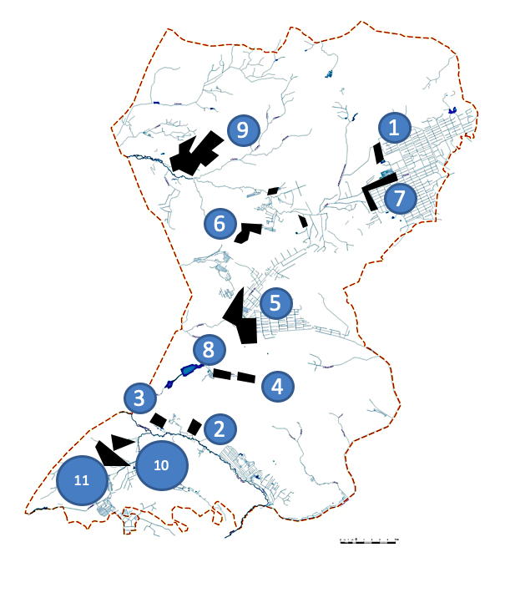

**Fig. 1**. Wetland restoration sites in the National park “Bielaviežskaja pušča” entre figures. Numbers correspond to those in Table 1.

The decade of restoration works showed that the cycle from the concept to completion of construction is taking over two years and the average pace of restoration of one site per year. Hence, the needs for restoration are much larger than the capacity to implement them, and the existing restoration plan constitutes an ambitious programme.

Current border wall construction on Belarus/Polish border will likely create additional problems with hydrological regime and will require even more resources to mitigate them on the both sides of the border.

REFERENCES

Arnolbik V., Bernatski D., Bubenko A., Kravchuk V., Kravchuk V., 2013. Inventory and creation of GIS of small and seasonal watercourses in the historic part of Bielaviežskaja pušča. Research report. [Провести инвентаризацию и создать ГИС малых и временных (сезонных) водотоков в исторической части Беловежской пущи». Отчет о НИР], Kameniuki, 47 p.

Grummo D., Zelenkevich N., Zylinski D., Mojseichik E., Petrov V., Babich E., 2021. Evaluate the current state of peatlands of the National park “Bielaviežskaja pušča” and develop a long term programme of their restoration. Research report. [Оценить современное состояние торфяников Национального парка «Беловежская пуща» и разработать долгосрочную программу их восстановления. Отчет о НИР], Minsk, 55 p.

Kozulin A., Maximenkov M., Skuratovich A., Giginiak Y., Korzun E., Vasilievskij A., Kulikva E., Grechanik L., 2010. Identify melioration systems which negatively affect ecosystems of Bielaviežskaja pušča and where rewetting is ecologically and economically justified. [Определить мелиоративные системы, негативно влияющие на экосистемы Беловежской пущи, на которых по экологическим и экономическим причинам целесообразно проведение повторного заболачивания. Отчет о НИР], Minsk, 113 p.

Management plan of the National park “Bielaviežskaja pušča”. Declarative part. 2008 [План управления Национальным парком «Беловежская пуща». Констатирующая часть], Minsk, 2008, 183 р.