# 3.3 Chemical reactions

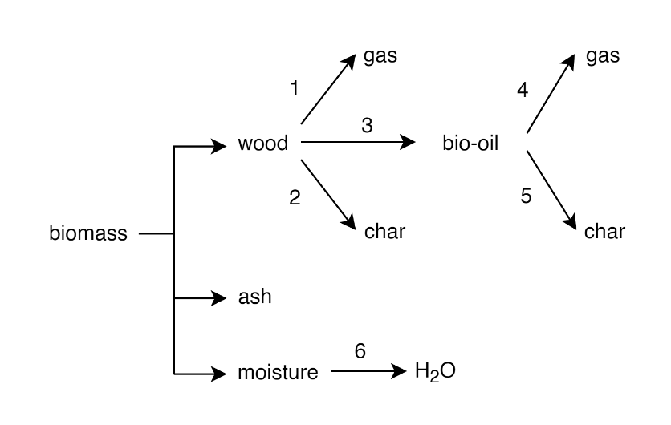

Figure .

Table .

|  |  |  |  |  |  |
| --- | --- | --- | --- | --- | --- |
| Reaction number | Name | A (s-1) | E (kJ mol-1) | Heat of reaction (kJ/kg) | Reference |
| 1 | Light-gassing | 4.38 × 109 | 152.7 | -20 | [1] |
| 2 | Charring | 3.27 × 106 | 111.7 | -20 | [1] |
| 3 | Tarring | 1.08 × 1010 | 148.0 | 255 | [1] |
| 4 | Cracking | 4.28 × 106 | 108.0 | -42 | [2] |
| 5 | Repolymerization | 1.00 × 106 | 108.0 | -42 | [2] |
| 6 | Evaporation | 5.13 × 106 | 87.6 | 2700 |  |

# 3.5 CFD-DEM modeling approach

A coarse-grained CFD-DEM model was implemented for biomass pyrolysis in MFiX, an open-source, Fortran-based code. The implemented coarse-grained CFD-DEM model in this research is an extension of the standard MFiX release. Gas-phase transport was described using conservation equations of mass, momentum, energy, and chemical species in the Eulerian framework (Equations (1) – (4), respectively).

|  |  |
| --- | --- |
|  | () |
|  | () |
|  | () |
|  | () |

where , , , , , , and ${\text{Y}}_{\text{i}}$ are gas phase volume fraction, density, velocity, pressure, stress tensor, conductive heat flux, and ith chemical species, respectively, $\text{t}$ is time, $\text{g}$ is acceleration due to gravity, $D_{i}$ is mass diffusion coefficient for species, $S_{ρ}$, ${\text{S}}_{u}$, $S_{E}$, and $S_{Y_{i}}$ are mass, momentum, energy, and chemical species source terms, respectively. Fixed quantities of discrete particles with identical initial conditions were lumped into a computational coarse-grained parcel (CGP), whose motion was governed by Newton’s second law of motion. All particle forces and contact dynamics were calculated on the parcel scale, whereas heat and mass transfers were calculated on the particle scale and projected to the entire parcel. Accordingly, all particles in the same coarse-grained parcel possess identical temperature, chemical species concentration, and momentum. The mass and diameter of each coarse-grained parcel were such that:

|  |  |
| --- | --- |
|  | () |
|  | () |

where is CGP mass, $m_{p}$ is distinct particle mass, $W$ parcel statistical weight, $d_{CGP}$ is CGP diameter, and $d_{p}$ is distinct particle diameter. Instantaneous accelerations – translational and rotational – for each coarse-grained parcel were calculated as:

|  |  |
| --- | --- |
|  | () |
|  | () |

where and $ω_{CGP}$ are the CGP translational and rotational velocities, $\text{g}$ is acceleration due to gravity, $m_{CGP}$ is CGP mass, $T_{CGP}$ is net torque on the CGP, and $I_{CGP}$ is CGP moment of inertia. The term $F_{p}$ represents pressure gradient force and is calculated as the product of the CGP volume and pressure gradient. The CGP collision forces ($F_{c}$) – parcel-parcel and parcel-wall collisions – was modeled according to linear spring-dashpot model [3]. Since the number of CGP collisions is significantly lower than the number of collisions expected in systems with distinct particles, the CGP coefficient of restitution was modified as a correction for energy dissipations during collisions. The proposed modification to the CGP coefficient of restitution is calculated following the kinetic theory of granular flow [4] as:

|  |  |
| --- | --- |
|  | () |

where is CGP coefficient of restitution and $e_{p}$ is distinct particle coefficient of restitution. Two different drag models were used to estimate CGP drag force ($F_{d}$) based on well-documented differences in the fluidization behavior of sand and biomass in the literature [5]. Drag force was estimated following Ganser-corrected Gidaspow drag model for sand (bed material) particles and a filtered drag model for biomass particles. Ganser correction [6] was coupled to Gidaspow model [7] to account for non-sphericity of the sand particles as expressed below:

|  |  |
| --- | --- |
|  | () |
|  | () |
|  | () |
|  | () |
|  | () |
|  | () |

The filtered drag model (modified Sarkar drag model) used in this research for biomass particles was proposed by Gao et al. [8] and was found by the authors to have relatively high prediction strength across multiple flow regimes in fluidized bed systems. The modified Sarkar drag model is derived fine-grid simulation with Wen-Yu drag model and can be computed as:

|  |  |
| --- | --- |
|  | () |
|  | () |
|  | () |
|  | () |
|  | () |
|  | () |
|  | () |
|  | () |
|  | () |
|  | () |
| = [0.75597773, 2.73931487, –5.60196497, –1.65853820, 16.70299223, –0.44145335, 0.18195034, –0.01827347, 0.28441799, –1.943573770, 0.22177961, 0.31175890, –0.15971960, 0.47750002, 0.062794180, 5.13011673, 0.67680355, –0.54535726] | () |

Table . Particle properties for biomass and bed material (sand).

|  |  |  |  |  |
| --- | --- | --- | --- | --- |
| Property | Biomass | Sand | Units | Description |
| $$d_{p}$$ | see Table 3 | 453 | µm | Particle diameter |
| $$ρ_{p}$$ | see Table 4 | 2500 | kg/m3 | Particle density |
| $$C_{p}$$ | † | 830 | kJ/kg-K | Particle heat capacity |
| $$ϕ$$ | – | 0.94 | – | Particle sphericity |
| $$e_{p}$$ | 0.2 | 0.61 | – | Particle–particle coefficient of restitution |
| $$e_{w}$$ | 0.2 | 0.61 | – | Particle–wall coefficient of restitution |
| $$e_{s}$$ | 0.2 | – | – | Particle-sand coefficient of restitution |
| $$μ_{p}$$ | 0.1 | 0.1 | – | Particle–particle coefficient of friction |
| $$μ_{w}$$ | 0.2 | 0.2 | – | Particle–wall coefficient of friction |
| $$μ_{s}$$ | 0.1 | – | – | Particle-sand coefficient of friction |
| $$k_{n}$$ | 100 | 100 | N/m | Sand particle spring constant |

† $C_{p}$ calculated based on particle composition

Table . Particle size distribution of biomass feedstock.

|  |  |  |
| --- | --- | --- |
| Sauter mean diameter (µm) | Mass fraction (%) | Mass flow rate (kg/h) |
| 278 | 12.1 | 0.018 |
| 344 | 51.0 | 0.076 |
| 426 | 34.2 | 0.051 |
| 543 | 2.7 | 0.004 |

Table . Chemical species composition of biomass feedstock.

|  |  |  |
| --- | --- | --- |
| Species | Mass fraction (%) | Density (kg/m3) |
| Moisture | 4.0 | 1000 |
| Wood | 95.9 | 500 |
| Ash | 0.1 | 2000 |
| Char | 0.0 | 300 |

Table . Simulation parameters settings.

|  |  |
| --- | --- |
| Parameter | Value |
| CFD cell size, $∆_{x}×∆_{y}×∆_{z}$ (mm) | 4.3 × 4.4 × 4.3 |
| Time step, $∆_{x}$ (s) | Variable |
| Biomass parcel statistical weight | 10 |
| Sand parcel statistical weight | 20 |
| Gas phase equation of state | Ideal |

Table . Simulation cases for different gas mixtures where columns denote gas flow rate (m3/s at 500 °C).

|  |  |  |  |  |  |  |  |
| --- | --- | --- | --- | --- | --- | --- | --- |
| ID | Case label | Fluidizing gas flow rate (m3/s at 500 °C) | | | | | |
| N2 | H2 | H2O | CO | CO2 | CH4 |
|  | N2 | 6.56e-04 | 0.00 | 0.00 | 0.00 | 0.00 | 0.00 |
|  | H2 | 0.00 | 6.37e-04 | 0.00 | 0.00 | 0.00 | 0.00 |
|  | H2O | 0.00 | 0.00 | 6.37e-04 | 0.00 | 0.00 | 0.00 |
|  | CO | 0.00 | 0.00 | 0.00 | 6.37e-04 | 0.00 | 0.00 |
|  | CO2 | 0.00 | 0.00 | 0.00 | 0.00 | 6.37e-04 | 0.00 |
|  | CH4 | 0.00 | 0.00 | 0.00 | 0.00 | 0.00 | 6.37e-04 |
|  | N2 + CO | 3.18e-04 | 0.00 | 0.00 | 3.18e-04 | 0.00 | 0.00 |
|  | N2 + CO2 | 3.47e-04 | 0.00 | 0.00 | 0.00 | 3.18e-04 | 0.00 |

* Additional 2.83 × 10-5 m3/s of N2 at 500 °C supplied at fluidizing gas inlet for all cases.
* Additional 2.55 × 10-5 m3/s of N2 at 25 °C supplied at biomass feed inlet for all cases.

# Results and discussion

## CFD-DEM simulation validation

The predicted yield of pyrolysis products (bio-oil, light gas, and biochar) was validated against experimental data reported by Reference. In their experimental work, Reference carried out biomass pyrolysis in the same NREL 2FBR fast pyrolysis system that is modeled and simulated in this research. Additionally, the process variables used in the experimental work are consistent with those implemented for the N2 and H2 cases in this research. Figure 2 shows that the predicted yields of pyrolysis products closely follow the experimental data with absolute deviation ranging between 1 and 6%. The largest observed deviations occur in the prediction of bio-oil and are attributed to the non-closure of mass balance for the experimental data. The reported mass closure for the experimental data was about 94%. A mass-proportional adjustment of the experimental data to enforce 100% mass closure decreases the absolute deviation of bio-oil prediction to about 2% or less.

From a qualitative point of view, the implemented CFD-DEM simulation in this research was able to acceptably predict the increase in light gas yield and decrease in biochar yield when fluidizing gas was changed from N2 to H2, as seen in the experimental data. Predicted bio-oil yield slightly increased when fluidizing gas was changed from N2 to H2, contrary to experimental data showing a slight decrease. The relative change in bio-oil yield between N2 to H2 was however quite small for both experimental data (2%) and CFD-DEM prediction (-1%).

These results demonstrate that the CFD-DEM model implemented in this research is capable of realistically simulating the characteristic effects of fluidizing gas on the performance of lignocellulosic biomass pyrolysis.

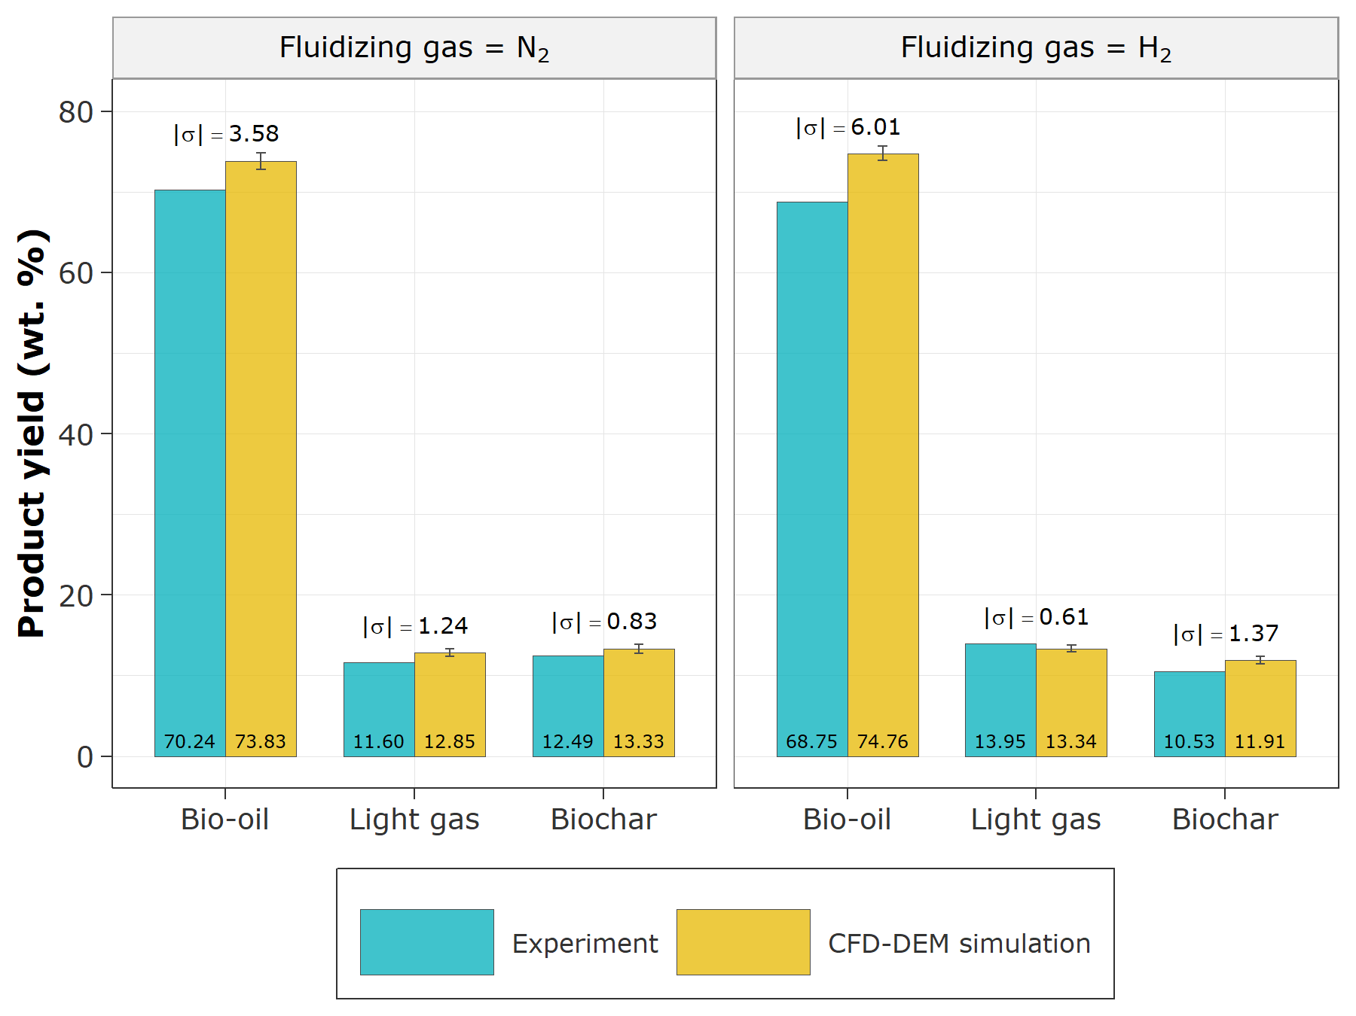

Figure . CFD-DEM simulation validation against experimental data. Product yields are calculated on a biomass basis. $σ=Experimental data – CFD-DEM prediction$.

## Fluidizing gas effect on pyrolysis performance

Figure 3 presents the volume-time averaged pressure drop and temperature along the height of the fluidized bed reactor. The different fluidizing gases considered in this research demonstrated similar effects on the pressure drop profile along the reactor height. Overall, the averaged bed height – as evidenced by the inflection point on the pressure drop curve – was about 0.14 m, regardless of fluidized gas. Similarly, the total pressure drop across the reactor was consistently about 1440 Pa for all fluidizing gases and mixtures. The volume-time averaged gas temperature ranged between 495 and 500 °C, depending on position along the reactor height and fluidizing gas. Gas temperature generally dipped around the biomass inlet and at the dense-bed/dilute-phase interface. The most noticeable trend in gas temperature occurs in the dilute-phase, with increasing gas temperature along the height of the reactor. Also noteworthy is the fact that gas temperature in the dilute-phase was highest when H2 was used as fluidizing gas. This observation is attributable to the large difference in the thermal conductivity of H2 and the other fluidizing gases (Figure ???). The impact of the difference in the thermal conductivity of fluidizing gases is also evident in the average particle temperature and mass loss profile (Figure 4). When H2 was used as fluidizing gas, biomass particles experienced significantly higher heating rate, and consequently higher mass loss rate, compared to when other fluidizing gases were used. Biomass heating and mass loss rate follow the order: H2 > CH4 > H2O > CO2 > N2 + CO2 > N2 > N2 + CO > CO, irrespective of the initial size of the biomass particle.

Furthermore, it was observed that tar conversion reactions (Reactions 4 and 5) slightly changed among fluidizing gas used, with the lowest being N2 and the highest being H2 (Figure 5). This observation explains the reason why despite H2 yielded the highest particle heating and mass loss rate (Figure 4), and one of the longest residence times (Figure 6), its bio-oil yield relative to biomass flow rate is negligibly different from the bio-oil yield with other fluidizing gases, especially N2. Nevertheless, the fact that we found that fluidizing gas can notably increase biomass heating and mass loss rate (pyrolysis conversion rate) suggest potential process intensification implication because increased heating and pyrolysis rate represents a system where pyrolysis can be completed at an increased rate and consequently offering increased system throughput. Our finding suggests that, at the least, fluidizing gas with produced light gases can be recirculated as fluidizing gas without detrimental consequences on pyrolysis performance.

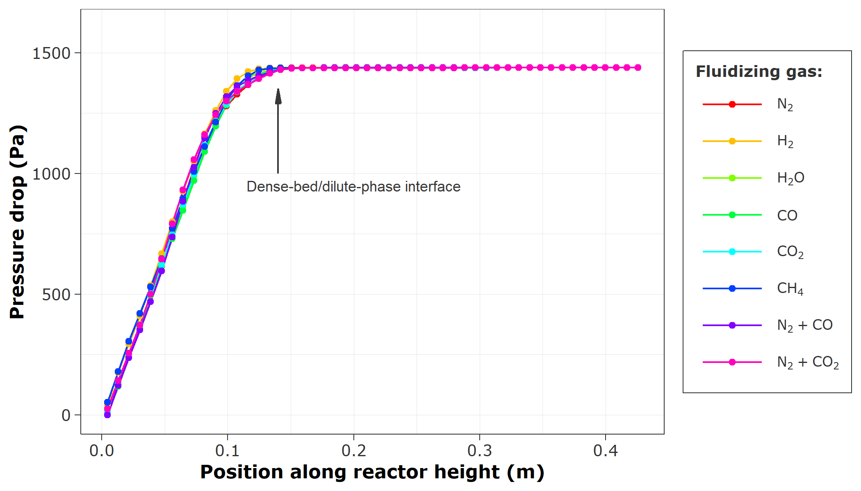 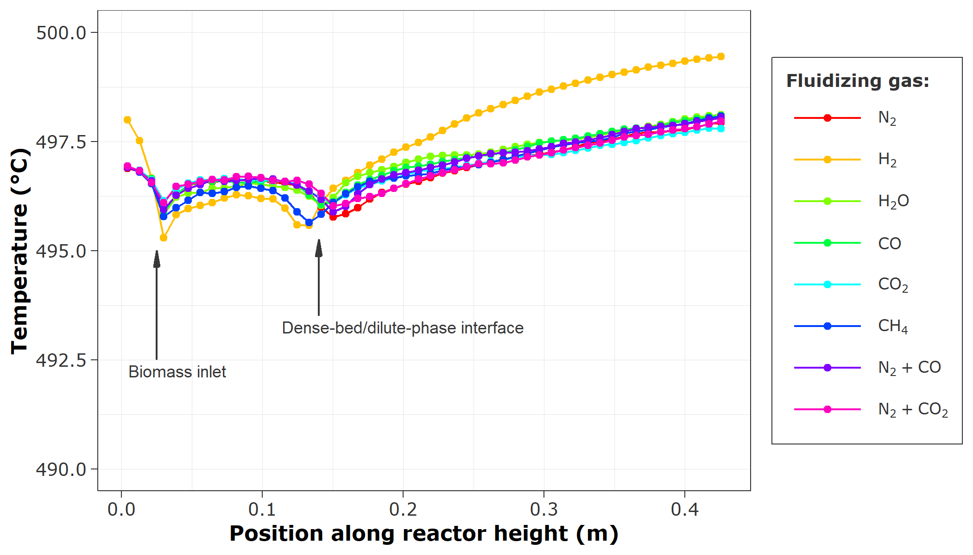

1. (b)

Figure . Time-averaged distribution of gas phase (a) pressure drop and (b) temperature along the reactor height.

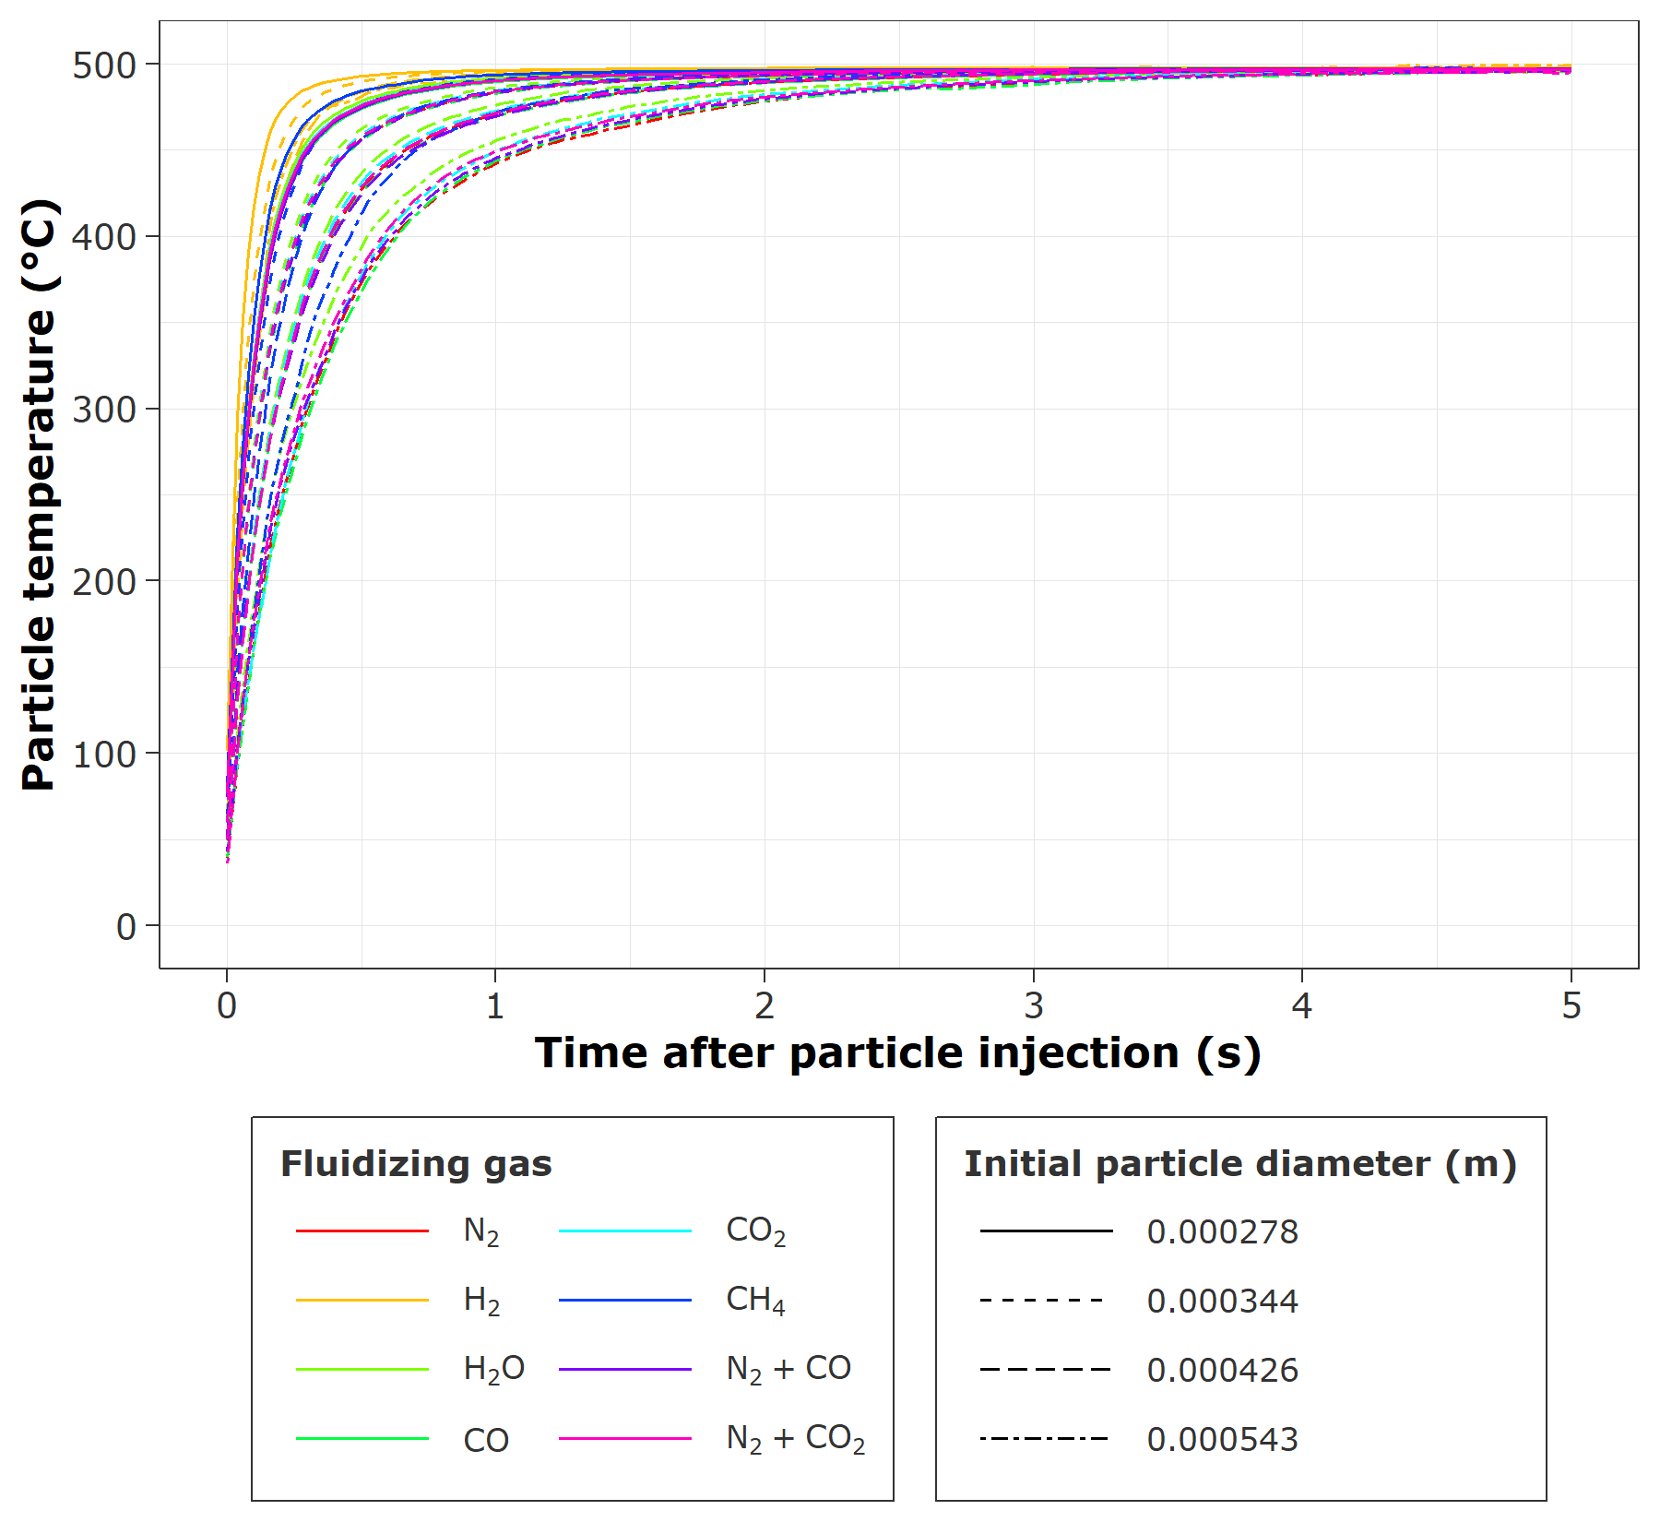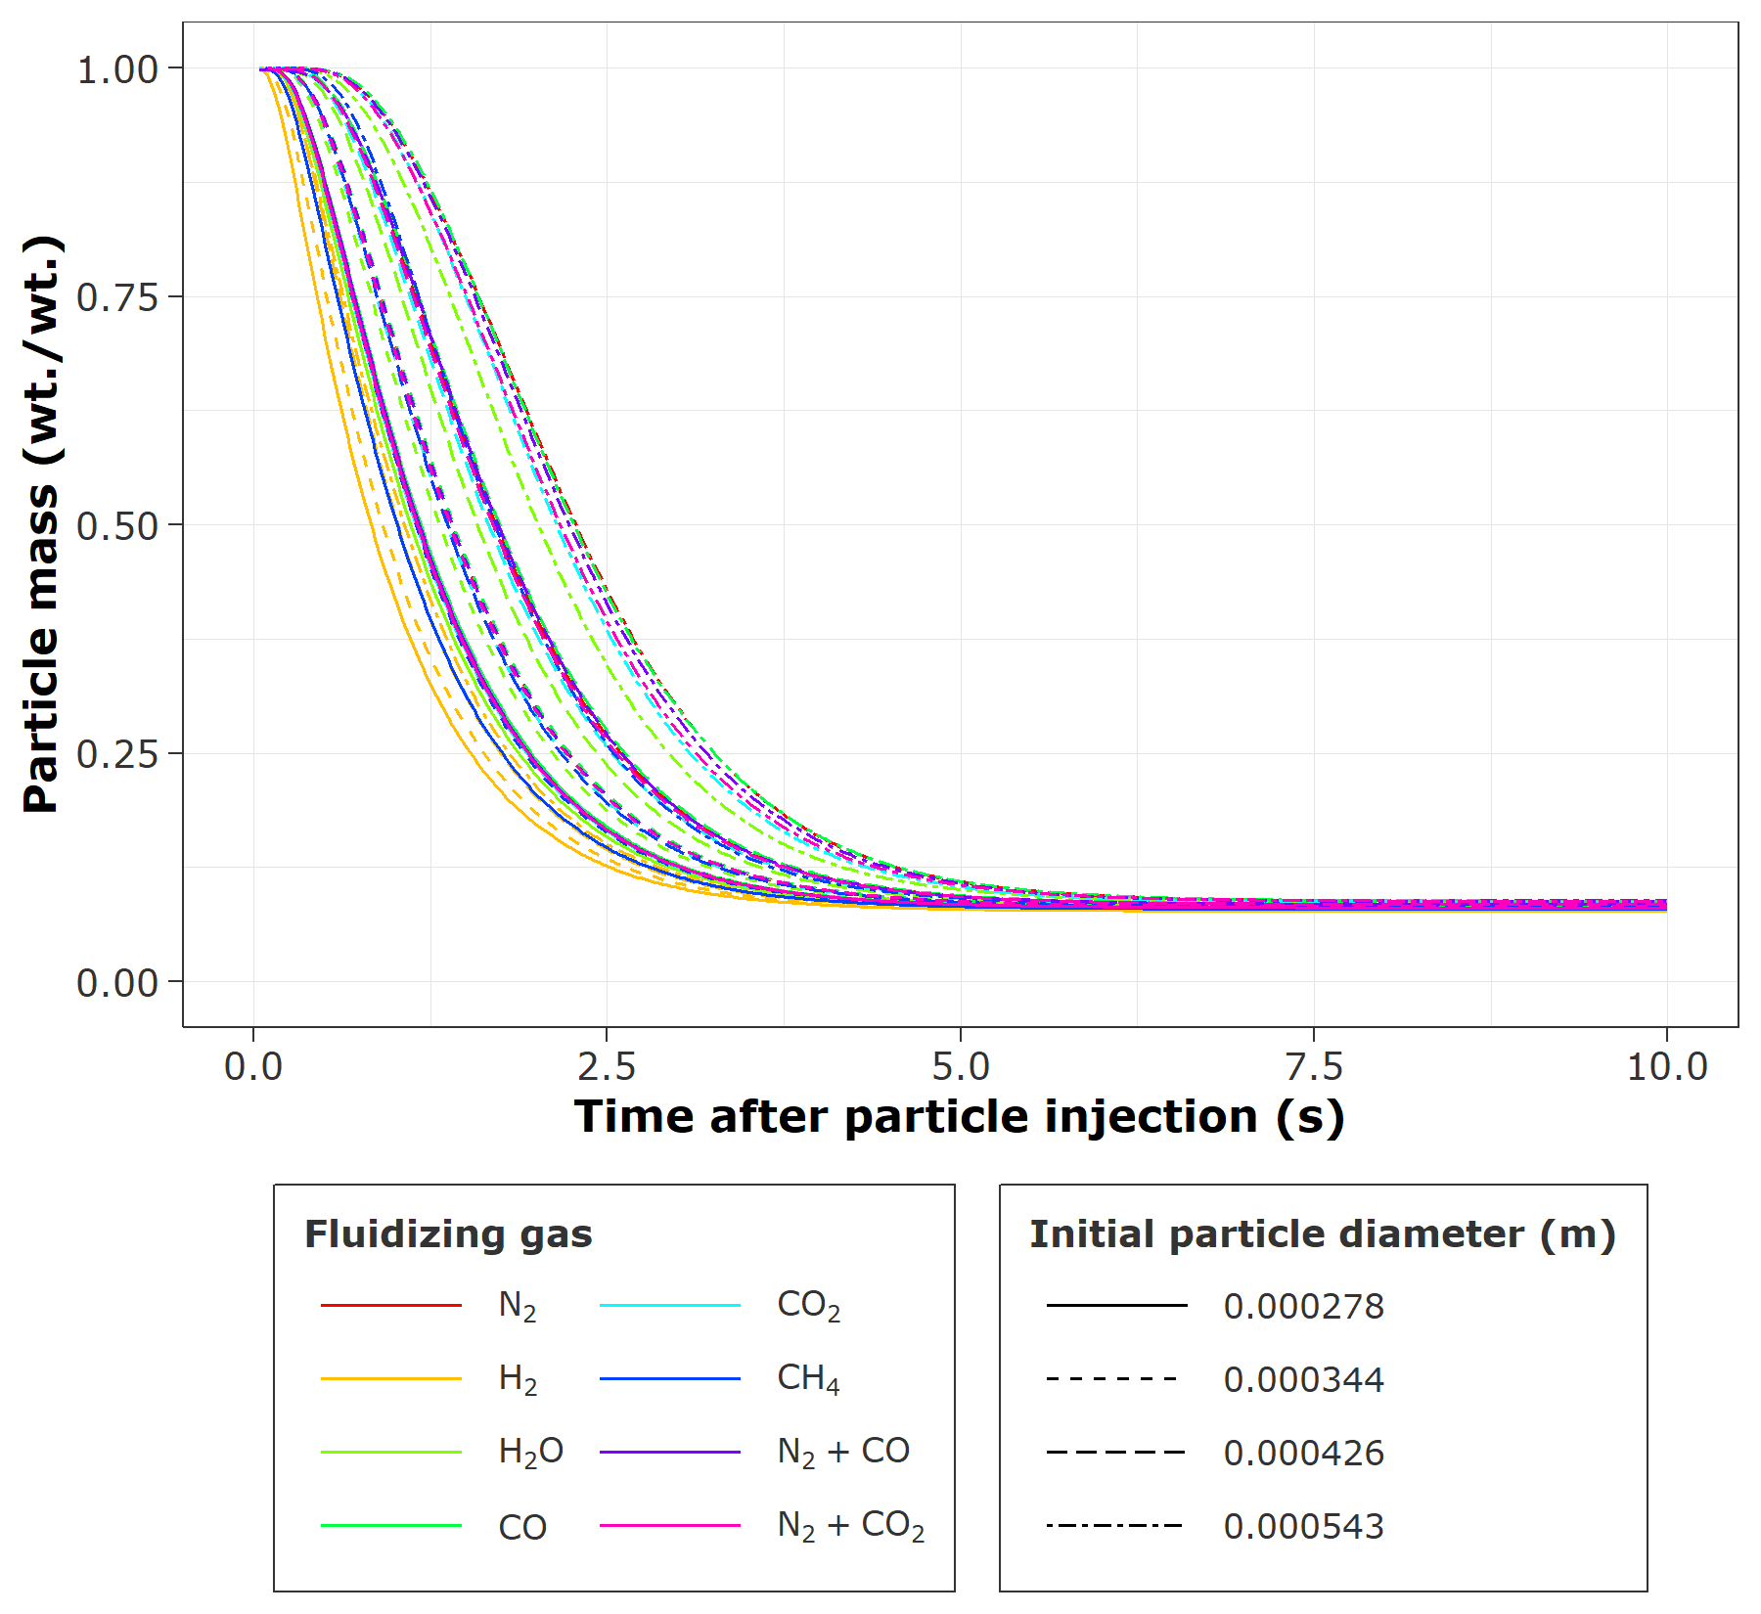



(a) (b)

Figure . Average particle (a) temperature and (b) mass loss profile during pyrolysis. Line color discriminates among fluidizing gas, whereas line type discriminates among initial particle diameter.

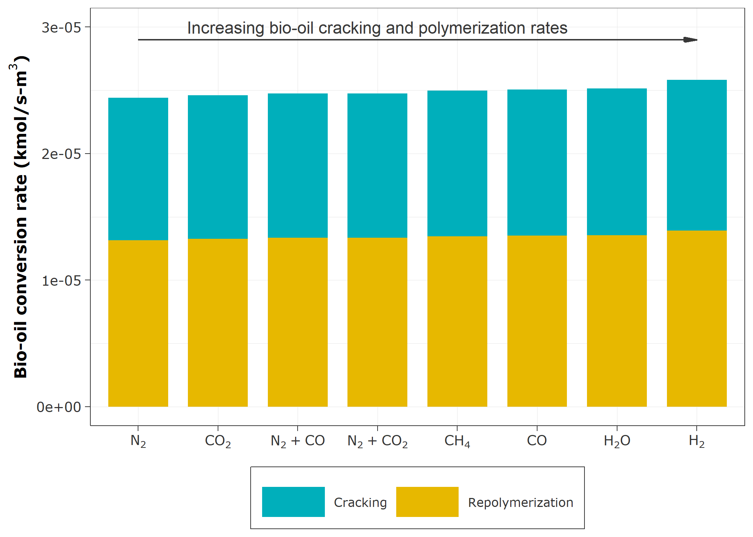

Figure . Time-average bio-oil cracking and polymerization rates.

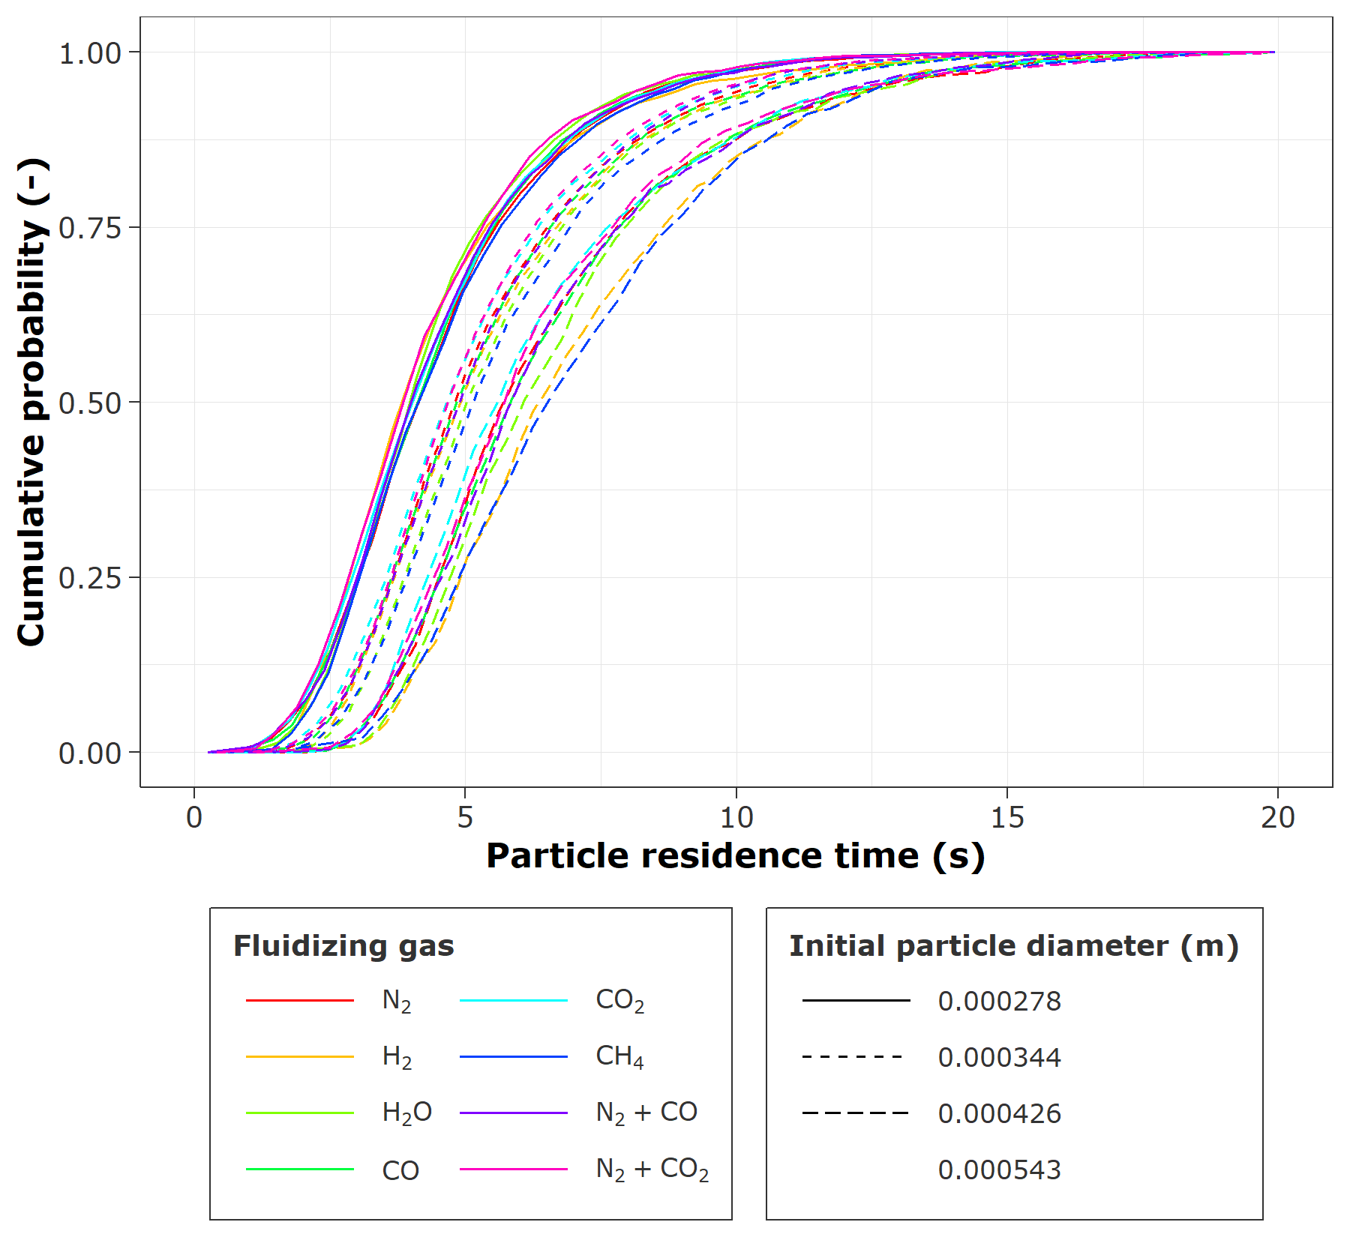

Figure . Cumulative particle residence time distribution as affected by fluidizing gas and initial particle diameter.

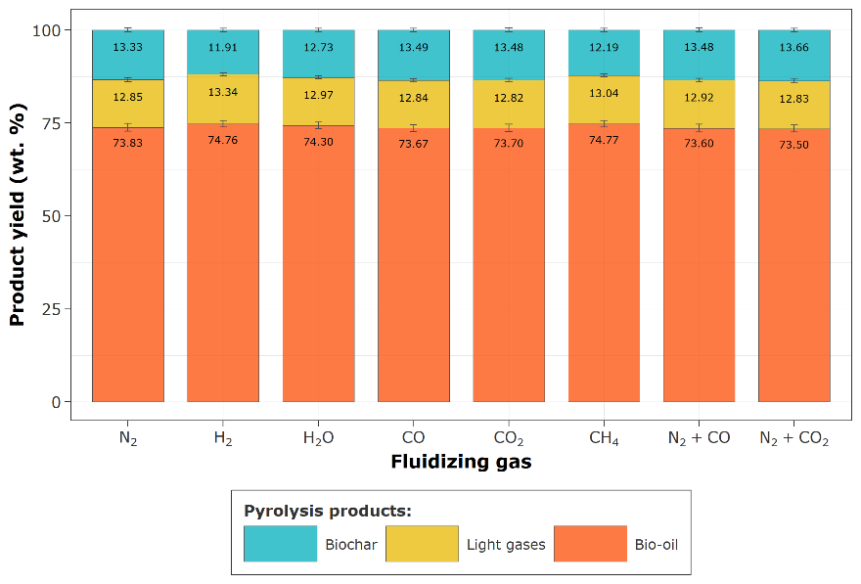

Figure . Pyrolysis product distribution as affected by fluidizing gas. Product yields are calculated on a biomass basis.

# Reference

[1] C. Di Blasi, C. Branca, C. Di Blasi, C. Branca, Kinetics of primary product formation from wood pyrolysis, Ind. Eng. Chem. Res. 40 (2001) 5547–5556. doi:10.1021/ie000997e.

[2] C. Di Blasi, Analysis of convection and secondary reaction effects within porous solid fuels undergoing pyrolysis, Combust. Sci. Technol. 90 (1993) 315–340. doi:10.1080/00102209308907620.

[3] H.A. Navarro, M.P. de Souza Braun, Determination of the normal spring stiffness coefficient in the linear spring–dashpot contact model of discrete element method, Powder Technol. 246 (2013) 707–722. doi:https://doi.org/10.1016/j.powtec.2013.05.049.

[4] L. Lu, J. Xu, W. Ge, Y. Yue, X. Liu, J. Li, EMMS-based discrete particle method (EMMS–DPM) for simulation of gas–solid flows, Chem. Eng. Sci. 120 (2014) 67–87. doi:https://doi.org/10.1016/j.ces.2014.08.004.

[5] T.J.P. Oliveira, C.R. Cardoso, C.H. Ataíde, Bubbling fluidization of biomass and sand binary mixtures: Minimum fluidization velocity and particle segregation, Chem. Eng. Process. Process Intensif. 72 (2013) 113–121.

[6] G.H. Ganser, A rational approach to drag prediction of spherical and nonspherical particles, Powder Technol. 77 (1993) 143–152. doi:https://doi.org/10.1016/0032-5910(93)80051-B.

[7] D. Gidaspow, Multiphase Flow and Fluidization: Continuum and Kinetic Theory Descriptions, 1st ed., Academic press, Massachusetts, USA, 1994.

[8] X. Gao, T. Li, A. Sarkar, L. Lu, W.A. Rogers, Development and validation of an enhanced filtered drag model for simulating gas-solid fluidization of Geldart A particles in all flow regimes, Chem. Eng. Sci. 184 (2018) 33–51. doi:https://doi.org/10.1016/j.ces.2018.03.038.