**PRACTICAL NO : 04**

**Title :** Design and develop custom Application (Mini Project) using Salesforce Cloud.

**STEPS TO CREATE AN APPLICATION(mini project) :**

1. Open salesforce in Lightning Experience
2. Open App Launcher → View all → Quick Search → App Manager → Click on New Lightning App → fill the mention information → Next → App option(optional ) → Next → Add Utility (optoinal) → Next → Navigation Item(you can add item) → Next → User Profile(use the user profile that can access this app) → Save and Finish.

You will get Lightning Experience App Manager Window → Search Your App by its name in App Launcher → just by entering some character, you can see app name with its logo → Click on App → you can see your application appearance in window → Output

Note : steps images are provided here……..

1. **. Open salesforce in Lightning Experience**

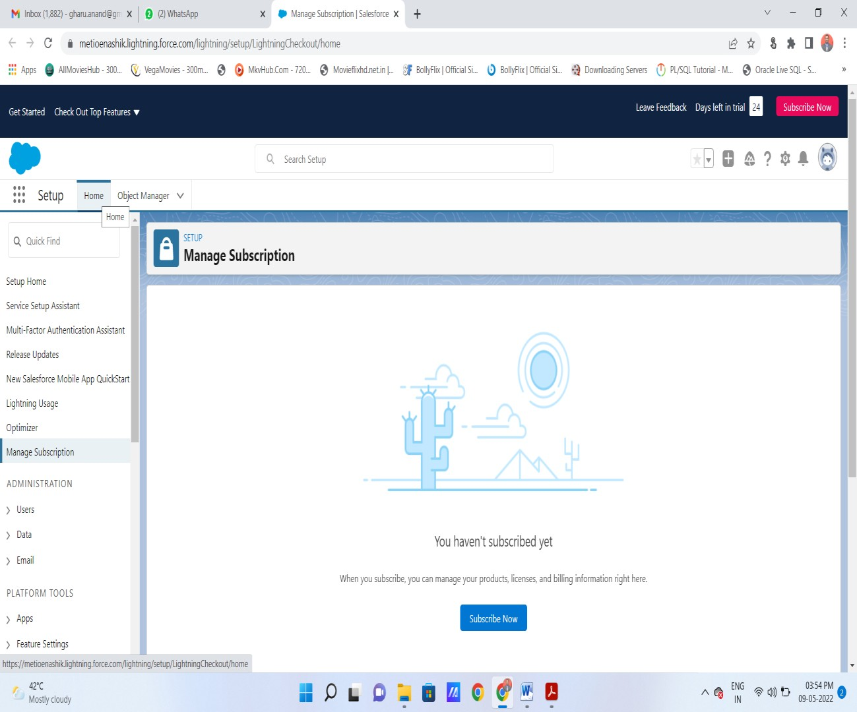

1. **Open App Launcher** → **View all** →**( Quick Search** → **App Manager)** → **Click on New Lightning App**

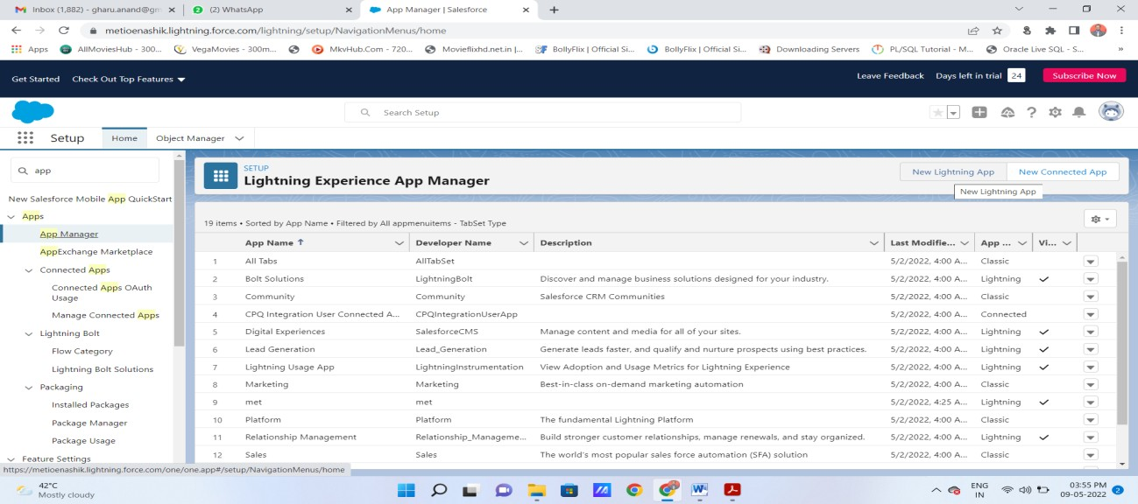

1. **fill the mention information in new lightning app : then next**

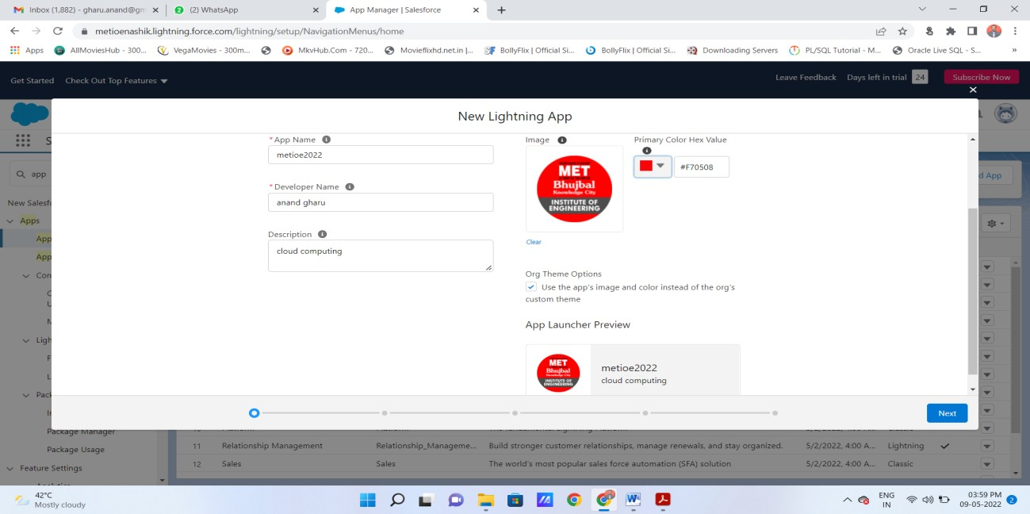

1. **App option(optional )** → **Next** →

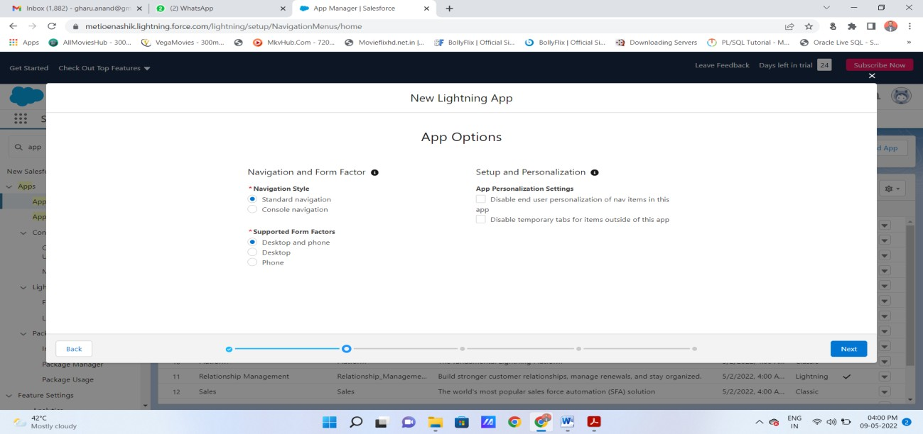

1. Add Utility (optoinal) → Next →.

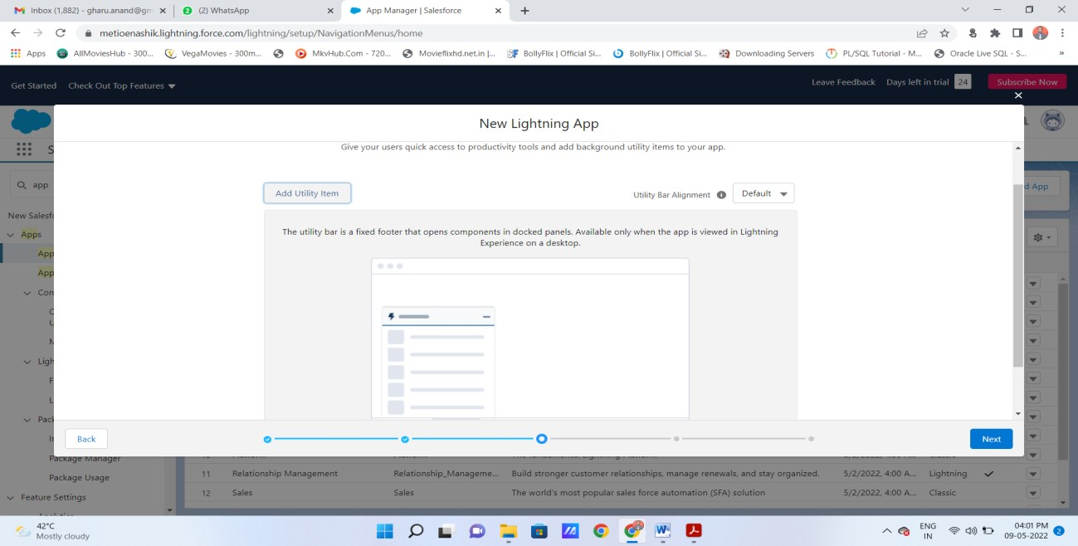

1. **Navigation Item(you can add item)** → **Next** →

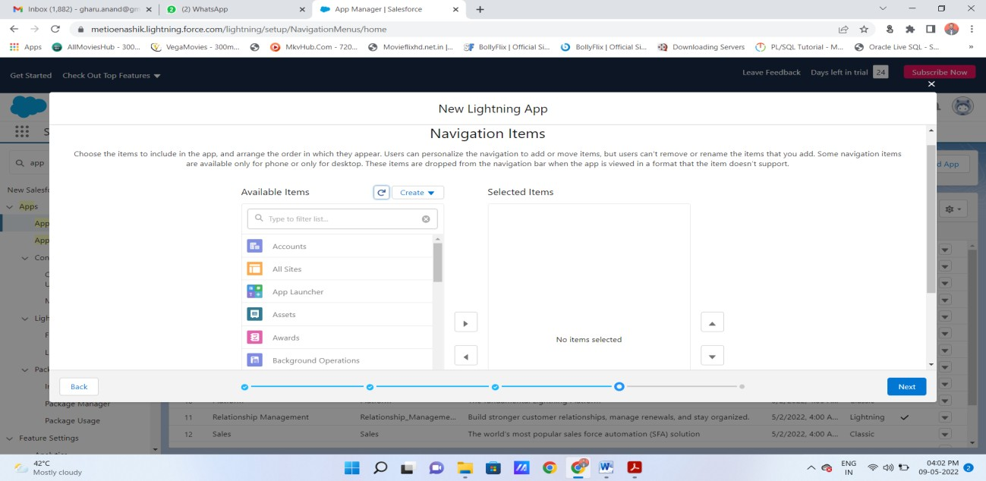

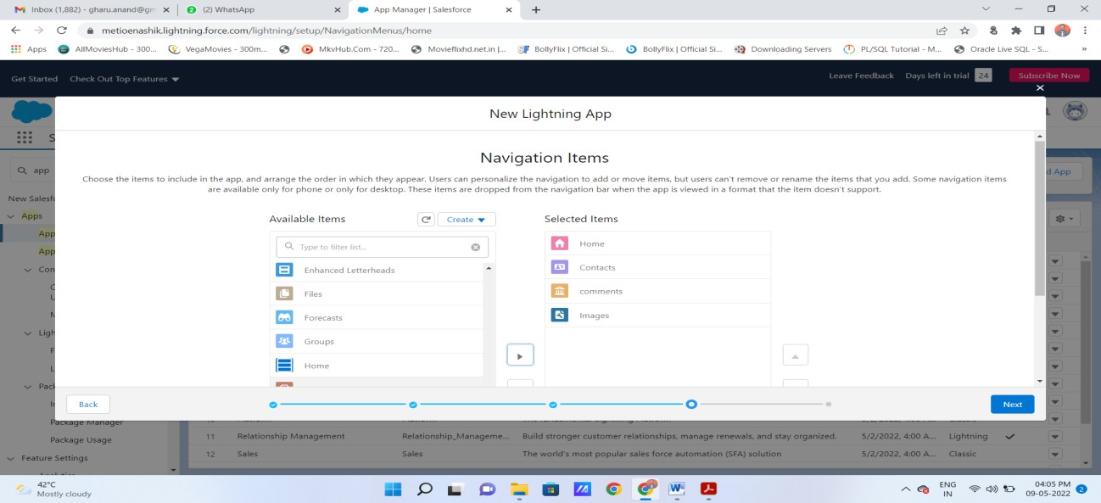

1. **User Profile(use the user profile that can access this app)** → **Save and Finish**

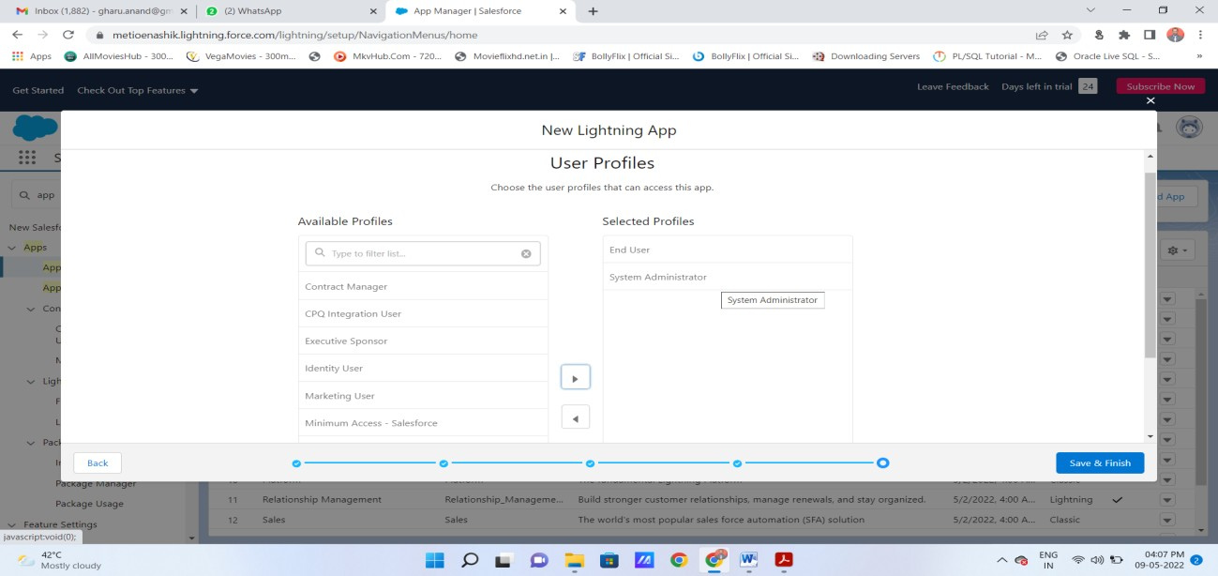

1. **You will get Lightning Experience App Manager Window(here, you can see your application)**

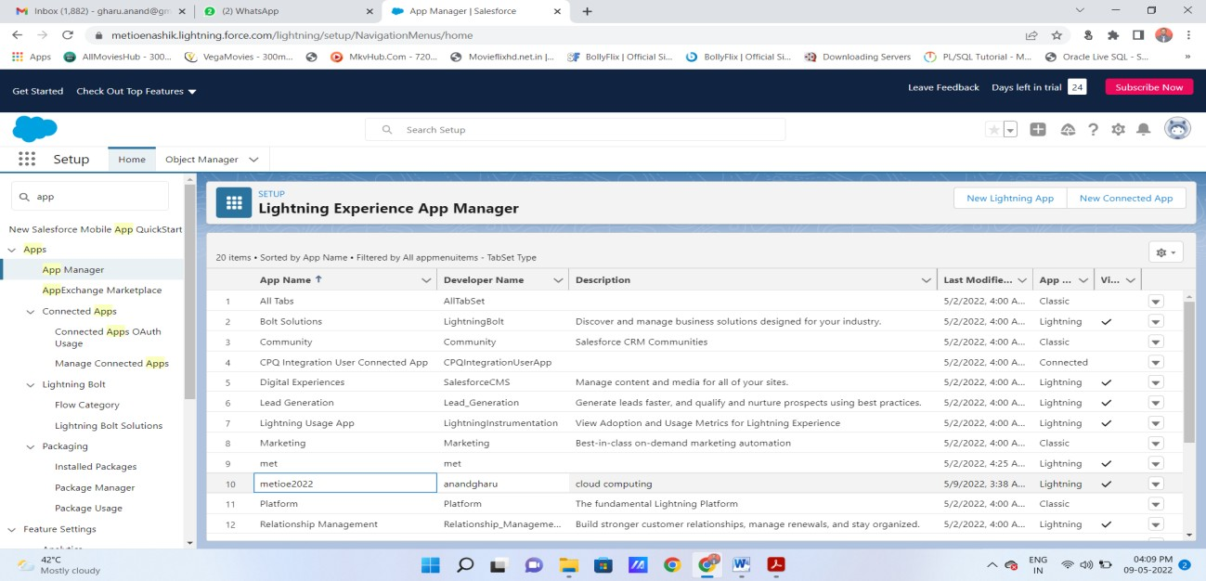

1. **Search Your App by its name in App Launcher** → **just by entering some character, you can see app name with its logo** → **Click on App** → **you can see your application appearance in window** → **Output.**

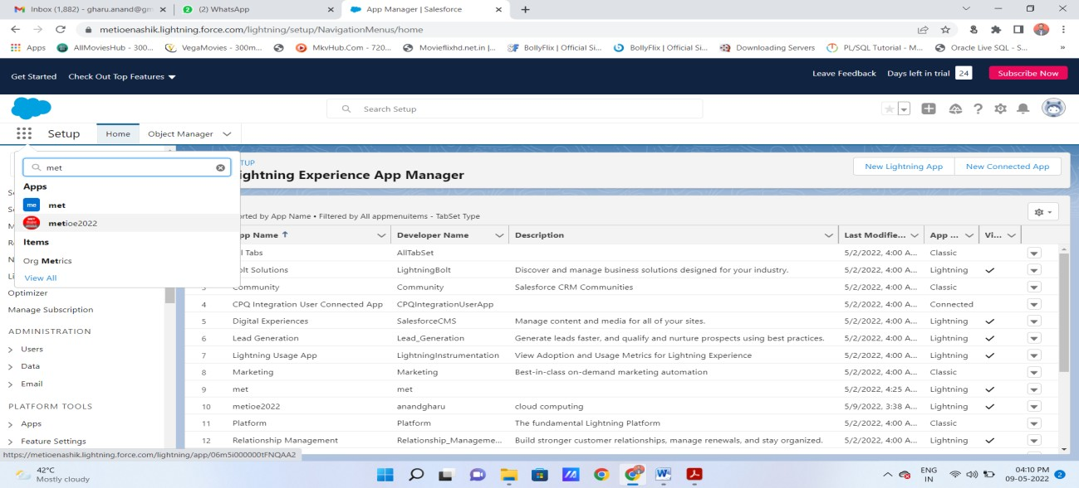

**Output : You can see your application here….**

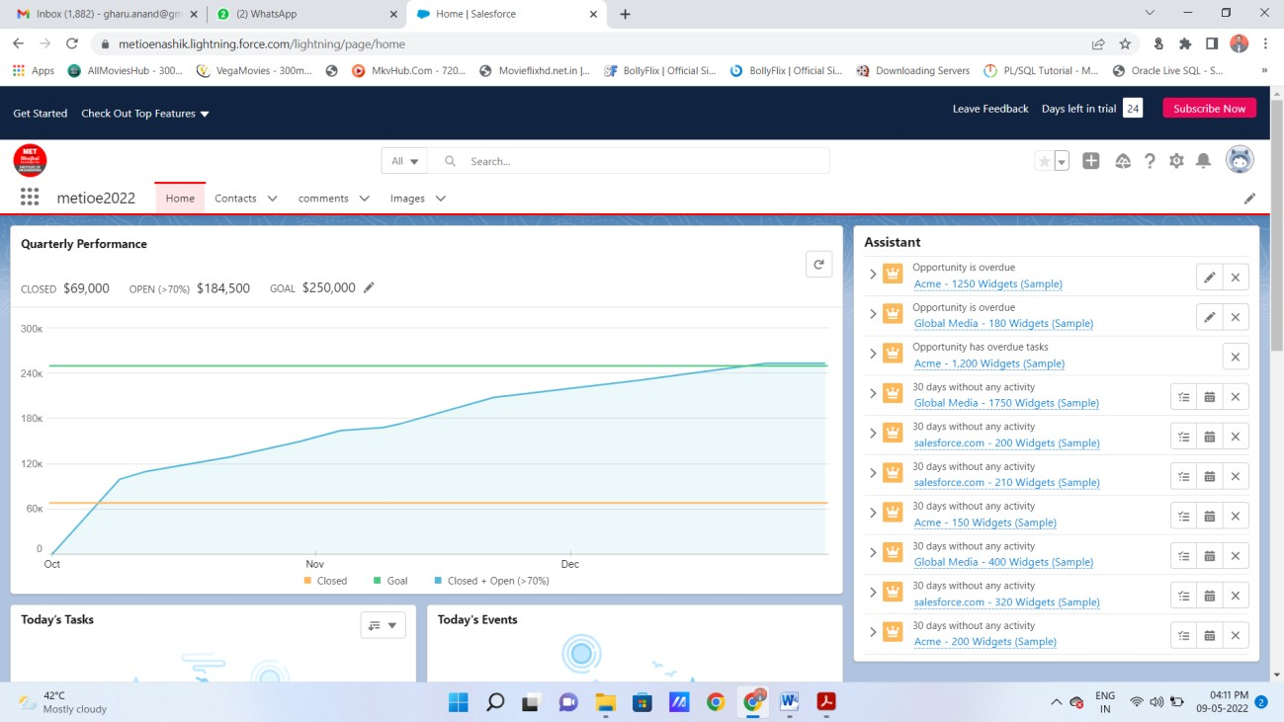

1. **You can add new contact in your application :**

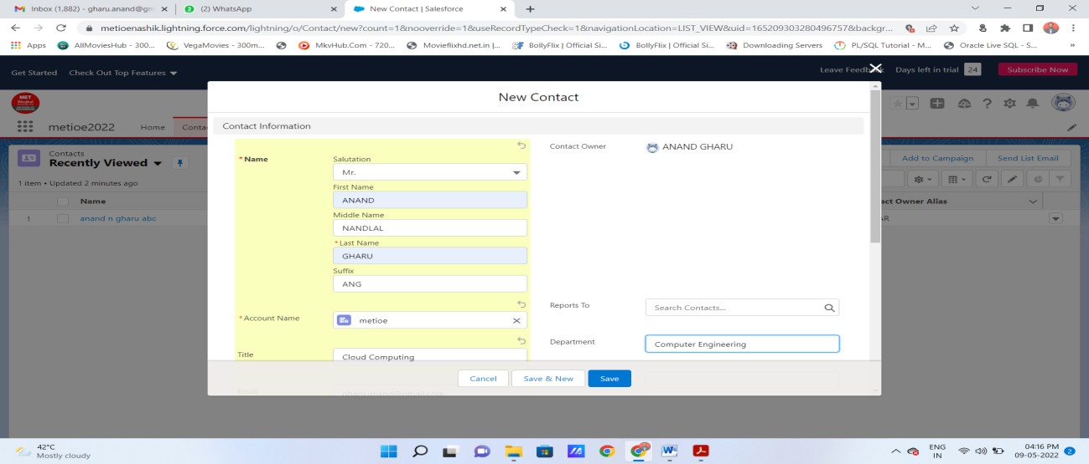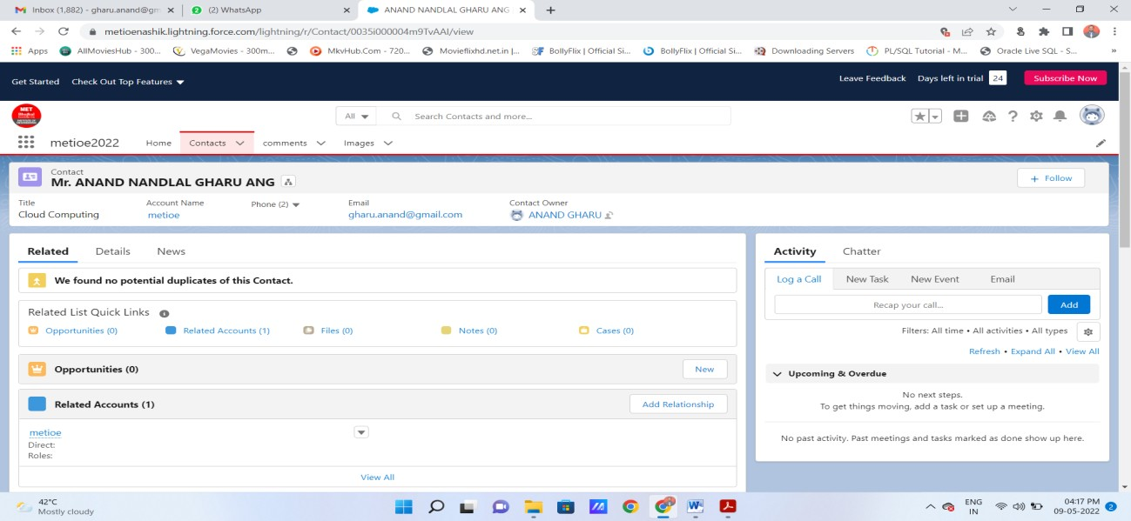

1. **You can add images also :**

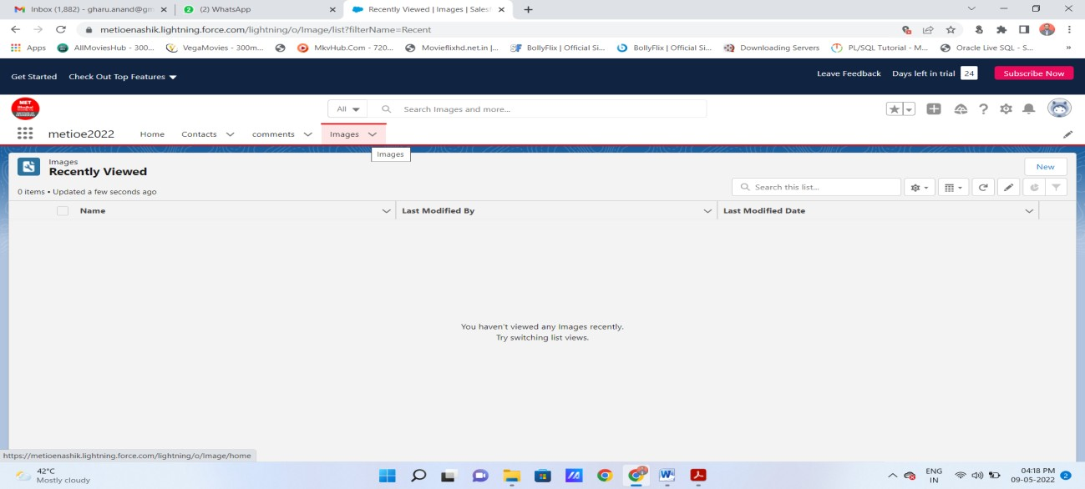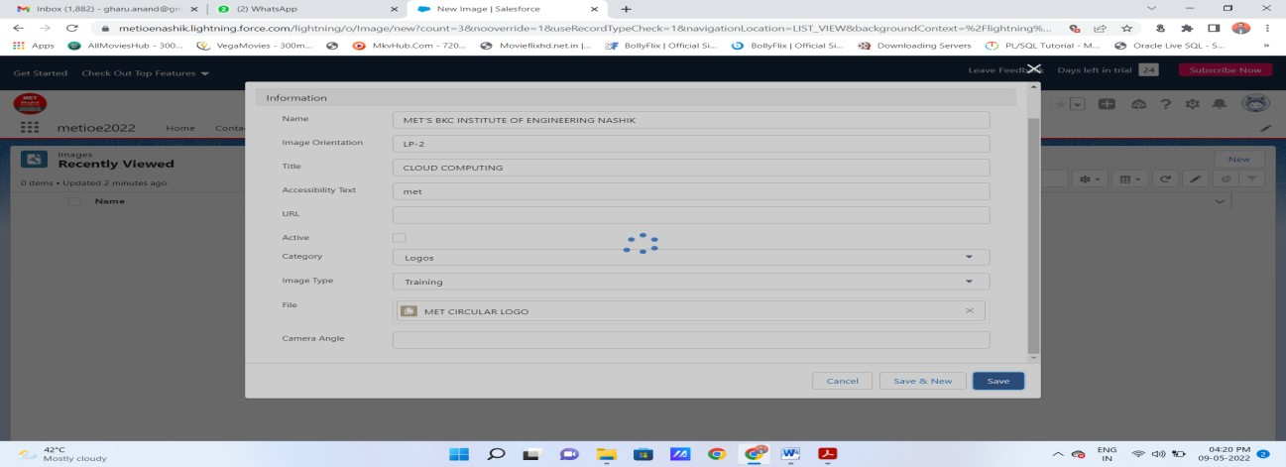

**You can see here that image is added as MET Circular logo(its image file name) :**

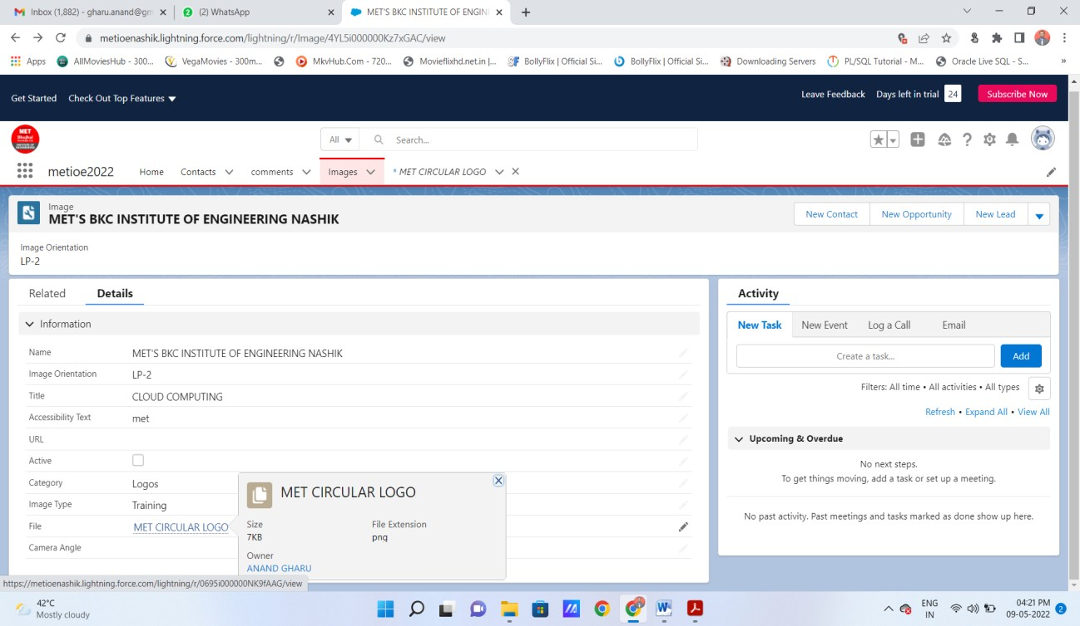

**You can see actual image by clicking on link :**

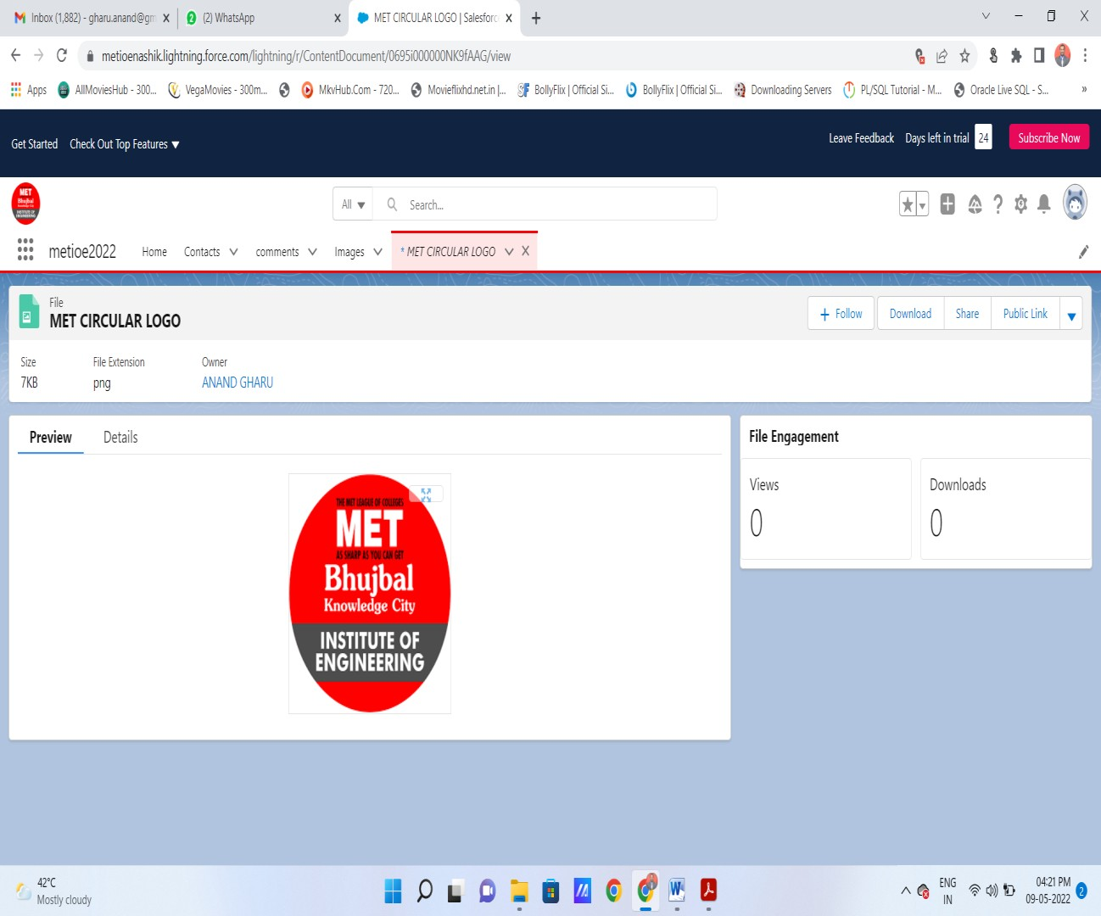

# You mini project application get created

**Note : you can add navigations, utilities , profiles as per your requirements for your mini project application.**