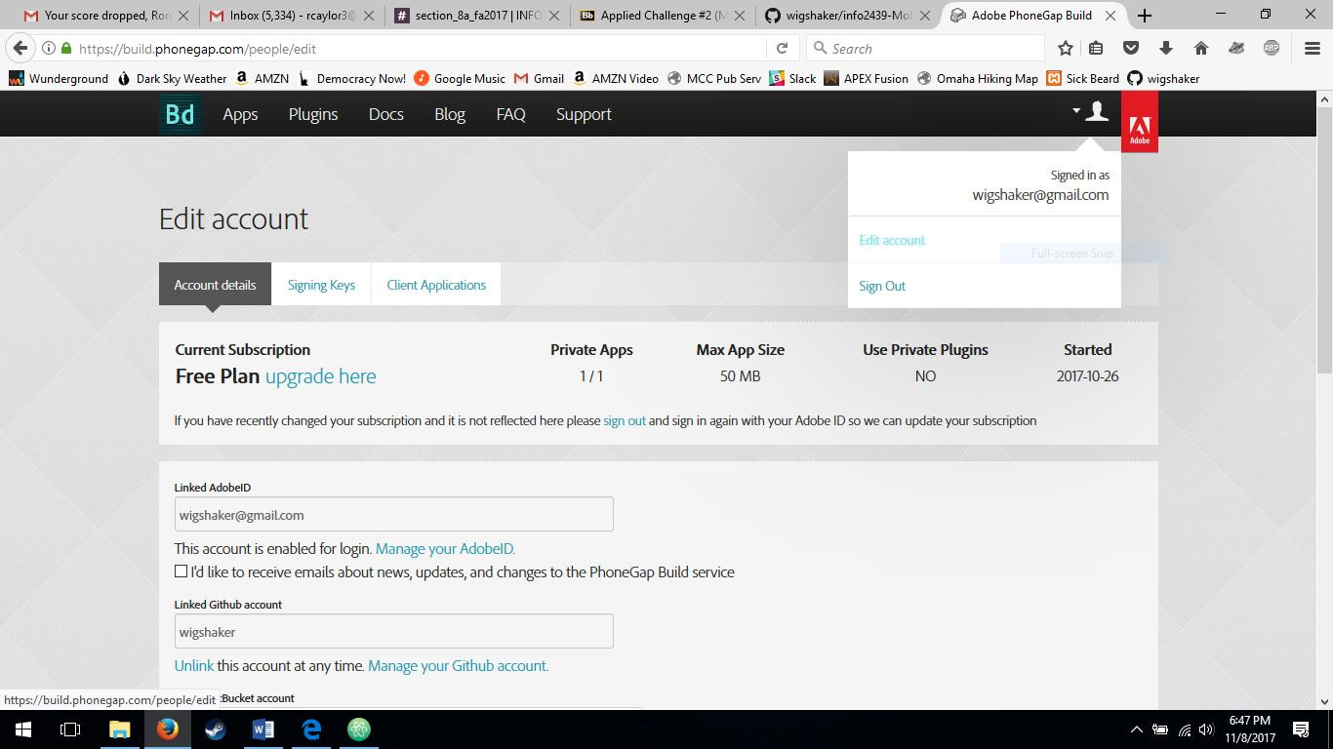

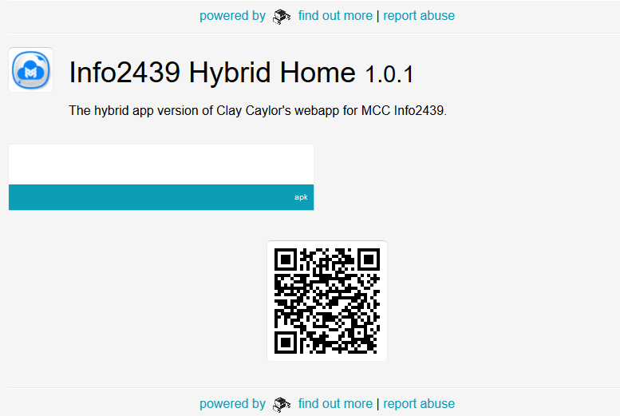

I used the following plugins:  
**Splashscreen** – for an intro image the first time the app is loaded.  
**Vibration** – with javascript triggering a short “feedback” vibration when the user clicks any of the assignment links on the main homepage.  
**Document Viewer** – I could not get this to work within our time allotted, but it was needed for the user to be able to view the AC1 Sage Bistro menus which are local PDFs.