# Introduction

We strongly recommend watching our video tutorial for the easiest installation process.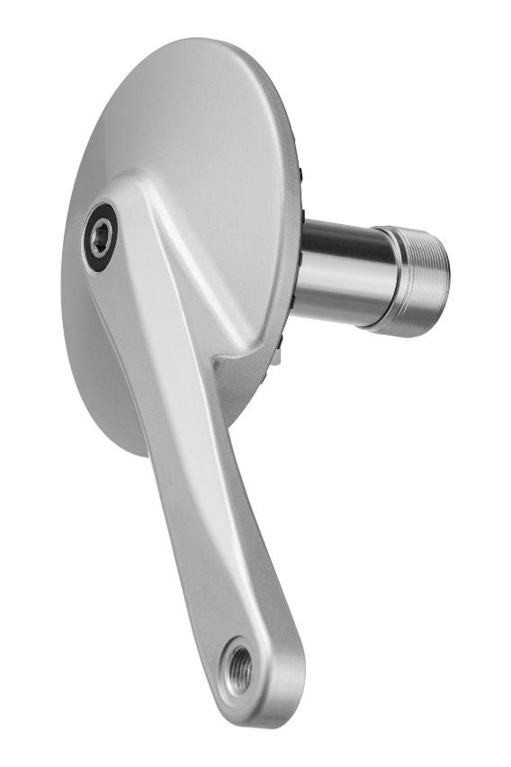

GTRO is dedicated to all non-sports bicycles. Please, remember it has not been tested for heavy-duty off-road riding that you may experience on your MTB, downhill or dirt bike, as well as rickshaw, tandem or heavy cargo-bike.

# Before installation

After opening the GTRO box, you’ll find inside:

* right crank with the gearbox inside
* left crank
* bottom bracket
* bag of extras

When you take the right crank in your hand, you’ll find it’s integrated with the shifting cable and the shifter. This makes the installation process much more comfortable. GTRO is by far the easiest to install front gearbox on the market.

When you take gearbox out, please, take notice of a [plastic separator](https://www.efneo.com/filesss/manuals/cable-separator.pdf), to avoid damage.

## Bag of extras

In the bag of extras you’ll find:

* Bolts for axle
* Cable-ties, black & white
* Cable-slider with a bolt
* Spacer for a BB cup (see more in section “BB cup spacers”)
* Other tools used for internal servicing or exchanging cable, if necessary

## Tools needed

Now let’s take a look at the required tools. You’ll need some basic bike mechanic tools.

* Flat 4mm-wide screwdriver
* Grease for BB cups
* Bottom bracket removal tool
* Wrench number 15 for pedals
* Crank removal tool
* Allen keys
* Torque wrench for bottom bracket (not necessary, but advisable)

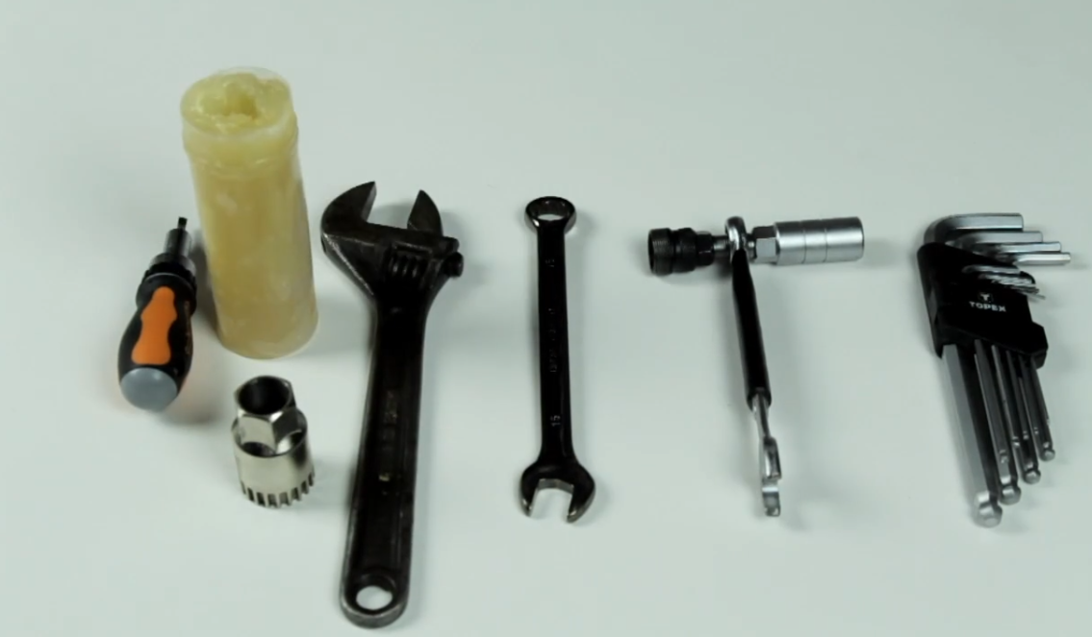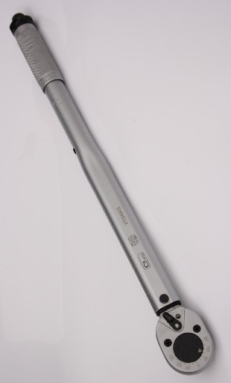

It’s most convenient to make the installation on a bike-stand that bike-shops are using to fix a bike for maintenance, but it’s not necessary. The bike should be positioned with wheels upwards.

# Installation process

## Step 1 - crank and front derailleur removal

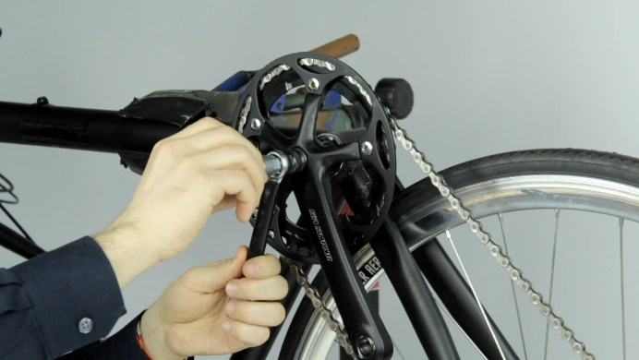If you have front cranks on your bike, you need to remove them. To do this, you need a simple tool called “crank removal tool” or “crank puller”. You can buy it in most, if not all, bike shops.

The process is straightforward, but if you need some tips, type “bicycle crank removal square taper” to your search engine and you’ll find plenty of videos showing how to do it.

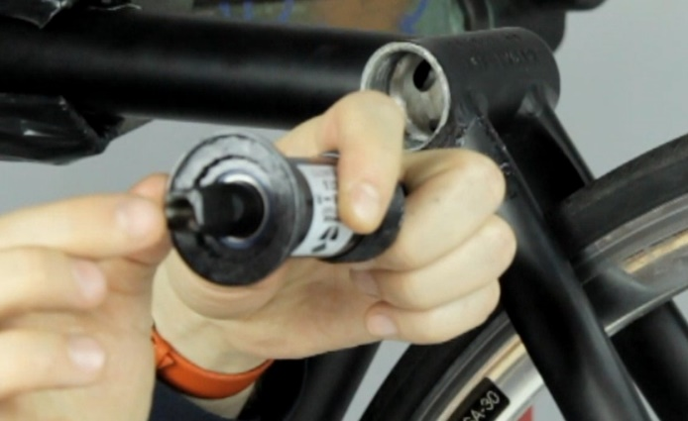If you have a front derailleur on your bike, you also need to remove it.

## Step 2 - bottom bracket replacement

GTRO is delivered with a bottom bracket. It is a standard high quality 68mm English threaded square tapered BB with a dedicated right cup. It is also possible that you receive a 100mm / 80mm fat-bike BB version if you choose this option during the purchase process.

To install the GTRO properly, you need to remove your old BB and put Efneo’s BB into the BB Shell. To do this, you need a tool called “bottom bracket removal tool” which is available in all bike shops.

Again, it’s best to type “square tapered bottom bracket replacement” to your web search engine and see the videos.

You have to remove your old bottom bracket. Even if it’s in good shape, you need to remove it. The reason is that on the right side the BB cup has a specified diameter of 46 millimetres and we need precisely 30,5mm of axle standing out; please, see technical drawing [here](http://efneo.com/filesss/manuals/BB-68mm-dim.png). If you do not use the Bottom Bracket provided by Efneo, the warranty will be voided. Our bottom bracket comes from a top-notch Japanese company, Tange Seiki, and is a top product in its class.

Once you’ve replaced the bottom bracket, you can start the gearbox installation.

## Step 3 - gearbox installation

Do the following:

1. Put the wave spring into the bottom bracket’s right cup’s niche (not necessary in the latest GTRO versions – see below)
2. Put the gearbox on the axle
3. Check the position of the reaction lever and the shifting cable
4. If the above is ok, bolt the gearbox on the axle

There are four things you must consider and double-check before you ride:

### Wave-spring positioning, in two versions

Depending on GTRO version, you may find a wave spring in two positions pre-installed:

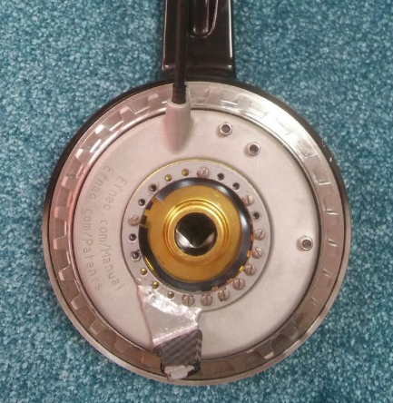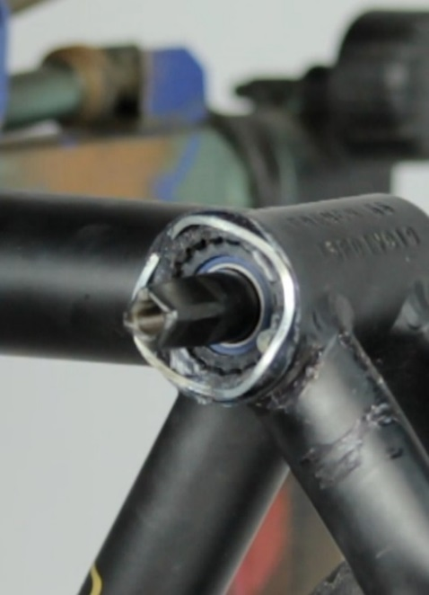Version 1 (photo 1): Stick the wave-spring in the bottom bracket’s niche with grease. When you put the gearbox on the axle, the wave-spring must keep its original position. You will find the wave-spring already put on the bottom bracket. The only thing you need is to keep its position like on the photo.

Version 2, new (photo 2): Wave-spring sits inside of the gearbox niche. In this case, you don’t need to do anything. Just put the gearbox on the BB axle.

### Reaction lever positioning on the chainstay

Reaction lever goes below your bike’s chainstay.

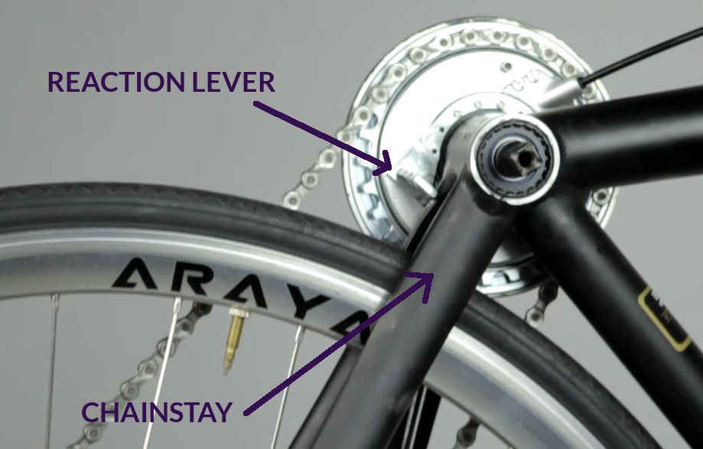

Please ensure that the lever touches the chainstay in a straight way, without touching the kickstand plate’s edge or any welding. This would put a twisting pressure on the gearbox. It can stick to the kickstand plate’s surface, if it’s even, but not the plate’s edge. You must absolutely avoid it. Take a look at the drawings:

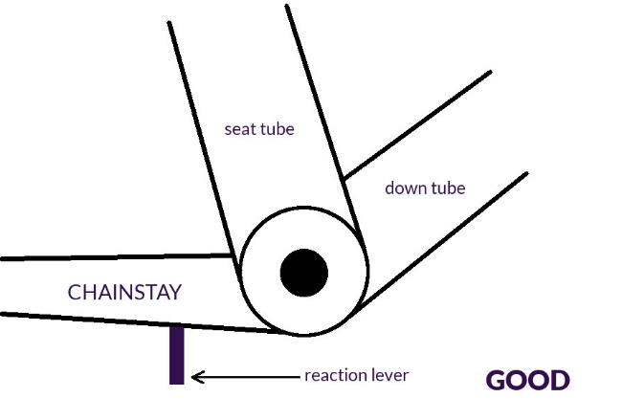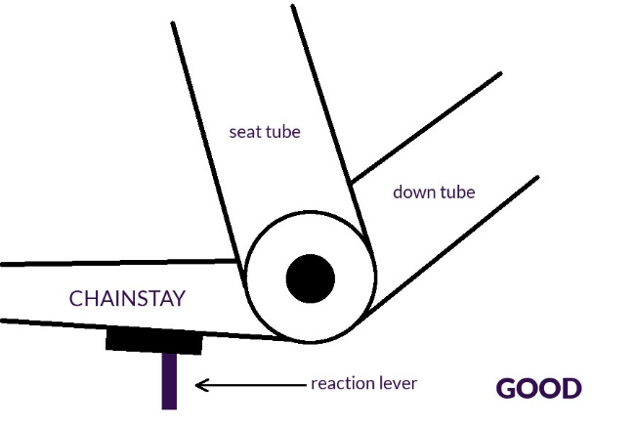

In both above positions the lever is pushing against the straight area – either directly chainstay or kickstand plate. This position is good and safe for your GTRO.

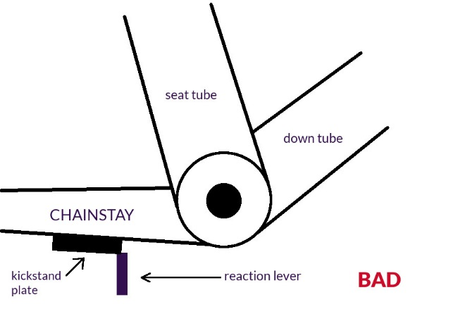

In this position, the lever is pushing against the edge of the kickstand’s plate. This would exert a twisting pressure on the gearbox and could even damage it. The same comes with irregular welding. In this case, you should somehow (e.g. with a file or a grinder) make the contact area straight.

### Shifting cable positioning against the down tube

The Down Tube is a tube that runs from your bottom bracket towards your handlebar. Unless you have a very uncommon bicycle, you’ll route your shifting cable along the down tube.

After you put your gearbox on the axle, take a look at the shifting cable. It should go out of the gearbox more or less parallel to the down tube so that you can route it comfortably towards the handlebar without bending it too much. Most bikes have a very similar angle between the chainstay and the down tube so that the gearbox would fit 9 out of 10 bikes without reaction lever repositioning.

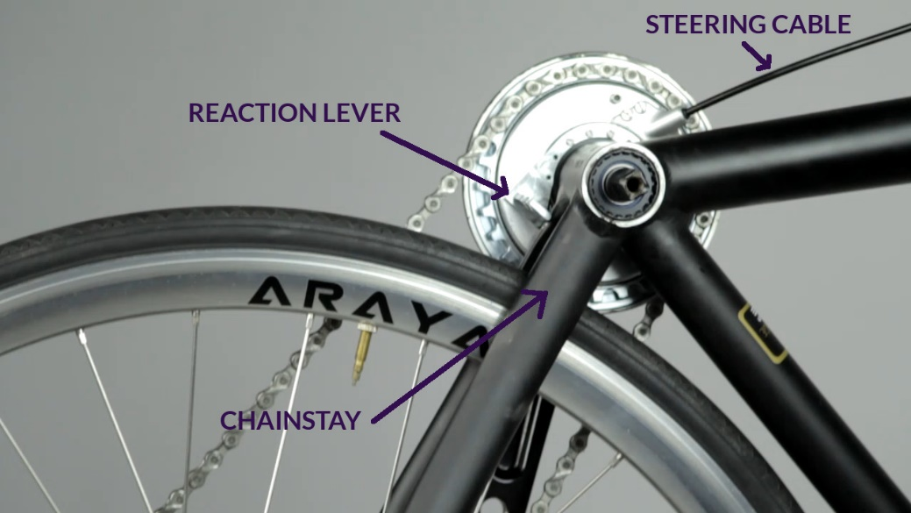

If the shifting cable goes out of the gearbox in undesired direction (e.g. your bike frame’s geometry is not typical, like in a trike or a recumbent bike), you may need to reposition the lever. It’s straightforward. You’ll find it in a separate video presentation here: <https://vimeo.com/219351462>. You only need a screwdriver and some grease to do it. Do the repositioning before you go on to the next steps.

Once the reaction lever and shifting cable are appropriately positioned, do the following:

1. use the 8mm Allen key to screw the gearbox crank in
2. fix the reaction lever firmly to the chainstay

Ad. 1 Screw in the axle bolt with a torque of 35 Nm, which is quite high (“the tool should bend”).

Ad. 2 Fasten it very firmly with two crossed plastic cable-ties that you’ll find in the extras bag. The lever should always touch the chainstay even when you back rotate the gearbox crank. Please, make a test. Take a look at the photos how it should look like.

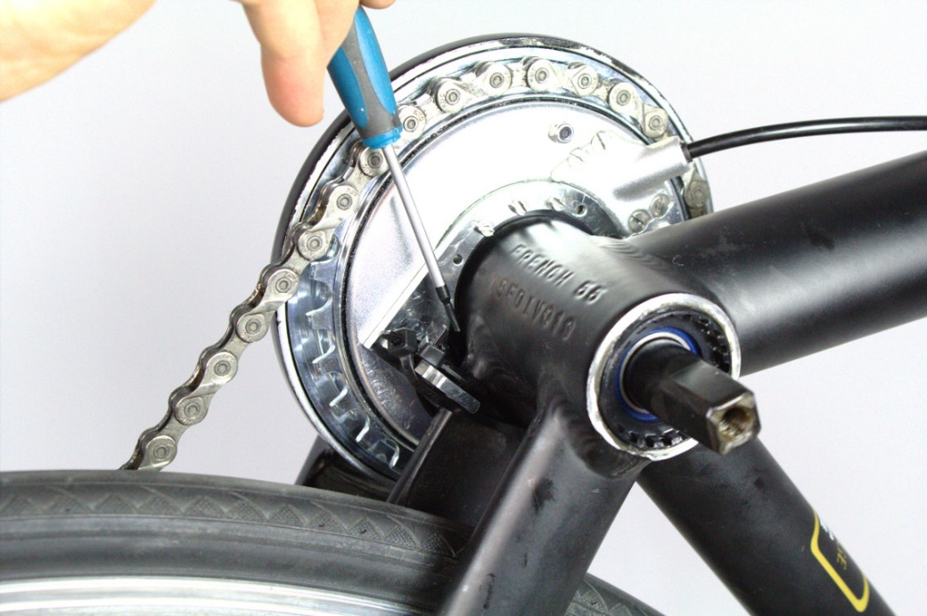

As you can see, the reaction lever touches the chainstay firmly, even when back rotating.

## Step 4 – BB cup spacers

Depending on a version of a product, most probably you will receive a BB with a spacer that is attached to the right BB Cup with grease. It may be 2mm-thick (standard) or even 7mm-thick (for some folding bikes). This spacer positions gearbox further away from the frame, to avoid a potential collision - gearbox should not touch the frame other than**:** 1// with the reaction lever under the chainstay, as shown in previous installation step, 2// around the BB cup flange. Any sideways contact gearbox<->frame must be avoided – if you notice it (please, check carefully), use an additional spacer from the extras bag or reposition the lever like shown on this video: <https://vimeo.com/219351462>. On the other hand, adding spacers changes the chainline or beltline (important for belts!).

## Step 5 – cable-slider installation

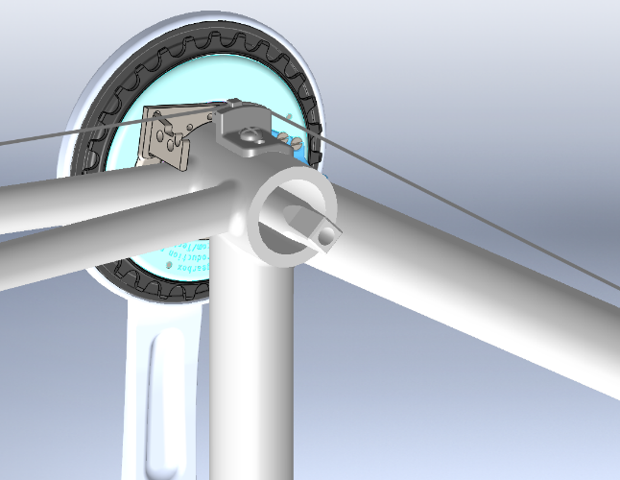If you use a rear derailleur with a shifting cable running along the chainstay, you may need to avoid collision with the lever, by utilising a cable-slider with a bolt (both to be found in the bag of extras). Standard frames have a threaded hole in the BB shell prepared for this purpose:

## Step 6 – shifter installation

GTRO is delivered to you integrated with the shifting cable and shifter. Once the gearbox is installed on the axle, you must find the best way for the shifting cable. Please remember – GTRO shifter is placed on the left side of your handlebar (like front derailleur’s shifter).

GTRO’s standard shifting cable housing length is 110 cm for grip or trigger shifter and 145 cm for the bar-end shifter. It fits the majority of bike’s frames. However, it may happen that you need a shorter or longer shifting cable – particularly if you have a trike/recumbent bike or a small folding bike. In this case, let us know what cable length would be the most convenient for you.

GTRO’s shifter is not integrated with a brake lever. If you have a front derailleur’s shifter integrated with a brake lever, you need to replace it with a separate brake lever. Choose one that fits your bike’s aesthetics from the bike shop.

GTRO is offered with few types of the shifter. Accordingly to the kind you ordered, please, do the following:

* Remove the handlebar grip (see hints [here](https://www.youtube.com/watch?v=cxkSXYKaDh4) or [here](http://www.parktool.com/blog/repair-help/handlebar-grip-installation-flat-bars#article-section-2))
* Remove the existing shifter (if you have one)
* Route the shifting cable and fix it to the frame
* Place GTRO’s shifter on the handlebar. Choose the right position for your thumb and finger to operate with the trigger paddles and adjust the shifter to the handlebar. If you have a twist-shift, choose the correct position, so that you can shift effortlessly between the gears.
* Check, if the shifting cable is not colliding with or touching the wheel. Twist your handlebar in both directions to be sure there is no collision or excess tension on the wire.
* Put the handlebar grip back on.

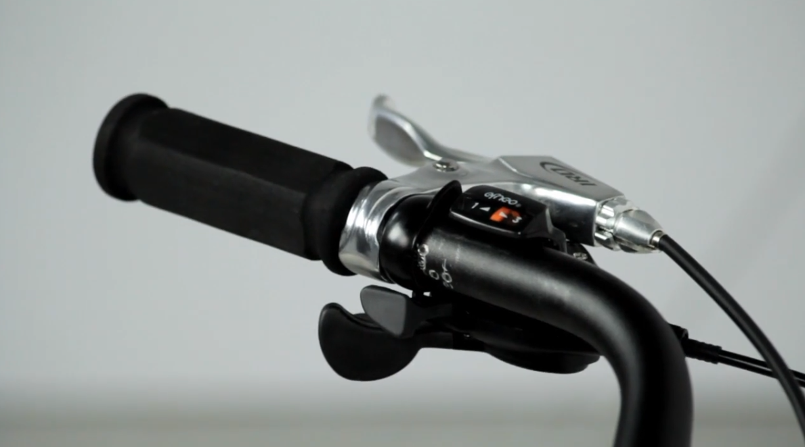

If you have a twist-shift version, before putting the handlebar grip back, it may be necessary to shorten it by 2-3 cm or 1 inch to make it more comfortable to shift gears with a slight move of your wrist. Take a look at your handlebar and make your own choice. It is also vital that you can reach out comfortably to a brake lever.

**If you experience any problem with gears**, like clicking or lack of a gear, check the last page of these manual**:** [grip or trigger shifter](http://efneo.com/filesss/manuals/Shifting-cable-exchange---grip-or-trigger.pdf).

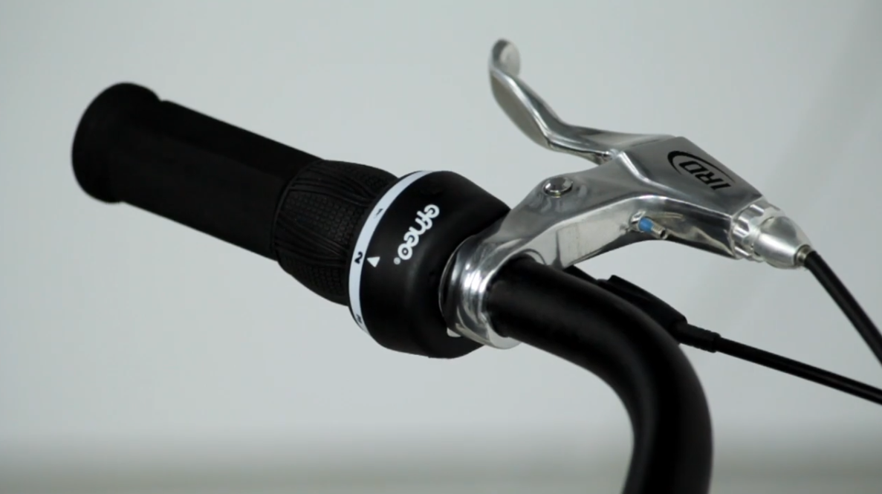

If you want to install the bar end version, please, refer to [this manual](http://efneo.com/filesss/manuals/Shifter-installation---bar-end.pdf).

If you want to change some other shifter into the bar end, please, refer to [this manual](http://efneo.com/filesss/manuals/Shifting-cable-exchange---bar-end.pdf).

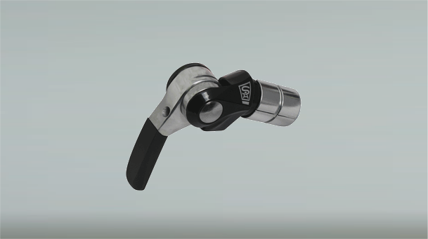

## Step 7 – chain length adjustment

The final step is chain length adjustment. GTRO’s physical chainring is 28T. It may happen that for the best effect, you may need to shorten your chain. You will find plenty of good video tutorials on the Internet how to do it.

Chains with thickness over 1/8 inch are not compatible with the gearbox. Chain 1/8 inch is O.K. for a single sprocket in the rear wheel. If you’re using a rear derailleur, you will need a 3/32 inch or thinner chain. It may happen, that you will hear a sound of chain touching the gearbox disc – if so, you will also need a thinner chain.

Please, do not put too much tension on the chain in single-speed bikes, as too much tension will result in noticeable drag and lead to premature wear of the gearbox.

## Step 8 – left crank and pedals installation

Install the left crank. Put at least 30 Nm of torque to be sure the crank is appropriately installed.

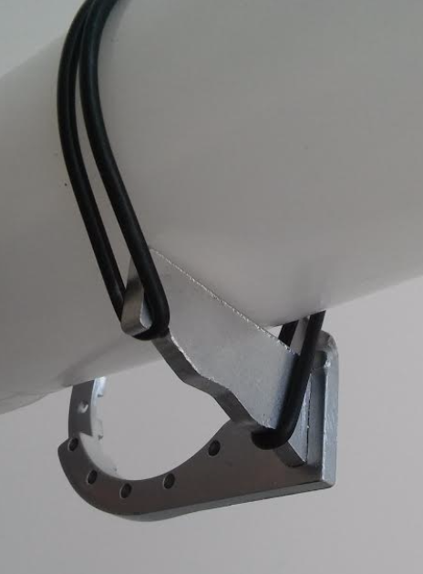Install the pedals (they are not included in the product). Be sure the pedals are firmly screwed into the cranks.

## No-chainstay bicycles (recumbents, trikes, some tandems, etc.)

For bicycles with no chainstay (e.g. recumbent or trikes) we include a rubber band (shown below) to mount the lever to the pedal boom, but you can also use a plastic cable tie.

# Shifting gears

Your gearbox is ready to ride. Please remember about these simple rules:

* You can always upshift, also under full load
* When you want to downshift, you need to lower the load a little bit for a fraction of a second. (It’s the same with most of the gearboxes on the market). You will get accustomed to it very quickly.

You can also shift gears when in a standstill, of course!

# GTRO usage in highly wet/humid area

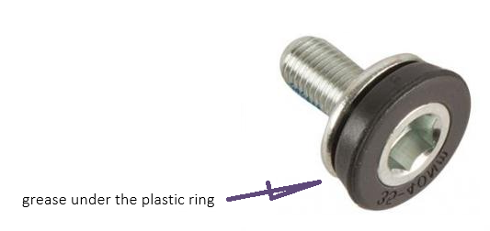If you are living in a wet or humid area, or if you ride a lot in rain/snow, put grease under the plastic cap of the crank bolt of the right crank. Use a significant amount of grease, press the ring back on the bolt, and remove the grease surplus with a tissue:

# Maintenance

The gearbox is maintenance-free.

# Adapter for beltring

# or larger chainring

Please, do not use Loctite or similar means for adapter bolts.

Here is manual for [installation of bolts](http://efneo.com/filesss/manuals/bolts-installation.pdf).

# Service

It may happen that your shifting cable gets damaged and you need to replace it. In this case, follow these links to see the manual of shifting cable exchange for [grip or trigger shifter](http://efneo.com/filesss/manuals/Shifting-cable-exchange---grip-or-trigger.pdf) or [bar-end shifter](http://efneo.com/filesss/manuals/Shifting-cable-exchange---bar-end.pdf).

If you have a gearbox version with a 37T, please, click [here to download](http://efneo.com/filesss/manuals/external-chainring-attachment.pdf) our manual for external chainring attachment. For 38T version, follow [this manual](http://efneo.com/filesss/manuals/bolts-installation.pdf).

# Warranty

Extent of Limited Warranty

EFNEO warrants its products to be free from defects in materials or workmanship for a period of two years after original purchase.

Claims under this warranty must be made through the retailer where the bicycle or the EFNEO component was purchased or directly through the EFNEO’s web site. Original proof of purchase is required.

Limitations of Liability

To the extent allowed by local law, except for the obligations specifically set forth in this warranty statement, in no event shall EFNEO or its third-party suppliers be liable for direct, indirect, special, incidental, or consequential damages.

Limitations of Warranty

• This warranty does not apply to products that have been incorrectly installed and/or adjusted according to the respective EFNEO technical installation manual. The EFNEO installation manuals can be found online at www.Efneo.com.

• This warranty does not apply to damage to the product caused by a crash, impact, abuse of the product, non-compliance with manufacturer’s specifications of usage or any other circumstances in which the product has been subjected to forces or loads beyond its design.

• This warranty does not apply when the product has been modified.

• This warranty does not apply when the serial number or production code has been deliberately altered, defaced or removed.

• This warranty does not apply to normal wear and tear. Wear and tear parts are subject to damage as a result of normal use, failure to service according to EFNEO recommendations and/or riding or installation in conditions or applications other than recommended.

# Disclaimer

Efneo Sp. z o.o. warrants this product to the original purchaser to be free from defects in material and workmanship (normal wear excluded) for a period of two years from the date of original retail purchase. Incorrect assembly and/or consumer assembly voids this warranty. Respect the environment and those who share it with you. Ride with care and only on approved trails and roads. Always wear a helmet and other appropriate safety equipment.