1. Research Problem and Questions
1.1 Background and Motivation
New York City's 311 system is the city's central non-emergency reporting channel, where residents log issues like heating outages, noise complaints, and street conditions. Each record includes a complaint type, descriptor, location, and timestamps for when the case was opened and closed, making 311 data a detailed source for studying neighborhood-level urban issues. Wang et al. (2017) showed that the mix of complaints from a given location works as a kind of "signature" for that area. More recent work has examined how city services interact with these complaints in practice. The NYC Comptroller's 2025 heating report documented uneven response times across neighborhoods, and Boxer et al. (2025) found that the act of reporting itself is unevenly distributed across communities. We focus on Manhattan in 2025 because the borough contains a wide mix of neighborhoods within a small area, which allows community-level comparison without the confounders of cross-borough analysis. If ZIP codes with similar complaint mixes receive systematically different levels of service, that gap is something city agencies can act on through reallocation or benchmarking, which is the kind of finding this analysis aims to produce.
1.2 Research Questions
We organize the analysis around three questions:
RQ1. What major issue themes can be identified from Manhattan 311 complaints in the 2025 monthly sampled data?
RQ2. Do Manhattan ZIP codes exhibit distinct community problem profiles based on complaint structure and dominant issue types?
RQ3. Are there systematic differences in case processing time across these community problem profiles?

2. Data
2.1 Source and Sample
We retrieved Manhattan 311 service requests from NYC Open Data through the Socrata API (dataset erm2-nwe9), pulling records from January through December 2025. To avoid potential bias from chronologically ordered API responses, we drew a random sample within each month rather than taking the first records returned. After cleaning, the working dataset contains 18,743 records, distributed roughly evenly across all twelve months of 2025. Each row represents a single service request identified by a unique case key. For ZIP-level analysis (RQ2), records are aggregated by incident_zip; for response-time analysis (RQ3), the unit of analysis is the individual closed case.
2.2 Key Variables
The cleaned dataset contains 19 variables. The fields most relevant to our research questions are complaint_type and descriptor (used for theme identification and community profiling), incident_zip (the level at which we aggregate for RQ2), and the case-level timestamps created_date and closed_date, from which we derive response_hours as the outcome variable for RQ3. Calendar features (month, season, is_weekend, etc.) and contextual fields (agency, location_type, community_board) are also retained to support interpretation.

2.3 Data Preparation
Standard cleaning steps were applied: datetime parsing, deduplication on unique_key, removal of records missing complaint_type or closed_date, and exclusion of negative response_hours values that reflect data-entry errors. To handle extreme values without discarding information, we flagged cases above the 99th percentile of response_hours (approximately 4,600 hours, n = 181) as outliers. These cases likely reflect administrative artifacts rather than typical service delivery and are excluded from the response-time analysis but retained in the dataset for transparency.

2.4 Suitability and Limitations
The dataset combines categorical complaint labels, free-text descriptors, ZIP-level geography, and case-level timestamps in a single integrated source, providing the four data types needed to address RQ1, RQ2, and RQ3. The sample size of nearly 19,000 records supports stable clustering and statistical testing, and the random monthly sampling ensures balanced coverage across the year.

Three limitations should be noted. The API pull is capped at a fixed number of records per month, so the dataset is a sample rather than a census. Cases still open at retrieval are excluded from response-time analysis, which may bias RQ3 toward faster-resolving complaint categories. Finally, we deliberately scoped the analysis to Manhattan to avoid cross-borough confounders such as housing stock and infrastructure age; future work could extend the framework to other boroughs.

3. Methods
3.1 Identifying Complaint Themes (RQ1)
To identify the major themes underlying Manhattan 311 complaints, we applied topic modeling to the descriptor field. Of the 18,743 records, 17,670 had non-empty descriptors and were used in this analysis.
Each descriptor was preprocessed by lowercasing, removing digits and punctuation, and normalizing whitespace. We then represented the cleaned text using TF-IDF vectorization with unigrams and bigrams (max_features = 100), and applied Latent Dirichlet Allocation (LDA) to discover latent themes from word co-occurrence patterns. Although 311 descriptors are short (averaging 2–3 words), which can make topic boundaries less crisp, K = 4 yielded four interpretable themes that we verified through manual inspection of top words and sample descriptors. We compared K = 3, 4, and 5 topics and selected K = 4 as the most interpretable solution. The four themes also serve as the building blocks for the ZIP-level clustering in Section 3.2.

3.2 Clustering Community Profiles (RQ2)
To group Manhattan ZIP codes into interpretable community profiles, we used K-Means clustering at the ZIP-code level. Each ZIP code was represented as a four-dimensional feature vector containing the share of its complaints in each of the four issue themes from Section 3.1. Forty Manhattan ZIP codes had enough records to be included.

Response_hours was excluded from the clustering features so that RQ3's response-time comparison cannot be circular. We chose K = 4 to align with the four RQ1 themes, which makes each cluster directly interpretable as a community profile dominated by one of those themes. Elbow inertia and silhouette scores for K = 2 to 8 were computed as a diagnostic check (Figure 1); the silhouette at K = 4 is moderate but acceptable given that Manhattan complaint patterns are inherently mixed. For visualization, we projected the four-dimensional features into two dimensions using Principal Component Analysis.

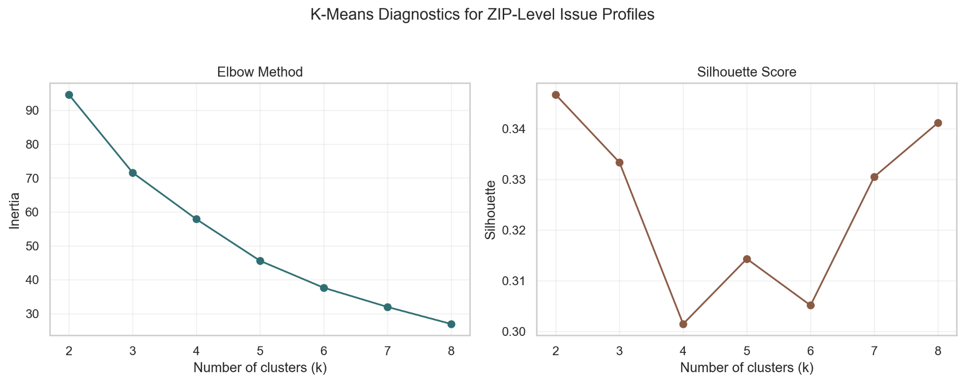
Figure 1. K-Means diagnostics for ZIP-level issue profiles. Left: elbow inertia across K = 2 to 8. Right: silhouette score across the same range. K = 4 was selected to align with the four RQ1 themes.

3.3 Comparing Service Response Times (RQ3)
For RQ3, we examined whether response_hours differs systematically across the four ZIP clusters from Section 3.2. The unit of analysis is the individual closed case; outlier cases flagged in Section 2.3 were excluded.
Because response_hours is strongly right-skewed, the main omnibus test is the Kruskal-Wallis test, which is non-parametric and does not assume normal distribution. As a robustness check, we also ran a one-way ANOVA on log1p(response_hours), which reduces skew through a log transformation while still using a parametric framework. When both tests agree, the conclusion is more credible than relying on either alone.
If the omnibus test indicates significant differences across clusters, we follow up with pairwise Mann-Whitney U tests with Holm correction across the six cluster comparisons. This identifies which specific cluster pairs differ.

4. Results
4.1 Descriptive Overview
Across 2025, monthly complaint volume is evenly distributed (Figure 2), confirming that the random monthly sampling avoids temporal bias.
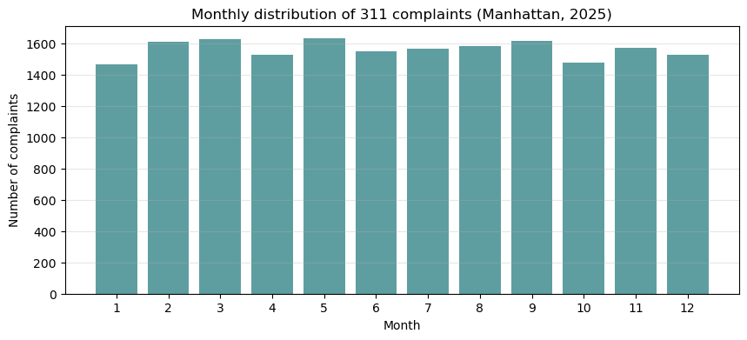
Figure 2. Monthly distribution of Manhattan 311 complaints in 2025.

Manhattan 311 spans 131 distinct complaint categories, but the distribution is highly concentrated. The top four categories - Heat/Hot Water, Noise-Residential, Illegal Parking, and Noise–Street/Sidewalk - account for roughly 38% of all complaints, and the top ten cover about 57% (Figure 3). NYPD and HPD together handle approximately 63% of all requests, meaning Manhattan's 311 functions in practice closer to a "policing-and-housing" channel than a full-spectrum service line.
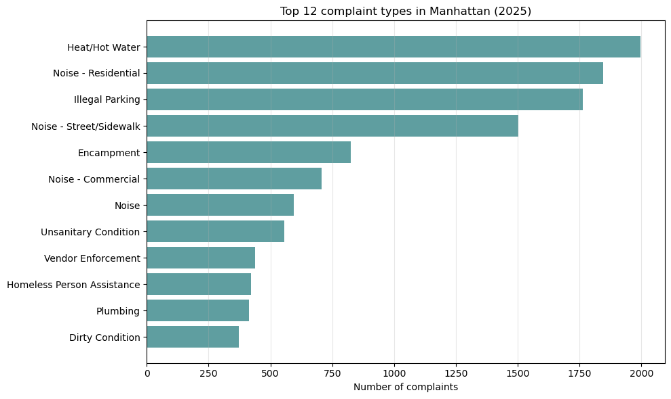
Figure 3. Top 12 complaint types in Manhattan (2025).

4.2 Major Complaint Themes (RQ1)
LDA identified four interpretable themes (Figure 4): Residential Noise & Street Disruption (loud, music, party), Sanitation & Property Conditions (trash, recycling, mold), Building Noise & Vendor Issues (banging, pounding, vendor), and Parking & Construction Violations (parking, sign violation, construction). The themes are relatively balanced (30.8%, 29.8%, 23.6%, and 15.8% respectively), indicating that LDA captured genuine thematic distinctions rather than collapsing into a single dominant topic.

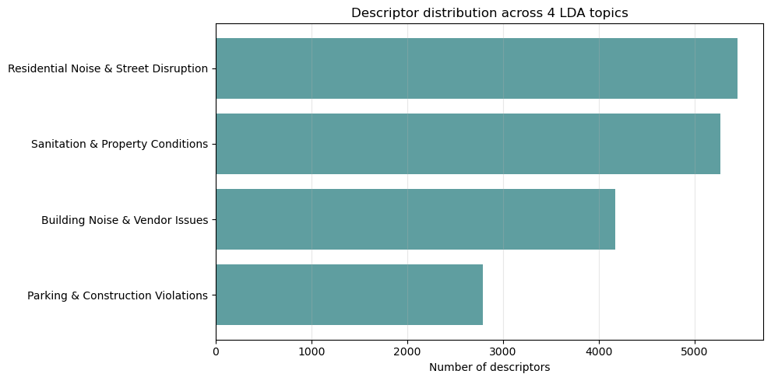
Figure 4. Distribution of complaints across the four LDA themes.
Two of the four themes: Residential Noise & Street Disruption and Building Noise & Vendor Issues are both noise-related and together account for over half of themed complaints. The TF-IDF analysis (Figure 5) reinforces this: the highest-weighted distinctive terms across the corpus are dominated by noise vocabulary, confirming noise as the most salient resident concern in Manhattan. The four-theme structure feeds directly into Section 3.2 as features for ZIP-level clustering.

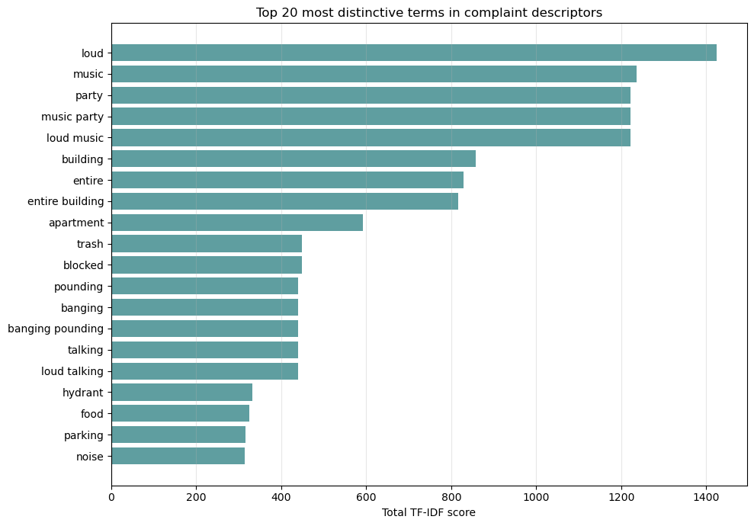
Figure 5. Top 20 most distinctive terms in Manhattan 311 complaint descriptors (TF-IDF weighted).

4.3 Community Profiles (RQ2)
K-Means produced four ZIP-level clusters that align closely with the RQ1 themes, with each cluster's dominant theme accounting for between 28.9% and 38.6% of its complaints. The four clusters separate into roughly four quadrants of PCA space: Cluster B in the upper left, Cluster A in the upper right, Cluster D in the lower left, and Cluster C in the lower right (Figure 6). The cluster-theme heatmap (Figure 7) confirms this picture: three of the four clusters have a single clearly dominant theme, while Cluster C is more evenly split between two themes. Table 1 reports the full cluster composition.
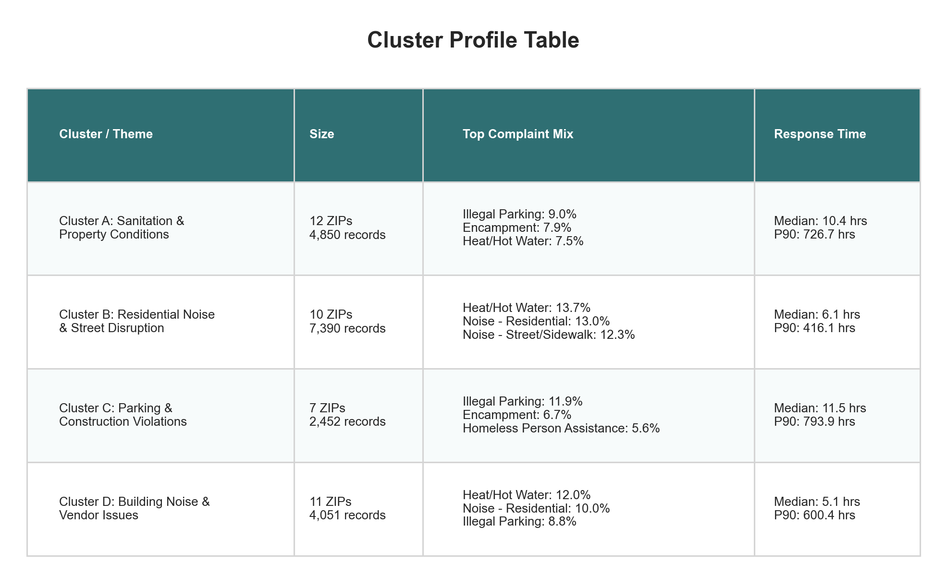
Table 1. Summary of ZIP-level community profiles identified by K-Means clustering (K = 4).

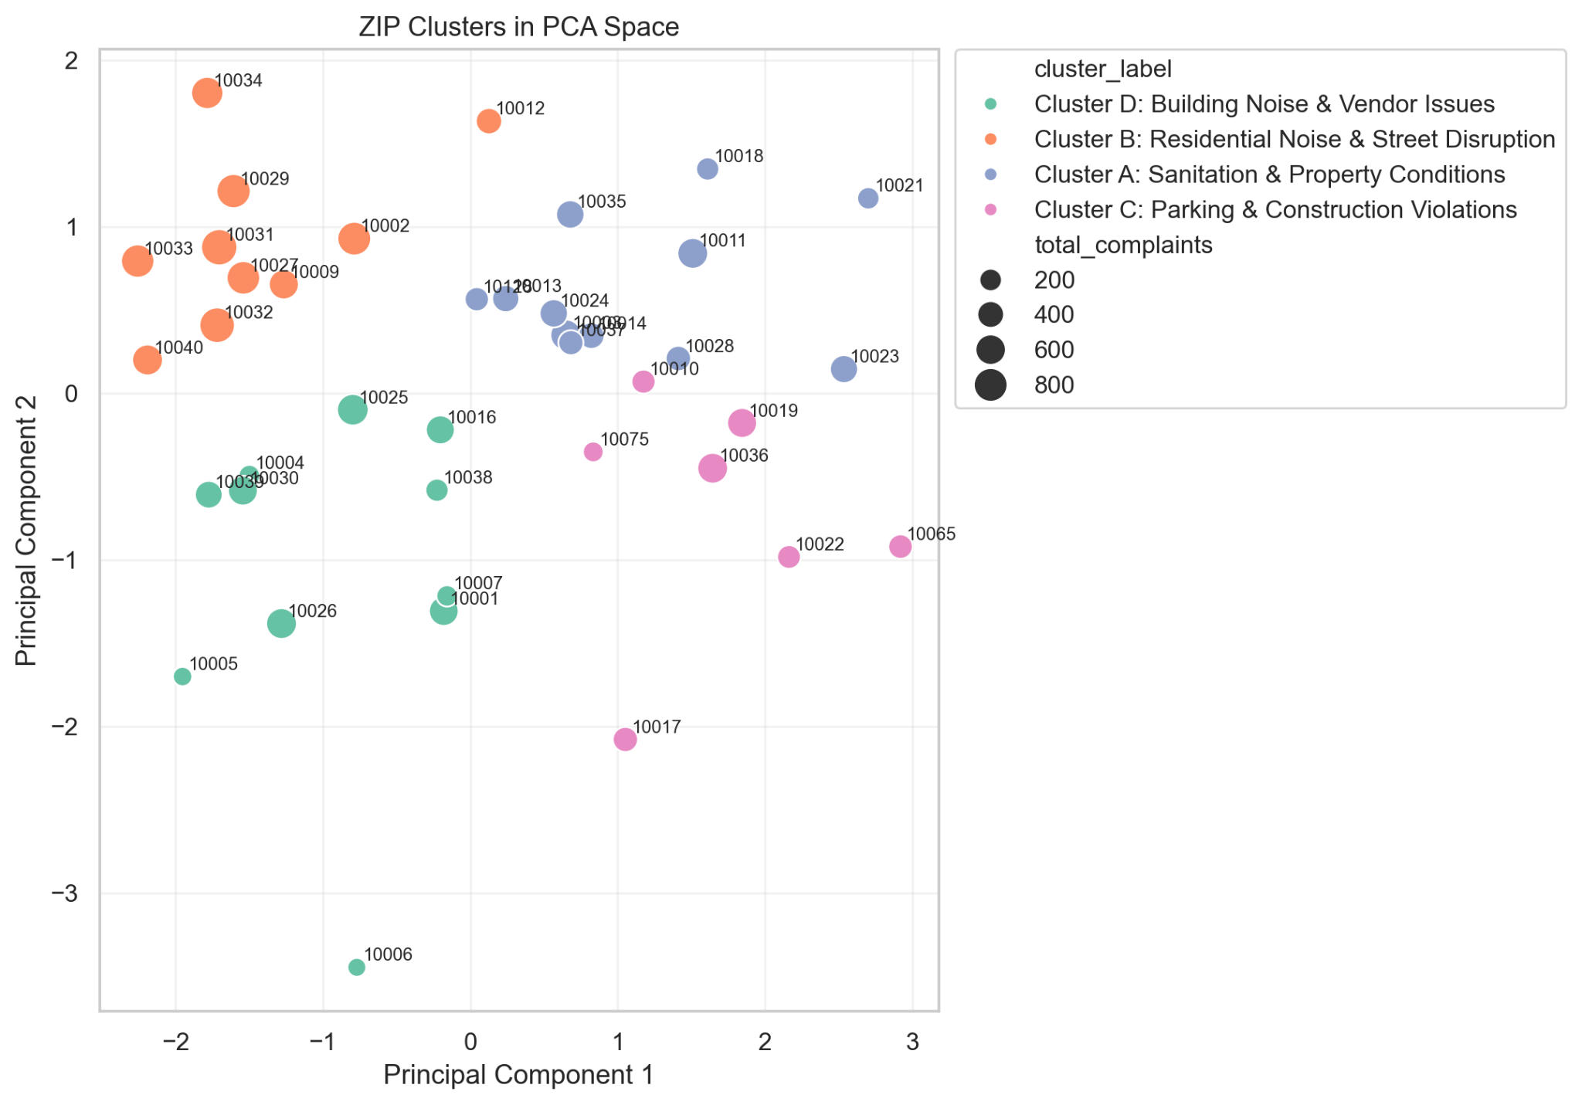
Figure 6. Manhattan ZIP codes plotted in two-dimensional PCA space. Each point represents one ZIP code; colors indicate cluster assignment from K-Means (K = 4), and point size reflects complaint volume.

Beyond what the dominant theme alone captures, each cluster carries a distinctive complaint signature (Table 1):
- Cluster A: Although Sanitation & Property Conditions is its dominant theme, top complaint types are spread relatively evenly, no single type exceeds 10% of the cluster.
- Cluster B: The largest cluster by record count, with the most concentrated complaint mix: Heat/Hot Water, Noise–Residential, and Noise–Street/Sidewalk together account for nearly 40%.
- Cluster C: The smallest cluster, and the only one where the assigned theme is not its strongest. Sanitation & Property Conditions actually has a slightly higher share than Parking & Construction Violations within this cluster, so the label reflects best alignment rather than a clear dominant theme.
- Cluster D: Vendor Enforcement appears among its top complaints: a profile not seen in any other cluster.

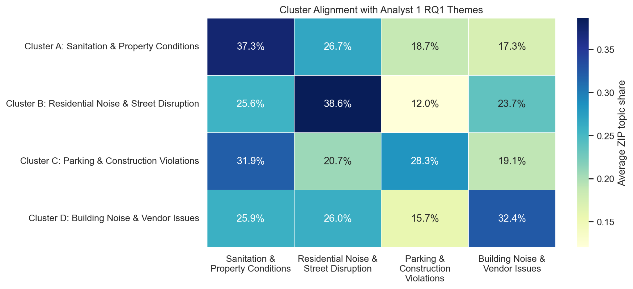
Figure 7. Cluster alignment with RQ1 themes. Each row shows the average ZIP-level theme share within a cluster; darker cells indicate stronger alignment between the cluster and the corresponding RQ1 theme.

One pattern stands out across all four clusters: Heat/Hot Water and Illegal Parking appear in every cluster's top complaints, suggesting a baseline of housing and parking issues shared across Manhattan. Clusters differ mainly in what is layered on top of this baseline. Together with the moderate silhouette score (0.301), this suggests Manhattan ZIP codes occupy a continuum of complaint mixes, but the four-cluster grouping still provides interpretable categories for RQ3.

4.4 Differences in Response Time (RQ3)
Response times differ significantly across the four ZIP clusters. The Kruskal-Wallis test produced H = 41.09 with p < 0.001, and the robustness check using one-way ANOVA on log1p(response_hours) reached the same conclusion (F = 14.20, p < 0.001). The boxplot reveals that the four clusters fall into two visibly different distributions rather than four evenly spaced ones, with Clusters A and C sitting noticeably higher than Clusters B and D (Figure 8). Median response times confirm this split: the slow clusters' medians are roughly twice those of the fast clusters (Table 1).
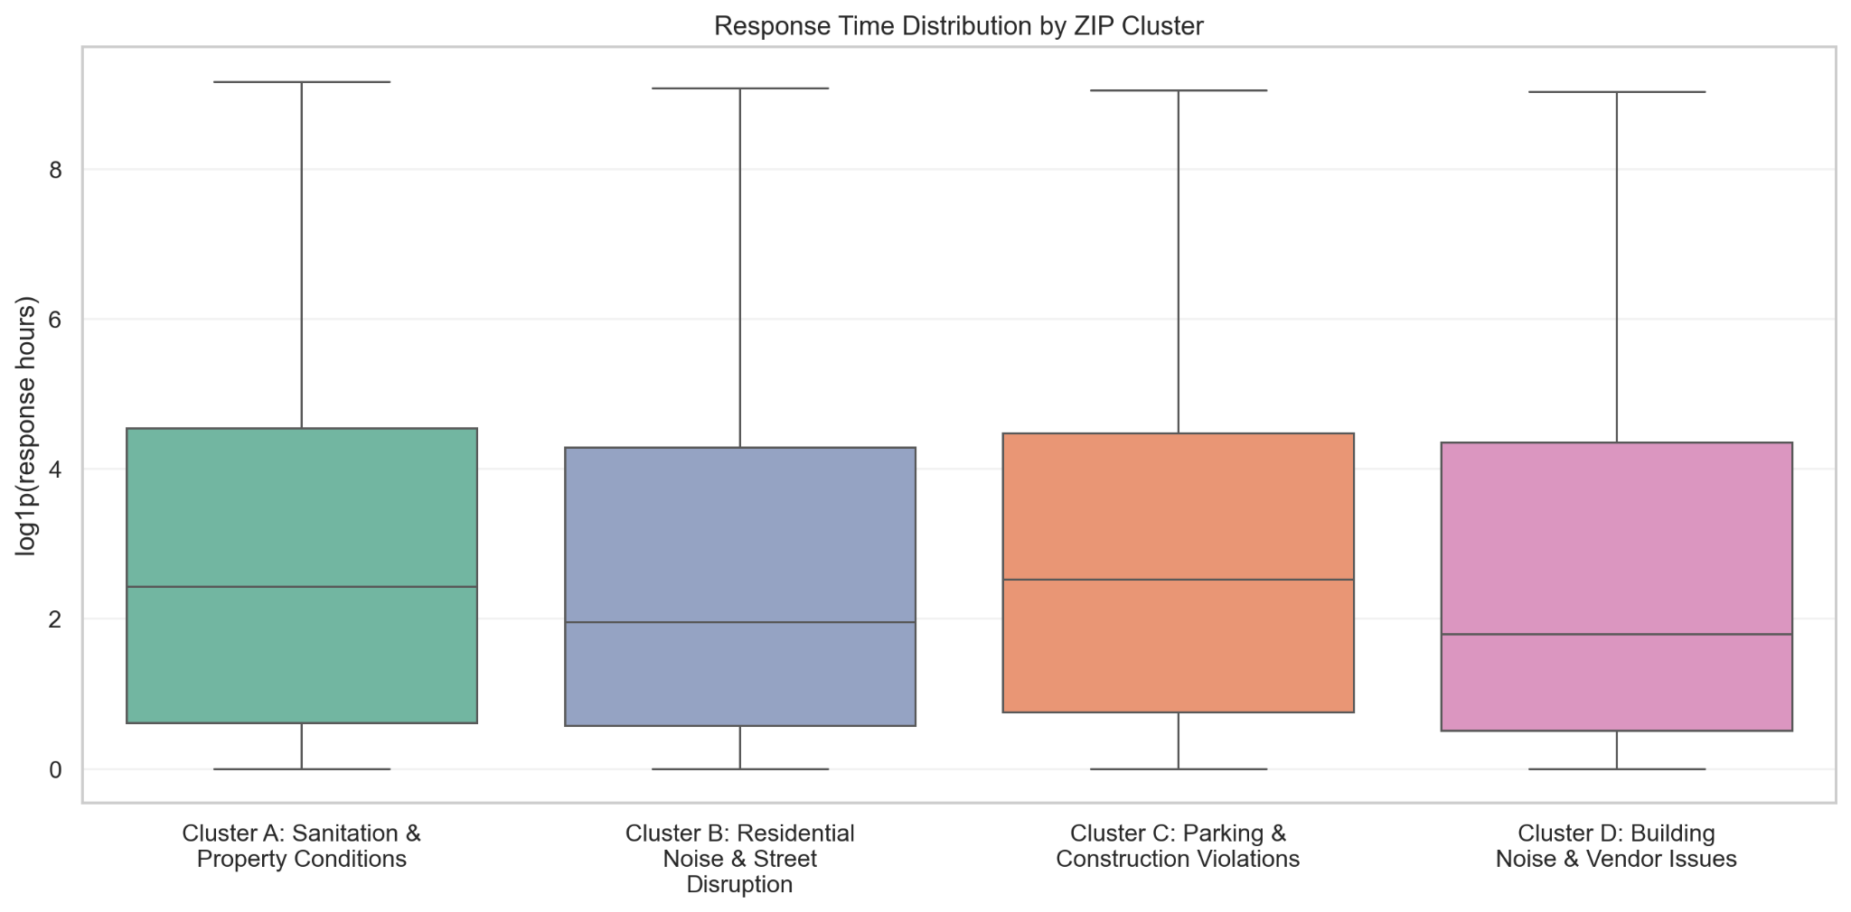
Figure 8. Distribution of case response time across the four community profiles. The y-axis uses log1p(response hours) because the raw response_hours variable is strongly right-skewed. Outlier cases above the 99th percentile are excluded.

The same gap holds at the 90th percentile, where the slow clusters' tails extend hundreds of hours longer than the fast clusters' (Table 1).

The pairwise Mann-Whitney tests (Holm-corrected) clarify the pattern further. The slow clusters (A and C) and the fast clusters (B and D) are statistically indistinguishable within each pair (p_holm > 0.5), while every comparison across the slow–fast boundary is significant (all p_holm < 0.001). This points to a meaningful split between two groups of Manhattan communities rather than four fully separate response-time tiers.

The slower-clusters group (A and C) is associated with sanitation, property-condition, encampment, and parking/construction issues, which often involve agency inspections or coordination across multiple agencies. The faster-clusters group (B and D) is more weighted toward noise complaints and heat/hot-water issues, which tend to follow more standardized response protocols. We return to the policy implications of this split in Section 5.

5. Conclusions and Recommendations
5.1 Key Findings
This analysis traced Manhattan 311 complaints from descriptor text to community-level profiles to service efficiency, and three findings emerged. First, complaints fall into four interpretable themes, but two of them are noise-related, making noise the single most salient concern in residents' own language. Second, Manhattan ZIP codes group into four community profiles aligned with these themes, although the clusters lie on a continuum rather than in sharply separated groups. Third, response times differ significantly across these profiles and split into two tiers: a slow group (Sanitation, Parking & Construction) and a fast group (Noise, Building & Vendor), with median response time roughly twice as long in the slow group. The slow tier is dominated by complaint types that typically require agency inspection or cross-agency coordination, while the fast tier is weighted toward complaints with more standardized response protocols.

5.2 Recommendations
Three recommendations follow from these findings:
- Prioritize the slow-cluster ZIPs for additional inspection and case-management capacity. Cluster A and Cluster C together cover 19 ZIPs that experience median response times nearly twice as long as the borough's faster clusters.
- Set complaint-type benchmarks for sanitation, encampment, and parking/construction cases, where the cross-agency nature of resolution appears to drive longer processing times. Benchmarks would make it easier to identify and address bottlenecks at the complaint-type level.
- Treat Manhattan as four community profiles for resource planning, rather than a single homogeneous borough. Even within Manhattan, the complaint mix and service experience vary in ways that uniform allocation can miss.

5.3 Limitations and Future Work
The dataset is a monthly random sample rather than a complete census, so volume estimates are approximations. Cases still open at retrieval are excluded from response-time analysis, potentially biasing RQ3 toward faster-resolving complaint types. Cluster C does not have a single clearly dominant theme and was named based on best alignment with the four RQ1 themes, so its interpretation is less clean than the other three clusters. Future work could extend this framework to other boroughs to test whether the slow/fast split persists across NYC, integrate demographic context to examine equity dimensions, or use the full unsampled 311 dataset for finer-grained temporal analysis.
References

Boxer, K. S., Hong, B., Kontokosta, C. E., & Neill, D. B. (2025). Estimating reporting bias in 311
complaint data. The Annals of Applied Statistics, 19(2), 1691–1713.
https://doi.org/10.1214/24-AOAS2003

Office of the New York City Comptroller. (2025, March 3). Turn up the heat: 2025 update.
https://comptroller.nyc.gov/reports/turn-up-the-heat-2025-update/

Wang, L., Qian, C., Kats, P., Kontokosta, C. E., & Sobolevsky, S. (2017). Structure of 311 service
requests as a signature of urban location. PLoS ONE, 12(10), e0186314.
https://doi.org/10.1371/journal.pone.0186314

