B10632026 吳苡瑄

**Test output**

function name: palindrome

input: 1 list, list1

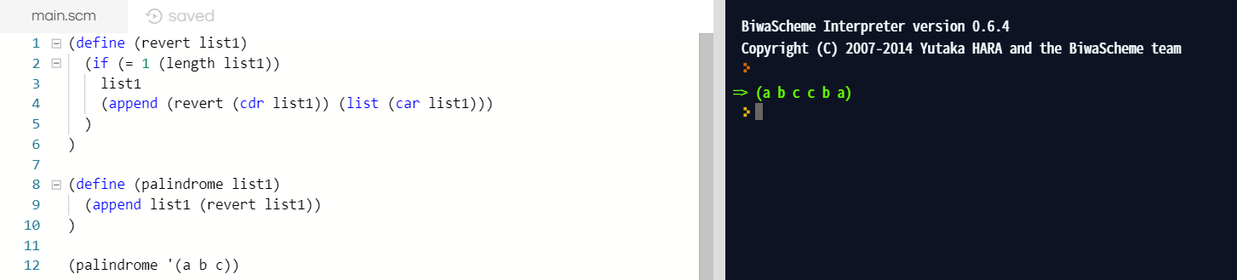output: list1 + inverse of list1

function name: dbl_atm

input: an atom and a list

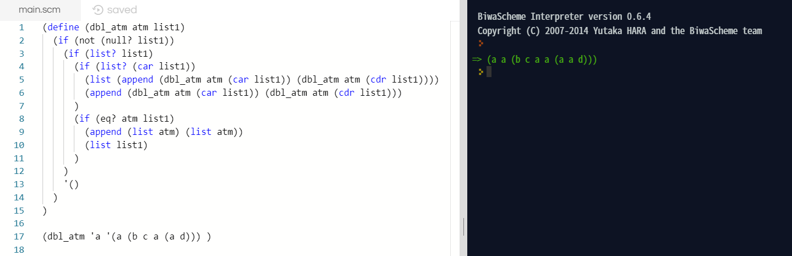output: a list with all occurrences of the given atom doubled