B10632026 吳苡瑄

**Show that using your rules,**

**you can infer that zues, rosa and fran are bitsy's cousins,**

cousin(bitsy, zues).

true

cousin(bitsy, rosa).

true

cousin(bitsy, fran).

True

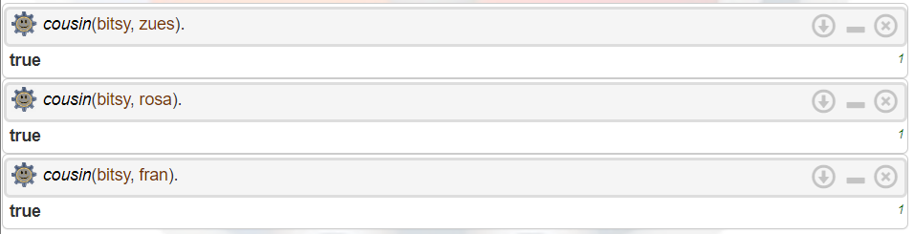

**and that bitsy and alan are one-another's brother and sister.**

sister(bitsy, alan).

true

brother(alan, bitsy).

true

sibling(bitsy, alan).

true

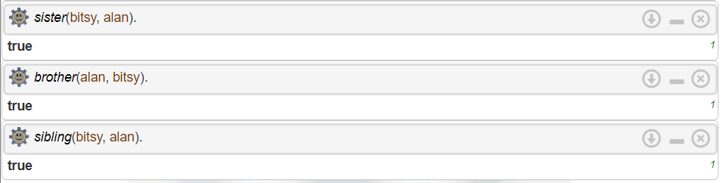

**Also create queries that test all predicates.**

mother(amy, richard)

true

father(mel, joan)

**false**

daughter(mark, janny)

true

daughter(janny, mark)

true

son(zues, richard)

true

