LSTM
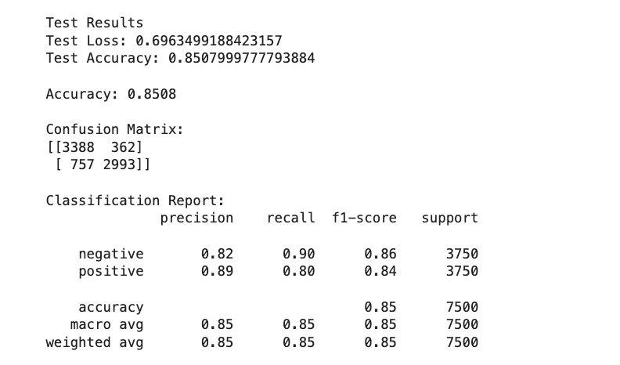
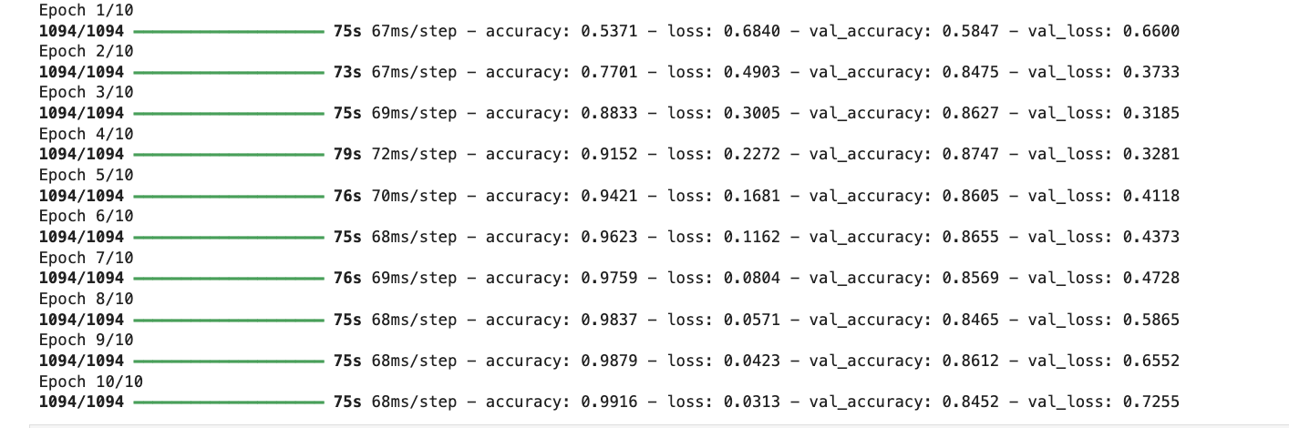
The LSTM model demonstrated a significant improvement over the previous dense neural network model, achieving a test accuracy of approximately 85%, compared to around 76–77% for the earlier approach. This improvement highlights the advantage of using sequence-based models that can capture contextual and sequential information from the full text rather than relying on limited numerical features. There is a difference between the training and validation losses and the training and validation accuracies, suggesting overfitting. This can be solved with early stopping, or dropout.

