Model Optimization and Performance Analysis

Model Configuration
The neural network model was designed as a feedforward architecture using the Sequential. It consists of:
- An input layer with 2 features (VADER and TextBlob sentiment scores)
- Two hidden layers with 8 and 4 neurons, respectively, using ReLU activation
- An output layer with 1 neuron using sigmoid activation for binary classification
The model was compiled using the Adam optimizer with a learning rate of 0.001, binary cross-entropy as the loss function, epoch equals to 32, and accuracy as the evaluation metric.

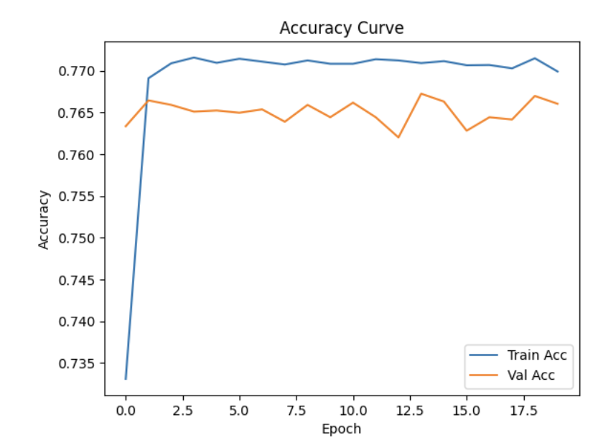
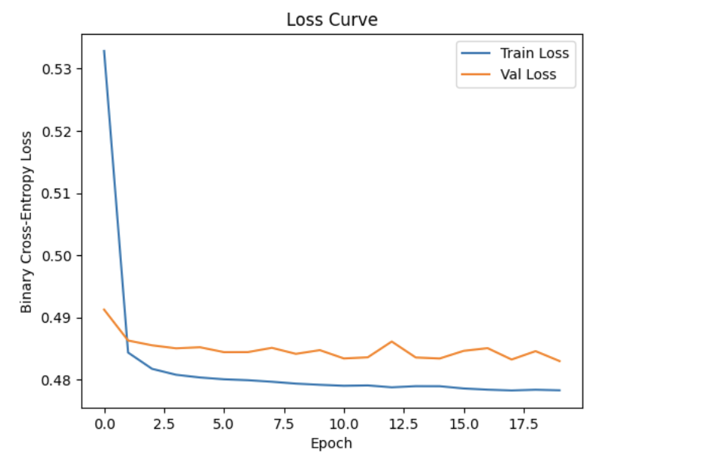
Accuracy and Loss Curve Analysis
The model was trained for 20 epochs with a batch size of 32.
Training loss decreased from about 0.53 to 0.48, while validation loss remained close to 0.48–0.49, indicating stable learning and no major overfitting. Training accuracy reached approximately 77.1%, while validation accuracy stabilized around 76.5%, indicating good generalization. However, both curves plateaued early, which suggests that the model quickly captured the available patterns and that additional gains would likely require better feature engineering rather than longer training alone.

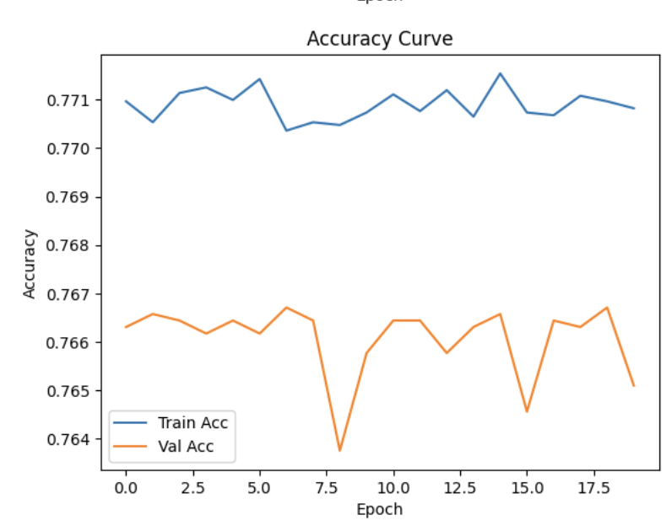
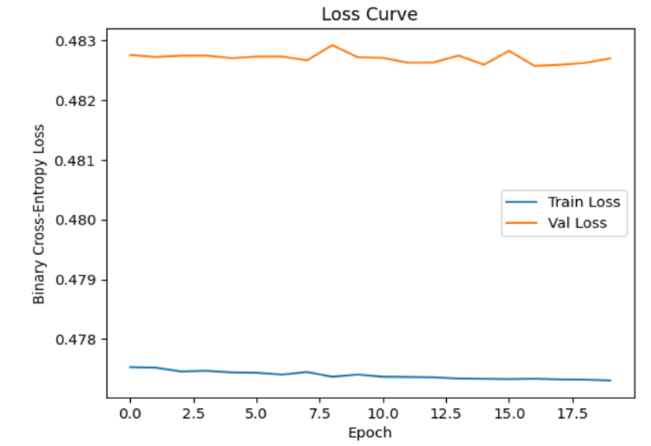
Same Architecture, Training rate=0.0001
The loss and accuracy are almost flat, which shows very little improvement across epochs. This highlights that the model is learning very slowly, as the learning rate is very small = 0.001.
These results highlight the importance of selecting an appropriate learning rate. A value that is too small can hinder learning by making updates excessively slow, while a well-chosen learning rate allows the model to converge efficiently.

Batch Size Tuning
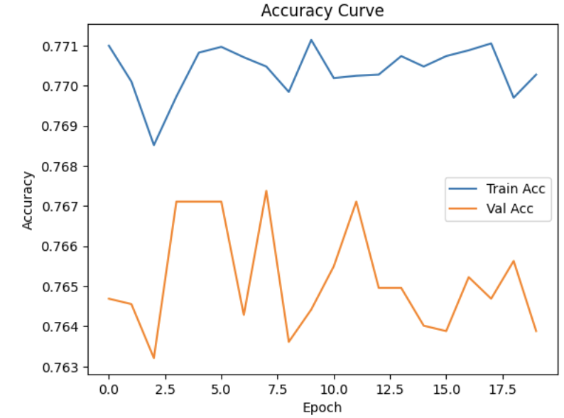
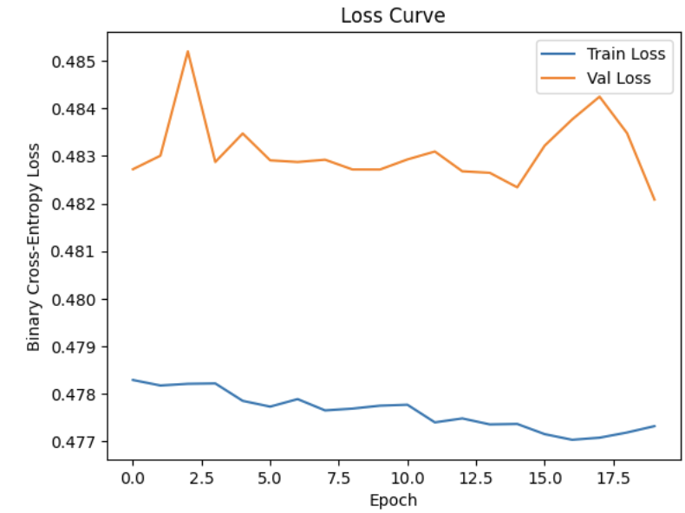
Batch size= 16
The results show that the model maintained similar performance in terms of both accuracy and loss. Training accuracy remained around 77%, while validation accuracy fluctuated between approximately 76.3% and 76.7%, consistent with previous experiments.
The loss and accuracy curves became less smooth and showed more fluctuations compared to the larger batch size. This behavior is expected, as smaller batch sizes introduce more noise in gradient updates, leading to less stable training.
Despite these fluctuations, no signs of overfitting were observed, as the gap between training and validation metrics remained small. The model continued to generalize well.

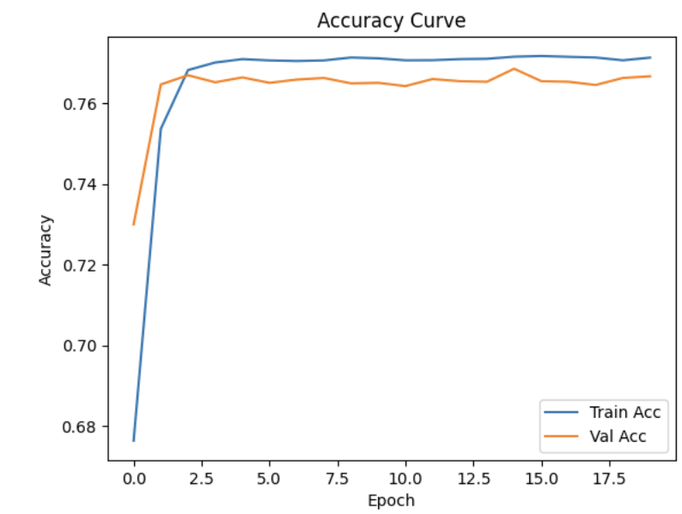
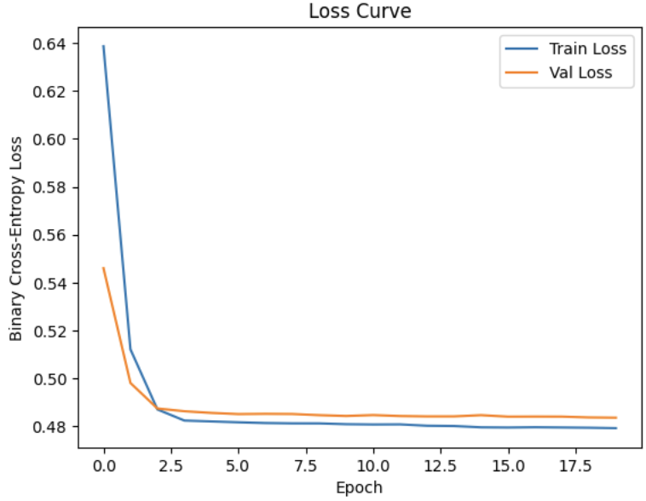
Batch size=64
The training loss drops quickly at the beginning, then becomes very smooth and stable, while the validation loss is also smooth and shows very small fluctuations. This shows that a larger batch size leads to smoother optimization. Each update uses more data and therefore shows less noise. The gradient is more stable. However, it did not affect the final accuracy and final loss much.

