

**Database Systems Project**

**Presented By**

**M.Waqas (22I - 2469)**

**Abdullah (22I - 8808)**

**To**

**Sir Bilal**

Table of Contents

1 Functional Requirements 3

2 Entity Relation Diagram 6

3 Enhanced Entity Relation Diagram 6

4 Relation Schema 7

5 Usage Guidelines 10

6 Screenshots of Project 11

# 1 Functional Requirements

**1. User Management**

* **Admin**
  + **Add User (Employee/Customer/Analyst):**
    - Fields for first name, last name, role, username, password, address, salary (employee, analyst), contact details.
    - Password complexity requirements.
    - Enforce unique usernames (across all user types) and emails (for customers).
  + **Remove User:**
    - Select user.
    - Confirmation for security.
    - Options for archiving vs. deleting data (e.g., customer orders for reporting).
  + **Edit User:**
    - Modify user information (excluding usernames).
  + **Manage Own Profile:**
    - View/edit name, password, address.

**2. Inventory Management**

* **Employee** 
  + **View Inventory Levels:**
    - Real-time inventory view with clear thresholds, search/filter functionality.
    - Highlight items below reorder levels.
  + **Generate Reorder Requests:**
    - Automatic low-stock notifications.
  + **Receive Inventory:**
    - Update inventory quantities when new stock arrives.
    - Potential link to supplier purchase orders.
  + **Ingredient-Level Tracking:**
    - System deducts ingredient quantities from InventoryItems based on Recipes and sales in TransactionItems.

**3. Product Management**

* **Admin**
  + **Menu Management:**
    - Add/edit/remove menu items with name, description, price, images, category, availability toggles.
    - Create/modify menu sections/categories.
    - Create new menus i: e Vegan Menu etc.
  + **Recipe Management:**
    - Create/edit recipes.
    - Link ingredients and quantities to recipe.
  + **Ingredient Management:**
    - Add/edit/remove ingredients with name, unit, cost, supplier information.

**4. Order Management**

* **Customer**
  + **Browse Menu**
    - Detailed menu view with descriptions.
    - Searching and filtering capabilities.
  + **Place Order:**
    - Add items to cart (quantity selection).
    - Select pickup/delivery time (if applicable).
    - Apply promotions/discounts, redeem loyalty points.
    - Provide payment information.
    - Review and confirm order.
  + **Track Order Status:**
    - Real-time updates: "Preparing," "Ready," "Out for Delivery," etc.
  + **View Order History:**
    - Past orders with details, ability to reorder easily.
* **Employee**
  + **Process Order (Cashier/Kitchen Staff):**
    - View incoming orders.
    - Change order status: "In Progress," "Ready," "Completed."
    - Manage fulfillment and communicate with delivery agents, if applicable.

**5. Promotions & Loyalty**

* **Admin**
  + **Promotions:**
    - Create promotions (percentage off, fixed amount, item-specific, etc.)
    - Set start/end dates, active/inactive toggles.
    - Manage promotional codes.
  + **Loyalty Program:**
    - Create/edit programs with points accrual rules, expiry, welcome bonus, etc.
    - Enroll/unenroll customers.
    - Tiered loyalty systems
* **Customer**
  + **Enroll in Loyalty:**
    - Opt in during signup or later.
  + **Track Loyalty Points:**
    - Clear points balance display.
  + **Redeem Loyalty Points:**
    - Apply points during checkout.

**6. Reporting & Analytics**

* **Data Analyst**
  + **Sales Dashboard:**
    - Visuals of key metrics: sales trends (daily, weekly, monthly), revenue, top-selling products, average transaction value, etc.
    - Filters by date range, product category.
  + **Customer Behavior:**
    - Customer segmentation.
    - Peak time analysis.
    - Customer Loyalty Tracking.
  + **Promotion Analysis:** Track redemption rates and effectiveness of promotions.
* **Manager** 
  + Daily/weekly sales snapshots.
  + Staff performance reports

# 2 Entity Relation Diagram

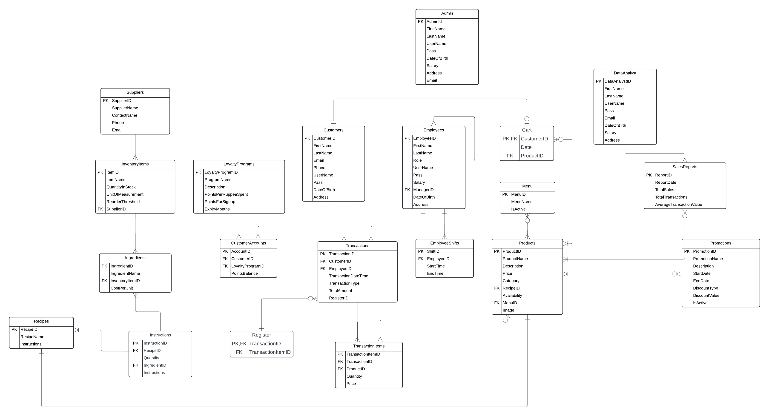

# 3 Enhanced Entity Relation Diagram

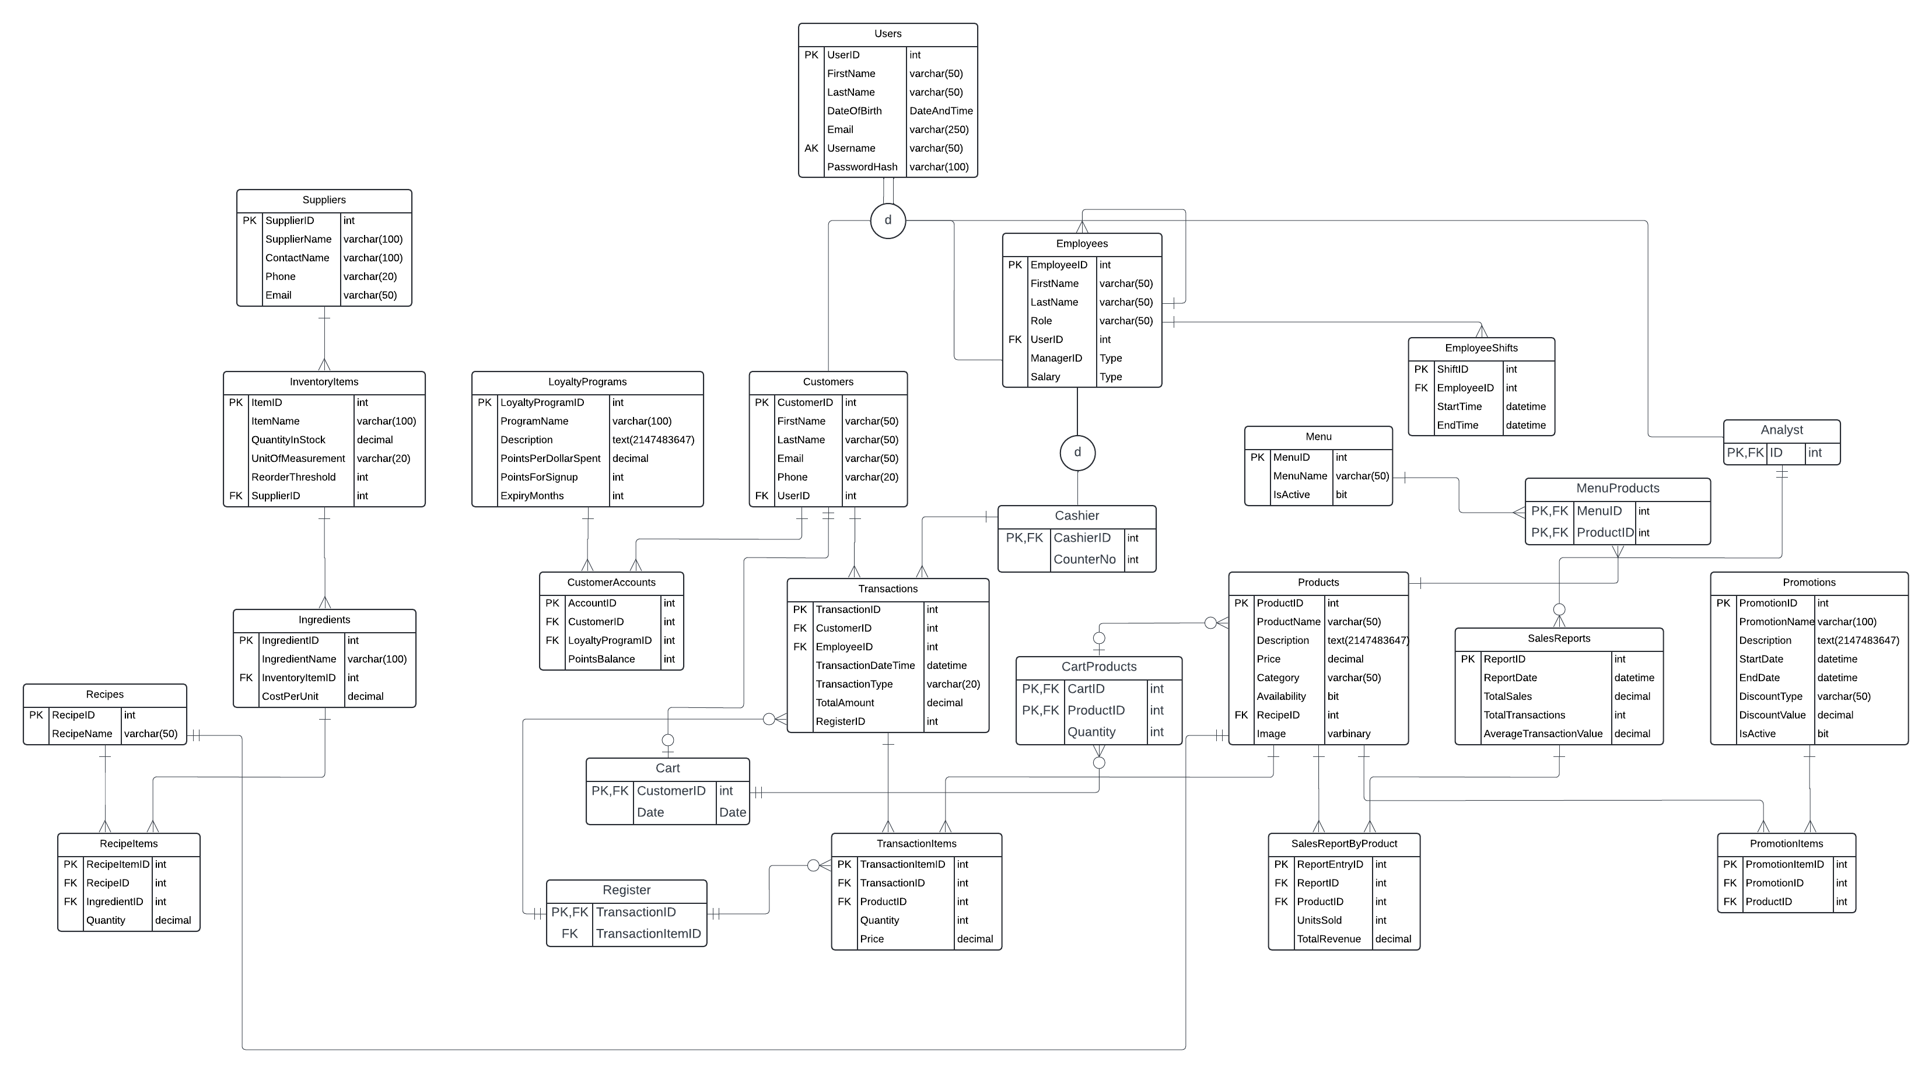

# 4 Relation Schema

Original Schema from Entity Relation Diagram.

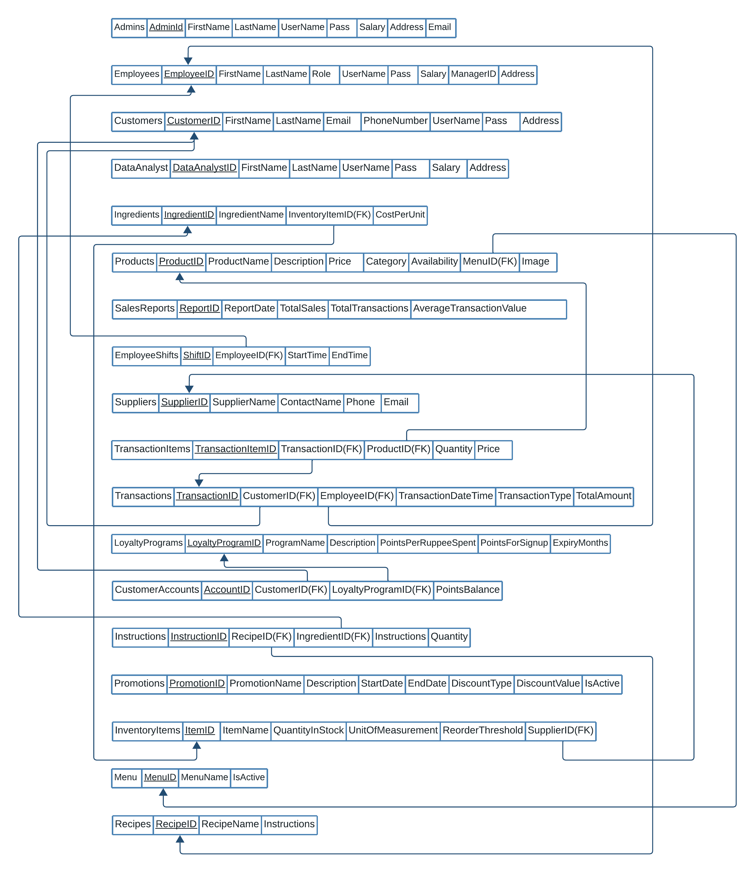

The below schema is in both 1NF and 2NF.

# 

The below schema is in 3NF.

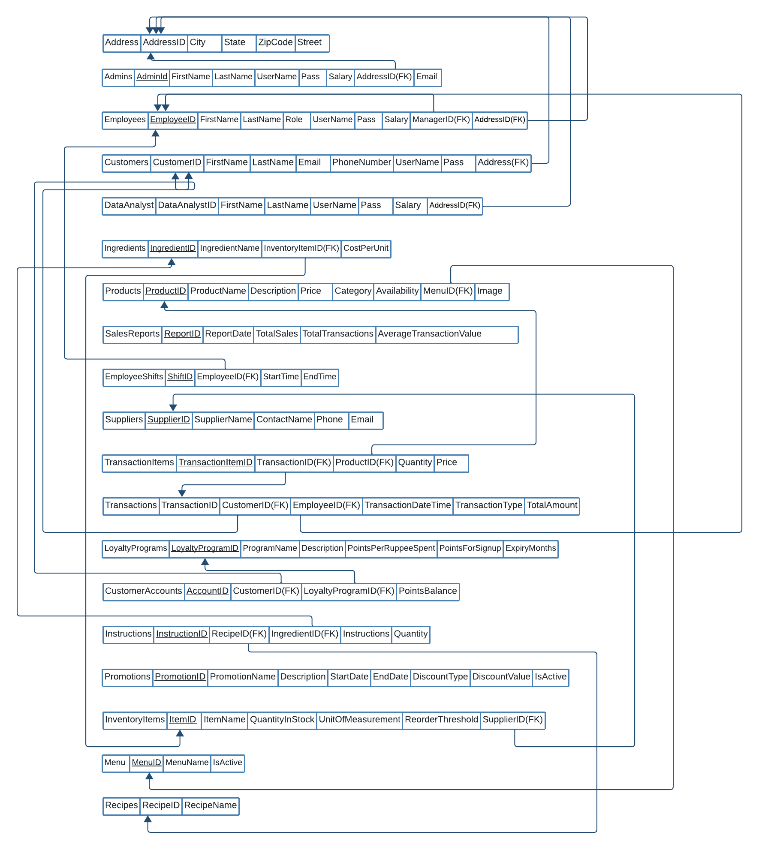

# 5 Usage Guidelines

* Enter the username and password in the login form if you are an admin employee, customer or data analyst.
* If you have not registered, you can click on the sign-up button and sign up as a customer.
* If you are a customer logged in, you can view the menu. Select a menu from the menu table and view the related products to add product to Court. Click on add to card button.
* If you are a customer and want to manage your profile, click on the profile button
* If you want to view the latest notifications, click on the notifications button
* If as a customer want to view your history of orders, click on history button
* If you want to place an order, click on the card button and if you want to remove product, click on remove, otherwise click on place order button
* If you are an admin, click on the profile button to manage your profile. Click on the manager employees’ button to add remove or edit an employee click on the manage customer button to add remove or view customers.
* If you are an employee, click on inventory button to view inventory and send notifications button to send promo promotions click on report button to generate reports. Click on history to view orders processed click on profile button to manage your profile.
* If you are on the manage inventory form, click on add new item to add a new item to the inventory or delete an item or update the item details in the table and click on save button.
* If you are on the reports form, click on a button from 1 to 18 to view accordingly reports and as well as on view 1-6 buttons.

# 6 Screenshots of Project

