

**Lab Task 15**

**Presented By**

**Waqas (22I - 2469)**

**Abdullah Mansoor (22I - 8808)**

**To**

**Mam Daniya**

Table of Contents

Question 1 3

Question 2 3

Question 3 3

Question 4 3

Question 5 3

Question 6 3

Question 7 3

Question 8 3

# Question 1

Below are the screenshots of installation process and configurations:

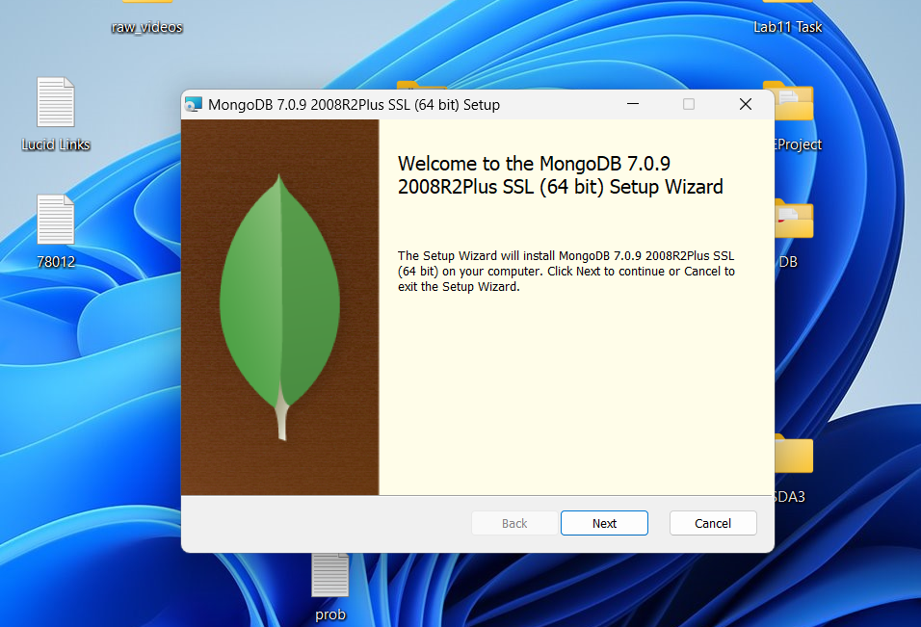

The Complete option was selected for installation.

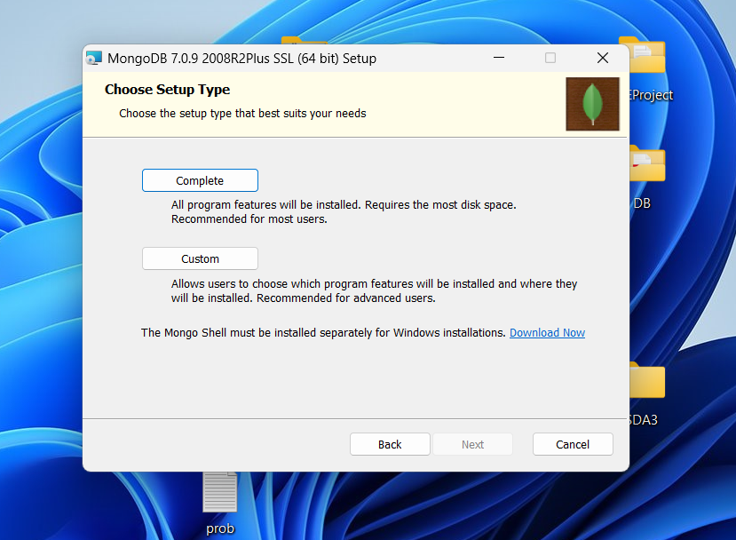

The default options were kept as it is.

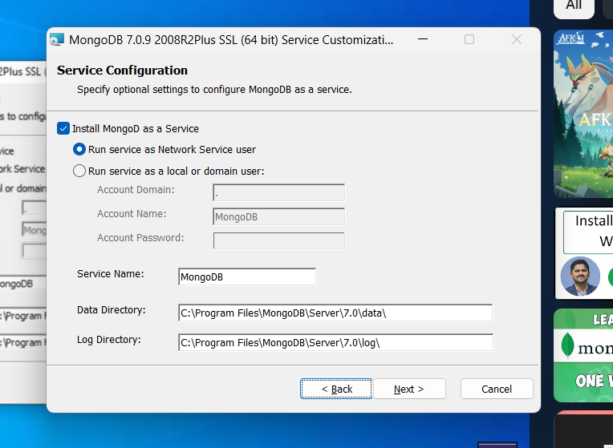

Afterwards the bin folder path of the installed MongoDB was copied and added to environmental variables path.

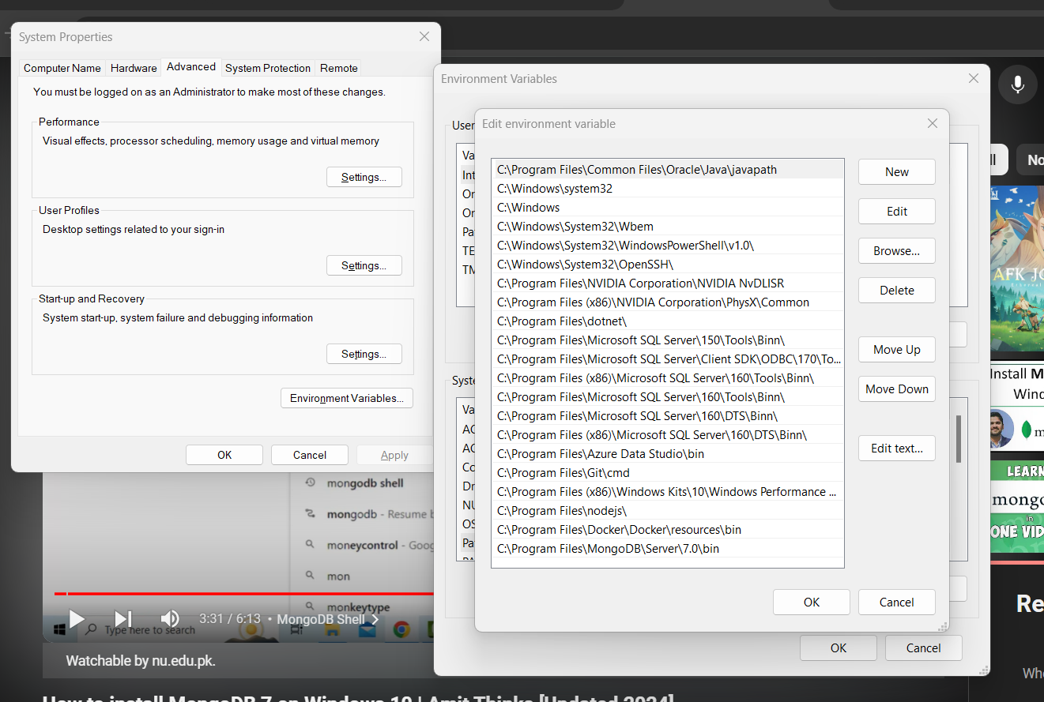

Then MongoDB shell was downloaded and installed.

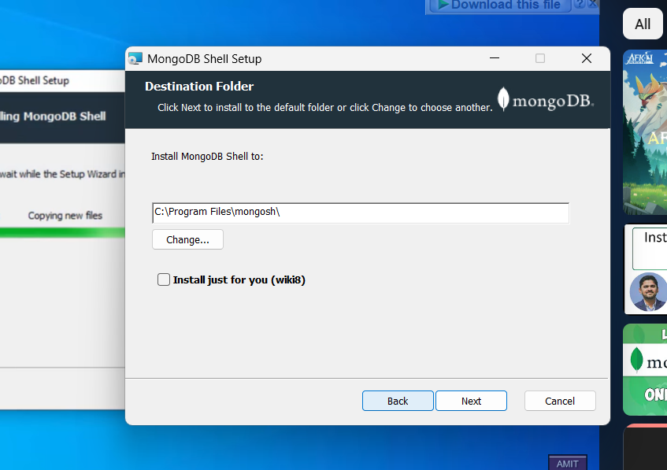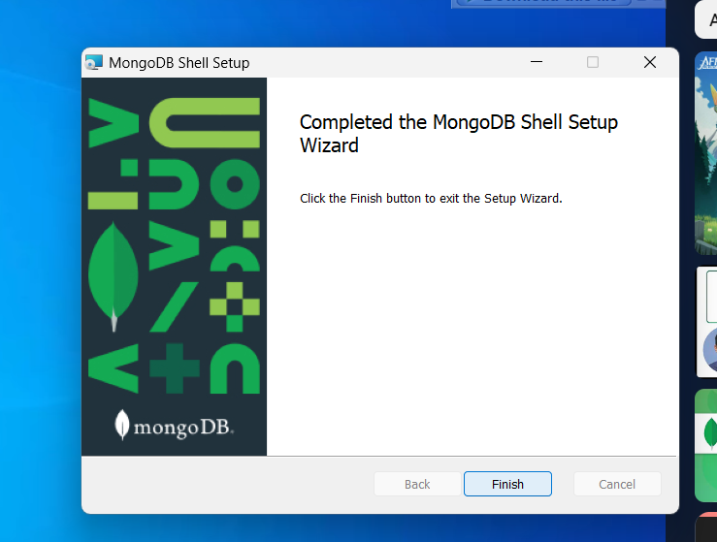

To verify installation cmd was opened and the command mongod –version showed us that installation was successful and all was working.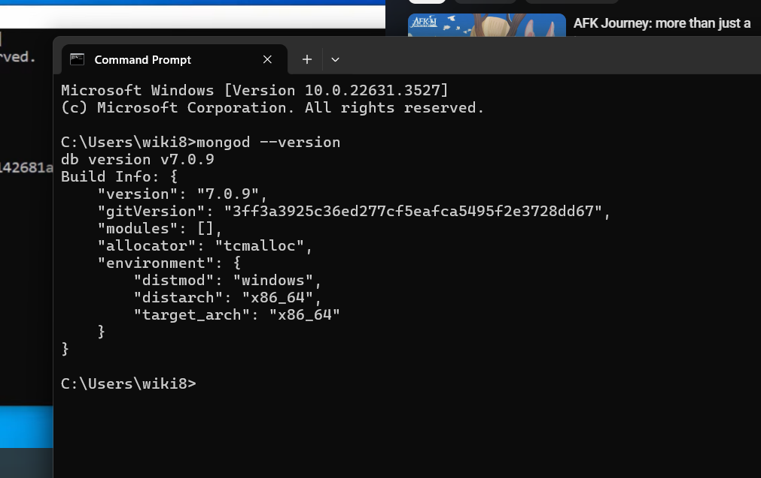

MongoDB compass screenshots:

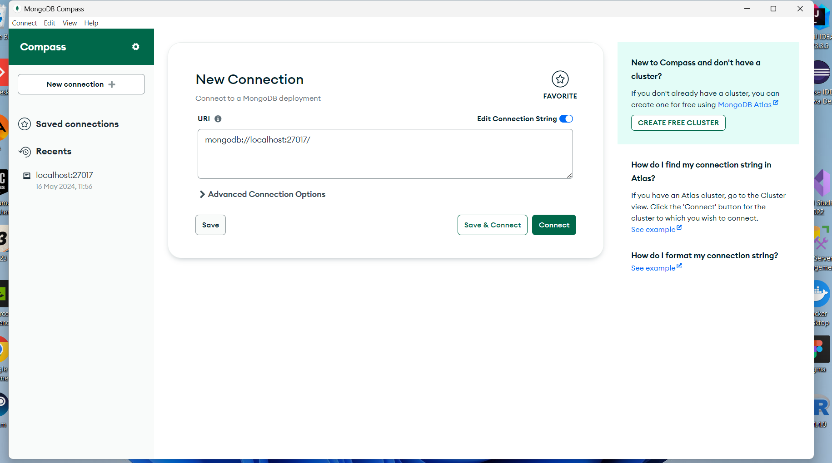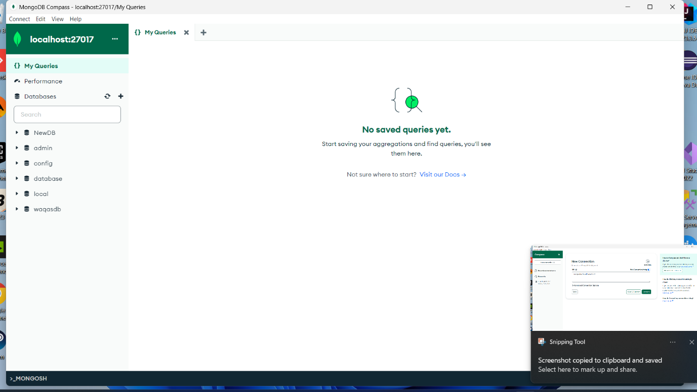

# Question 2

First, we downloaded mongodb and then installed the complete setup. Afterwards, the bin path was added to environmental variables. We installed MongoDB compass also which allows UI interaction. Then MongoDB shell was downloaded and installed. The process went fine and no issues were faced.

# Question 3

To create a database, we had two options via shell or MongoDB compass.

Steps involved in creating database in cmd:

1. Open cmd.
2. Type “mongosh”.
3. Type “use waqasdb” to create a new database.
4. Type “Show databases” to view databases. It is not necessary that the new database may show up as it is empty at first.

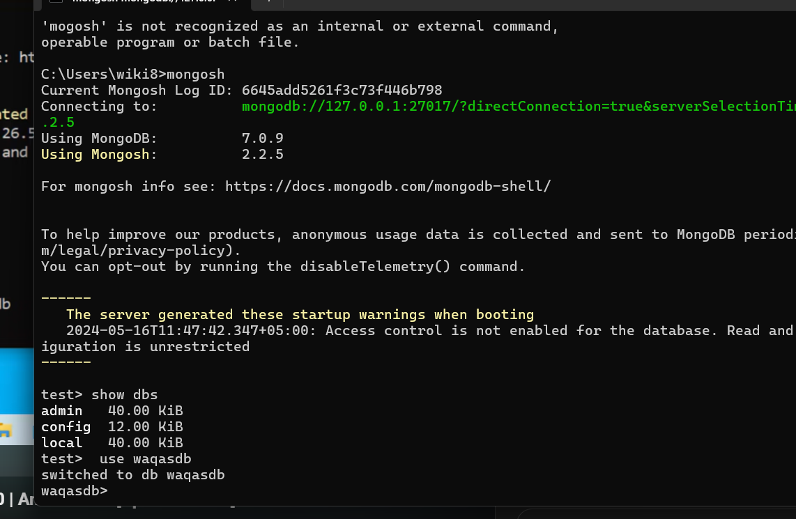

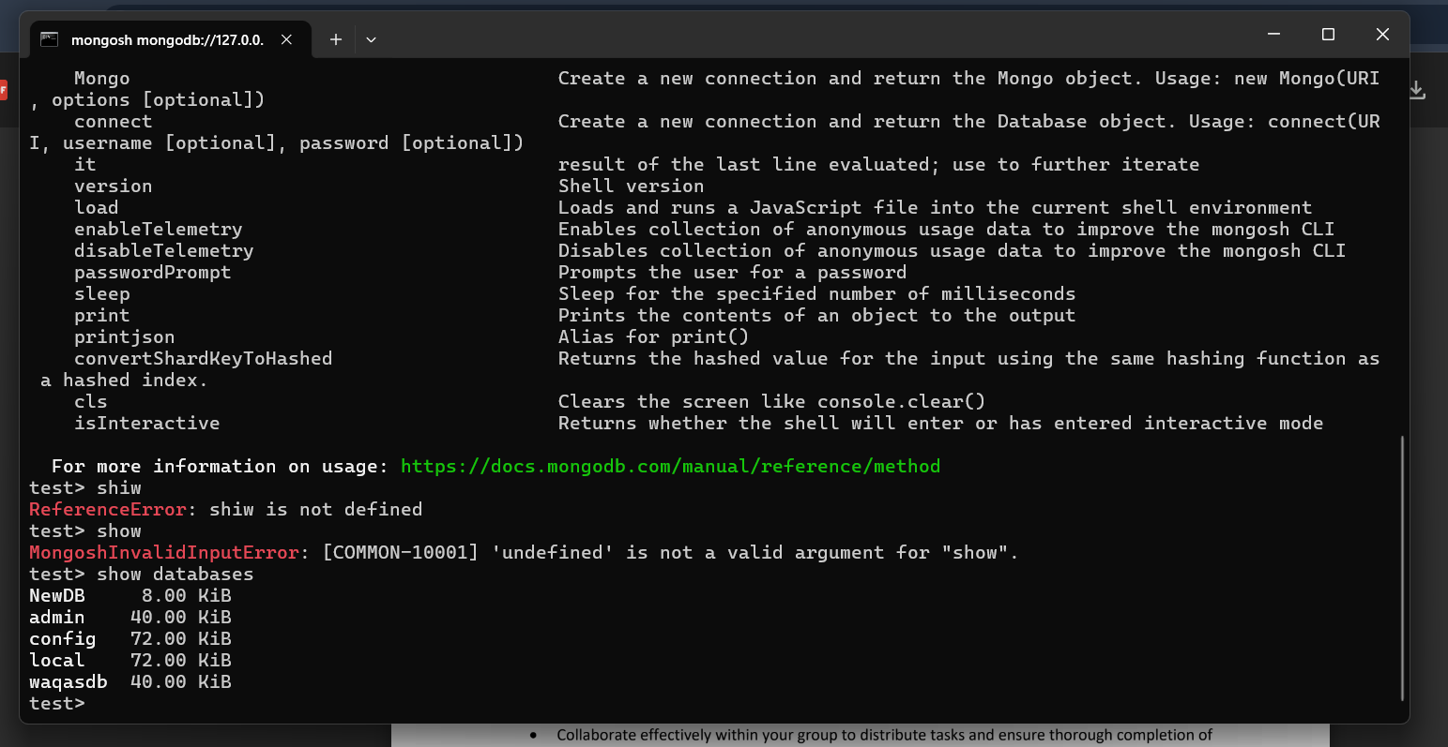

# Question 4

To add sample data, we followed these steps:

1. Type “use waqasdb”.
2. Type “db.students.insertMany([{name : "Waqas" , rollNo : "22I-2469", class: "SE-E"}, {name : "Abdullah", rollNo: "22I-8808", class: "SE-E"}]);”. Db is the keyword for database. Students is the collection name like a Table in SSMS. InsertMany indications multiple values being inserted in the table.
3. We get a confirmation message.
4. Type “db.students.find().pretty()” to list tuples. Pretty() beautifies the output.

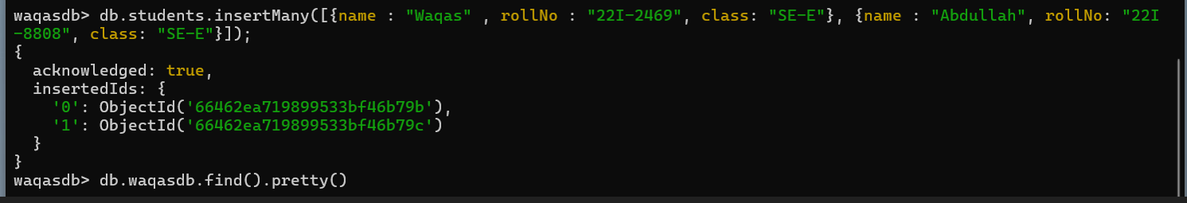

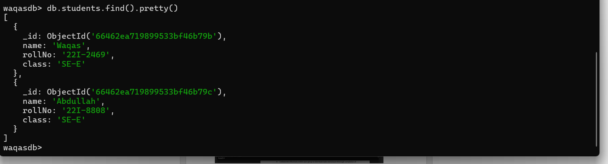

# Question 5

For Create and Insert operations the steps are:

1. For creating collection (like table) and adding data to it type db.students.insertMany([{name : "Waqas" , rollNo : "22I-2469", class: "SE-E"}, {name : "Abdullah", rollNo: "22I-8808", class: "SE-E"}]);”. Db is the keyword for database. Students is the collection name like a Table in SSMS. InsertMany indications multiple values being inserted in the table.
2. To add a single tuple we typed db.students.insertOne({ name: "Umer", rollNo:"22I-RRRR", class:"SE-E"});

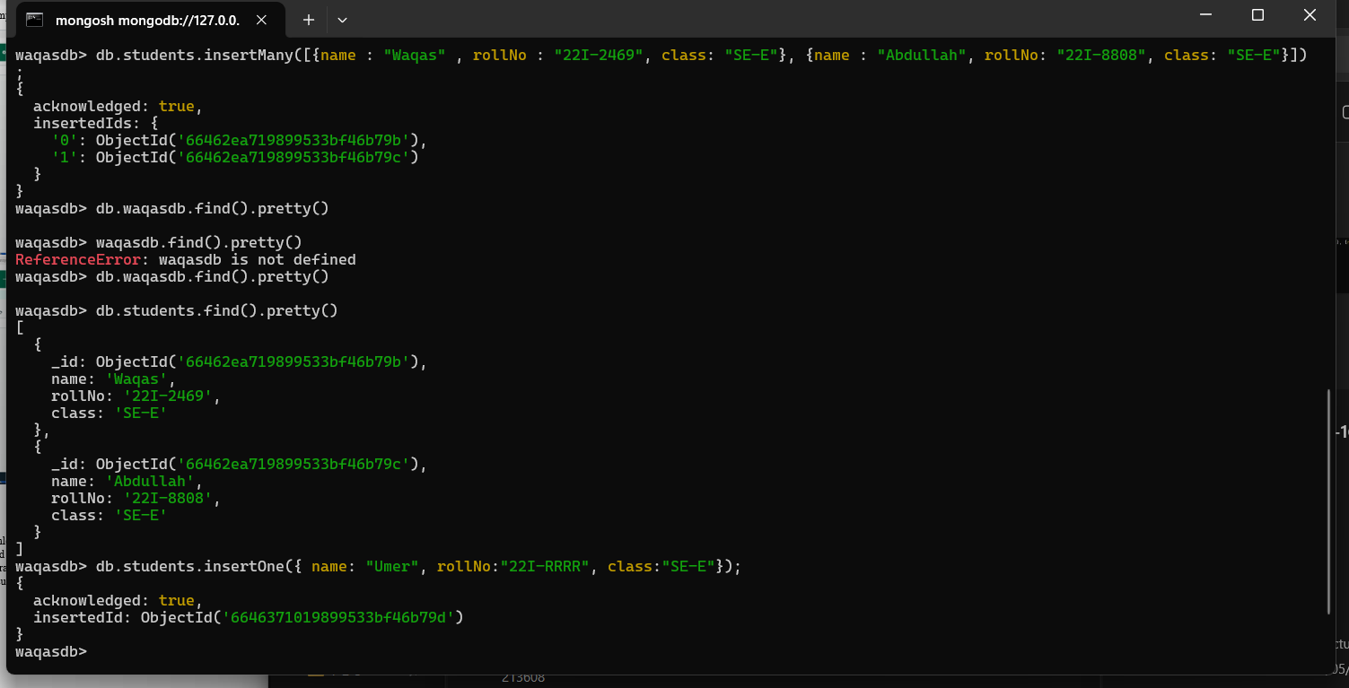

For Reading contents of collection (like select * from table in sql) we used db.students.find().pretty();

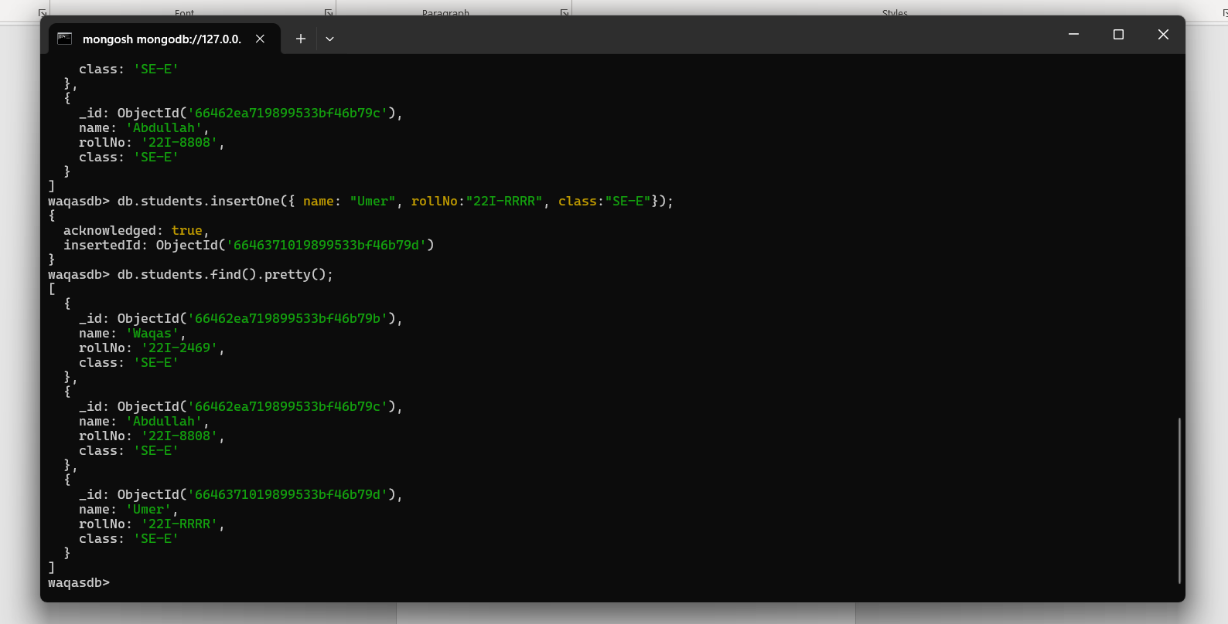

We updated the section of Waqas from SE-E to SE-Z using rollNo as tuple identifier.

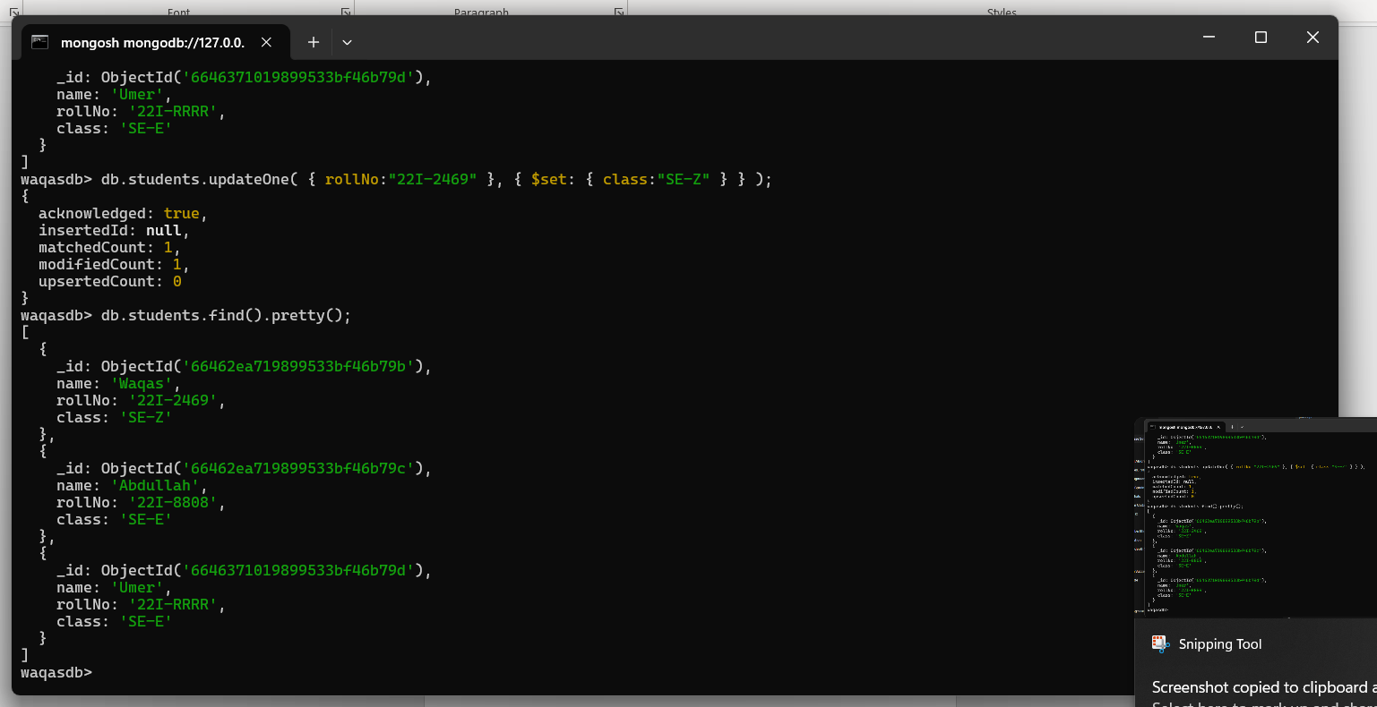

We deleted the tuple with the roll No 22I-RRRR

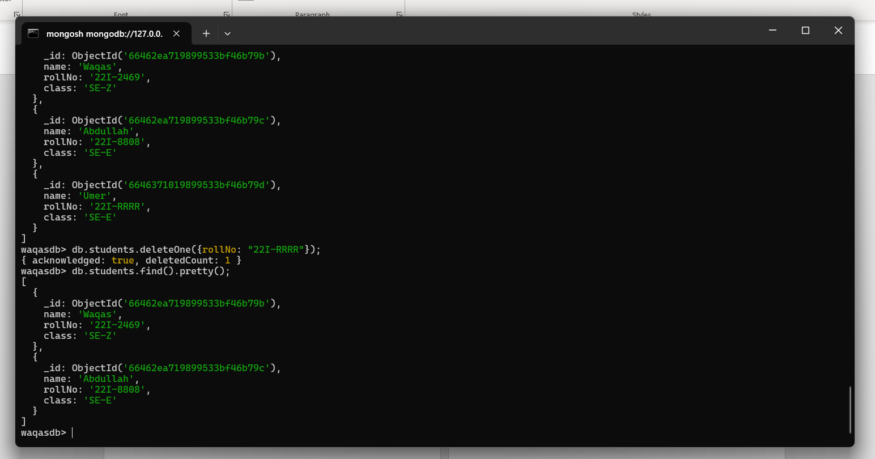

# Question 6

Create and Insert Commands. 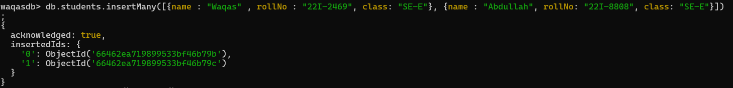

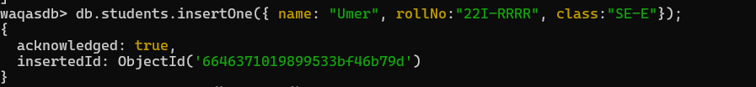

For reading.

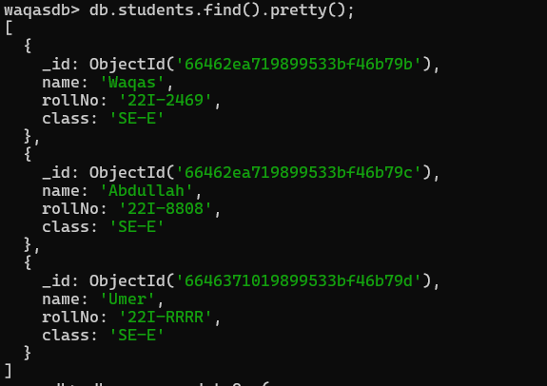

For Updating.

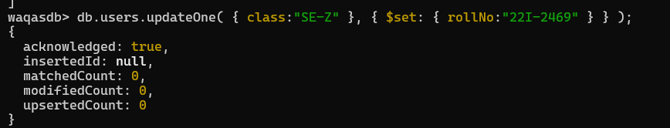

For Deleting.



# Question 7

The key learnings are:

* The databases in MongoDB are not relational.
* Instead of tables collections are used in MongoDB.
* The databases can be managed via cmd (mongo shell) or MongoDB compass.
* The syntax is easy to understand and learn.
* The CRUD operations have a little similarity to SSMS but have their differences.

# Question 8

Working in group allowed us to better understand and learn the concepts. We both explored things other than the lab task like MongoDB compass and various commands.