Efficiency and Accuracy of Few-Shot Learning Frameworks

1. Abstract
This document presents a pure performance comparison of various Few-Shot Learning (FSL) frameworks applied to hyperspectral crop signature classification. The objective is to evaluate the efficiency and accuracy of different combinations of FSL frameworks and backbone architectures.

2. Frameworks Evaluated
The evaluation was conducted across three state-of-the-art FSL frameworks:
- Prototypical Networks (ProtoNet): Metric-based FSL representing classes by average embeddings.
- Relation Networks (RelationNet): Metric-based FSL learning a non-linear similarity metric.
- Model-Agnostic Meta-Learning (MAML): Optimization-based FSL for fast adaptation.

3. Accuracy Comparison
The following graph and data summarize the final validation accuracies achieved after optimization.
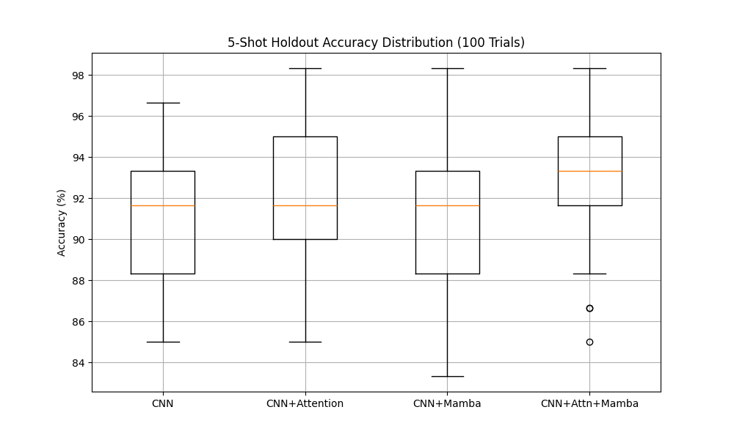
Figure 1: ProtoNet Accuracy
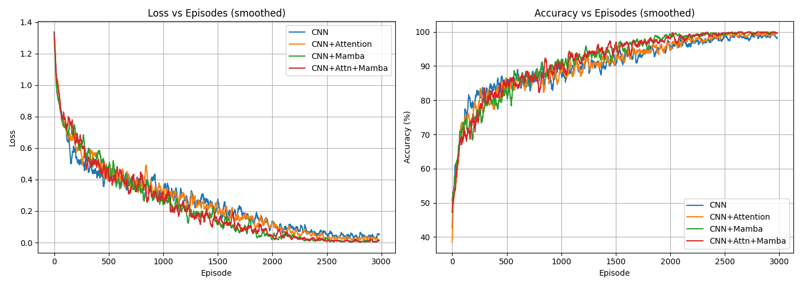
Figure 2: RelationNet Accuracy

4. Results Data
Architecture | Accuracy
ProtoNet + CNN+Mamba | 99.93%
RelationNet + CNN+Mamba | 99.79%
ProtoNet + CNN+Attn | 99.64%
RelationNet + CNN+Attn | 99.29%
MAML + CNN | ~50.00%

5. Key Findings
- Optimal Architecture: ProtoNet with CNN+Mamba achieved near-perfect accuracy (99.93%). Mamba's efficient state-space modeling handles sequential hyperspectral data exceptionally well.
- MAML Limitations: MAML suffered from second-order gradient explosion when paired with deep backbones like CNN+Mamba on this timeseries dataset, limiting accuracy to ~50%.

