Mailing Lists and Social Semantic Web
Sergio Fernández, Diego Berrueta, Lian Shi
Fundación CTIC
Parque Científico y Tecnológico, Cabueñes, Gijón, Spain
{sergio.fernandez, diego.berrueta, lian.shi}@fundacionctic.org

Jose E. Labra
Universidad de Oviedo, Department of Computer Science
Campus de los Catalanes, Oviedo, Spain
labra@uniovi.es

Patricia Ordóñez de Pablos
Universidad de Oviedo, Department of Business Administration
Avda. del Cristo, Oviedo, Spain
patriop@uniovi.es
ABSTRACT
Electronic Mailing lists are a key part of the Internet. They have enabled the development of social communities who share and exchange knowledge in specialized and general domains. In this chapter we describe methods to capture some of that knowledge which will enable the development of new datasets using semantic web technologies. In particular, we present the SWAML project, which collects data from mailing lists. We also describe smushing techniques that normalize RDF datasets capturing different resources that identify the same one. We have applied those techniques to identify persons through the mailing lists of open source communities. These techniques have been tested using a dataset automatically extracted from several online open source communities.
KEYWORDS
Mailing list, Semantic web, RDF, SPARQL, SIOC, FOAF, SWAML.
- INTRODUCTION
Early forms of electronic mailing lists were invented almost as soon as electronic Mail (e-Mail) and are a cornerstone of Internet, allowing a lot of people to keep up to date on news related with their interests. Besides direct messaging between individuals, mailing lists exist as private or public forums for information exchange in communities with shared interests. Mailing list archives are compilations of the previously posted messages that are often converted into static HTML pages for their publication on the web. They represent a noteworthy portion of the contents that are indexed by web search engines, and they capture an impressive body of knowledge that, however, is difficult to locate and browse.
The reason for this difficulty can be traced back to the translation procedure that is run to transform the e-mail messages into static HTML pages. This task is fulfilled by scripts that create static HTML pages for each message in the archive. In addition, some indexes (by date, by author, by thread) are generated and usually split by date ranges to avoid excessive growth.
On the one hand, this fixed structure reduces the flexibility when users explore the mailing list archives using their web browsers. On the other hand, most of the meta-data that were associated to each e-mail message are lost when the message is rendered as HTML for presentational purposes.
We propose to use an ontology and RDF (Resource Description Framework (Klyne 2004)) to publish the mailing list archives into the (Semantic) web, retaining the meta-data that were present in the messages. Additionally, by doing so, the information can be merged and linked to other vocabularies, such as FOAF (Brickley and Miller, 2005).
The rest of the chapter is organized as follows: in section 2 we describe the main developments of Social Semantic Web related with mailing lists. In section 3, we explain several techniques to collect RDF datasets from mailing lists. Section 4 contains a description of the SWAML project that collects those RDF datasets from mailing lists. In section 5, we describe several applications that consume that data. In section 6, we present some experiments that we have done over those datasets. Finally, in section 7 we present some conclusions and future work.
- SOCIAL SEMANTIC WEB
The semantic web vision tries to develop new ways to integrate and reuse the information published on the web. To that end, the W3c has developed several technologies, like RDF, which enable to add metadata descriptions that contain meaningful values and global properties to resources. The resulting metadata forms a graph model which can be easily composed with other graphs incrementing the knowledge represented by the original graph. Those values and properties formalize the knowledge of a particular. In 2004, the W3c consortium developed OWL (Patel-Schneider et al, 2004), a web ontology language which facilitates the definition of those formalizations, called ontologies. Based on description logics, OWL has been adopted as the standard ontology language with several available editors, reasoners and tools. There have been also a number of ontologies developed in OWL for different purposes and with different level of detail, from generic to domain-specific ones.
On the other hand, in the last years, the concept of Web 2.0 has attracted a lot of interest. One of the key aspects of Web 2.0 applications is the social part of the web. Users are not considered as mere consumers of information, but also as producers. People want to share knowledge, establish relationships, and even work together using web environments. It is necessary to develop people-oriented web technologies which can represent people interests and that enable the integration and reuse of people related information in the same way that the semantic web vision advocates. These technologies can be seen as social semantic web and we expect that there will be more and more applications making use of them.
One of the first developments is the FOAF vocabulary, which represents basic properties of people, like their name, homepage, etc. as well as the people they know. FOAF descriptions are very flexible and can be extended to other domains. There are already web portals which export their user profiles in FOAF format and the number of FOAF applications is increasing.
Given the distributed nature of RDF, it is expected that there will be different RDF datasets describing aspects of the same resources. The term smushing has been defined as the process of normalizing an RDF dataset in order to unify a priori different RDF resources which actually represent the same thing. The application which executes a data smushing process is called a smusher. The process comprises two stages:
First, redundant resources are identified; then, the dataset is updated to reflect the recently acquired knowledge. The latter is usually achieved by adding new triples to the model to relate the pairs of redundant resources. The OWL property owl:sameAs is often used for this purpose, although other properties without built-in logic interpretations can be used as well (e.g.: ex:hasSimilarName). Redundant resources can be spotted using a number of techniques. In this paper, we explore two of them: (1) using logic inference and (2) comparing labels.
Apart from FOAF, there are other ontologies related to the social semantic web. In particular, SIOC (Semantically-Interlinked Online Communities), provides a vocabulary to interconnect different discussion methods such as blogs, web-based forums and mailing lists (Breslin 2005, Breslin 2006). Although we will apply mainly SIOC to mailing-lists, it has a wider scope than just mailing lists, and generalizes all kinds of online discussion primitives in the more abstract sioc:Forum concept. Each forum represents an online community of people that communicate and share a common interest. The goal of SIOC is to interconnect these online communities.
Other relevant concepts of the ontology are sioc:User and sioc:Post, which model respectively the members of the communities and the content they produce. Instances of these three classes (forums, users and posts) can be linked together using several properties, as depicted in Figure 1.
The SIOC ontology was designed to express the information contained both explicitly and implicitly in Internet discussion methods. Several software applications, usually deployed as plug-ins, are already available to export SIOC data from some popular blogging platforms and content management systems. The effort, however, is focused on web-based communities (blogs, discussion forums), while little has been done so far to extend the coverage to legacy non-web communities, such as mailing lists and Usenet groups.
SIOC classes and properties are defined in OWL, and their instances can be expressed in RDF. Therefore, they can be easily linked to other ontologies. The obvious choice here is FOAF, which provides powerful means to describe the personal data of the members of a community.
Mailing lists can be easily described by instantiation of the SIOC classes and properties. Each mailing list can be represented by an instance of sioc:Forum (a subclass of Forum might be used instead, although it is not required). Messages sent to the list and their replies become instances of sioc:Post.
Finally, people involved into the list are instances of sioc:User. The SIOC ontology provides a property to link forums and users, namely sioc:has_subscriber. We argue that being subscribed to a mailing list is just one of the roles a user can play with respect to a forum. Moreover, the list of subscribers is often available only to the system administrator for privacy reasons. On the other hand, it is easy to collect the set of people who post to the list, i.e., the people actively involved in the forum. Depending on the settings, the latter may be a subset of the former, in particular in those mailing lists that forbid posting privileges to non-subscribers. Ideally, these two different semantics would be captured using new properties. However, for practical reasons, and to avoid privacy issues, we consider just the already existent sioc:has_subscriber property, and we populate it with the set of active members of a forum. Consequently, inactive members of the forum remain hidden, but this does not represent a problem due to the open world assumption.
Additionally, the Dublin Core (Dublin Core Metadata Element Set, Version 1.1, 2006) and Dublin Core Terms vocabularies are used to capture meta-data such as the message date (dcterms:created) and title (dc:title).
- COLLECTING DATA INTO THE SOCIAL SEMANTIC WEB
Since SIOC is a recent specification, its adoption is still low, and only a few sites export SIOC data. There exist a number of techniques that can be used to bootstrap a network of semantic descriptions from current social web sites. We classify them in two main categories: intrusive and non-intrusive techniques.
On the one hand, methods which require direct access to the underlying database behind the social web site are intrusive techniques. The web application acts as the controller and publishes different views of the model in formats such as HTML and RSS. In terms of this pattern, publishing SIOC data is as simple as adding a new view. From a functional point of view, this is the most powerful scenario, because it allows a lossless publication due to the direct access to the back-end database. The SIOC community has contributed a number of plugins for some popular web community-building applications, such as Drupal, WordPress and PhpBB2. Mailing lists are also covered by SWAML, which is described in the next section. There is, however, a major blocker for this approach. All these software components need a deployment in the server side (where the database is). This is a burden for system administrators, who are often unwilling to make a move that would make it more difficult to maintain, keep secure and upgrade their systems. This is particularly true when there is no obvious immediate benefit of exporting SIOC data.
On the other hand, methods which do not require direct access to the database and can operate on resources already published on the web are non-intrusive. One technique is the use of cooked HTML views of the information, the same ones that are rendered by web browsers for human consumption. An example could be RSS/Atom feeds, which have become very popular in the recent years. They can be easily translated into SIOC instances using XSLT stylesheets (for XML-based feeds) or SPARQL queries (for RSS 1.0, which is actually RDF). Unfortunately, these feeds often contain just partial descriptions. Another technique is the use of public APIs. The Web 2.0 trend has pushed some social web sites to export (part of) their functionality through APIs in order to enable their consumption by third-party mash-ups and applications. Where available, these APIs offer an excellent opportunity to create RDF views of the data. A shared aspect of these sources is their ubiquitous availability through web protocols and languages, such as HTTP and XML. Therefore, they can be consumed anywhere, and thus system administrators are freed of taking care of any additional deployment. In contrast, they cannot compete with the intrusive approaches in terms of information quality, as their access to the data is not primary.
- SWAML Project
SWAML (Fernández et al, 2007) is a Python script that reads mailing list archives in raw format, typically stored in a “mailbox” (or “mbox”), as defined in RFC 4155 (Hall 2005). It parses mailboxes and outputs RDF descriptions of the messages, mailing lists and users as instances of the SIOC ontology. Internally, it re-constructs the structure of the conversations in a tree structure, and it exploits this structure to produce links between the posts. This script is highly configurable and non-interactive, and has been designed to be invoked by the system task scheduler. This low-coupling with the software that runs the mailing list eases its portability and deployment.
SWAML could be classified as an intrusive technique because it requires access to the primary data source, even if in this case it is not a relational database but a text file. Anyway, it is worth mentioning that some servers publish these text files (mailboxes) through HTTP. Therefore, sometimes it is possible to retrieve the mailbox and build a perfect replica of the primary database in another box. In such cases, SWAML can be used without the participation of the system administration of the original web server.
There are many ways in which a mailing list message might be related with other messages. However, we consider just two scenarios. The first one links a post with its replies (sioc:has_reply). Actually, due to sequential layout of the messages in the most widely used format to store mailing list archives (mailbox), it is easier to generate the inverse property (sioc:reply_of). Anyway, the has_reply property can be generated either by a description logics reasoner or by performing two passes over the sequence.
The second link among messages is established between a post and its immediate successor (or predecessor) in chronological order. It is worth to note that this link is not strictly necessary, because the following (or preceding) message can be obtained by sorting by date the sequence of posts. However, this is a rather expensive operation, because the whole set of posts is required in order to perform the sorting. The open world assumption makes this query even more challenging. Therefore, considering that browsing to the previous or next message is a common use case, and the complete set of posts can be very large or even unavailable, we introduced two new properties, next_by_date and prev_by_date. These properties where eventually accepted into the SIOC ontology. An RDF representation of a sample message is shown in Figure 2.
<rdf:RDF
xmlns:dcterms='http://purl.org/dc/terms/'
xmlns:sioc='http://rdfs.org/sioc/ns#'
xmlns:rdf='http://www.w3.org/1999/02/22-rdf-syntax-ns#'
xmlns:dc='http://purl.org/dc/elements/1.1/'
xml:base='http://example.org/swaml-devel/'>
<sioc:Post rdf:about="2006-Sep/post-52">
<dc:title>Re: [swaml-devel] Changing SWAML ontology</dc:title>
<sioc:has_creator rdf:resource="subscriber/s10"/>
<dcterms:created>Wed, 6 Sep 2006 20:14:44 +0200</dcterms:created>
<sioc:content><!-- ommitted --></sioc:content>
<sioc:has_reply rdf:resource="2006-Sep/post-69"/>
<sioc:previous_by_date rdf:resource="2006-Sep/post-51"/>
<sioc:next_by_date rdf:resource="2006-Sep/post-53"/>
</sioc:Post>
</rdf:RDF>
Figure 1. SIOC Post example in RDF/XML
SWAML is essentially a mailbox parser and translator implemented in Python. Its output is a number of SIOC instances (Forum, Posts and Users) in a set of RDF files. SWAML is a highly configurable, non-interactive application designed to be invoked by the system task scheduler.
Parsing the mailbox and rebuilding the discussion threads may be sometimes tricky. Although each mail message has a supposedly unique identifier in its header, the Message-ID, defined by RFC 2822 (Resnick, 2001), in practice its uniqueness cannot be taken for granted. Actually, we have found some messages with repeated identifiers in some mailing lists, probably due to non-RFC compliant or ill-configured mail transport agents. Therefore, SWAML assumes that any reference to a message (such as those created by the In-Reply-To header) is in fact a reference to the most recent message with that ID in the mailbox (obviously, only previous messages are considered). Using this rule of thumb, SWAML builds an in-memory tree representation of the conversation threads, so sioc:Posts can be properly linked.
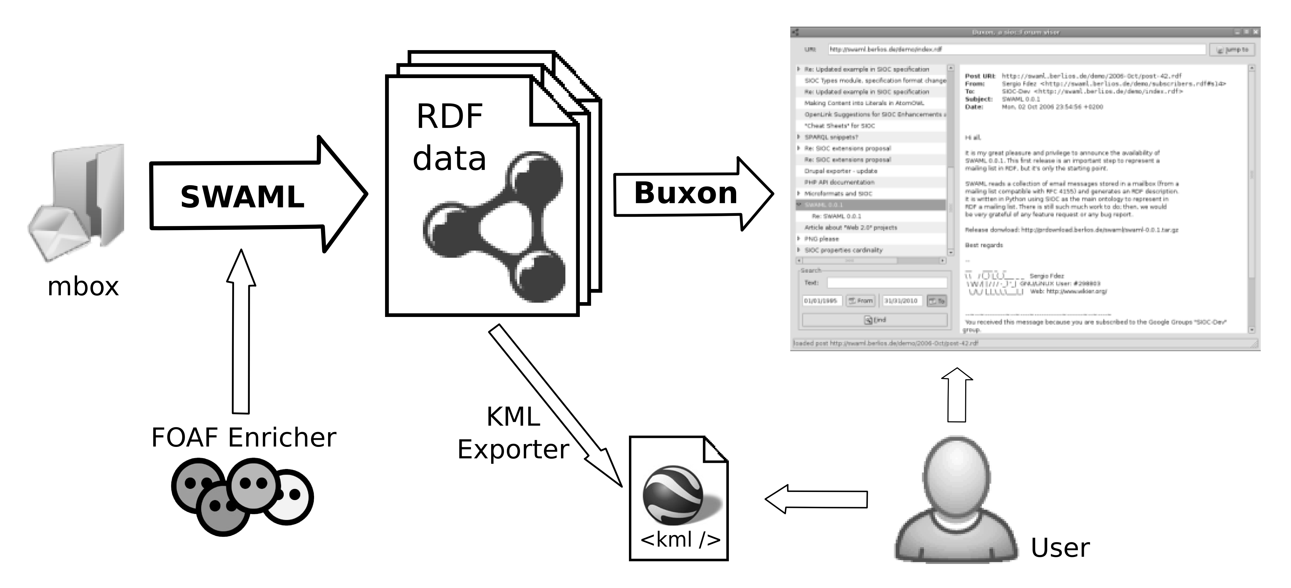
Figure 2. Buxon is an end-user application that consumes sioc:Forum instances, which in turn can be generated from mailboxes using SWAML.
Actually, SWAML goes further than just a format-translation tool. A dedicated subroutine that runs as part of the batch execution but may be also separately invoked on any sioc:Forum, tries to find a FOAF description for each sioc:User. To the best of our knowledge, there is not any wide-scope web service to fetch FOAF descriptions from a given e-mail address, so we mocked it. Some of the authors of this paper are also currently working on a functional implementation of such a service as part of a different project.
One important requirement of the semantic web is to be an extension (and not a replacement) of the current document-based web. Ideally, each user agent must be able to retrieve the information in their format of choice. For instance, current web browsers prefer (X)HTML documents, because they can be rendered and presented to the end user. However, semantic web agents require information to be available in a serialized RDF format, such as RDF/XML or N3. Furthermore, different representations of the same information resource should share a unique URI. Fortunately, the HTTP protocol supports this feature by using “content-negotiation”. Clients of the protocol can declare their preferred formats in the headers of an HTTP request using the Accept header. Web servers will deliver the information in the most suited available format, using the Content-type header of the HTTP response to specify the actual format of the returned delivered content. MIME types such as text/html and application/rdf+xml are used as identifiers of the requested and available formats.
Setting up the content negotiation in the server-side usually requires some tuning of the web server configuration. It also depends on some choices made by the publisher of the information, such as the namespace scheme for the URIs or the fragmentation of the information. In (Miles et al, 2006) there is a list of some common scenarios, which are described to great detail, and configuration examples for the Apache web server are provided. The most suitable scenarios (or recipes, as they are called) to publish mailing list metadata are the fifth and sixth, i.e., multiple documents available both in HTML and RDF.
The fifth scenario is extensively described in the referred source, and it has been implemented in SWAML. At the same time RDF and HTML files are written, SWAML also produces htaccess local configuration files for Apache. One of these configuration file is shown in Figure 5, while a sample request/response negotiation is depicted in Figure 4.
RewriteEngine On
RewriteBase /demos/swaml-devel/
AddType application/rdf+xml .rdf
Options -MultiViews

RewriteCond %{HTTP_ACCEPT} text/html [OR]
RewriteCond %{HTTP_ACCEPT} application/xhtml\+xml [OR]
RewriteCond %{HTTP_USER_AGENT} ^Mozilla/.*
RewriteRule ^/([0-9]{4})-([A-Za-z]+)/post-([0-9]+)$
$1-$2/post-$3.xhtml [R=303]

RewriteCond %{HTTP_ACCEPT} application/rdf\+xml
RewriteRule ^/([0-9]{4})-([A-Za-z]+)/post-([0-9]+)$
$1-$2/post-$3.rdf [R=303]
Figure 4: A sample htaccess configuration file for Apache generated by SWAML. These two rules redirect the request to the proper file based on the content negotiation field of the HTTP request. Some lines have been wrapped for readability.
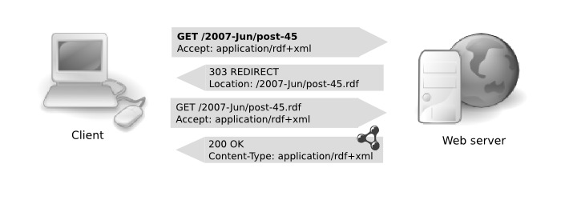
Figure 3: An HTTP dialog with content negotiation

RDF metadata generated by SWAML can grow to a large size for lists with a high traffic and several years of operation, where there are tens of thousands of messages. The partition of the information might be an issue in such cases. On the one hand, information chunks are preferred to be small so any conceivable use case can be satisfied without retrieving a significant overload of unneeded information. However, scattering the metadata across a myriad of small files has some disadvantages. For instance, the number of resources that must be retrieved to fulfill a single query is greatly increased. Therefore, storing the RDF graph in a specialized database is an appealing alternative.
Fortunately, a common protocol to access semantic repositories using SPARQL as the query language is available (Clark 2006) and is gaining support by the RDF databases. This protocol exposes a simple API to execute and retrieve the results of SPARQL queries (at the present moment, SPARQL is a read-only query language, although there are proposals to extend it with full CRUD capabilities such as those of SQL). This abstract query API may be realized by different means, such as SOAP bindings (described by a WSDL 2.0 interface) and HTTP bindings. The former enables interoperability with web service frameworks, while the latter can be exploited without the full-blown web service machinery.
Web service endpoints which implement the SPARQL protocol are sprouting on the web, some of them pouring huge amounts of data into the semantic web. We argue that metadata of large mailing lists can be conveniently exposed as SPARQL endpoints. That means to effectively translate the decision on data selection to the client (Pan 2006), and therefore minimizing the number of requests and the data overload. For instance, the client agent can retrieve all the headers of the messages in a given date range, but skip the body of the messages, saving a considerable amount of bandwidth.
RewriteEngine On
RewriteBase /lists/archives

RewriteCond %{HTTP_ACCEPT} application/rdf\+xml
RewriteRule ^mylist/(.+)
http://internal-server/sesame-server/repositories/mylist-rep/
?query=CONSTRUCT+{<http://example.org/lists/mylist/$1>+?y+?z}
+WHERE+{<http://example.org/lists/mylist/$1>+?y+?z}
&queryLn=sparql [R=303]
Figure 5: Sample Apache web server rewrite rule to translate HTTP request into SPARQL queries using a Sesame RDF repository. The last line has been wrapped for readability.
However, non SPARQL-aware agents still need to access the information. This is the scenario of the sixth scenario (recipe) of the above cited document, but unfortunately this one is still being discussed. We propose a simple solution based on URL rewriting of the requests in order to translate conventional HTTP requests for resources into SPARQL queries that dynamically generate an RDF subgraph that contains the requested information about the resource. The rewriting mechanism, the SPARQL query and even the presence of a data repository instead of static files is kept completely hidden to the client. At the same time, by avoiding the undesirable data replication, this technique helps to keep the information consistent. The most representative feature of our proposal is that it does not require any kind of server side script or application to translate the queries, because the data repository can serve the information directly in the format desired by the client.
We have implemented this technique using the Apache web server and Sesame 2.0beta RDF repository (Broekstra et al, 2002). Figure 6 reproduces the hand-made htaccess file (as opposed to the ones that are automatically produced by SWAML). Unfortunately, Sesame still lacks support for the DESCRIBE sentence of SPARQL, so we use CONSTRUCT instead. Of course, the rewrite rule must be fired only when RDF data is requested, while requests for HTML must go through it.
We note, however, that our proposal presents some security-related issues. In particular, it is easily vulnerable to SPARQL-injection. Therefore, we strongly discourage the use of this technique in production environments. Nevertheless, some changes in the regular expressions are possible in order to prevent this kind of attack.
<html xmlns='http://www.w3.org/1999/xhtml'
xmlns:dcterms='http://purl.org/dc/terms/'
xmlns:sioc='http://rdfs.org/sioc/ns#'
xmlns:dc='http://purl.org/dc/elements/1.1/'>
<head profile='http://www.w3.org/2003/g/data-view'>
<link href='http://www-sop.inria.fr/acacia/soft/RDFa2RDFXML.xsl'
rel='transformation' />
<title>[swaml-devel] CfP: FEWS2007</title>
</head>
<body>
<div about='http://example.org/swaml/post/2007-May/5'
class='sioc:Post'>
<h1 property='dc:title'>[swaml-devel] CfP: FEWS2007</h1>
<p>strong>From: </strong>
<a href='http://example.org/swaml/subscriber/s2'
rel='sioc:has_creator'>Diego Berrueta</a>
</p>
<p><strong>To: </strong>
<a href='http://example.org/swaml/forum'
rel='sioc:has_container'>SWAML Devel</a>
</p>
<p><strong>Date: </strong>
<span property='dcterms:created'>
Tue, 15 May 2007 19:24:49
</span>
</p>
<pre property='sioc:content'><!-- omitted --></pre>
<p>Previous by Date:
<a href='http://example.org/swaml/post/2006-Sep/4'
rel='sioc:previous_by_date'>previous</a>
</p>
<p>Next by Date:
<a href='http://example.org/swaml/post/2007-Mar/6'
rel='sioc:next_by_date'>next</a>
</p>
</div>
</body>
</html>
Figure 6: A single message rendered as XHTML code with RDFa and GRDDL markup by SWAML.
There is another different approach to publishing metadata: to embed it into the HTML content. W3C is pushing two complementary technologies, RDFa (Adida & Birbeck, 2007) and GRDDL (Connolly, 2007), which respectively encode into, and extract RDF data from XHTML documents. We have also explored this path. SWAML generates simple XHTML pages for each message to illustrate the usage of both RDFa and GRDDL in their current development versions. We must remark that these pages are just a proof-of-concept of the semantic enrichment, and they lack many of the fancy features and complex templates of the already-existent applications which generate plain HTML.
- CONSUMING MAILING LIST METADATA
5.1 Buxon
Buxon is a multi-platform desktop application written in PyGTK. It allows end users to browse the archives of mailing lists as if they were using their desktop mail application. Buxon takes the URI of a sioc:Forum instance (for example, a mailing list exported by SWAML, although any sioc:Forum instance is accepted) and fetches the data, retrieving additional files if necessary. Then, it rebuilds the conversation structure and displays the familiar message thread list (see Figure 7).
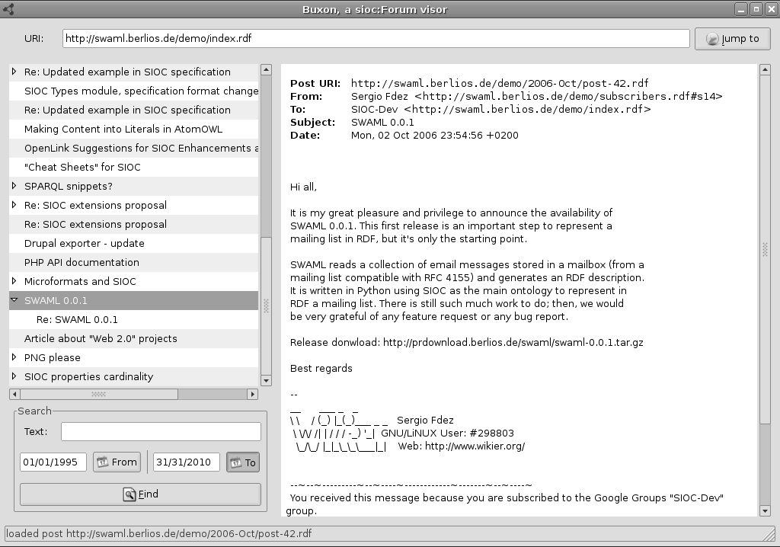Figure 7. Buxon browsing SIOC-Dev mailing list.
Buxon also gives users the ability to query the messages, searching for terms or filtering the messages in a date range. All these queries are internally translated to SPARQL (Prud'hommeaux & Seaborne, 2007) to be executed over the RDF graph. Newer versions of Buxon can send the sioc:Forum URI to PingTheSemanticWeb.com, a social web service that tracks semantic web documents. That way, Buxon contributes to establish an infrastructure that lets people easily create, find and publish RDF documents.
5.2 Other browsers and clients
The SIOC RDF data can be explored and queried using any generic RDF browser, such as Tabulator (Berners-Lee et al., 2006). The most interesting applications appear when instances of sioc:User are linked to FOAF descriptions of these users. For instance, it is trivial to write a query to obtain the geographical coordinates of members of a mailing list and to codify them into a KML file (Ricket 2006), provided they describe their location in their FOAF file using the basic geo vocabulary (Brickley 2006). The KML file can be plotted using a map web service such as Google Maps (Figure 8).
It is also possible execute visualize the messages in a time line view using the Timeline DHTML widget by the MIT SIMILE project using a query like the one we propose in Figure 9.
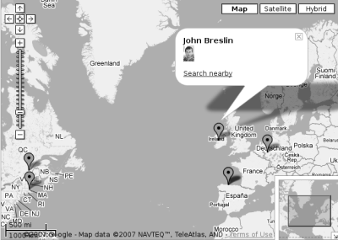
Figure 8. Plotting the geographical coordinates of the members of a mailing list using KML and Google Maps.
- Experimentation
PREFIX sioc: <http://rdfs.org/sioc/ns#>
PREFIX rdf: <http://www.w3.org/1999/02/22-rdf-syntax-ns#>
PREFIX dcterms: <http://purl.org/dc/terms/>
PREFIX dc: <http://purl.org/dc/elements/1.1/>
SELECT ?start ?title ?description ?link
WHERE {
?post rdf:type sioc:Post .
?post dcterms:created ?start .
?post dc:title ?title .
?post sioc:link ?link .
?post sioc:content ?description
}
Figure 9. SPARQL query to extract the information required to visualize a time line of the messages posted to any sioc:Forum instance.
A corpus of RDF data with many foaf:Person instances was assembled by crawling and scrapping five online communities. There is a shared topic in these communities, namely open source development, hence we expect them to have a significant number of people in common. We continue the work started in Berrueta et al (2007) to mine online discussion communities, and we extend it to new information sources. We use the following sources:
- GNOME Desktop mailings lists: all the authors of messages in four mailing lists (evolution-hackers, gnome-accessibility-devel, gtk-devel and xml) within the date range July 1998 to June 2008 were exported to RDF using SWAML.
- Debian mailing lists: all the authors of messages in four mailing lists (debian-devel, debian-gtk-gnome, debian-java and debian-user) during years 2005 and 2006 were scrapped from the HTML versions of the archives with a set of XSLT style sheets to produce RDF triples.
- Advogato: this community exports its data as FOAF files. We used an RDF crawler starting at Miguel de Icaza's prole. Although Advogato claims to have +13,000 registered users, only +4,000 were found by the crawler.
- Ohloh: the RDFohloh4 project exposes the information from this directory of open source projects and developers as Linked Data. Due to API usage restrictions, we could only get data about the +12,000 oldest user accounts.
- Debian packages: descriptions of Debian packages maintainers were extracted from apt database of Debian packages in the main section of the unstable distribution.
Instances generated from these data sources were assigned a URI in a different namespace for each source. Some of these data sources do not directly produce instances of foaf:Person, but just instances of sioc:User. An assumption is made that there is a foaf:Person instance for each sioc:User, with the same e-mail address and name. These instances were automatically created when missing. This assumption obviously leads to redundant instances of foaf:Person which will be later detected by the smusher.
The ultimate goal of our experiments is to exercise the smushing processes described previously against a realistic dataset. Two million RDF triples were extracted from the sources described above, and put into OpenLink Virtuoso server which provides not only an effective triple store, but also a SPARQL endpoint that was used to execute queries using scripts.
We evaluated two smushers: the first one smushed foaf:Person instances assuming that foaf:mbox sha1sum is an IFP; the second one smushed the same instances comparing their foaf:name labels for string strict equality, without any normalization. Both smushers were implemented using SPARQL CONSTRUCT rules. The newly created owl:sameAs triples were put in different named graphs. These links were analyzed to find co-occurrences of people in different communities. The absolute co-occurrence figures are presented in Tables 2 and 3, respectively. Later, the two named graphs were aggregated. Table 4 contains the absolute co-occurrence considering the combined results of both smushers.
Some communities use the e-mail address as their primary key to identify its users. However, other communities use a different primary key, thus allowing users to repeat their e-mail addresses. For instance, a small number of users have registered more than one account in Advogato with the same e-mail (these accounts have been manually reviewed, and they seem to be accounts created for testing purposes).
Our data acquisition process introduces a key difference between how user accounts are interpreted in Debian mailing lists and GNOME mailing lists. The former considers e-mail address as globally unique, i.e., the same e-mail address posting in different Debian mailing lists is assumed to belong to the same user.
On the other hand, a more strict interpretation of how Mailman works is made with respect to the GNOME mailing lists, where identical e-mail address posting in different mailing lists are assumed to belong to a priori different users. In the second case, we rely on the smushing process to merge the identities of these users.
Although they must be handled with extreme care due to the issues afore-mentioned, the combined results of the two smushing processes are consistent with the expected ones. For instance, there is a very high overlap between the Debian developers (maintainers of Debian packages) and the Debian mailing lists. Obviously, Debian developers are a relatively small group at the core of the Debian community, thus they are very active in its mailing lists. Another example is the overlap between Advogato and GNOME mailing lists. Advogato is a reputation-based social web site that blossomed at the same time that the GNOME project was gaining momentum. Advogato was passionately embraced by the GNOME developers, who used Advogato to rate each others' development abilities.
We also studied whether there are some people that are present in many of the communities at the same time. We chose communities which are closely related to each other, consequently, we expected a high number of cross-community subscribers. There are several people who are present in many communities. We can conclude that almost all the most active open source developers in our dataset are core members of the Debian community. Another interesting fact is that only a few people among the top members of the communities consistently use a single e-mail address and just one variant of their names. This fact proves the difficulty of the smushing process, but also its usefulness.
- Conclusions and future work
There is a lot of ongoing effort to translate data already reachable on the web into formats which are semantic web-friendly. Most of that work focuses on relational databases, micro-formats and web services. However, at the time of this writing and to the best of our knowledge, e-mail was almost excluded from the Semantic Web. Our project, in combination with the generic SIOC framework, fills this gap, conveniently providing an ontology and a parser to publish machine-readable versions of the archives of the countless mailing lists that exist on the Internet.
Furthermore, the SWAML project fulfills a much-needed requirement for the Semantic Web: to be able to refer to semantic versions of e-mail messages and their properties using resource URIs. By re-using the SIOC vocabulary for describing online discussions, SWAML allows any semantic web document (in particular, SIOC documents) to refer to e-mail messages from other discussions taking place on forums, blogs, etc., so that distributed conversations can occur across these discussion media. Also, by providing e-mail messages in RDF format, SWAML is providing a rich source of data, namely mailing lists, for use in SIOC applications.
The availability of these data leads to some benefits. In the first place, data can be fetched by user applications to provide handy browsing through the archives of the mailing lists, providing features that exceed what is now offered by static HTML versions of the archives on the web.
Secondly, the crawlers of the web search engines can use the enhanced expressivity of the RDF data to refine search results. For instance, precise semantic descriptions of the messages permit to filter out repeated messages, advance in the fight against spam, or introduce additional filter criteria in the search forms.
Another consequence of no lesser importance is that each e-mail message is assigned a URI that can be resolved to a machine-readable description of the message. This actually makes possible to link a message like any other web resource, and therefore enriches the expressivity of the web.
Integration of the SWAML process with popular HTML-based mailing list archivers, such as Hypermail or Pipermail, would be a giant push to speed up the adoption of SWAML. It is well known that one of the most awkward problems of any new technology is to gain a critical mass of users. The semantic web is not an exception. A good recipe to tackle this problem is to integrate the new technology into old tools, making a smooth transition without requiring any extra effort from users. Merging the SWAML process into the batch flow of tools such as Hypermail would allow users to generate both RDF and production-quality, semantically enriched HTML versions of the archives.
So far, no semantic annotation relative to the meaning of the messages is considered. Obviously, such information can not be automatically derived from a RFC 4155-compliant mailbox. However, it is conceivable that it could be added by other means, such as social tagging using folksonomies, or parsing the metadata added by the authors of the messages using micro-formats or RDFa when posting in XHTML format. The inherent community-based nature of mailing lists can be exploited to build recommendation systems (Celma 2006).
We have also explored smushing techniques to spot redundant RDF instances in large datasets. We have tested these techniques with more than 36,000 instances of foaf:Person in a dataset automatically extracted from different online open source communities. We have used only public data sources, consequently, these instances lack detailed personal information.
We are aware of the extreme simplicity of our experimentation using label comparison. In our opinion, however, it contributes to show the potential of this smushing technique. We note that it is possible to have more usages for it, for instance, smushing not just by people's names, but also by their publications, their organizations, etc. Surprisingly, the named-based smushing finds a high number of redundant resources even if the comparison strategy for labels (names) is very simplistic (in this case, case-sensitive string equality comparison). More intelligent comparison functions should lead to a higher recall. In this direction, we are evaluating some normalization functions for names. We have also evaluated classical information retrieval comparison functions that take into account the similarity of the strings (e.g., Levenshtein); nevertheless, their applicability to compare people's names is open to discussion.
We believe that the ratio of smushing can be further improved if the dataset is enriched with more detailed descriptions about people. Experiments are being carried out to retrieve additional RDF data from semantic web search engines as a previous step to smushing.
We have implemented a smusher application for persons, and we intend to use it to further investigate the potential for the optimization of the smushing process. The way in which these techniques are translated into actual algorithms is critical to achieve a promising performance of the smushing process, especially for very large datasets. In parallel, increasing the precision of smushing will require to study how to enable different smushing strategies to interrelate and reciprocally collaborate.
ACKNOWLEDGEMENTS
The authors would like to express their gratitude to Dr. John Breslin and Uldis Bojārs from DERI Galway, whose support and contributions have been of great help to this project. Also thanks to Ignacio Barrientos for his contribution packaging the project for Debian GNU/Linux.
REFERENCES
Adida, B. & Birbeck, M (2007). RDFa Primer 1.0, Technical report, W3C Working Draft.
D. Berrueta, S. Fernández, and L. Shi (2007). Bootstrapping the Semantic Web of Social Online Communities. In Proceedings of workshop on Social Web Search and Mining (SWSM2008), co-located with WWW2008, Beijing, China.
Berners-Lee, T. et al, (2006). Tabulator: Exploring and Analyzing linked data on the Semantic Web. Proceedings of the 3rd International Semantic Web User Interaction Workshop (SWUI06) workshop, Athens, Georgia.
Bojārs, U. & Breslin, J. (2007). SIOC Core Ontology Specification. Available at http://rdfs.org/sioc/spec/.
Breslin, J. et al (2006). SIOC: an approach to connect web-based communities. International Journal of Web Based Communities, Vol. 2, No. 2, pp 133-142.
Breslin, J. et al (2005). Towards Semantically-Interlinked Online Communities. Proceedings of the 2nd European Semantic Web Conference, ESWC 2005, Heraklion, Crete, Greece.
Brickley, D., (2006). Basic geo (WGS84 lat/long) vocabulary, Technical report, W3C Informal Note.
Brickley, D. & Miller, L. (2005). FOAF Vocabulary Specification, Technical report.
Broekstra, J. et al (2002) Sesame: A generic architecture for storing and querying RDF and RDF Schema. In Springer Lecture Notes in Computer Science, Vol. 2342, pp. 54–68.
Celma, O. (2006). FOAFing the music: Bridging the semantic gap in music recommendation. Proceedings of the 5th International Semantic Web Conference, Athens, USA.
Clark, K. G. (2006). SPARQL protocol for RDF, Technical report, W3C Candidate Recommendation.
Connolly, D. (2007). Gleaning Resource Descriptions from Dialects of Languages (GRDDL), Technical report, W3C Candidate Recommendation.
S. Fernández, D. Berrueta, and J. E. Labra (2007). Mailing lists meet the semantic web. In BIS 2007 Workshop on Social Aspects of the Web, 2007.
Hall, E. (2005). RFC 4155 - the application/mbox media type, Technical report, The Internet Society.
Klyne, G. and Carroll, J. J. (2004). Resource Description Framework (RDF): Concepts and abstract syntax, Technical report, W3C Recommendation.
Miles, A. et al, (2006). Best practice recipes for publishing RDF vocabularies, Technical report, W3C Working Draft.
Pan, Z. et al (2006). An investigation into the feasibility of the semantic web, Technical Report LU-CSE-06-025, Dept. of Computer Science and Engineering, Lehigh University.
P. F. Patel-Schneider, P. Hayes, and I. Horrocks, (2004) OWL Web Ontology Language: Semantics and Abstract Syntax. Recommendation, W3C, February
Prud'hommeaux, E. and Seaborne, A. (2007). SPARQL Query Language for RDF, Technical report, W3C Candidate recommendation.
Resnick, P. (2001). RFC 2822 - internet message format, Technical report, The Internet Society.
Ricket, D. (2006). Google Maps and Google Earth integration using KML, in American Geophysical Union 2006 Fall Meeting.

