A semantic web approach to publish and consume mailing lists
Sergio Fernández
Fundación CTIC
Parque Científico y Tecnológico, Cabueñes, Gijón, Spain
sergio.fernandez@fundacionctic.org

Diego Berrueta
Fundación CTIC
Parque Científico y Tecnológico, Cabueñes, Gijón, Spain
diego.berrueta@fundacionctic.org

Jose E. Labra
Universidad de Oviedo, Computer Science Department
Campus de los Catalanes, Oviedo, Spain
labra@uniovi.es
ABSTRACT
Mailing list archives (i.e., the compilation of the messages posted up-to-now) are often published on the web and indexed by conventional search engines. They store a vast knowledge capital. Unfortunately, the ability to automatically recognize and process the information is mostly lost at publishing time. As a result, the mailing list archives currently available on the web are difficult to query and have a limited use. This paper describes an usage of the Semantic Web technologies in order to avoid the information loss and to allow new applications to exploit the information in a more powerful way.
KEYWORDS
Mailing list, Semantic web, RDF, SPARQL, SIOC, FOAF, SWAML.
- INTRODUCTION
Electronic mail (e-mail) remains one of the most popular applications of the Internet. Besides direct messaging between individuals, mailing lists exist as private or public forums for information exchange in communities with shared interests. Mailing list archives are compilations of the previously posted messages that are often converted into static HTML pages for their publication on the web. They represent a noteworthy portion of the contents that are indexed by web search engines, and they capture an impressive body of knowledge that, however, is difficult to locate and browse.
The root of these problems can be traced back to the translation procedure that is run to transform the e-mail messages into static HTML pages. This task is fulfilled by scripts that create static HTML pages for each message in the archive. In addition, some indexes (by date, by author, by thread) are generated and usually split by date ranges to avoid excessive growth.
On the one hand, this fixed structure reduces the flexibility when users explore the mailing list archives using their web browsers. On the other hand, most of the meta-data that were associated to each e-mail message are lost when the message is rendered as HTML for presentational purposes.
We propose to use an ontology and RDF (Resource Description Framework (Klyne 2004)) to publish the mailing list archives into the (Semantic) web, retaining the meta-data that were present in the messages. Additionally, by doing so, the information can be merged and linked to other vocabularies, such as FOAF (Brickley and Miller, 2005).
The rest of the article is organized as follows: Section 2 introduces the SIOC ontology and how it can be used to describe mailing lists and messages. Section 3 describes the alternatives from the mailing list publisher's point of view, and we present an application (SWAML) which translates mailboxes into RDF graphs. In Section 4 we tackle the challenges and introduce the opportunities from the other side, the perspective of the consumer of the information. We close the paper with the conclusions and a discussion on future plans in Section 5.
- SIOC
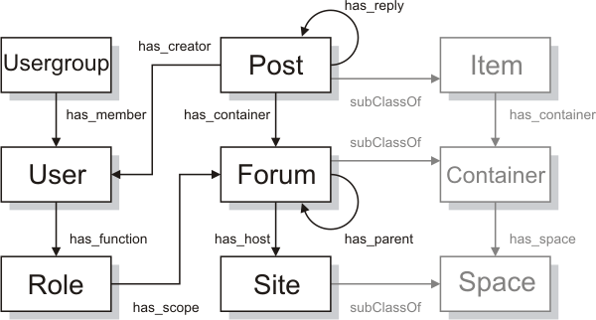
Figure 1. Main SIOC classes and their relationships. Reprinted, with permission, from Bojārs & Breslin, 2007An ontology to capture the meta-data of a mailing list was clearly recognized as the first milestone to fulfill our purposes. Fortunately, an effort leaded by DERI Galway has produced SIOC (Semantically-Interlinked Online Communities), an ontology that provides a vocabulary to interconnect different discussion methods such as blogs, web-based forums and mailing lists (Breslin 2005, Breslin 2006). Indeed, SIOC has a wider scope than just mailing lists, and generalizes all kinds of online discussion primitives in a more abstract sioc:Forum concept. Each forum represents an online community of people that communicate and share a common interest. The goal of SIOC is to interconnect these online communities.
Other relevant concepts of the ontology are sioc:User and sioc:Post, which model respectively the members of the communities and the content they produce. Instances of these three classes (forums, users and posts) can be linked together using several properties, as depicted in Figure 1.
The SIOC ontology was designed to express the information contained both explicitly and implicitly in Internet discussion methods. Several software applications, usually deployed as plug-ins, are already available to export SIOC data from some popular blogging platforms and content management systems. The effort, however, is focused on web-based communities (blogs, discussion forums), while little has been done so far to extend the coverage to legacy non-web communities, such as mailing lists and Usenet groups.
SIOC classes and properties are defined in OWL, and their instances can be expressed in RDF. Therefore, they can be easily linked to other ontologies. The obvious choice here is FOAF, which provides powerful means to describe the personal data of the members of a community.
Mailing lists can be easily described by instantiation of the SIOC classes and properties. Each mailing list can be represented by an instance of sioc:Forum (a subclass of Forum might be used instead, although it is not required). Messages sent to the list and their replies become instances of sioc:Post.
Finally, people involved into the list are instances of sioc:User. The SIOC ontology provides a property to link forums and users, namely sioc:has_subscriber. We argue that being subscribed to a mailing list is just one of the roles a user can play with respect to a forum. Moreover, the list of subscribers is often available only to the system administrator for privacy reasons. On the other hand, it is easy to collect the set of people who post to the list, i.e., the people actively involved in the forum. Depending on the settings, the latter may be a subset of the former, in particular in those mailing lists that forbid posting privileges to non-subscribers. Ideally, these two different semantics would be captured using new properties. However, for practical reasons, and to avoid privacy issues, we consider just the already existent sioc:has_subscriber property, and we populate it with the set of active members of a forum. Consequently, inactive members of the forum remain hidden, but this does not represent a problem due to the open world assumption.
Additionally, the Dublin Core (Dublin Core Metadata Element Set, Version 1.1, 2006) and Dublin Core Terms vocabularies are used to capture meta-data such as the message date (dcterms:created) and title (dc:title).
2.1 Linking messages
There are many ways in which a mailing list message might be related with other messages. However, we consider just two scenarios. The first one links a post with its replies (sioc:has_reply). Actually, due to sequential layout of the messages in the most widely used format to store mailing list archives (mailbox), it is easier to generate the inverse property (sioc:reply_of). Anyway, the has_reply property can be generated either by a DL reasoner or by performing two passes over the sequence.
The second link among messages is established between a post and its immediate successor (or predecessor) in chronological order. It is worth to note that this link is not strictly necessary, because the following (or preceding) message can be obtained by sorting by date the sequence of posts. However, this is a rather expensive operation, because the whole set of posts is required in order to perform the sorting. The open world assumption makes this query even more challenging. Therefore, considering that browsing to the previous or next message is a common use case, and the complete set of posts can be very large or even unavailable, we introduced two new properties, next_by_date and prev_by_date. These properties where eventually accepted into the SIOC ontology.
An RDF representation of a sample message is shown in Figure 2.
- PUBLISHING MAILING LISTS
<rdf:RDF
xmlns:dcterms='http://purl.org/dc/terms/'
xmlns:sioc='http://rdfs.org/sioc/ns#'
xmlns:rdf='http://www.w3.org/1999/02/22-rdf-syntax-ns#'
xmlns:dc='http://purl.org/dc/elements/1.1/'
xml:base='http://example.org/swaml-devel/'>
<sioc:Post rdf:about="2006-Sep/post-52">
<dc:title>Re: [swaml-devel] Changing SWAML ontology</dc:title>
<sioc:has_creator rdf:resource="subscriber/s10"/>
<dcterms:created>Wed, 6 Sep 2006 20:14:44 +0200</dcterms:created>
<sioc:content><!-- ommitted --></sioc:content>
<sioc:has_reply rdf:resource="2006-Sep/post-69"/>
<sioc:previous_by_date rdf:resource="2006-Sep/post-51"/>
<sioc:next_by_date rdf:resource="2006-Sep/post-53"/>
</sioc:Post>
</rdf:RDF>
Figure 2. SIOC Post example in RDF/XML
An ontology provides no service to end users by itself. Software tools are actually required to publish and consume information. We have built and released free software implementations of both kinds of tools. In this section we describe just the former, but the whole picture is provided in Figure 3.
3.1 SWAML
SWAML is the name of an application that covers the data-generation phase, and it is intended to be used by mailing list administrators, who usually have access to the archives in raw format. The most popular format for mailing list archives is the “mailbox” (or “mbox”), as defined in RFC 4155 (Hall 2005). SWAML is essentially a mailbox parser and translator implemented in Python. Its output is a number of SIOC instances (Forum, Posts and Users) in a set of RDF files. SWAML is a highly configurable, non-interactive application designed to be invoked by the system task scheduler.
Parsing the mailbox and rebuilding the discussion threads may be sometimes tricky. Although each mail message has a supposedly unique identifier in its header (Message-ID, defined by RFC 2822 (Resnick 2001)), in practice its uniqueness cannot be taken for granted. Actually, we have found some messages with repeated identifiers in some mailing lists, probably due to non-RFC compliant or ill-configured mail transport agents. Therefore, SWAML assumes that any reference to a message (such as those created by the In-Reply-To header) is in fact a reference to the most recent message with that ID in the mailbox (obviously, only previous messages are considered). Using this rule of thumb, SWAML builds an in-memory tree representation of the conversation threads, so sioc:Posts can be properly linked.
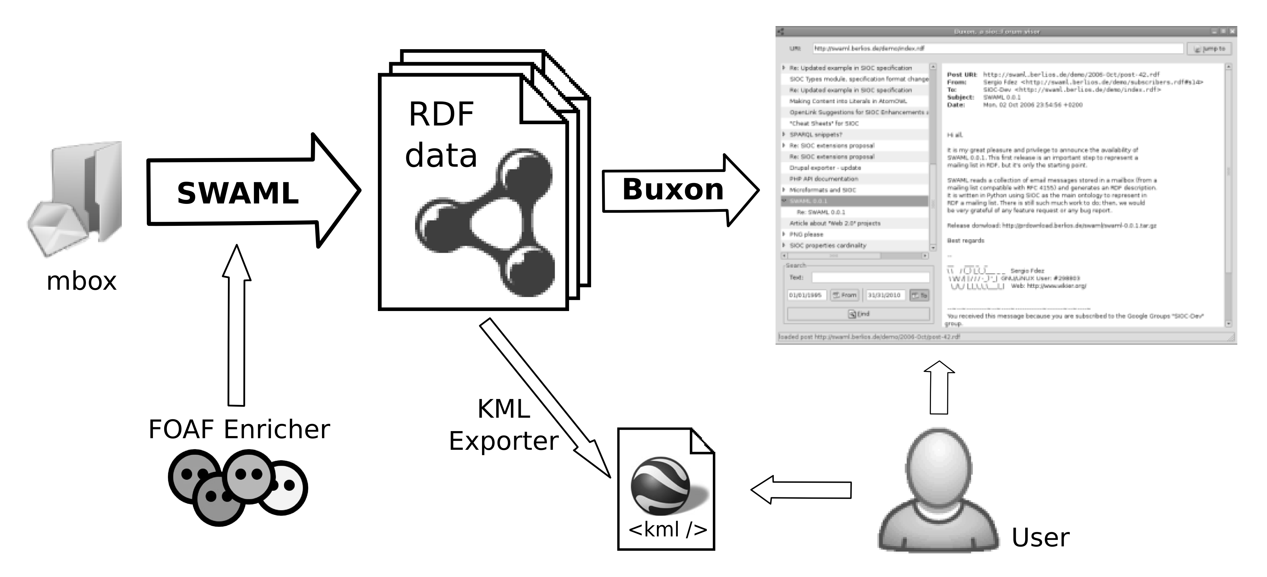
Figure 3. Buxon is an end-user application that consumes sioc:Forum instances, which in turn can be generated from mailboxes using SWAML.
Actually, SWAML goes further than just a format-translation tool. A dedicated subroutine that runs as part of the batch execution but may be also separately invoked on any sioc:Forum, tries to find a FOAF description for each sioc:User. To the best of our knowledge, there is not any wide-scope web service to fetch FOAF descriptions from a given e-mail address, so we mocked it. Some of the authors of this paper are also currently working on a functional implementation of such a service as part of a different project.
3.2 Delivering RDF using content negotiation
One important requirement of the semantic web is to be an extension (and not a replacement) of the current document-based web. Ideally, each user agent must be able to retrieve the information in their format of choice. For instance, current web browsers prefer (X)HTML documents, because they can be rendered and presented to the end user. However, semantic web agents require information to be available in a serialized RDF format, such as RDF/XML or N3. Furthermore, different representations of the same information resource should share a unique URI. Fortunately, the HTTP protocol supports this feature by using “content-negotiation”. Clients of the protocol can declare their preferred formats in the headers of an HTTP request using the Accept header. Web servers will deliver the information in the most suited available format, using the Content-type header of the HTTP response to specify the actual format of the returned delivered content. MIME types such as text/html and application/rdf+xml are used as identifiers of the requested and available formats.
Setting up the content negotiation in the server-side usually requires some tuning of the web server configuration. It also depends on some choices made by the publisher of the information, such as the namespace scheme for the URIs or the fragmentation of the information. In (Miles et al, 2006) there is a list of some common scenarios, which are described to great detail, and configuration examples for the Apache web server are provided. The most suitable scenarios (or recipes, as they are called) to publish mailing list metadata are the fifth and sixth, i.e., multiple documents available both in HTML and RDF.
The fifth scenario is extensively described in the referred source, and it has been implemented in SWAML. At the same time RDF and HTML files are written, SWAML also produces htaccess local configuration files for Apache. One of these configuration file is shown in Figure 5, while a sample request/response negotiation is depicted in Figure 4.
RewriteEngine On
RewriteBase /demos/swaml-devel/
AddType application/rdf+xml .rdf
Options -MultiViews

RewriteCond %{HTTP_ACCEPT} text/html [OR]
RewriteCond %{HTTP_ACCEPT} application/xhtml\+xml [OR]
RewriteCond %{HTTP_USER_AGENT} ^Mozilla/.*
RewriteRule ^/([0-9]{4})-([A-Za-z]+)/post-([0-9]+)$
$1-$2/post-$3.xhtml [R=303]

RewriteCond %{HTTP_ACCEPT} application/rdf\+xml
RewriteRule ^/([0-9]{4})-([A-Za-z]+)/post-([0-9]+)$
$1-$2/post-$3.rdf [R=303]
Figure 5: A sample htaccess configuration file for Apache generated by SWAML. These two rules redirect the request to the proper file based on the content negotiation field of the HTTP request. Some lines have been wrapped for readability.
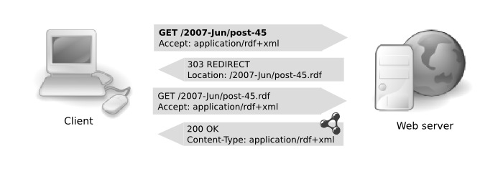
Figure 4: An HTTP dialog with content negotiation
3.3 Exposing a SPARQL server
RDF metadata generated by SWAML can grow to a large size for lists with a high traffic and several years of operation, where there are tens of thousands of messages. The partition of the information might be an issue in such cases. On the one hand, information chunks are preferred to be small so any conceivable use case can be satisfied without retrieving a significant overload of unneeded information. However, scattering the metadata across a myriad of small files has some disadvantages. For instance, the number of resources that must be retrieved to fulfill a single query is greatly increased. Therefore, storing the RDF graph in a specialized database is an appealing alternative.
Fortunately, a common protocol to access semantic repositories using SPARQL as the query language is available (Clark 2006) and is gaining support by the RDF databases. This protocol exposes a simple API to execute and retrieve the results of SPARQL queries (at the present moment, SPARQL is a read-only query language, although there are proposals to extend it with full CRUD capabilities such as those of SQL). This abstract query API may be realized by different means, such as SOAP bindings (described by a WSDL 2.0 interface) and HTTP bindings. The former enables interoperability with web service frameworks, while the latter can be exploited without the full-blown web service machinery.
Web service endpoints which implement the SPARQL protocol are sprouting on the web, some of them pouring huge amounts of data into the semantic web. We argue that metadata of large mailing lists can be conveniently exposed as SPARQL endpoints. That means to effectively translate the decision on data selection to the client (Pan 2006), and therefore minimizing the number of requests and the data overload. For instance, the client agent can retrieve all the headers of the messages in a given date range, but skip the body of the messages, saving a considerable amount of bandwidth.
RewriteEngine On
RewriteBase /lists/archives

RewriteCond %{HTTP_ACCEPT} application/rdf\+xml
RewriteRule ^mylist/(.+)
http://internal-server/sesame-server/repositories/mylist-rep/
?query=CONSTRUCT+{<http://example.org/lists/mylist/$1>+?y+?z}
+WHERE+{<http://example.org/lists/mylist/$1>+?y+?z}
&queryLn=sparql [R=303]
Figure 6: Sample Apache web server rewrite rule to translate HTTP request into SPARQL queries using a Sesame RDF repository. The last line has been wrapped for readability.
However, non SPARQL-aware agents still need to access the information. This is the scenario of the sixth scenario (recipe) of the above cited document, but unfortunately this one is still being discussed. We propose a simple solution based on URL rewriting of the requests in order to translate conventional HTTP requests for resources into SPARQL queries that dynamically generate an RDF subgraph that contains the requested information about the resource. The rewriting mechanism, the SPARQL query and even the presence of a data repository instead of static files is kept completely hidden to the client. At the same time, by avoiding the undesirable data replication, this technique helps to keep the information consistent. The most representative feature of our proposal is that it does not require any kind of server side script or application to translate the queries, because the data repository can serve the information directly in the format desired by the client.
We have implemented this technique using the Apache web server and Sesame 2.0beta RDF repository (Broekstra et al, 2002). Figure 6 reproduces the hand-made htaccess file (as opposed to the ones that are automatically produced by SWAML). Unfortunately, Sesame still lacks support for the DESCRIBE sentence of SPARQL, so we use CONSTRUCT instead. Of course, the rewrite rule must be fired only when RDF data is requested, while requests for HTML must go through it.
We note, however, that our proposal presents some security-related issues. In particular, it is easily vulnerable to SPARQL-injection. Therefore, we strongly discourage the use of this technique in production environments. Nevertheless, some changes in the regular expressions are possible in order to prevent this kind of attack.
<html xmlns='http://www.w3.org/1999/xhtml'
xmlns:dcterms='http://purl.org/dc/terms/'
xmlns:sioc='http://rdfs.org/sioc/ns#'
xmlns:dc='http://purl.org/dc/elements/1.1/'>
<head profile='http://www.w3.org/2003/g/data-view'>
<link href='http://www-sop.inria.fr/acacia/soft/RDFa2RDFXML.xsl'
rel='transformation' />
<title>[swaml-devel] CfP: FEWS2007</title>
</head>
<body>
<div about='http://example.org/swaml/post/2007-May/5'
class='sioc:Post'>
<h1 property='dc:title'>[swaml-devel] CfP: FEWS2007</h1>
<p>strong>From: </strong>
<a href='http://example.org/swaml/subscriber/s2'
rel='sioc:has_creator'>Diego Berrueta</a>
</p>
<p><strong>To: </strong>
<a href='http://example.org/swaml/forum'
rel='sioc:has_container'>SWAML Devel</a>
</p>
<p><strong>Date: </strong>
<span property='dcterms:created'>
Tue, 15 May 2007 19:24:49
</span>
</p>
<pre property='sioc:content'><!-- omitted --></pre>
<p>Previous by Date:
<a href='http://example.org/swaml/post/2006-Sep/4'
rel='sioc:previous_by_date'>previous</a>
</p>
<p>Next by Date:
<a href='http://example.org/swaml/post/2007-Mar/6'
rel='sioc:next_by_date'>next</a>
</p>
</div>
</body>
</html>
Figure 7: A single message rendered as XHTML code with RDFa and GRDDL markup by SWAML.
3.4 RDFa and GRDDL
There is another different approach to publishing metadata: to embed it into the HTML content. W3C is pushing two complementary technologies, RDFa (Adida & Birbeck, 2007) and GRDDL (Connolly, 2007), which respectively encode into, and extract RDF data from XHTML documents. We have also explored this path. SWAML generates simple XHTML pages for each message (see Figure 7) to illustrate the usage of both RDFa and GRDDL in their current development versions. We must remark that these pages are just a proof-of-concept of the semantic enrichment, and they lack many of the fancy features and complex templates of the already-existent applications which generate plain HTML.
- CONSUMING MAILING LIST METADATA
4.1 Buxon
Buxon is a multi-platform desktop application written in PyGTK. It allows end users to browse the archives of mailing lists as if they were using their desktop mail application. Buxon takes the URI of a sioc:Forum instance (for example, a mailing list exported by SWAML, although any sioc:Forum instance is accepted) and fetches the data, retrieving additional files if necessary. Then, it rebuilds the conversation structure and displays the familiar message thread list (see Figure 8).
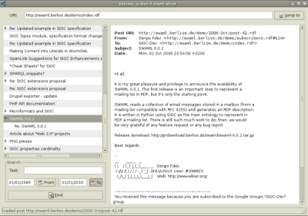 Figure 8. Buxon browsing SIOC-Dev mailing list.
Buxon also gives users the ability to query the messages, searching for terms or filtering the messages in a date range. All these queries are internally translated to SPARQL (Prud'hommeaux & Seaborne, 2007) to be executed over the RDF graph. Newer versions of Buxon can, at user's request, send the sioc:Forum URI to PingTheSemanticWeb.com, a social web service that tracks semantic web documents. That way, Buxon contributes to establish an infrastructure that lets people easily create, find and publish RDF documents.

Other browsers and clients
The SIOC RDF data can be explored and queried using any generic RDF browser, such as Tabulator (Berners-Lee et al., 2006). The most interesting applications appear when instances of sioc:User are linked to FOAF descriptions of these users. For instance, it is trivial to write a query to obtain the geographical coordinates of members of a mailing list and to codify them into a KML file (Ricket 2006), provided they describe their location in their FOAF file using the basic geo vocabulary (Brickley 2006). The KML file can be then plotted using a map web service such as Google Maps (Figure 9).

It is also possible execute visualize the messages in a time line view using the Timeline DHTML widget by the MIT SIMILE project using a query like the one we propose in Figure 10.
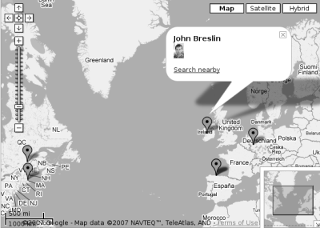
Figure 9. Plotting the geographical coordinates of the members of a mailing list using KML and Google Maps.
- Conclusions and future work
PREFIX sioc: <http://rdfs.org/sioc/ns#>
PREFIX rdf: <http://www.w3.org/1999/02/22-rdf-syntax-ns#>
PREFIX dcterms: <http://purl.org/dc/terms/>
PREFIX dc: <http://purl.org/dc/elements/1.1/>
SELECT ?start ?title ?description ?link
WHERE {
?post rdf:type sioc:Post .
?post dcterms:created ?start .
?post dc:title ?title .
?post sioc:link ?link .
?post sioc:content ?description
}
Figure 10. SPARQL query to extract the information required to visualize a time line of the messages posted to any sioc:Forum instance.
There is a lot of ongoing effort to translate data already reachable on the web into formats which are semantic web-friendly. Most of that work focuses on relational databases, micro-formats and web services. However, at the time of this writing and to the best of our knowledge, e-mail was almost excluded from the Semantic Web. Our project, in combination with the generic SIOC framework, fills this gap, conveniently providing an ontology and a parser to publish machine-readable versions of the archives of the countless mailing lists that exist on the Internet.
Furthermore, the SWAML project fulfills a much-needed requirement for the Semantic Web: to be able to refer to semantic versions of e-mail messages and their properties using resource URIs. By re-using the SIOC vocabulary for describing online discussions, SWAML allows any semantic web document (in particular, SIOC documents) to refer to e-mail messages from other discussions taking place on forums, blogs, etc., so that distributed conversations can occur across these discussion media. Also, by providing e-mail messages in RDF format, SWAML is providing a rich source of data, namely mailing lists, for use in SIOC applications.
The availability of these data leads to some benefits. In the first place, data can be fetched by user applications to provide handy browsing through the archives of the mailing lists, providing features that exceed what is now offered by static HTML versions of the archives on the web.
Secondly, the crawlers of the web search engines can use the enhanced expressivity of the RDF data to refine search results. For instance, precise semantic descriptions of the messages permit to filter out repeated messages, advance in the fight against spam, or introduce additional filter criteria in the search forms.
Another consequence of no lesser importance is that each e-mail message is assigned a URI that can be resolved to a machine-readable description of the message. This actually makes possible to link a message like any other web resource, and therefore enriches the expressivity of the web.
We are exploring some directions for future work. Some of them are:
- Integration of the SWAML process with popular HTML-based mailing list archivers, such as Hypermail or Pipermail, would be a giant push to speed up the adoption of SWAML. It is well known that one of the most awkward problems of any new technology is to gain a critical mass of users. The semantic web is not an exception. A good recipe to tackle this problem is to integrate the new technology into old tools, making a smooth transition without requiring any extra effort from users. Merging the SWAML process into the batch flow of tools such as Hypermail would allow to generate both RDF and production-quality, semantically enriched HTML versions of the archives.
- So far, no semantic annotation relative to the meaning of the messages is considered. Obviously, such information can not be automatically derived from a RFC 4155-compliant mailbox. However, it is conceivable that it can be added by other means, such as social tagging using folksonomies, or parsing the metadata added by the authors of the messages using micro-formats or RDFa when posting in XHTML format. The inherent community-based nature of mailing lists can be exploited to build recommendation systems (Celma 2006).
- Our prototypical forum browser, Buxon, can only fetch data in RDF/XML format. Support for RDFa and GRDDL would be a remarkable enhancement, because these formats are expected to gain a wide adoption due to their ability to meld human-readable and machine-readable information in a single file. Moreover, RDFa and GRDDL ease the publication of the data because there is no need to set up content negotiation in the web server. Additionally, we would like to add a client of the SPARQL protocol to Buxon, so it could retrieve the precise amount of data required for each operation.
- It is not always possible to obtain a mailbox file for a mailing list. For these cases, an alternative is envisaged: a high-capacity mail account can be subscribed to the mailing list with the unique purpose of collecting and storing the messages. A simple extension to SWAML that makes it possible to read the contents of a GMail account has been developed.
ACKNOWLEDGEMENTS
The authors would like to express their gratitude to Dr. John Breslin and Uldis Bojārs from DERI Galway, whose support and contributions have been of great help to this project. Also thanks to Ignacio Barrientos for his contribution packaging the project for Debian GNU/Linux.
REFERENCES
Adida, B. & Birbeck, M. (eds.), 2007. RDFa Primer 1.0, Technical report, W3C Working Draft.
Berners-Lee, T. et al, 2006. Tabulator: Exploring and Analyzing linked data on the Semantic Web. Proceedings of the 3rd International Semantic Web User Interaction Workshop (SWUI06) workshop, Athens, Georgia.
Bojārs, U. & Breslin, J. (eds.), 2007. SIOC Core Ontology Specification. Available at http://rdfs.org/sioc/spec/.
Breslin, J. et al, 2006. SIOC: an approach to connect web-based communities. International Journal of Web Based Communities, Vol. 2, No. 2, pp 133-142.
Breslin, J. et al, 2005. Towards Semantically-Interlinked Online Communities. Proceedings of the 2nd European Semantic Web Conference, ESWC 2005, Heraklion, Crete, Greece.
Brickley, D., 2006. Basic geo (WGS84 lat/long) vocabulary, Technical report, W3C Informal Note.
Brickley, D. & Miller, L., 2005. FOAF Vocabulary Specification, Technical report.
Broekstra, J. et al, 2002. Sesame: A generic architecture for storing and querying RDF and RDF Schema. In Springer Lecture Notes in Computer Science, Vol. 2342, pp. 54–68.
Celma, O., 2006. FOAFing the music: Bridging the semantic gap in music recommendation. Proceedings of the 5th International Semantic Web Conference, Athens, USA.
Clark, K. G., 2006. SPARQL protocol for RDF, Technical report, W3C Candidate Recommendation.
Connolly, D., 2007. Gleaning Resource Descriptions from Dialects of Languages (GRDDL), Technical report, W3C Candidate Recommendation.
Dublin Core Metadata Element Set, Version 1.1, 2006. Technical report.
Hall, E., 2005. RFC 4155 - the application/mbox media type, Technical report, The Internet Society.
Klyne, G. and Carroll, J. J., 2004. Resource Description Framework (RDF): Concepts and abstract syntax, Technical report, W3C Recommendation.
Miles, A. et al, 2006. Best practice recipes for publishing RDF vocabularies, Technical report, W3C Working Draft.
Pan, Z. et al, 2006. An investigation into the feasibility of the semantic web, Technical Report LU-CSE-06-025, Dept. of Computer Science and Engineering, Lehigh University.
Prud'hommeaux, E. and Seaborne, A. (eds.), 2007. SPARQL Query Language for RDF, Technical report, W3C Candidate recommendation.
Resnick, P., 2001. RFC 2822 - internet message format, Technical report, The Internet Society.
Ricket, D, 2006. Google Maps and Google Earth integration using KML, in American Geophysical Union 2006 Fall Meeting.

