Something in calibri font and bigger and italic and bold.

Something in Time New Roman and bigger and italic and bold.

A table in Arial font:
Row 1, column 1 | Row 1, column 2 | Row 1, column 3 | Row 1, column 4 | Row 1, column 5
Row 1, column 1 | Row 2, column 2 | Row 2, column 3 | Row 2, column 4 | Row 2, column 5

Some more text in Abadi MT and it should have a comment on it. Justified right.

Back in Times New Roman for a bulleted list:
- Item 1
- Item 2
- Item 3

A subscript.

A superscript.

At the end of this red sentence is a footnote.

Here comes an image:
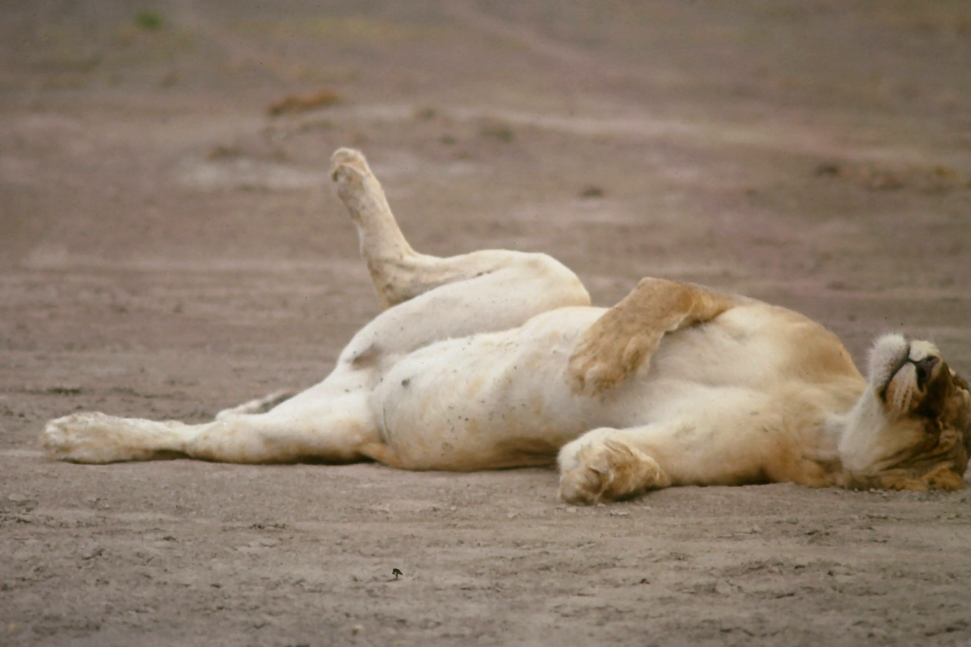

Some non-latin characters: 鵑鵙鶫ヮァЪЩ

An equation:

At the end of this sentence is a content container that has a reference from my gameaudio WIKINDX (Grimshaw-Aagaard 2019). This in-text reference also appears in the bibliography content container below.
Grimshaw-Aagaard, M. (2019). Sonic virtuality, environment, and presence. In J. Braga (Ed.), Conceiving Virtuality: From Art To Technology (pp. 69–80). Switzerland: Springer Nature.

A footnote.

