***Reported Bugs (from Homework 3)***

Bug Class

1. Library Limitations
2. Architectural Design
3. UI Requirement Change
4. Module Miscommunication
5. Network Communication
6. Security Vulnerabilities
7. Legal Responsibilities
8. Hardware Limitations
9. Performance
10. Lack of Communication between Teams
11. Implementation Errors

Bug Details

Defect Submission: UI Architecture doesn’t make sense.

Error Category: 2

Description: The UI design as stated in the design document is incapable of producing the UI as defined in the SRS and sketches.

Location: Display Module

Estimation of time to fix: 50 hours

Defect Submission: UI Team broke Network’s working code

Error Code: 10

Description: The display team altered the model module. In the process working code was deleted. The code communicated back and forth between the controller.

Estimation of time to fix: 20 minutes

Defect Submission: Parent-Child relationship was left out of architecture

Error Category: 2

Description: The UI and controller were not designed to represent the parent-child relationship. So the controller doesn’t accept the proper parameters. The model is not designed to include the parent relationship.

Estimation of time to fix: 2hrs

Defect Submission: Parser returns incorrect set

Error Category: 11

Description: The parser does not return the correct set of information after it parses a page.

Estimation of time to fix: 45min

Defect Submission: UI Node Bug

Error Category: 2

Description: Fast mouse movements and clicks cause the scatter widget (Node) to break. It will rotate around and scale up and down unexpectedly.

Estimation of time to fix: Included in Architecture Redesign

Defect Submission: UI Controls Translation

Error Code: 2

Description: The UI controls for searching, making a new search, and sharing the graph do not translate as the scatterplane pans.

Estimation of time to fix: Included in Redesign

Defect Submission: UI Control Scale

Error Code: 2

Description: The UI Controls do not scale properly as the scatter plane zooms in and out.

Estimation of time to fix: Included in Redesign

Defect Submission: Cannot Remove Non Type UI pop up

Error Code: 2

Description: The UI Pop Up tries to remove the search bar twice when the yes option for new search is selected.

Estimation of Time to fix: Included in Redesign.

Defect Submission: X already has a parent

Error Code: 2

Description: A widget will try to add X twice. The first add succeeds, but the second throws an exception.

Estimation of time to fix: Included in Redesign

Defect Submission: The Picture moves faster than background

Error Code: 2

Description: The nested widget Node has a background and an Async Image attached to it. The stencil for the Async Image will translate faster than the parent as the scatterplane is panned.

Estimation of time to fix: Included in Redesign

Defect Submission: Summary Pop Up doesn’t appear and throws exception

Error Code: 2

Description: When a node is clicked, the summary popup will not display. The Pop Up class is designed to hold a single widget. So to get around that I nested multiple widgets inside the contents of the Pop Up. Kivy did not like that.

Estimation of time to Fix: Included in Redesign

Defect Submission: RstDocument is an inappropriate choice for Text Summary Pop Up

Error Code: 2

Description: The RstDocument is classified as an experimental Widget. It does not have a robust implementation. Consequently the UI design that used a RstDocument to display the Node Summary failed.

Estimated time to fix: Included in Redesign

Defect Submission: The Page Layout causes the scatter plane to reset to (0,0)

Error Code: 2

Description: When a user clicks a node, the scatterplane will move to the initial position before the text summary appears.

Estimated time to fix: Included in Redesign

Defect Submission: The text box distorts text

Error Code: 2

Description: Once the user performs a search and chooses yes for new search, the textbox that appears distorts the text.

Estimated time to fix: 45 min

***Defect Graphs (from GitHub)***

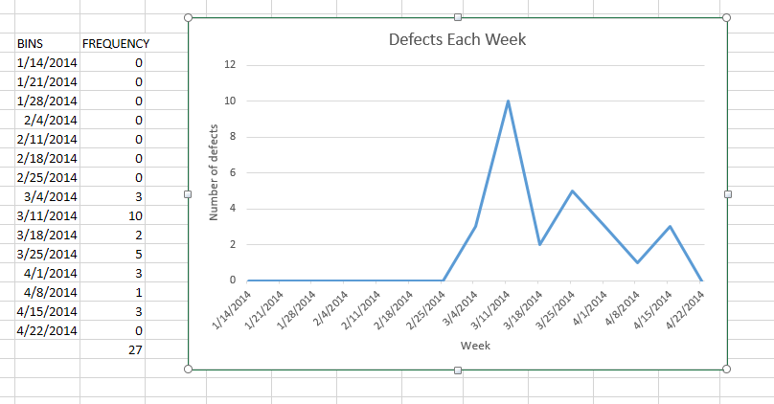

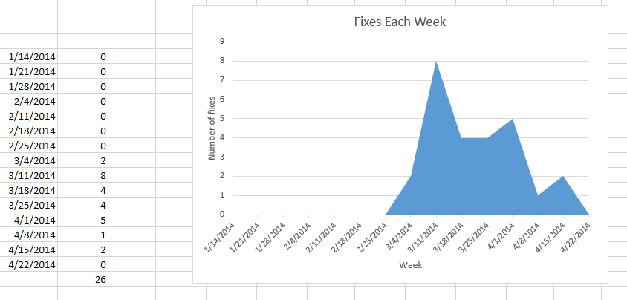

***Other Issues***

A complete set of issues as reported on GitHub can be found at:

<https://github.com/wikiviz/wikiviz/issues>