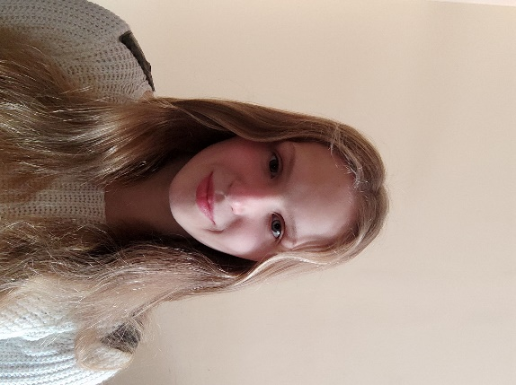 [Przyciągnij uwagę czytelnika interesującym cytatem z dokumentu lub podaj w tym miejscu kluczową kwestię. Aby umieścić to pole w dowolnym miejscu strony, wystarczy je przeciągnąć.]

* **ABOUT ME**

A big part of my life is sport, which taught me how to organize my time and helped me gain the ability to quickly learn new things. I have many hobbies including history, reading fantasy books, psychology and math. However, IT is the most important area of my interests and many of my activities focus on self-development and looking for opportunities in this field. I am a very creative person, which often allows me to quickly solve even more complex problems. I am a patient person and willing to take on challenges. I treat problems as an opportunity to develop and find new paths to achieve my goals. In the future I want to be a game developer.

Wiktoria Cioch-Gradzik

**JĘZYKI OBCE**

**Polish**

**Advanced – C2**

**German  
**

**Intermediate-advanced – B1**

* **INTRESTS**
* **In my free time I like to cook. I am especially interested in Italian and Chinese cuisine**
* **I like reading fantasy books and write my own stories**
* **I do sports (swimming), I am interested in dietetics and a healthy lifestyle**
* **I enjoy history and I like to read novels set in the Middle Ages or World War II**
* **I am interested in the mechanisms behind the creation of computer games and I am constantly learning about the latest works of well-known companies.**
* **In my free time I also help a family with younger cousins**

**EXPERIENCE   
TUTOR** 03/2020-04/2021Katowice/Lublin, Poland

* Helping younger people and people in my age in chemistry and mathematics

**EDUCATION  
X LO Mistrzostwa Sportowego –** Lublin, Poland 09/2019- 05/2022

* I won several times the award of the Prime Minister for outstanding achievements at school.
* Scholarship for outstanding academic achievements with a grade point average of 5.87(Highest possible 6.0)
* I trained in the SMS Lublin swimming team, winning many medals from the Polish Swimming Championships

**Lewis University-** Romeoville, Illinois, United States 09/2022-currently   
 **Major:** Computer Science

* Achievements on the university with an average grade of 3.97
* I train in the swimming team at the university, where I won awards for special achievements in the past year
* I took part in many extracurricular activities at the university, including math and environmental classes
* **SKILLS**
* **Creativity**
* **Ability to set priorities and independence**
* **I am very good at both individual and team work**
* **Very good organization of work**
* **Knowledge of the JAVA**
* **Knowledge of the PYTHON**
* **Outstanding swimming ability**
* **The ability to think logically and connect facts quickly**
* **CONTACT**
* **One University Parkway Romeoville Il**
* **8156140049**
* [**wiktoria.cioch.gradzik@gmail.com**](mailto:wiktoria.cioch.gradzik@gmail.com)