Pruebas
Nombre: Wilmer Alonso Romero Ampuero
Arrancamos Config Server
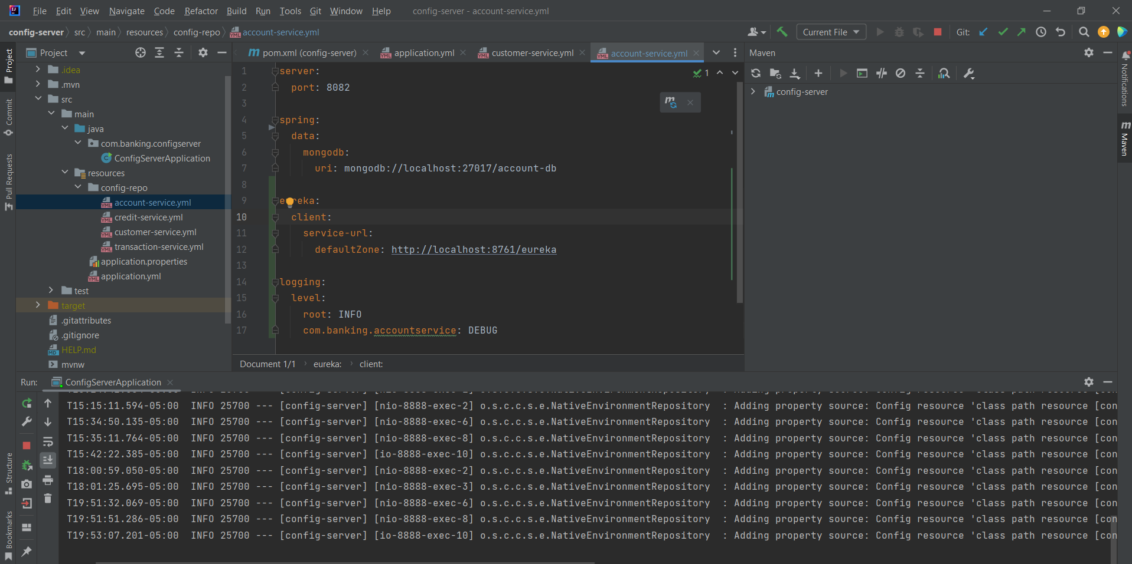
Arrancamos Eureka Server
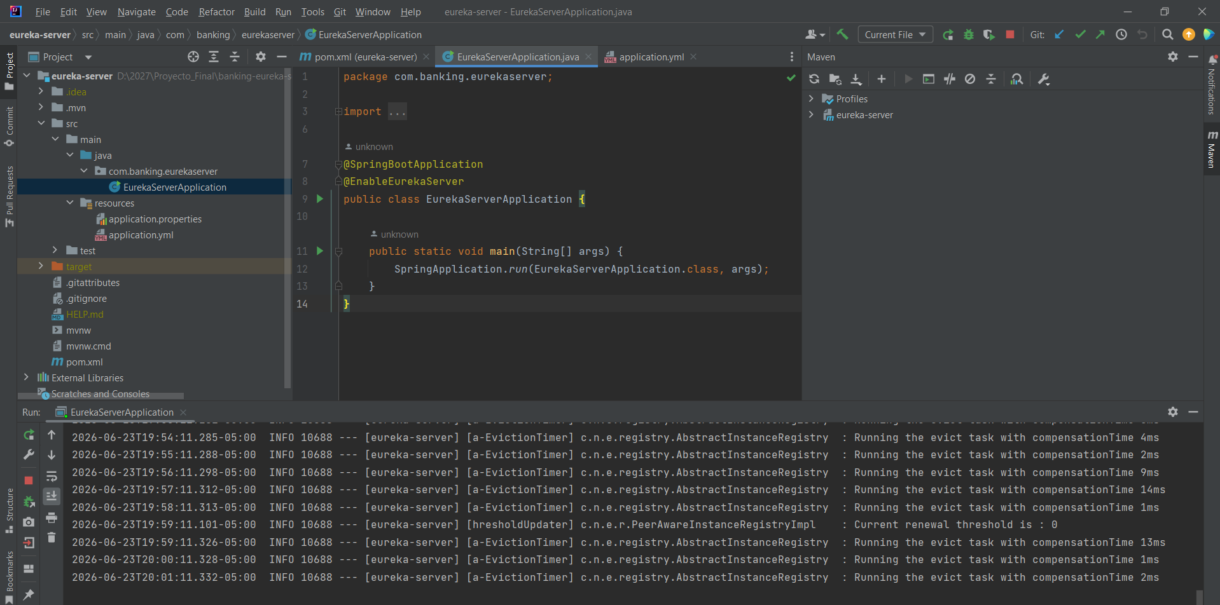
Arrancamos Api Gateway
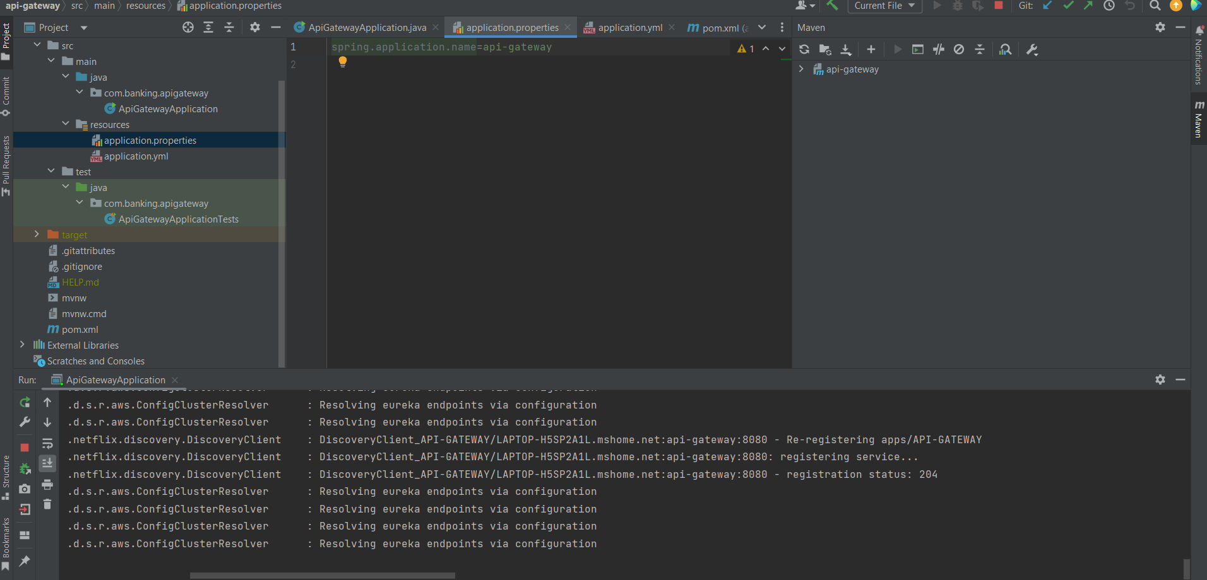
Ejecutamos las pruebas
http://localhost:8888/account-service/default
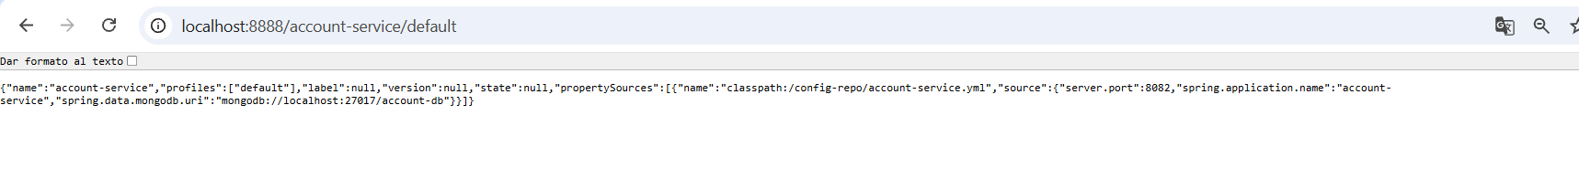
http://localhost:8888/account-service.yml
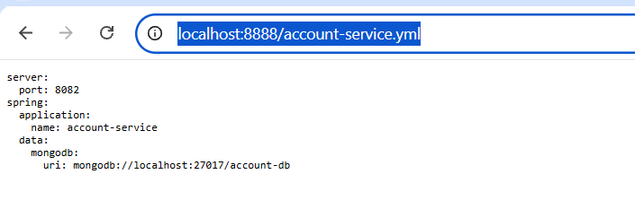
http://localhost:8761/

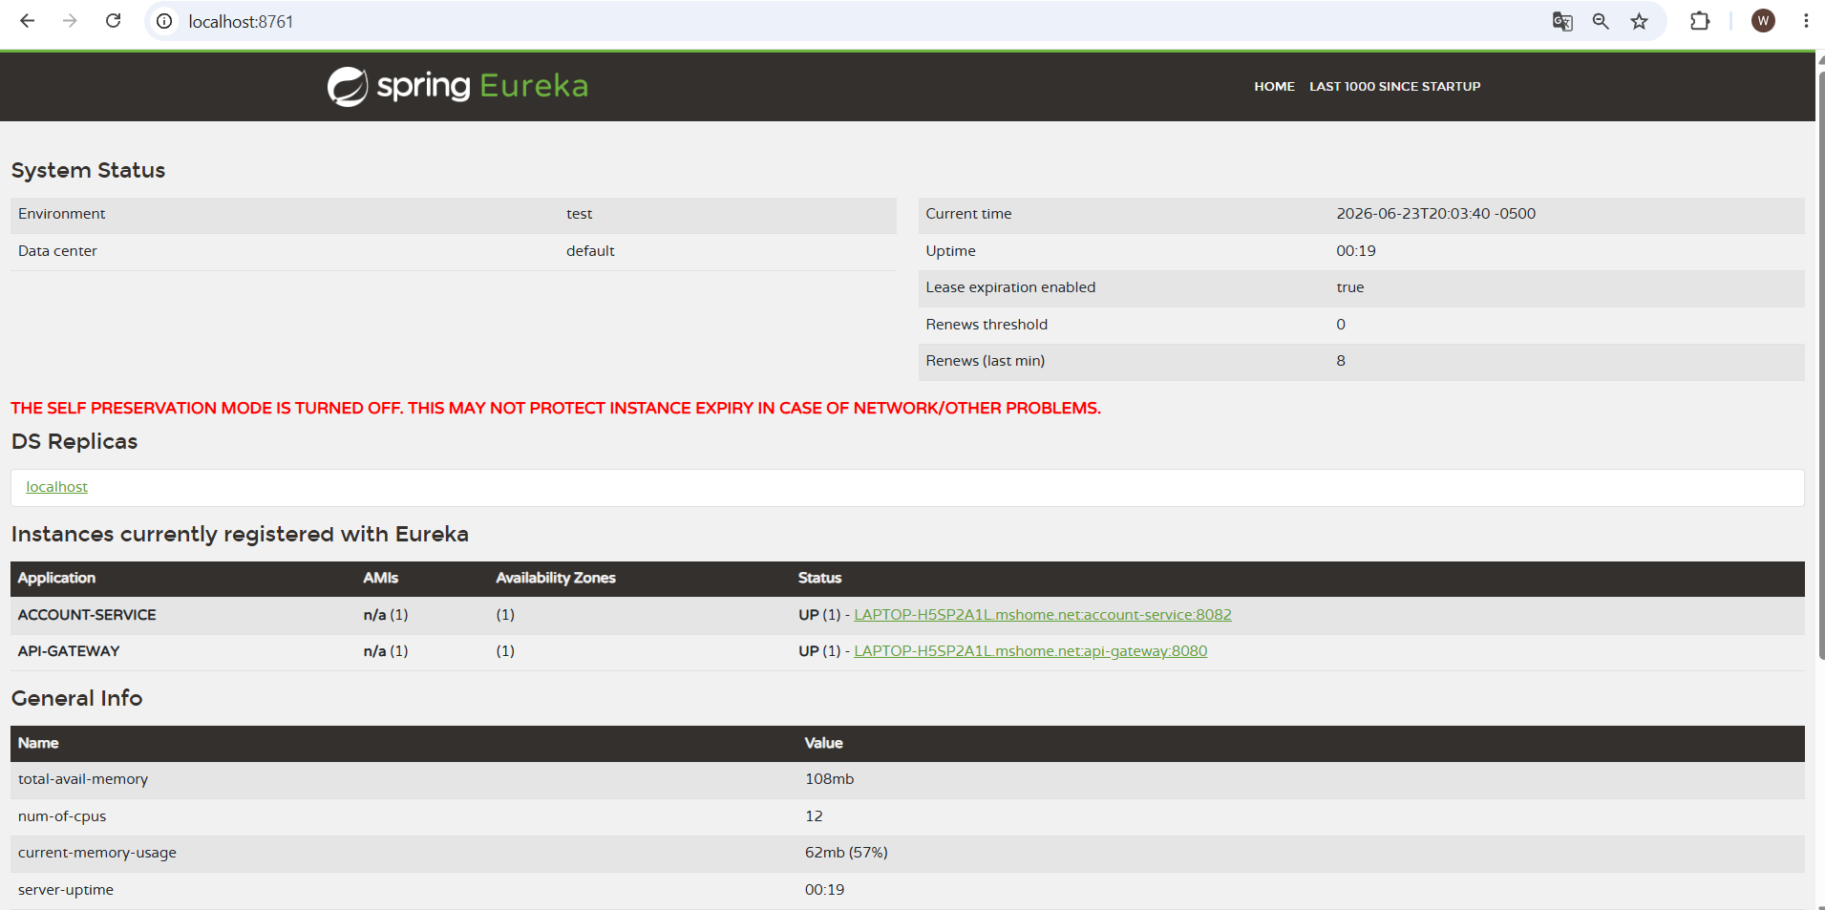
http://localhost:8080/actuator/health

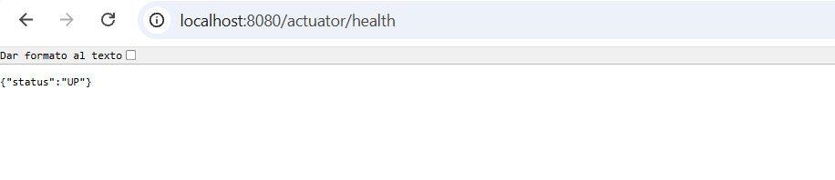
POST http://localhost:8080/api/accounts

{
"customerId": "66c123abc",
"type": "SAVINGS",
"balance": 1000.0
}
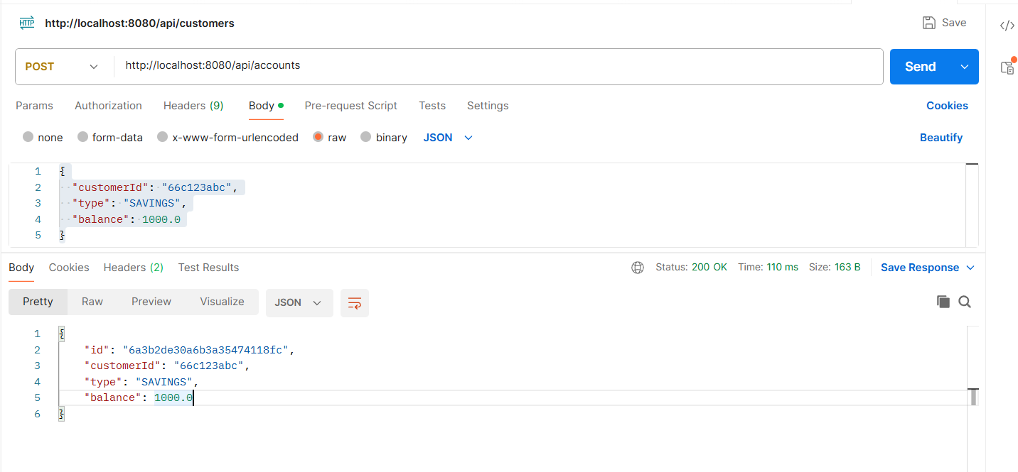
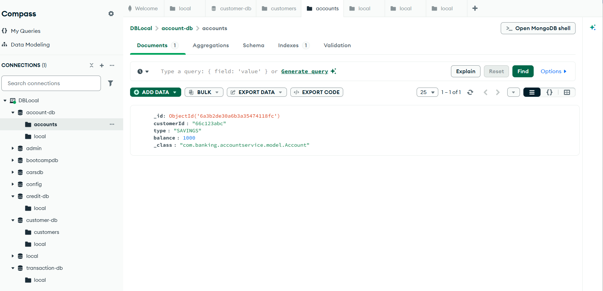
2. GET ALL ACCOUNTS
http://localhost:8080/api/accounts
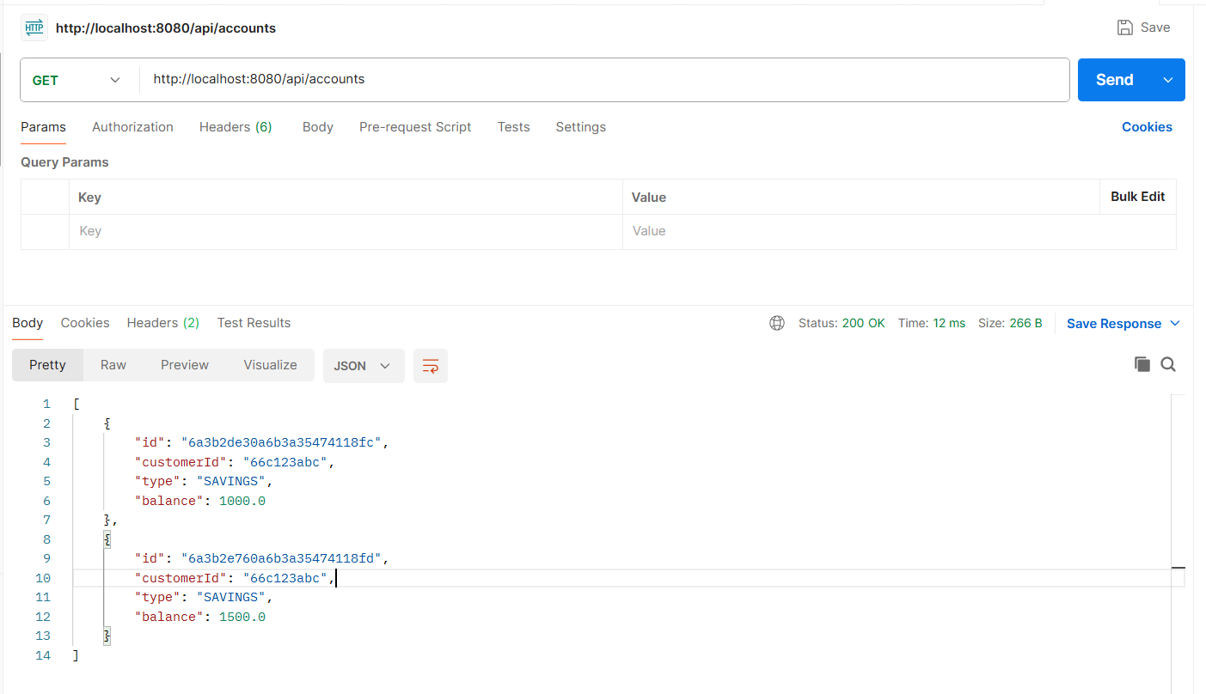
3. GET ACCOUNT BY ID

GET http://localhost:8080/api/accounts/{id}
http://localhost:8080/api/accounts/6a3b2e760a6b3a35474118fd

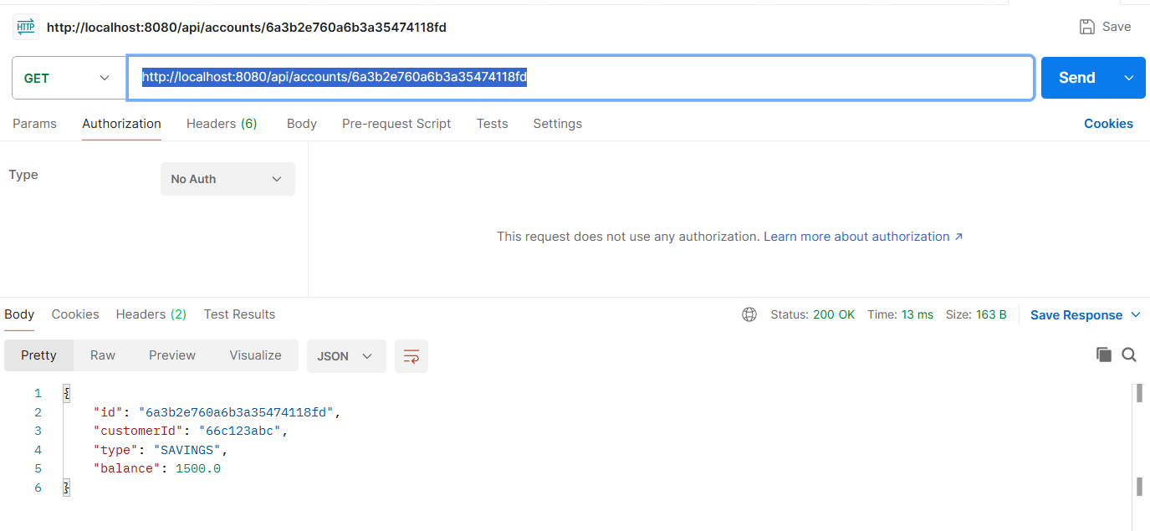
4. UPDATE ACCOUNT
PUT http://localhost:8080/api/accounts/{id}

{
"customerId": "66c123abc",
"type": "CURRENT",
"balance": 2000.0
}

http://localhost:8080/api/accounts/6a3b2e760a6b3a35474118fd

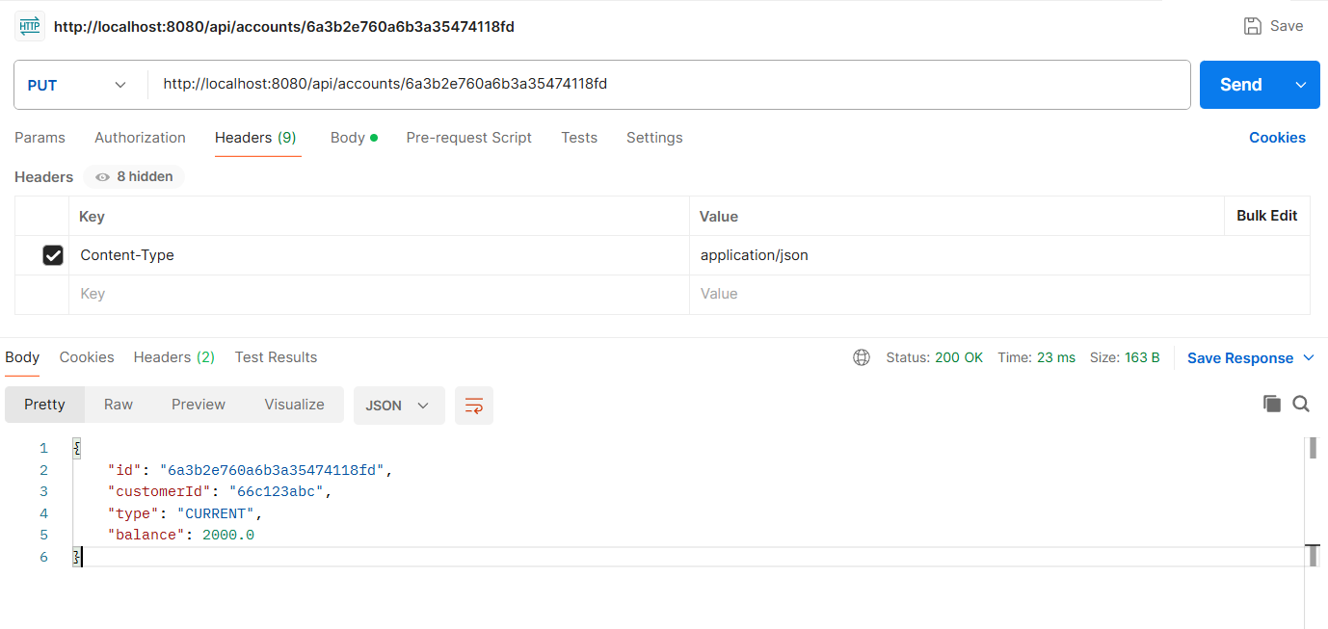

5. DELETE ACCOUNT
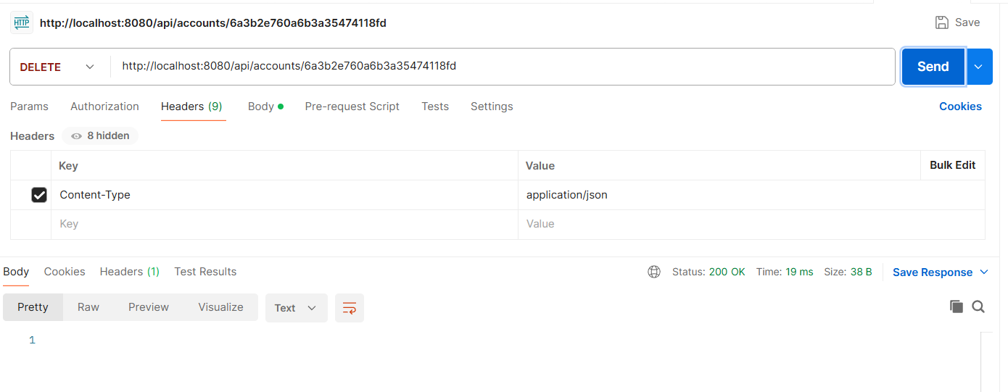

Listamos account

