Testing
Crear crédito
POST /api/credits
http://localhost:8080/api/credits
{
"customerId": "ID_CUSTOMER",
"type": "PERSONAL",
"limitAmount": 5000,
"balance": 0
}
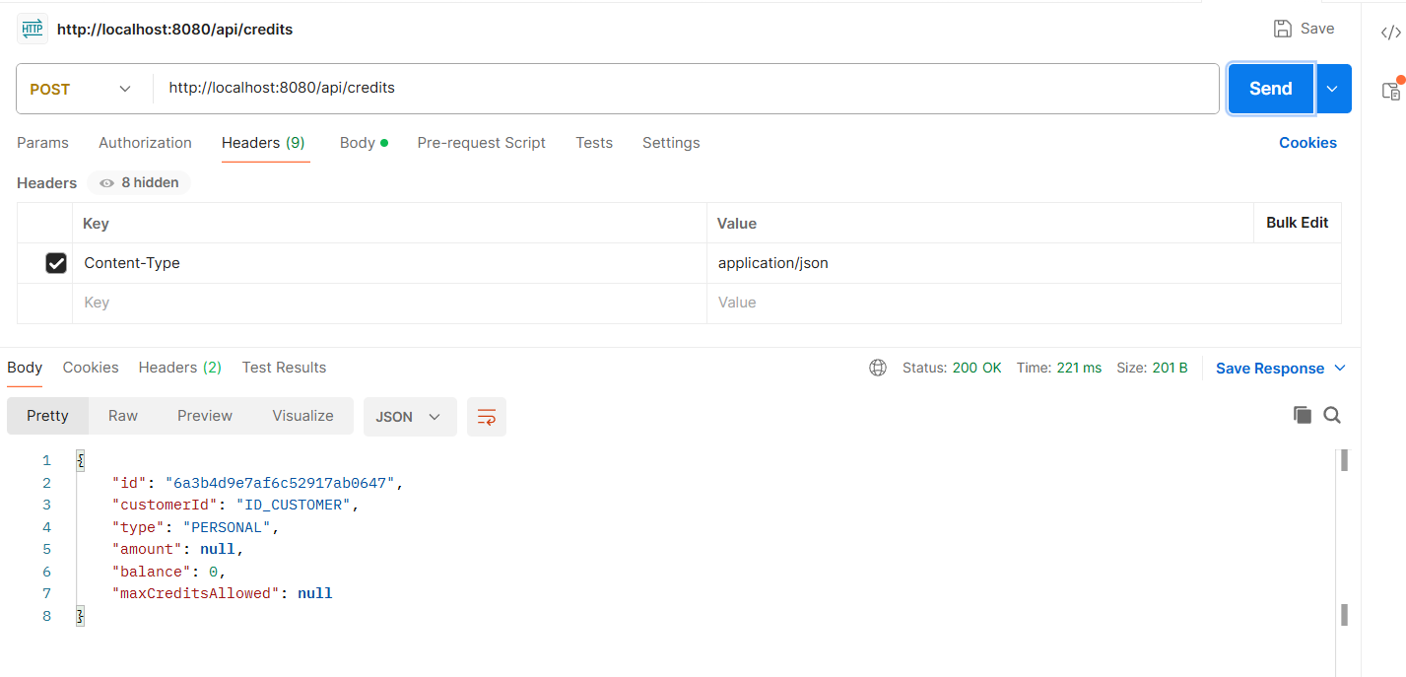
Listar créditos
http://localhost:8080/api/credits
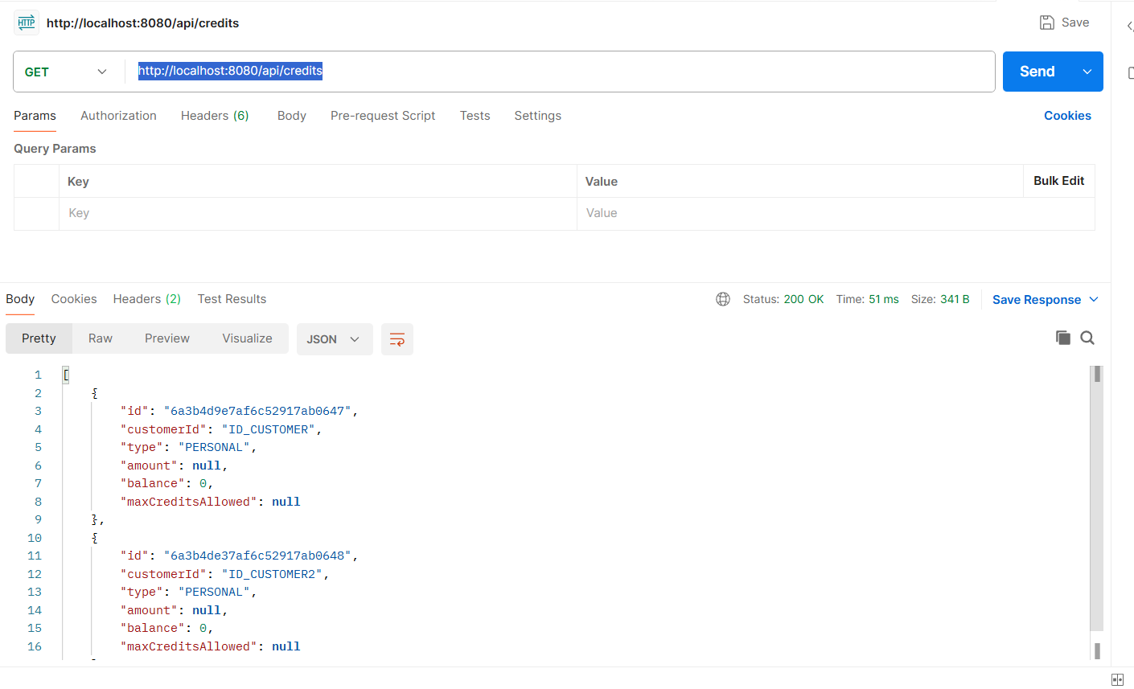
Buscar por cliente
GET /api/credits/customer/{customerId}

http://localhost:8080/api/credits/6a3b4de37af6c52917ab0648

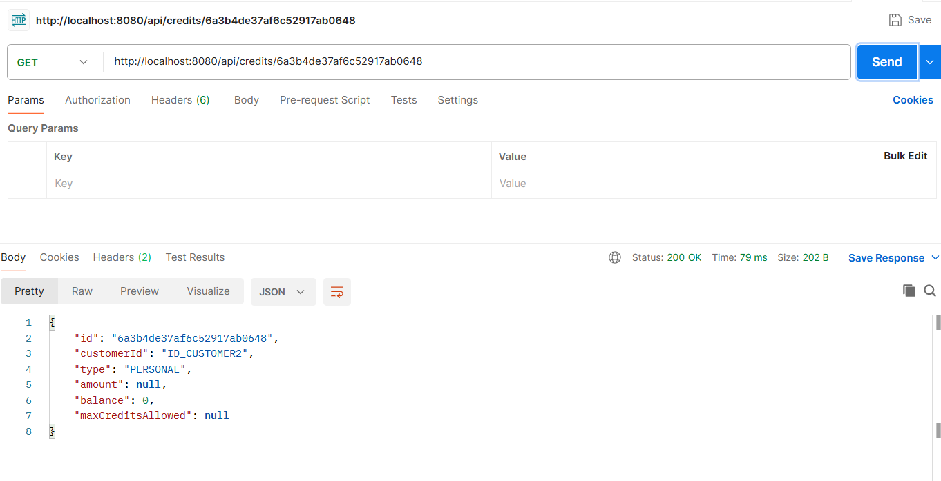

DELETE /api/credits/{id}
http://localhost:8080/api/credits/6a3b4d9e7af6c52917ab0647
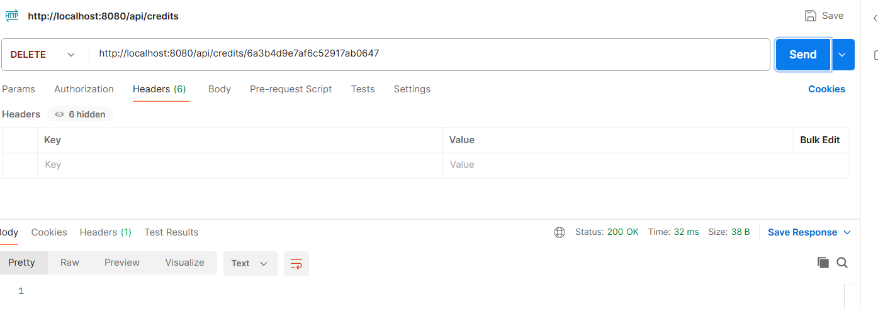

Otros test
Pago de crédito

POST /api/credits/{id}/payment
Body
{
"amount": 200
}

Consumo tarjeta crédito
POST /api/credits/{id}/consume

{
"amount": 150
}

Pruebas de infraestructura

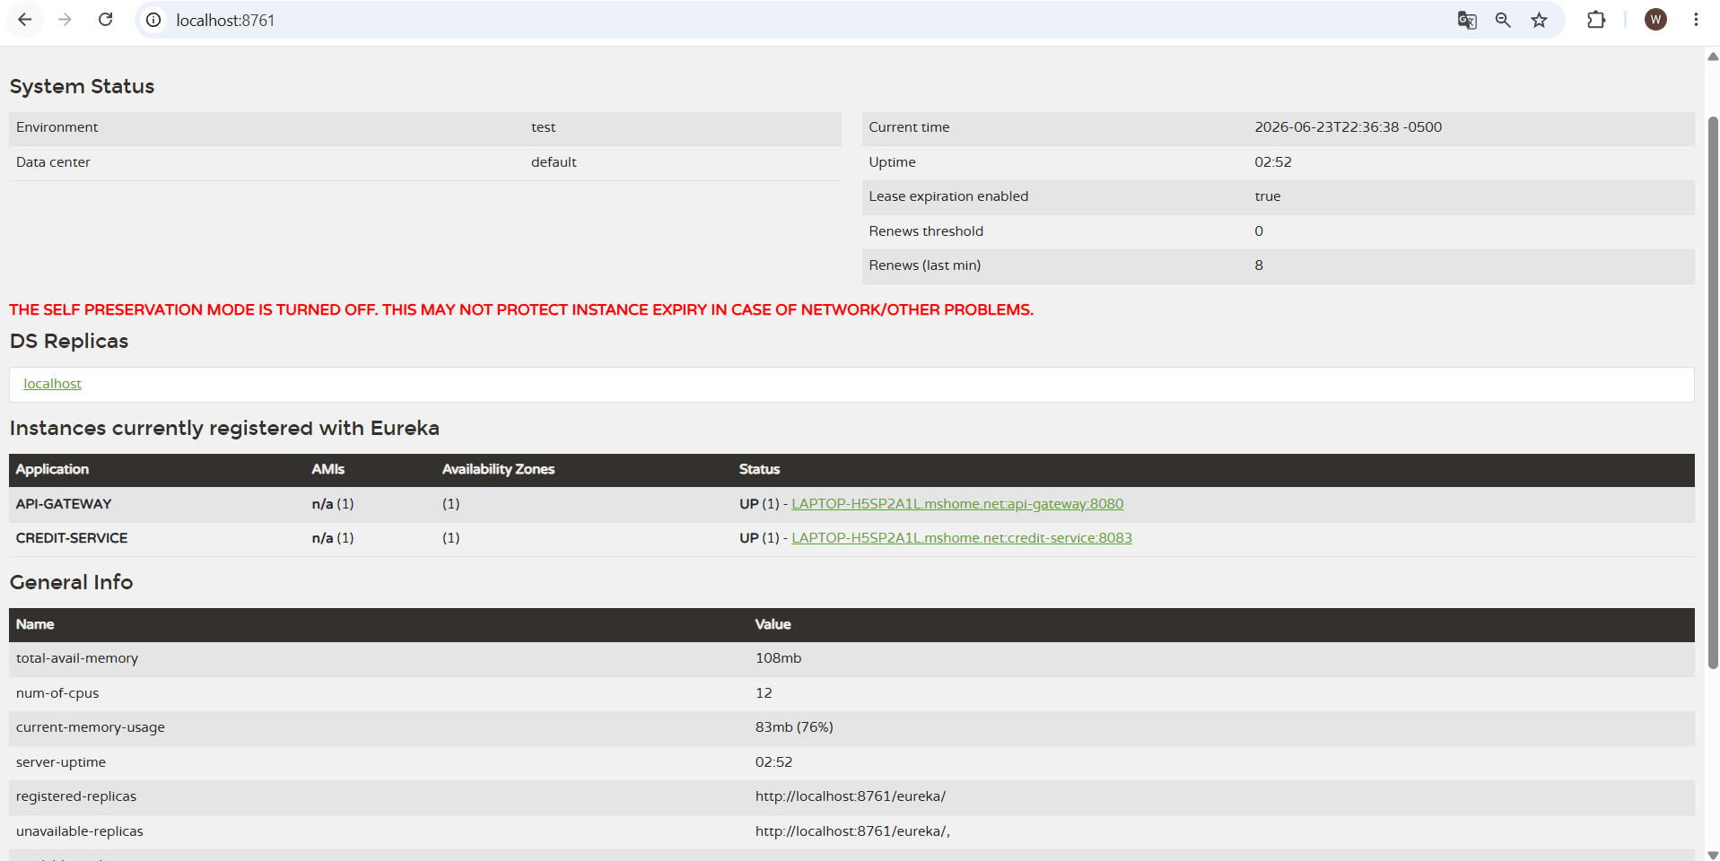
http://localhost:8888/credit-service/default
