Pruebas
Autor: Wilmer Alonso Romero Ampuero
Ejecutamos Config Server
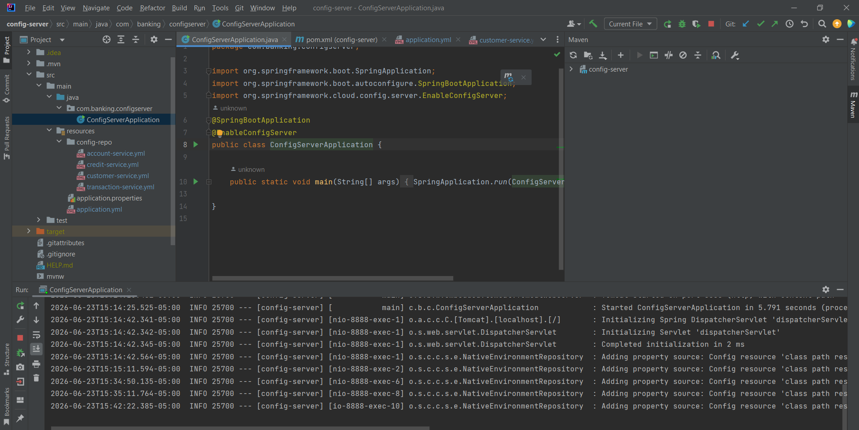
Vemos que se ha lanzado correctamente
Ejecutamos Eureka Server
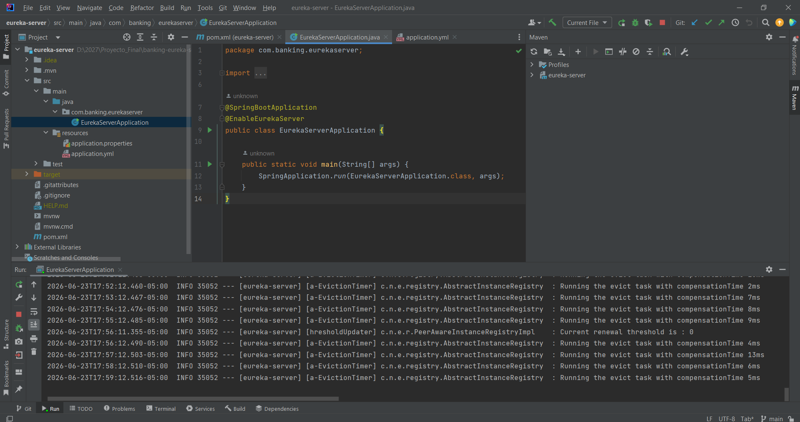
Ejecutamos API Gateway
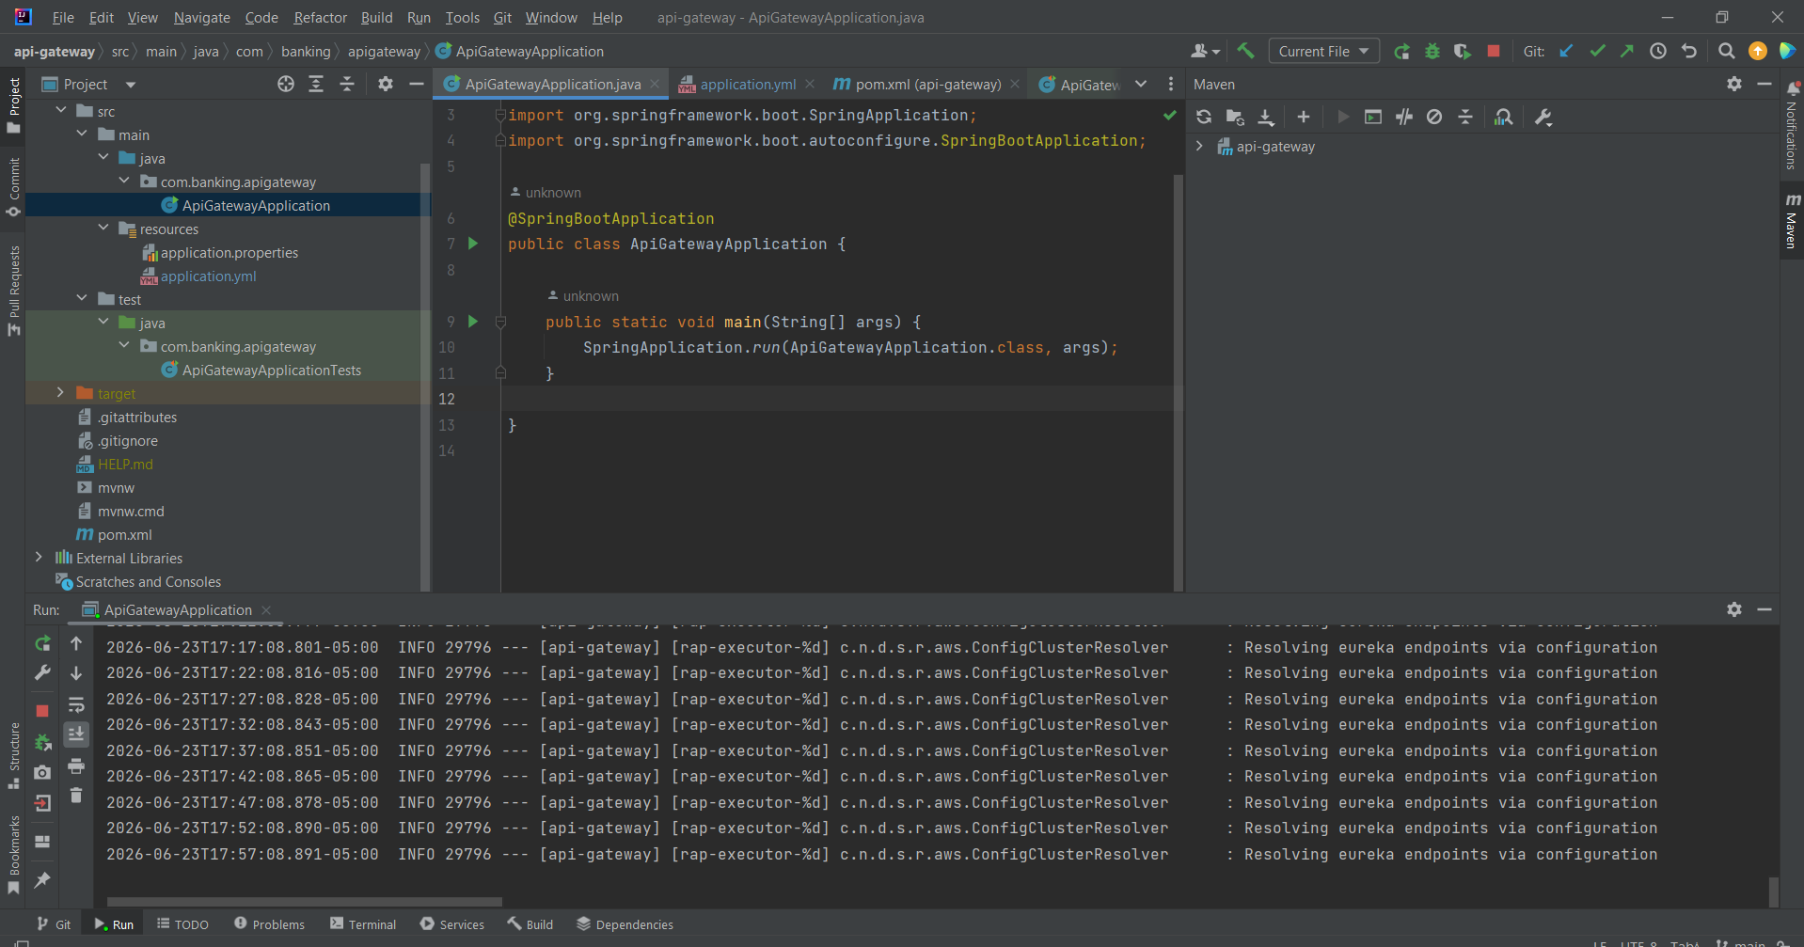
Verificamos si esta levantado
http://localhost:8888/customer-service/default
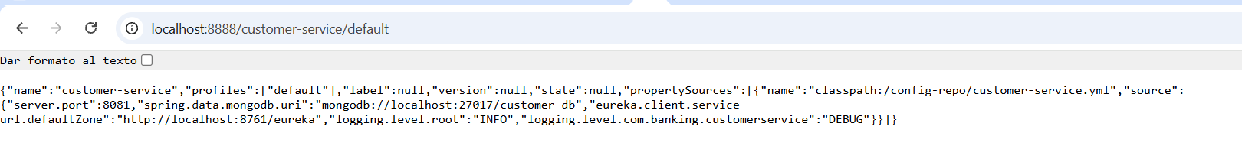
http://localhost:8888/customer-service.yml
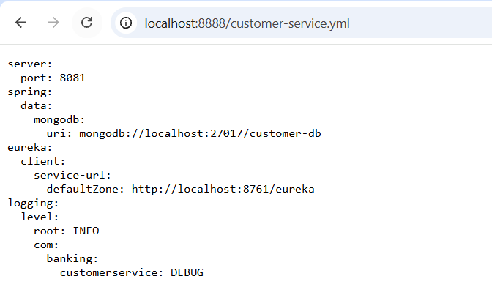
http://localhost:8761/
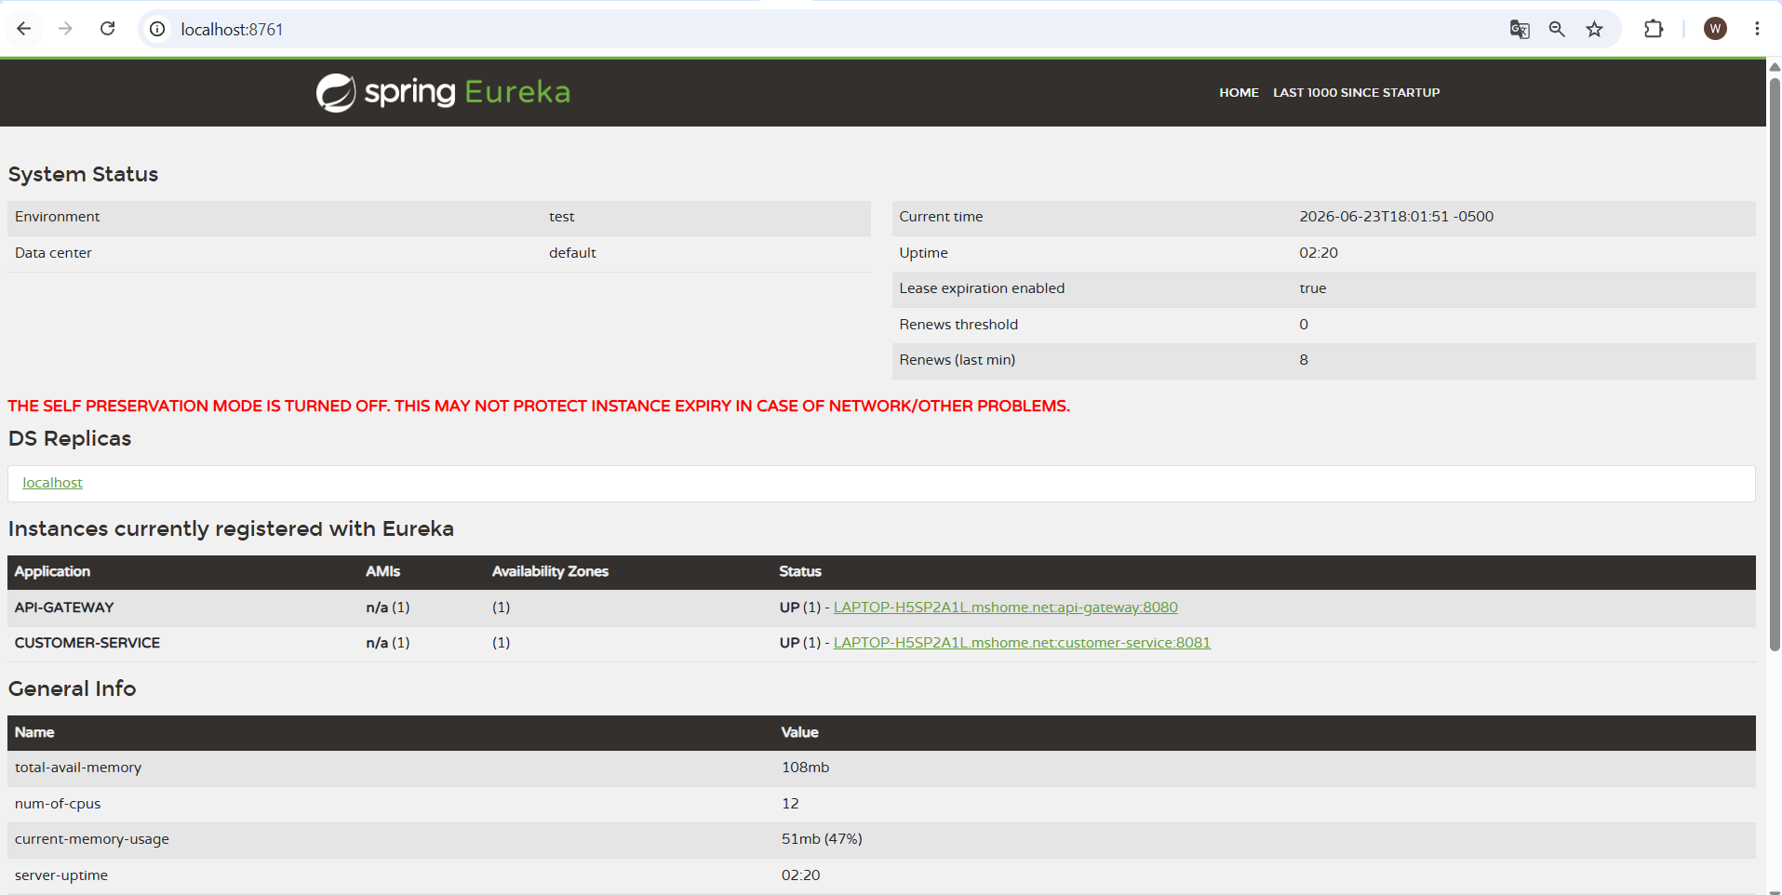
http://localhost:8080/actuator/health

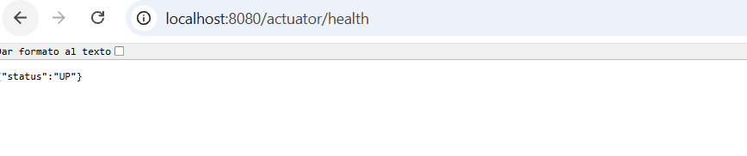

CUSTOMER CRUD
CREATE CUSTOMER

POST http://localhost:8080/api/customers
Content-Type: application/json
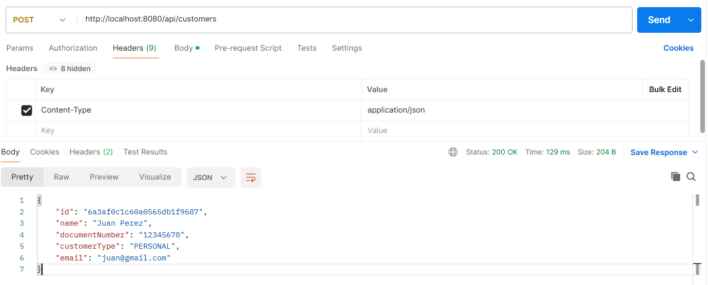
GET ALL CUSTOMERS
GET http://localhost:8080/api/customers
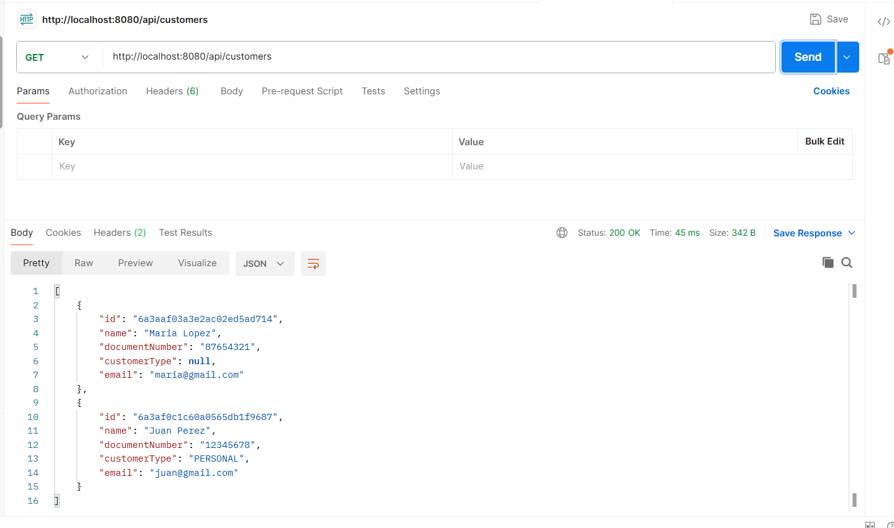
GET CUSTOMER BY ID
GET http://localhost:8080/api/customers/{id}
http://localhost:8080/api/customers/6a3aaf03a3e2ac02ed5ad714
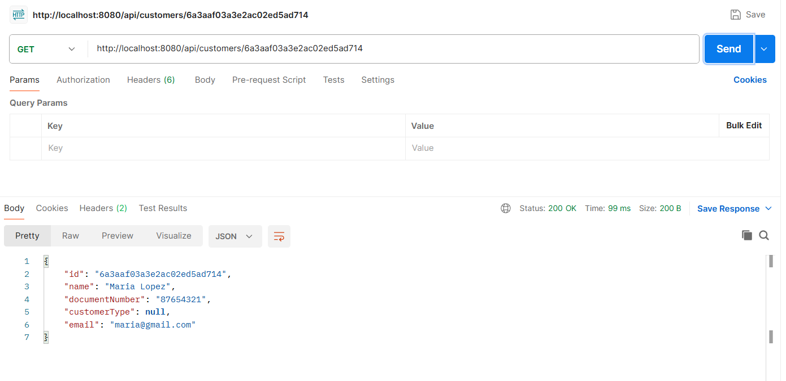
UPDATE CUSTOMER
PUT http://localhost:8080/api/customers/{id}
http://localhost:8080/api/customers/6a3aaf03a3e2ac02ed5ad714
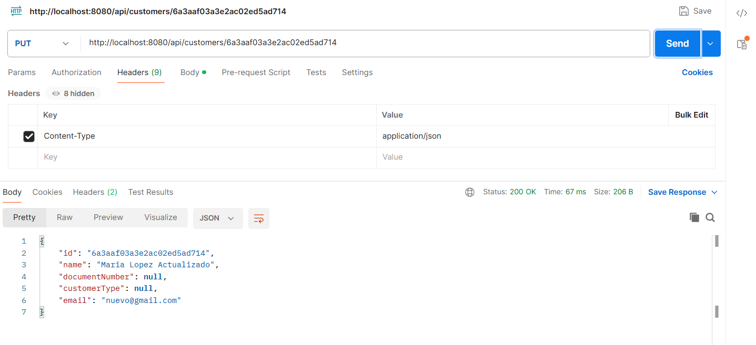
DELETE
http://localhost:8080/api/customers/{id}

http://localhost:8080/api/customers/6a3aaf03a3e2ac02ed5ad714

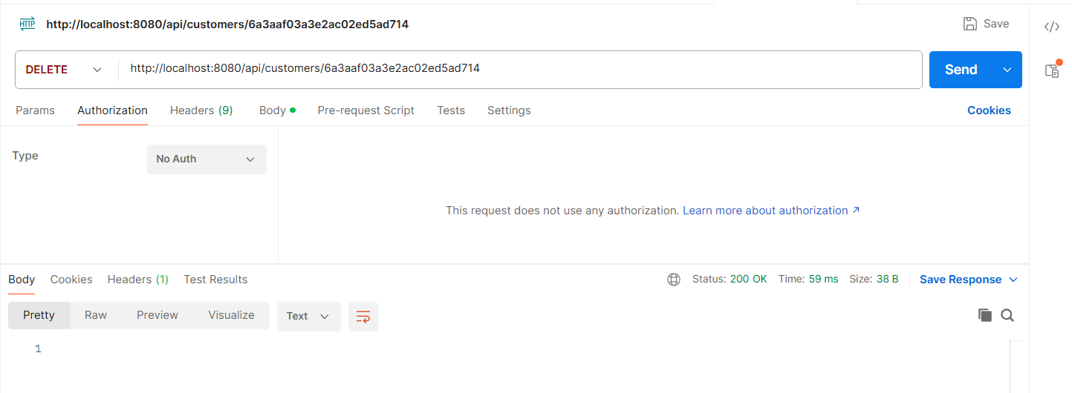
VOLVEMOS A LISTAR

