Testing
Pruebas de infraestructura
http://localhost:8761/
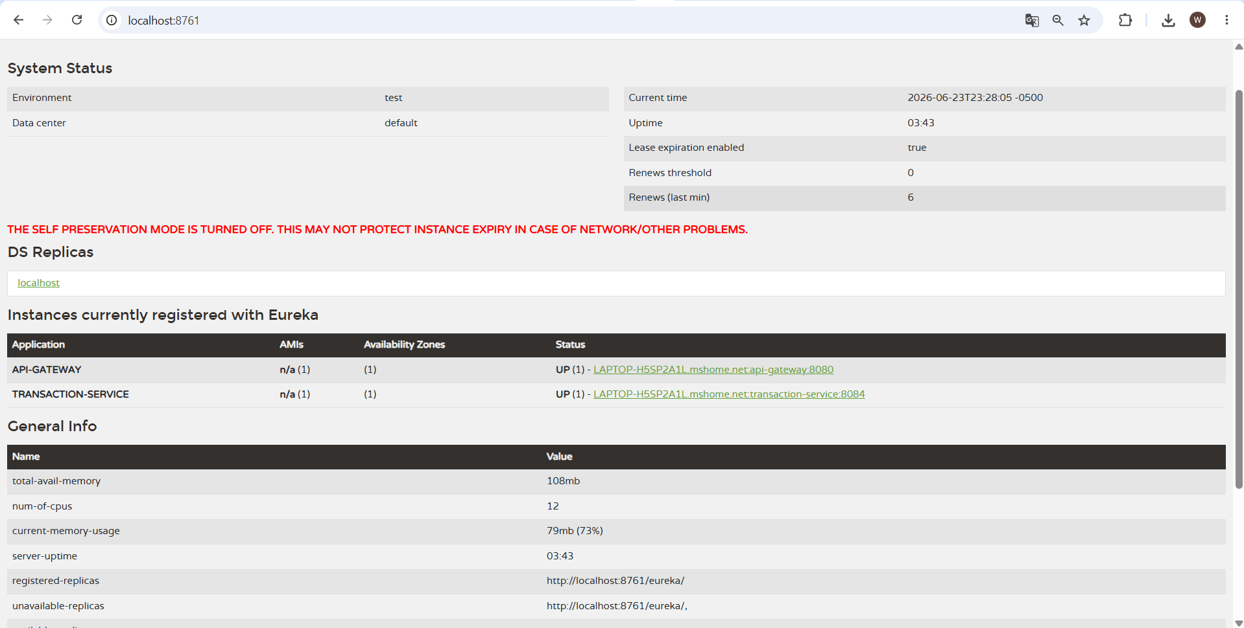
http://localhost:8888/transaction-service/default
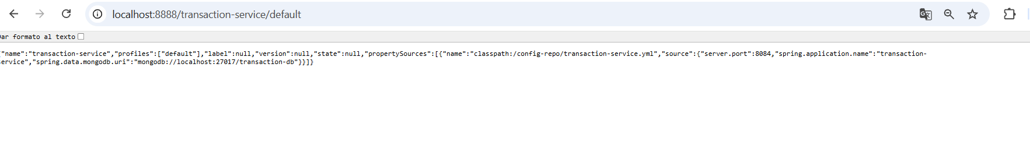

TRANSACTION SERVICE
Crear transacción (depósito / retiro)
POST http://localhost:8080/api/transactions
{
"customerId": " 6a3af0c1c60a0565db1f9687",
"accountId": " 66c123abc",
"type": "DEPOSIT",
"amount": 200
}
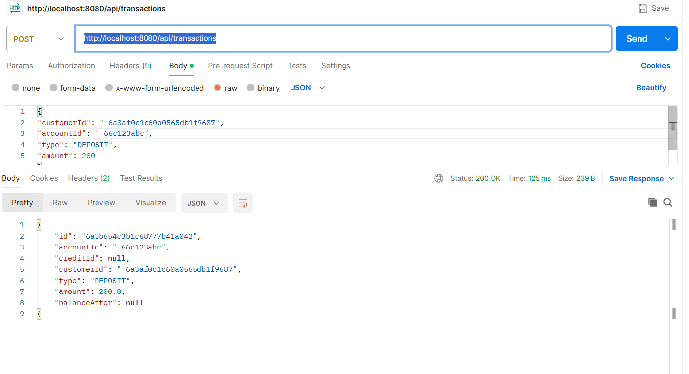
LISTAR TODAS LAS TRANSACCIONES
http://localhost:8080/api/transactions
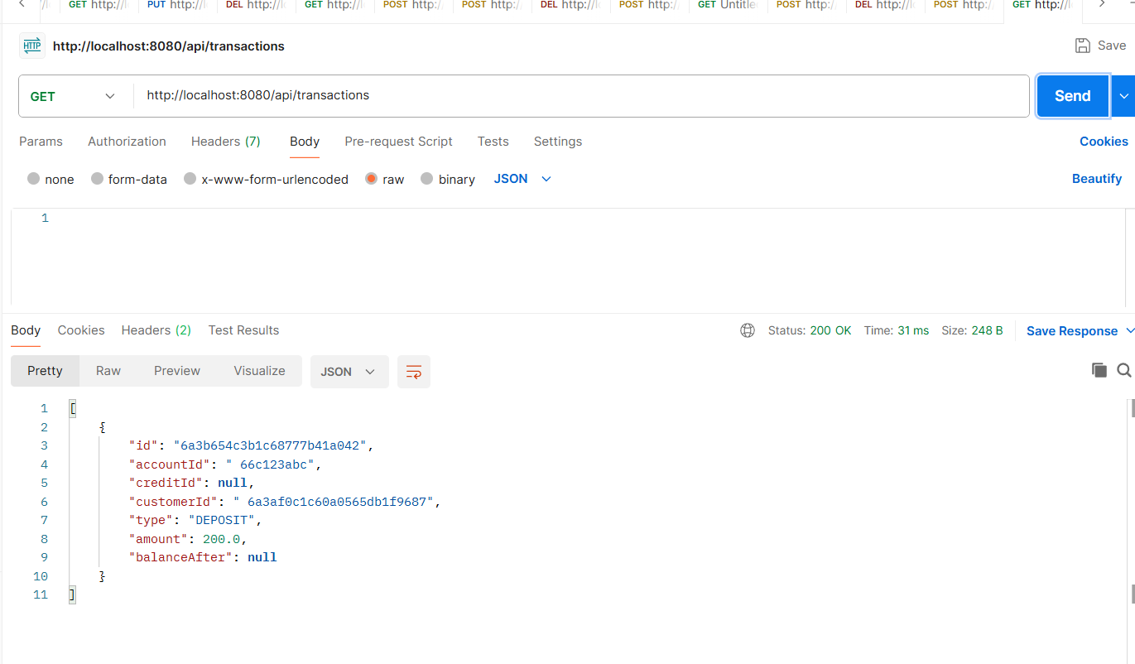
BUSCAR POR CUSTOMER ID
http://localhost:8080/api/transactions/customer/CUST-001
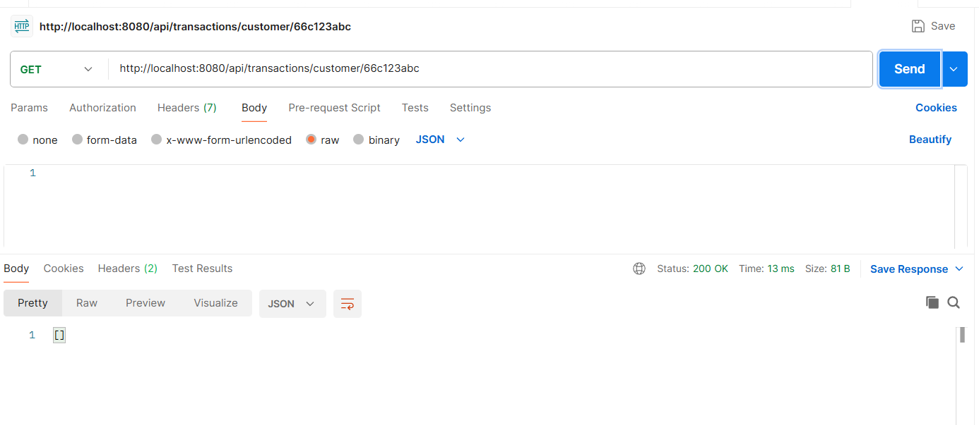
ACTUALIZAR TRANSACCIÓN
http://localhost:8080/api/transactions/6a3b654c3b1c68777b41a042
{
"accountId": " 66c123abc",
"customerId": " 6a3af0c1c60a0565db1f9687",
"type": "DEPOSIT",
"amount": 800.00
}

{
"id": "6a3b654c3b1c68777b41a042",
"accountId": " 66c123abc",
"creditId": null,
"customerId": " 6a3af0c1c60a0565db1f9687",
"type": "DEPOSIT",
"amount": 800.0,
"balanceAfter": null
}

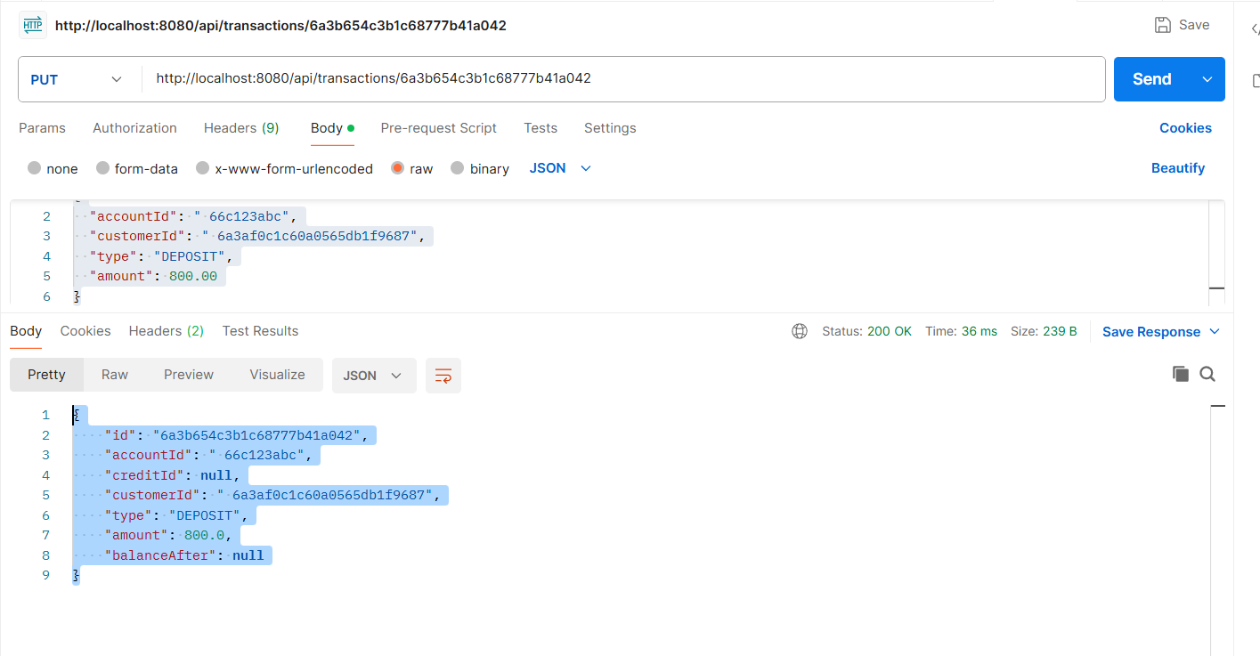
ELIMINAR TRANSACCIÓN
http://localhost:8080/api/transactions/{id}
http://localhost:8080/api/transactions/6a3b654c3b1c68777b41a042
