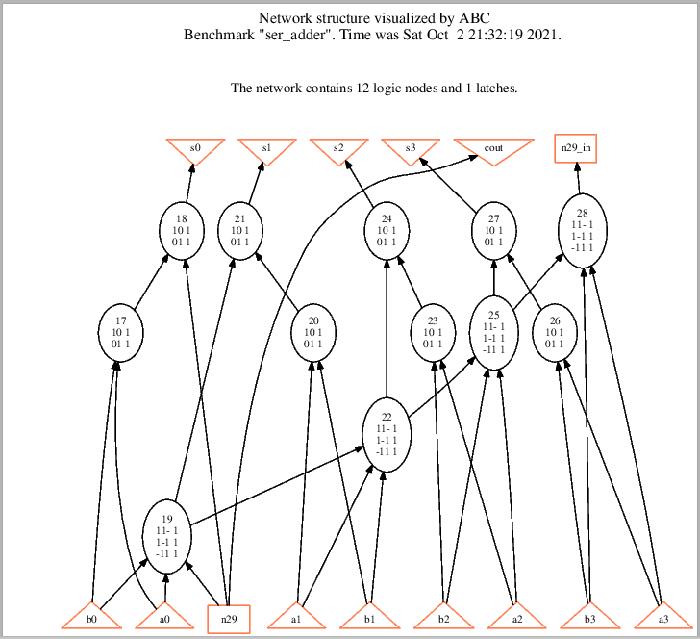
Logic Network

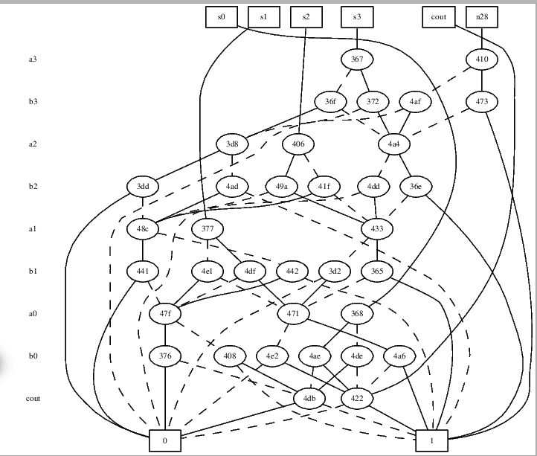

BDD, using collapsed

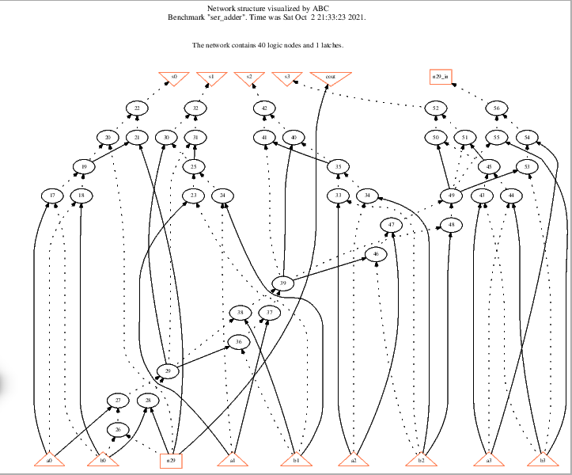

aig

(1) logic network in AIG (by command aig) vs. structurally hashed AIG (by command strash)

aig command convert the local function node in logic network to aig

strash command convert the global function into a aig

(2) logic network in BDD (by command bdd) vs. collapsed BDD (by command collapse)
bdd command convert the local function node in logic network to bdd
collapse command build the global bdd for global function
(3) Given a structurally hashed AIG, find a sequence of ABC command(s) to covert it to a logic network with node function expressed in sum-of-products (SOP)
using command $logic

