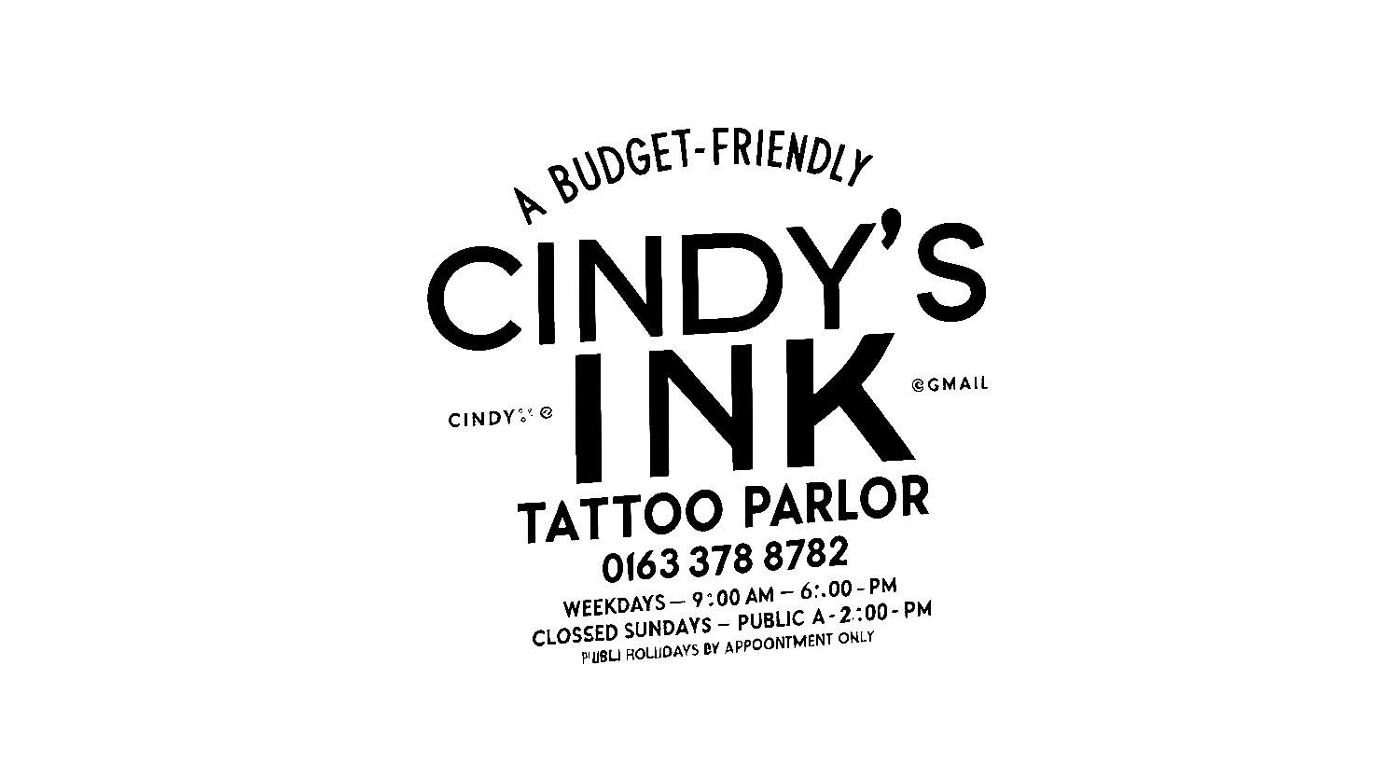
INVOICE
DATE: 12 April 2025
INVOICE NO: 1001
FOR: Tattoo
BILL TO: shannonvos@icloud.com

DESCRIPTION | AMOUNT
Pijon tattoo in colour + wine glass | R1600
Pijon, wine glass + dinosaur | R1400
Late penalty Shannon forfeit deposit | R800
SUBTOTAL | R3800
TAX
OTHER | CASH
TOTAL | R3800

