Sr W.W. Matthee  HSM(PgDip) · Gen Nur · Psych · Midv · Com Nur (R425)  CLINICAL GOVERNANCE LEAD | NURSE SPECIALIST | CASE MANAGER  SANC Reg: 15831886 | No Criminal Record |  |  | 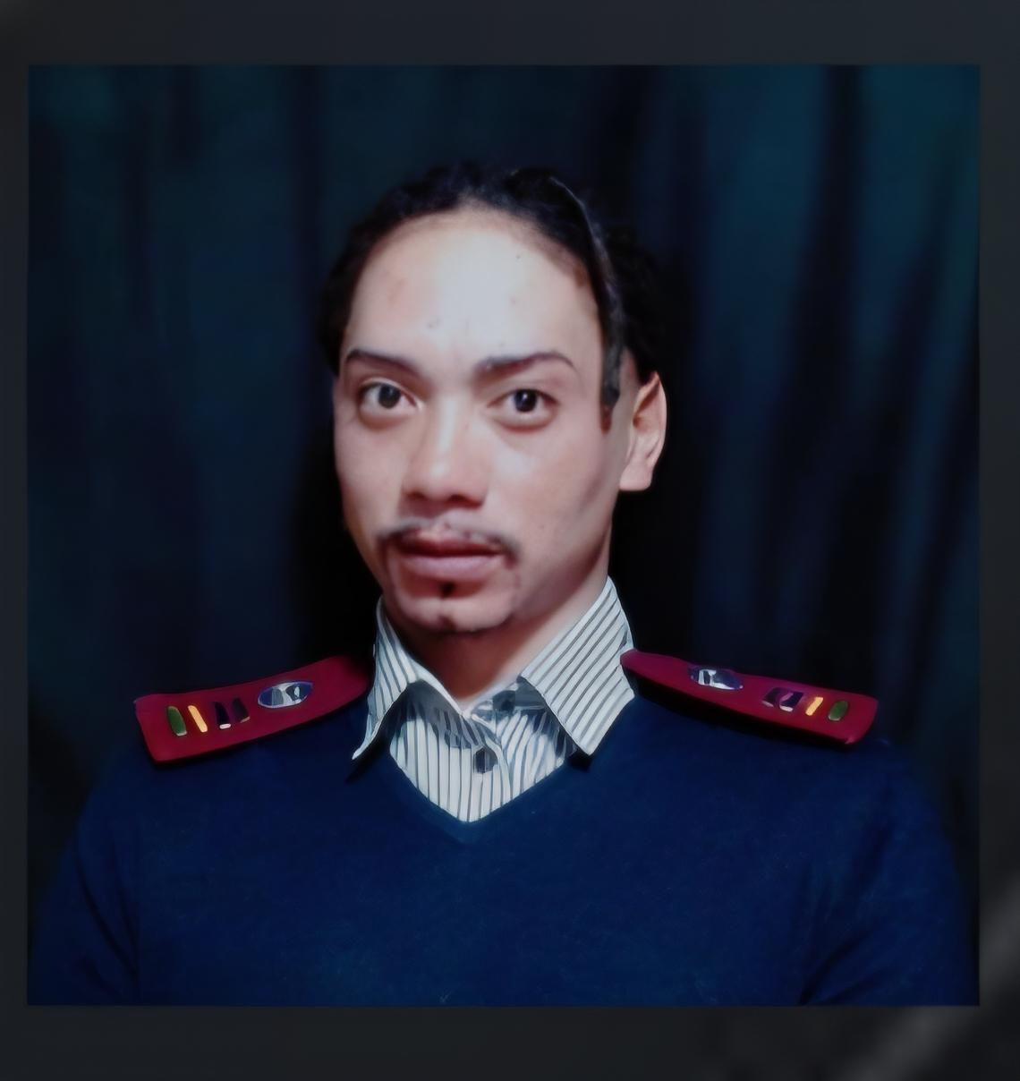
✆ 069 635 1435 | info@ethichawks.co.za | www.ethichawks.co.za | LinkedIn Profile

PROFESSIONAL PROFILE
Clinical Governance and Compliance Professional with 16+ years of experience engineering regulatory frameworks, conducting forensic audits, and driving quality assurance. Specialist in identifying structural integration gaps and operationalizing ICH-GCP standards. Combines clinical domain expertise with risk architecture to build governance models that function in reality, not just on paper.
​Guiding Principle: True accountability is not occasional; it is structural
Demonstrated track record of leading interdisciplinary teams, engineering CPD and governance frameworks, managing complex clinical trials to ICH-GCP standards, and delivering compassionate, patient-centred care across diverse South African healthcare settings. Currently advancing expertise through a Postgraduate Diploma in Occupational Health Care Nursing at CPUT (2026) on hold.

PERSONAL DETAILS

Full Name: | Wilbur William Matthee |  | Identity No: 890903 5151 087
Primary Email: | info@ethichawks.co.za |  | SANC Reg: 15831886
Secondary Email: | wilburmat@gmail.com |  | Criminal Record: None
Location: | 15 Bellevue Street, Voorbrug, Cape Town, 7100 |  | Driver's Licence: Code B

CORE COMPETENCIES & SKILLS

Systems Architecture | ICH-GCP & Clinical Governance | Case Management & Utilisation Review
Emergency & Critical Care Nursing | Clinical Trial Management (EDC/IWRS) | Infection Prevention & Control
Risk Stratification & Readmission Prevention | ALCOA+ Data Integrity Standards | Interdisciplinary Team Leadership
Palliative & End-of-Life Care | Regulatory Compliance (Nursing Act 33/2005) | CPD Framework Design & SANC Compliance
Forensic Audit & Governance Architecture | Health Information Systems (HIS/EMR) | Conflict Resolution & Crisis Intervention
Occupational Health Nursing (on hold) | Advanced Wound Care & Phlebotomy | Patient & Family Education

PROFESSIONAL EXPERIENCE
​Founder & Forensic Governance Architect | EthicHawks (Sep 2025 – Present)
​Design and execute customized corporate governance audits and Root Cause Analyses (RCA) for systemic safety failures.

Case Manager | May 2024 – December 2025
Afrocentric Health | Medscheme | GEMS | Cape Town

Key Achievements & Responsibilities:
- Served as Acting Chairperson of the Employee Health and Safety Committee and Lead First Aider, providing oversight and emergency leadership for 13 staff members across 3 floors.
- Coordinated comprehensive care pathways for a diverse patient load, ensuring seamless transitions from acute care to rehabilitative and home-based settings, optimising Length of Stay (LOS) and cost-efficiency.
- Spearheaded the design and launch of a proprietary Business CPD Framework automating tracking and compliance of nursing staff CPD, ensuring 100% alignment with the SANC 2024/2025 phased-in mandate (15 annual CPD points per practitioner) and mitigating registration lapse risk.
- Architected a forensic governance model monitoring CPD point accrual and standardised Portfolio of Evidence (PoE) protocols, facilitating seamless submission of SANC Forms 5, 6, and 7 for all clinical staff.
- Navigated complex managed-care ecosystems to secure authorisations and approvals, minimising claim denials and financial risk to the facility.
- Developed and implemented risk-stratification tools to identify high-risk patients, significantly reducing 30-day readmission rates through proactive intervention strategies.
- Led interdisciplinary case conferences involving physicians, nursing staff, and allied health professionals to align clinical goals with patient-centred outcomes.
- Ensured 100% compliance with clinical governance frameworks and statutory health regulations, maintaining audit-ready documentation at all times.
- Integrated regulatory compliance audits into the CPD framework, enabling real-time oversight of nursing credentials per the Nursing Act (Act No. 33 of 2005).
- Spearheaded interdisciplinary training programmes serving as 'Double-Duty' activities — providing clinical value while fulfilling the Development tier of the SANC CPD grid for maximum point output.
- Facilitated family and patient education sessions, empowering stakeholders to make informed decisions regarding long-term care and palliative options.
Key Competencies: Clinical Governance · Risk Architecture & Forensic Auditing · HIS/EMR Proficiency · South African Healthcare Legislation · NQF Level 8 Management Standards · Conflict Resolution · Crisis Intervention · Strategic Communication
Reference: Allison Philander | +27 78 028 0697

Study Nurse / Clinical Research Coordinator | Jan 2022 – Apr 2024
Clinical Research Site · Cape Town

Key Achievements & Responsibilities:
- Established audit-ready site protocols: engineered standardised site-visit readiness checklists ensuring 100% compliance during Sponsor and CRO monitoring visits, significantly reducing frequency of major findings and minimising Time-to-Close on monitoring reports.
- Directed end-to-end execution of Phase II/III clinical trials in strict accordance with ICH-GCP (International Council for Harmonisation – Good Clinical Practice) and specific sponsor protocols, maintaining zero protocol deviations across the study lifecycle.
- Conducted pre-emptive internal audits of the Trial Master File (TMF) and Investigator Site File (ISF), ensuring data cleanliness and perpetual site-visit readiness.
- Managed complex inventory systems for Investigational Products (IP) and lab kits, implementing a just-in-time stock methodology that eliminated expiration wastage and prevented trial delays due to stock-outs, preserving cold-chain integrity for all biological samples.
- Streamlined source document capture and Electronic Data Capture (EDC) query resolution, achieving a <24-hour turnaround time for data entry and verification — directly accelerating trial progress toward database lock and regulatory submission.
- Ensured all Adverse Events (AE) and Serious Adverse Events (SAE) were reported within the strict 24-hour statutory reporting window, safeguarding patient safety and regulatory compliance.
- Applied ALCOA+ principles (Attributable, Legible, Contemporaneous, Original, Accurate) across all data lifecycle management activities, improving overall data integrity scores.
- Managed forensic integrity of trial data and specimen storage, maintaining temperature-controlled environments and restricted-access protocols aligned with POPIA and international data protection standards.
- Conducted rigorous patient screening and enrolment oversight, maximising patient retention and ensuring protocol adherence throughout the trial.
- Obtained certifications in Good Clinical Practice (International & South Africa), Good Clinical Laboratory Practice, IATA ISSR, Human Subject Protection, and CPR for Health Professionals (all 2022).
Key Competencies: Clinical Governance · HIS/EMR Proficiency · South African Healthcare Legislation · NQF Level 8 Management Standards · Conflict Resolution · Crisis Intervention · Strategic Communication
Reference: Wendy Wakens | +27 72 539 3711

Community & Palliative Care Nurse | January 2023 – September 2023
St Luke's Combined Hospices · 92 Harfield Road, Kenilworth, 7708

- Delivered compassionate end-of-life care, assessing and managing pain and symptom control in collaboration with multidisciplinary advisory teams.
- Developed and implemented individualised nursing plans aligned with patient interdisciplinary team goals; prepared patients and families for end-of-life transitions.
- Provided after-hours and weekend on-call support, maintaining continuity of care for patients and families in the community.
- Maintained meticulous patient records in compliance with legal requirements and SLCH organisational guidelines.
Key Competencies: Clinical Governance · Palliative Clinical · Multidisciplinary Risk Mitigation · Clinical Record Compliance · Care Pathway Architecture · Symptom Management & Triage · Psychosocial Support & Communication · SLCH Regulatory Adherence
Reference: Palliative Care Manager – Ms. Maryna Boddenberg | 079 172 3044

Professional Nurse – Shift Lead (Emergency Department) | March 2020 – June 2022
Mitchell's Plain District Hospital · 8 AZ Berman Road, Mitchells Plain, 7789

- Led emergency nursing operations during the COVID-19 pandemic first and second waves, providing advanced life support including CPR, defibrillation, and intubation for critically ill patients.
- Managed triage, monitoring of vital signs, wound care, blood draws, and medication administration for high-acuity, undifferentiated emergency presentations.
- Received formal written commendation from Dr. PMJ Ohm for exemplary clinical knowledge, shift leadership, patient dignity, and de-escalation skills in a high-pressure emergency environment.
- Earned Excellence in Customer Service Award (2019, Surgical Department) for outstanding patient-centred care.
Key Competencies: Emergency Protocol Compliance · Crisis Management & Pandemic Response · Triage Risk Stratification · High-Acuity Operations Leadership · Conflict De-escalation · Medication Governance · Quality Assurance & Patient Dignity Standards
Reference: Operational Manager Emergency – Sr. Nomvuso Willie | 071 445 4604
Reference: Emergency Medical Consultant – Dr. Katya Evans | 084 209 2856

Professional Nurse – Shift Lead (Surgical Ward) | August 2018 – March 2020
Mitchell's Plain District Hospital · Mitchells Plain, 7789

- Supervised and co-ordinated ward personnel, delegating duties according to level of training and competence; scheduled shifts and managed time-off to ensure optimal staffing.
- Performed clinical duties including dressing changes, IV cannulation, catheterisation, and medication administration; monitored vitals and reported adverse reactions promptly.
- Ensured compliance with hospital policies and procedures; undertook facility management responsibilities after-hours and over weekends.
Key Competencies: Perioperative Clinical Governance · Workforce Resource & Scope Compliance · After-Hours Facility Leadership · Pharmacovigilance & Incident Reporting · Clinical Supply Chain & Inventory Risk · Pre/Post-Op Pathway Oversight · Hospital Policy Enforcement
Reference: Operational Manager – Sr. Toni / Sr. Mariella Martin Standhardt | 084 261 6567

Clinical Nurse | January 2017 – July 2018
Clicks Retailers – The Paddocks · 9 Racecourse Road, Milnerton Ridge, 7441

- Managed a commercially viable retail clinic providing primary health care, phlebotomy, reproductive health, adult and infant immunisations, lifestyle screening, and wound care.
- Conducted Well-Baby clinics including growth monitoring and immunisation programmes; planned and implemented Health Day community outreach events.
Key Competencies: Commercial Healthcare Operations · Revenue Generation & Business Viability · Primary Care Clinical Governance · Public Health & Immunisation Compliance · Strategic Community Outreach · Preventative Health Risk Screening · Retail Operational Compliance
Reference: Sr. Brusset Du Plessis | 079 172 3044

Community Service Nurse | August 2015 – July 2016
Harry Comay Hospital · Sandkraal Road, George, 6536

- Provided specialised community service care for patients with multi-drug resistant (MDR) and extreme drug resistant (XDR) TB, including Direct Observed Therapy (DOT), strict drug scheduling, and co-infection management (HIV).
- Coordinated multidisciplinary team interventions including blood draws, sputum collections, eye and auditory testing, and social/psychological referrals.
Key Competencies: Infectious Disease Protocol Compliance · Pharmacovigilance (MDR/XDR-TB & DOT) · Multidisciplinary Clinical Governance · Scheduled Medication Oversight · Diagnostic Pathway Integrity · Psychosocial Risk Mitigation · Public Health Regulatory Adherence
Reference: Nursing Services Manager – Sr. Linda Geweld | 084 732 5408
EDUCATION & QUALIFICATIONS

Postgraduate Diploma: Occupational Health Care Nursing | 2026 (Accepted)
Cape Peninsula University of Technology (CPUT)
Head of Department: To be confirmed | Currently on Hold
Postgraduate Diploma: Primary Care Nursing | Feb 2023 – Dec 2024
Cape Peninsula University of Technology (CPUT)
Head of Department: Dr. Odilia Sehume | Part-time study |on Hold
Postgraduate Diploma: Health Services Management (HSM) | Jan 2022 – Dec 2022
Cape Peninsula University of Technology (CPUT)
Head of Department: Prof. Karien Jooste
BTech / Diploma: Nursing Science | Jan 2010 – Jul 2015
Western Cape College of Nursing / Cape Peninsula University of Technology
Specialisations: General Nursing · Psychiatry · Accoucheur (Midwifery) · Community Nursing (R425) | Principal: Dudley Govin
Senior Certificate (Matric) | 2008
Sao Bras High School
Principal: Mrs. Chantal Briesies

PROFESSIONAL CERTIFICATIONS

- Good Clinical Practice – International (Sep 2022) | - Good Clinical Practice – South Africa (Sep 2022)
- Good Clinical Laboratory Practice (Sep 2022) | - IATA – Infectious Substances Shipping Regulation (Sep 2022)
- Human Subject Protection (Oct 2022) | - Cardiopulmonary Resuscitation for Health Professionals (Dec 2022)
- TB/MDR-TB Management – Stellenbosch University (2019) | - Family Planning & Contraceptives – Dept. of Health (2018)
- Contraception & Fertility Planning – Momentum (2018) | - Advanced Wound Care – Smith & Nephew (2017)
- Clinical Management of Drug-Sensitive & Drug-Resistant TB (2015) | - IMCI – Cape Peninsula University of Technology

ACHIEVEMENTS & RECOGNITION
- Excellence in Customer Service Award – Mitchell's Plain District Hospital, Surgical Department (2019)
- Formal written commendation by Dr. PMJ Ohm (Emergency Medical Officer) for clinical excellence, leadership, and patient dignity standards during COVID-19 pandemic response.
- Cape Peninsula University of Technology Postgraduate Quality Desk Member (2022) – recognised for academic contribution to postgraduate programme quality assurance.
- Acting Chairperson – Employee Health and Safety Committee; Lead First Aider for 13 staff across 3 floors (2024–2025).

COMPUTER & SYSTEMS PROFICIENCY
Microsoft Office Suite (Word, Excel, PowerPoint, Outlook) | Clinicom | HECTIS | Xero Viewer | Allegra | Unisolv | REDCap (Clinical Research Database) | Electronic Data Capture (EDC) Systems | Interactive Web Response Systems (IWRS) | Electronic Medical Records (EMR) | Health Information Systems (HIS) | Gexus/Nexus | DMS (Disease Management System |(Artificial intelligence) Co-Pilot | Gemini | Kimi | Deepseek | Claude by Antrophic | Grok |Github | Supabase | Cloudflare | Stackblits | Evernote |NotebookLM | Web development and code writing

Sr W.W. Matthee | info@ethichawks.co.za | 069 635 1435 | www.ethichawks.co.za

