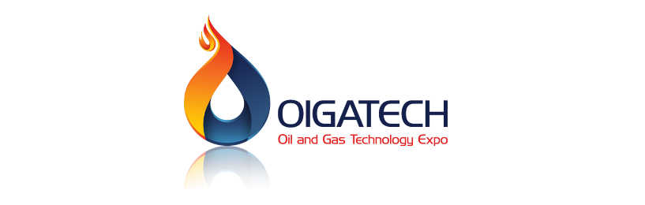

**اللوكو الرئيسي**

**هيدلاين المعرض**

Iraq Oil and Gas Technology Exhibition “OIGATECH 2025”

**شورت وورد جوة الهيد لاين**

Iraq Oil and Gas Technology Exhibition for the period from 1-6 June 2025 on the grounds of Baghdad International Fair.

**اللوكوات اسفل الفورم**

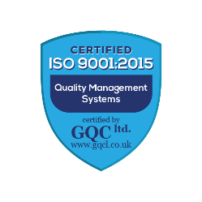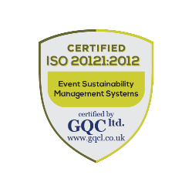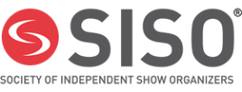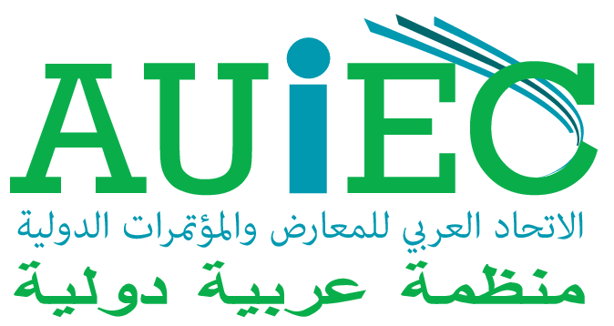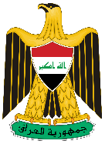

Member of

ISO

Organized By

Host Venue

In association with

Sponsored by

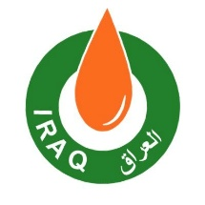

****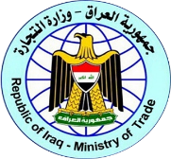

**لينكات السوشيال ميديا**

**Instagram**

**LinkedIn**

**Facebook**

https://www.instagram.com/oigatech.iq?igsh=enM3YmJqZHVlandp

https://iq.linkedin.com/showcase/oigatechiq/

https://www.facebook.com/share/15kykiAxfu/?mibextid=wwXIfr

**رقم الهاتف:**

+964 7702 444 844

**ايميل:**

[info@oigatech.iq](mailto:info@oigatech.iq)

**ترتيب الفورم**

First Name:

Last Name:

Position:

Company Name:

Country:

Participation Type: (Exhibitor – Visitor – Press – Organizer)

Phone Number:

Email:

Photo:

**Submit:**