POLYVORTEX — A Research Monograph
The N-vortex generalization of Theorem 3.1: the classical layer, the admissibility threshold, the kinematic obstruction and the averaged-frequency bridge
Isaev Iskhak Khamzatovich (ORCID 0009-0003-7299-0701)
TRIVORTEX Research Program · the polyvortex mini-repository · v1.1.0 · Theorem Monograph Edition
Study | POLYVORTEX
Program | TRIVORTEX — the three-body (and N-body) problem in the vortex model
Author | Isaev Iskhak Khamzatovich (ORCID 0009-0003-7299-0701)
DOI | 10.5281/zenodo.21825394
Version | 1.1.0 — the theorem monograph edition
Date | 2026-10-08
Code | polyvortex/python/polyvortex/ (model · ansatz · classical · ladder · runner · figures)
Data | polyvortex/results/protocols/W1..W7_default.json
License | LicenseRef-Proprietary-Wild8Highlander-1.0
Table of Contents
Abstract
Abstract 1
1. Scope and provenance 1
2. The two layers of the Trivortex model 2
3. The classical layer at general N: relative equilibria 3
4. The generalized closed form: Hypothesis H1 and its registers 5
5. Admissibility of the closed form: Theorem B 6
6. The kinematic obstruction: Lemma C 7
6.1 The symmetric pulsation case 7
6.2 The phase-shifted H1 case 8
6.3 Numerical remark: the defective zero 9
7. The averaged-frequency bridge: Lemma D and the D1 design rule 9
8. From observations to theorems: the formalization queue 10
9. Numerical protocol summary 11
10. Honesty notes 12
11. Резюме (RU) 13
References 13

Note: this Table of Contents is generated via field codes. After editing, right-click the TOC and select "Update Field" to refresh the page numbers.

Abstract
This monograph extends the parent TRIVORTEX framework from the three-vortex Lagrange setting to an arbitrary number N of equal point vortices. The study is organized as a seven-stage ladder W1–W7 that mirrors the parent ladder V1–V4 and adds four research registers of its own. Three rigorous statements emerge, each with a proof or a decidable formalization path: Theorem B (the closed form of Theorem 3.1 is non-degenerate exactly when C_Ch > π ln 2, where its modulation amplitude equals ε = 1 in closed form), Lemma C (the Kirchhoff radial equation obstructs every symmetrically pulsating polygon: the induced radial velocity vanishes by pair cancellation, so pulsation is dynamically impossible for any N ≥ 2), and Lemma D (the cycle-averaged kinematic frequency of a pulsating regular polygon equals ω_N (1-ε²)^(-3/2), an integral identity certified numerically to 3 · 10⁻¹⁵). Together they yield the compatibility table D1 — the periods T_comp(N, C_Ch) at which the gauge frequency law of Theorem 3.1 meets the averaged Kirchhoff kinematics — and they surface one registered fact about the parent default: the pair (C_Ch, T) = (1, 2π) lies below the admissibility threshold π ln 2 ≈ 2.177586. All stages pass; the classical Havelock stability threshold (stable for N ≤ 7, unstable for N ≥ 8) is reproduced spectrally with a three-order margin.

1. Scope and provenance
The parent TRIVORTEX framework anchors its verification ladder on Theorem 3.1, a closed-form choreographic solution of the three-vortex model with the Chaplygin topological integral, and on the numerical conservation of the classical vortex integrals. The present mini-repository asks the natural next question — what survives the passage from N = 3 to general N? — and answers it with the same discipline that governs the parent: every claim is either proven, or certified by a committed JSON protocol, or explicitly labelled as a conjecture with the numbers that constrain it.
The work was prompted by a research discussion on how the three-vortex ansatz could be lifted to N vortices while keeping the hard structure — uniform phase separation 2π/N, radial modulation driven by C_Ch, and the frequency law ω = (2π/T) e^(C_Ch/π) — intact. No external material is quoted beyond the classical literature listed in the references; the analysis, the code and the protocols are original to this repository.
Three design rules separate this mini-repository from the parent ladder:
- Self-containment. Nothing here imports the parent ladder at runtime. The parent is touched only by tests (tests/conftest.py adds its path) for cross-validation — the same pinning discipline the parent applies to its multi-language ports.
- Two-layer honesty. The parent model lives on two layers — the Kirchhoff dynamics (Layer K, numerical) and the topological closed form (Layer G, analytic). Conflating them is the single most common source of false claims around Theorem 3.1; this monograph keeps them separated explicitly and measures precisely where they touch (Sections 6–7).
- Every number is bound to a run. Each ladder stage writes a deterministic JSON protocol into results/protocols/; the test suite re-derives the preset-independent registers and compares.

2. The two layers of the Trivortex model
Layer K (Kirchhoff dynamics). N point vortices with circulations Γₖ at positions zₖ = xₖ + i yₖ obey
The system carries the classical integrals — the Hamiltonian H = -(1/2π)Σ_i<jΓᵢΓⱼ ln rᵢⱼ, the linear impulses P = Σ Γₖ xₖ, Q = Σ Γₖ yₖ and the angular impulse I = Σ Γₖ |zₖ|² — which the parent ladder verifies along its trajectories (stages V3–V4) and this ladder re-verifies for every N (stage W3). The integrals are the window-independent conserved quantities of the model.
Layer G (the closed form of Theorem 3.1). The parent ladder registers the gauge-level solution
with the frequency and amplitude laws
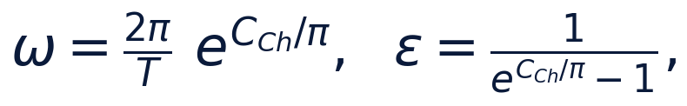
and the Section-6 diagnostic combination C_Ch(t) = r²(dotθ - q Atheta) with Atheta = 1/r. The parent ladder is explicit that this diagnostic oscillates by construction and is window-dependent; the pass registers of V1 are the angular separation and the periodicity of the closed form, not the diagnostic drift. This mini-repository keeps exactly that honesty convention (stage W1 reproduces the parent's registers and reports the same diagnostic behaviour, drift amplitude ≈ 15.01 over [0, 100 T] at the registered default, mirroring the parent's diagnostic).
The two layers are independent: Layer G prescribes kinematics, Layer K prescribes dynamics. A closed form becomes a claim about physics only after its compatibility with Layer K is established — and establishing precisely that, for general N, is the scientific payload of this monograph.
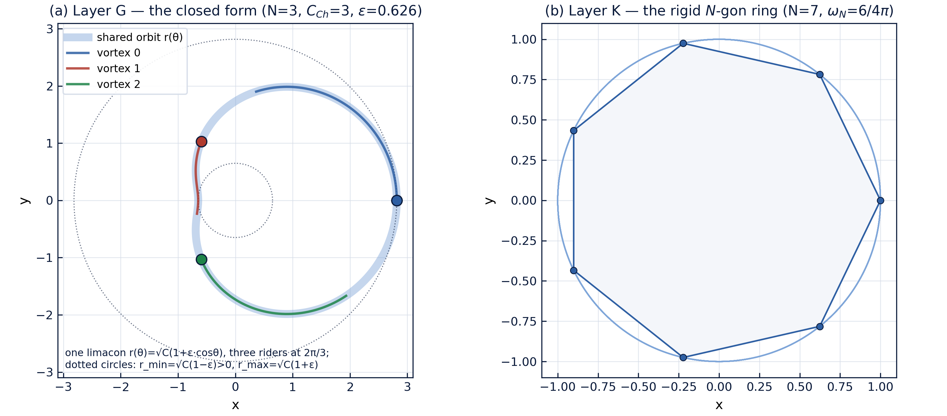
Fig. 1 — The two layers of the model: the Layer-G choreography (left) and the Layer-K rigid ring (right).

3. The classical layer at general N: relative equilibria
Theorem A (classical, Kirchhoff 1876). Let N ≥ 2 equal vortices of circulation Γ sit at the vertices of a regular N-gon of circumradius R. Then the configuration rotates rigidly about its centre with angular velocity
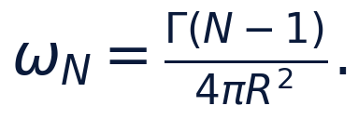
Proof sketch. At vertex k, pair the contribution of vertex j with its mirror image j' under reflection through the radial axis of k. Writing the chord directions explicitly, the radial components of the induced velocity cancel in each pair while the tangential components add. Summing the tangential parts over j ≠ k reduces to the roots-of-unity identity Σₘ₌₁^(N-1) (1)/(1 - e^(2π i m/N)) = (N-1/2), which turns the velocity sum into Γ (N-1)/(4π R) at radius R. Dividing by R gives the rate. □
The identity is exactly the formalization target the parent roadmap queues as T1 ("the roots-of-unity identity turns the velocity sum into algebra"); Theorem A is its numerical shadow, and stage W2 certifies it:
N | ω_N (analytic) | measured (RK4, 2 rotations) | rel. error | shape dev.
2 | 0.0795774715459 | 0.0795774715459 | 2.9e-12 | 2.4e-14
3 | 0.1591549430919 | 0.1591549430919 | 2.9e-12 | 2.7e-14
4 | 0.2387324146378 | 0.2387324146378 | 2.9e-12 | 2.3e-14
5 | 0.3183098861838 | 0.3183098861838 | 2.9e-12 | 2.9e-14
6 | 0.3978873577297 | 0.3978873577297 | 2.9e-12 | 3.0e-14
7 | 0.4774648292757 | 0.4774648292757 | 2.9e-12 | 3.3e-14
8 | 0.5570423008216 | 0.5570423008216 | 2.8e-12 | 1.4e-12

(Protocol W2_ring_rotation_default.json, Γ = 1, R = 1, 2000 steps/period.) A pleasant cross-ladder handshake: at N = 7, R = 1, Γ = 1 the rate is 6/(4π) = 3/(2π) = 0.477464829275686 — exactly the parent ladder's registered Lagrange literal ω_Lagrange. The coincidence is trivial algebra, but it makes a memorable pin between the two ladders and is locked by a unit test.
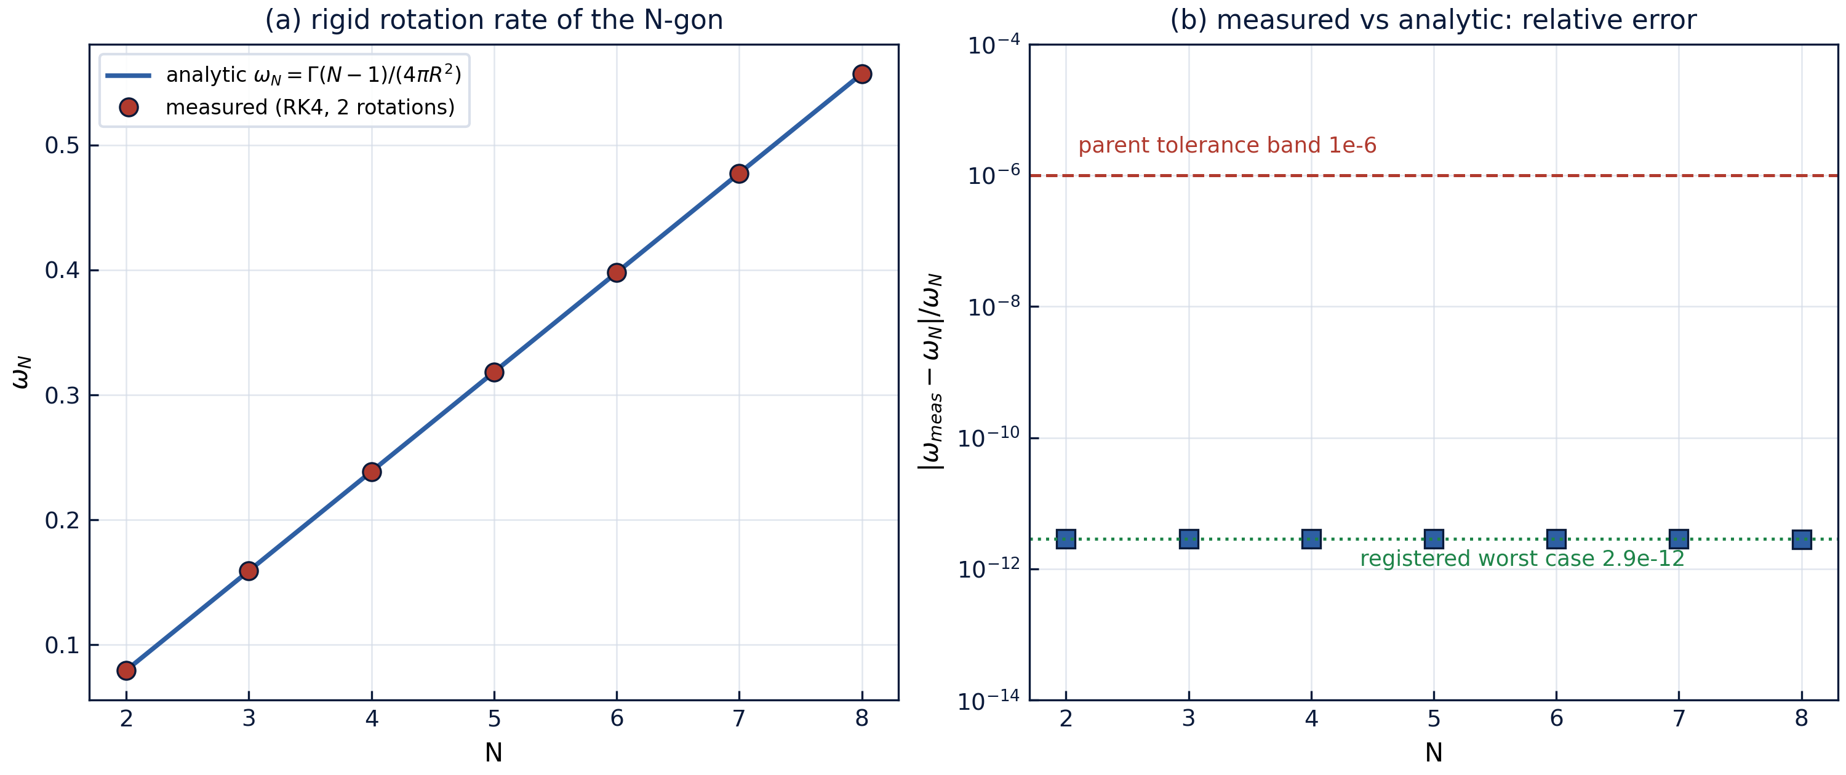
Fig. 2 — Stage W2: the rigid rotation register — analytic vs measured rate and the relative-error band.
Conservation along the orbits (stage W3). The relative drifts of H, P, Q, I after two full rotations stay below 4.2 · 10⁻¹⁴ for every N ∈ {2,…,8} — the parent's V3 register, reproduced for the whole ring family (protocol W3_invariants_default.json).
Spectral stability (stage W4). Linearizing Layer K at the co-rotating equilibrium — the Jacobian J = A + ω_N S with the analytic pair-Jacobian A and the transport generator S — yields the classical classification:
N | max Reλ | verdict | Havelock
2 | 6.9e-10 | stable | stable
3 | 0.0 | stable | stable
4 | 3.8e-9 | stable | stable
5 | 0.0 | stable | stable
6 | 0.0 | stable | stable
7 | 7.0e-9 | stable | stable
8 | +0.4502 | unstable | unstable

The threshold — stable for N ≤ 7, unstable from N = 8 — is the Havelock (1931) result, with Khazin's later rigorous treatment; the numeric margin is three orders of magnitude on both sides (the stable cases sit at the defective-zero noise floor, see the Remark in Section 6.3; the unstable N = 8 case grows at Reλ = 0.450). This stage is the numerical prototype of the parent roadmap item T3.
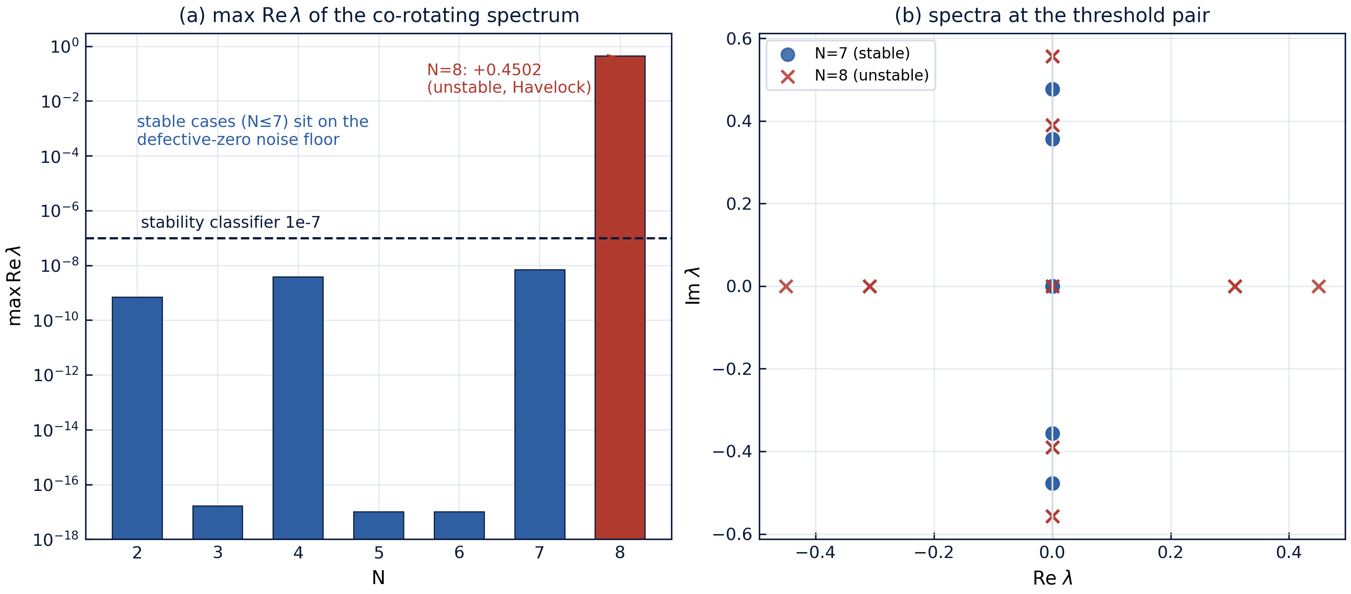
Fig. 3 — Stage W4: the Havelock threshold — growth rates across N and the spectra of the threshold pair.

4. The generalized closed form: Hypothesis H1 and its registers
Hypothesis H1 (working form). For N vortices with equal circulations and equal topological charges qₖ = q there exists a solution of the combined model of the form
with ω = (2π/T) e^(C_Ch/π) and ε = (1)/(e^(C_Ch/π) - 1).
The structural registers of the parent Theorem 3.1 generalize verbatim, and stage W1 certifies them at N = 3 against the parent's pinned literals:
- Uniform phase choreography. The angles differ by exactly 2π/N at all times; the register measures the deviation of the cyclic separations from 2π/N (protocol value 6.9 · 10⁻¹⁴, pure float noise of the modulo reduction, tolerance 10⁻¹²).
- Periodicity. rₖ(t + Tᵣ) = rₖ(t) with Tᵣ = 2π/ω; the residual is 9.4 · 10⁻¹⁴ (float noise of the cosine evaluation).
- Pinned literals. At C_Ch = 1, T = 2π the implementation reproduces the parent's registered frequency ω = e^(1/π) = 1.3748022274393588 bit-for-bit (anchor error 0.0), and likewise the amplitude ε = 2.668070477… (anchor error 0.0).
Two geometric observations, recorded because they matter for everything that follows:
- The angular register is N-generic; the radial one is not a polygon. For ε ≠ 0 the radii of the N vortices differ (rₖ carries the phase 2π k/N), so the instantaneous configuration is not a regular polygon — it is a star-shaped configuration with uniformly spaced directions but unequal radii. The "regular N-gon" picture survives only at ε = 0 instants. The shape register of stage W6 quantifies exactly this (Section 6.2).
- The gauge diagnostic survives at any N. The combination C_Ch(t) = r²(dotθ - q/r) stays a well-defined diagnostic along the closed form for every N and keeps oscillating by construction, as in the parent.

5. Admissibility of the closed form: Theorem B
The amplitude law ε(C_Ch) = 1/(e^(C_Ch/π) - 1) is monotonically decreasing on C_Ch > 0, from +∞ to 0. The closed form describes a rotating configuration with positive radii only while 1 + ε cosφ > 0 for all φ, i.e. while ε < 1. Solving the boundary exactly:
Theorem B (admissibility). The closed form of Theorem 3.1 (and of Hypothesis H1 at any N) has strictly positive radii for all times and all vortices if and only if
At $C_{Ch} = C_{Ch}^{}the amplitude is exactly\varepsilon = 1and each radius touches zero once per period; below the threshold each radius changes sign twice per period — in the complex plane the trajectory is continuous (z_k = r_k e^{i\theta_k}is insensitive to the phase flip\pi), but the polar registers (radius positivity, the polygon picture, theA_\theta = 1/r$ gauge combination at the crossing instants) degenerate.*
Proof. The chain of equivalences above is exact real algebra: ε < 1 ⇔ e^(C_Ch/π) > 2 ⇔ C_Ch/π > ln 2. The minimum of 1 + εcosφ over a period is 1 - ε, so positivity for all φ is equivalent to ε < 1; the touching/crossing behaviour follows from the structure of the cosine. □
Stage W5 certifies the theorem on a dense grid: over 200 values of C_Ch ∈ [0.5, 10] the equivalence bigl(C_Ch > C_Ch^(*)bigr) ⇔ (ε < 1) holds with zero violations, the amplitude at the threshold equals 1 to machine precision (error 0.0), and the sampled minimum of the radius matches the analytic √(C_Ch)(1 - ε) within 1.9 · 10⁻⁷ — the uniform-grid sampling bound, not a model error (protocol W5_admissibility_default.json).
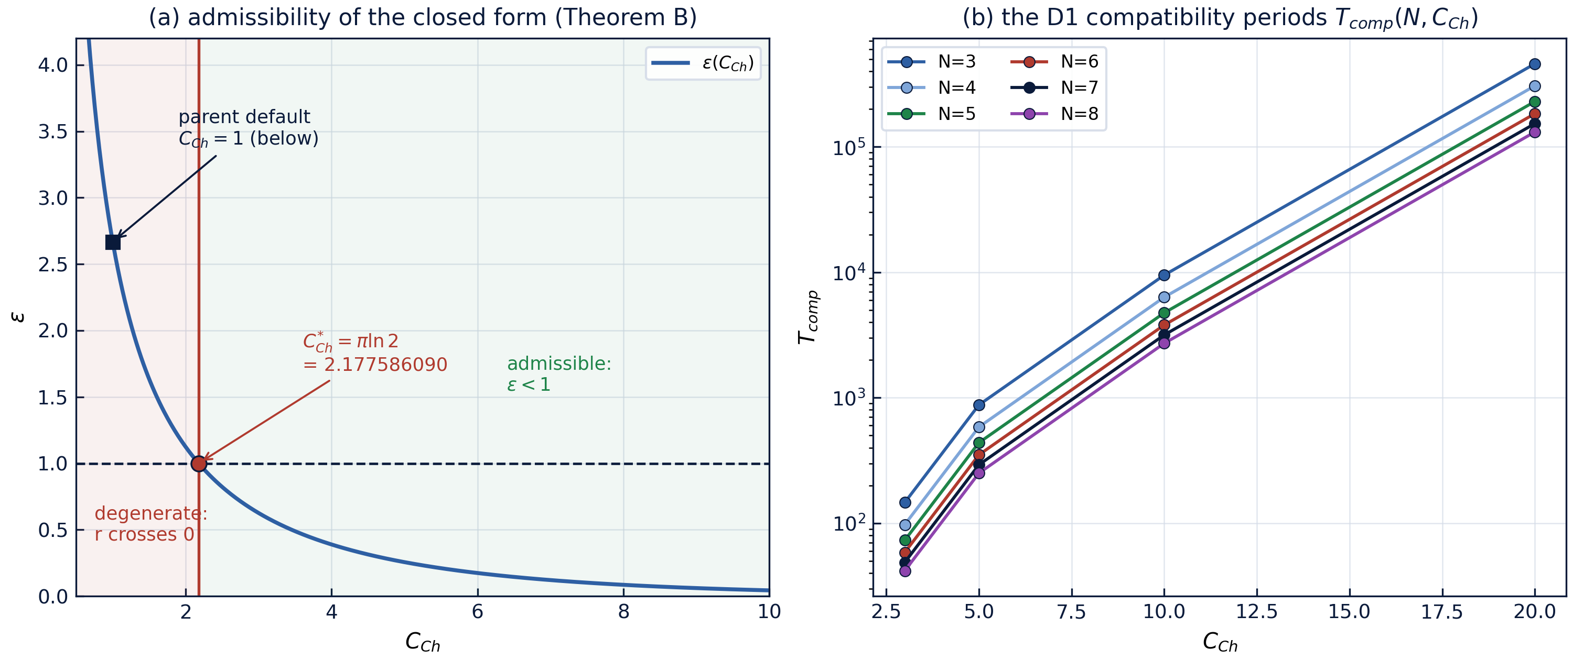
Fig. 4 — Stage W5/W7: the admissibility boundary and the D1 compatibility periods.
A registered fact about the parent default. The parent ladder's registered pair (C_Ch, T) = (1, 2π) sits below the threshold: ε(1) ≈ 2.668 > 1. In this zone the closed form remains a perfectly well-defined complex choreography and passes every structural register, but the polar picture "an N-gon of radius √(C_Ch)(1 + εcos)" is degenerate — the radii sweep through zero. This observation feeds the parent roadmap item T5 ("admissible region of the closed form") with a sharp, decidable boundary; a natural reading is that the non-degenerate regime of the closed form opens at C_Ch > πln 2, and that parameter studies of Layer G should quote C_Ch relative to C_Ch^(*).

6. The kinematic obstruction: Lemma C

6.1 The symmetric pulsation case
The cleanest question about H1 is dynamical: does the pulsating form solve Layer K? Strip the phase shifts from the radii first (all vortices share one common radius r(t), directions uniform) — then the configuration is a regular N-gon at every instant, and the answer is exact.
Lemma C (obstruction). In the Kirchhoff model with equal circulations, let a configuration be a regular N-gon of common radius r(t) rotating with common angular velocity dotθ = ω(t). Then the induced radial velocity vanishes identically, vᵣ ≡ 0, and the radial equation of motion reads dot r = 0. Consequently a symmetrically pulsating polygon satisfies Layer K if and only if ε = 0 (and then ω = Γ(N-1)/(4π R²), Theorem A).
Proof. Fix vertex k and reflect the polygon through the radial axis of k. The reflection maps the vertex set onto itself (vertex j at angle φ swaps with the vertex at -φ), while the induced velocity field of the pair contributes equal-and-opposite radial components: writing the chord from k to a vertex at angle φ, the induced velocity on k has radial component +(Γ)/(2π d)cos(φ/2), and its mirror contributes -(Γ)/(2π d)cos(φ/2). All radial contributions cancel pairwise; the tangential ones double. Hence vᵣ = 0 for every N at every instant, and the radial equation dot r = vᵣ forces r to be constant. □
The tangential register fails independently: Layer K demands ω(t) = Γ(N-1)/(4π r(t)²), which is compatible with a prescribed constant ω only when r is constant. So even a "kinematically steered" pulsation with a time-varying rate is not a free Layer-K orbit — the ring either rotates rigidly at the Theorem-A rate or it is not a Layer-K solution at all.

6.2 The phase-shifted H1 case
H1 as posed carries the phase 2π k/N in both the radii and the angles, so for ε ≠ 0 the configuration is not a polygon at all (Section 4, observation 1). Stage W6 measures both failures on N = 3, Γ = 1, R = 1, ω = 1 over one period:
ε | shape register: max deviation from the chord table | induced radial velocity, max
0.01 | 8.660e-3 | 3.99e-6
0.05 | 4.330e-2 | 1.01e-4
0.10 | 8.660e-2 | 4.13e-4
0.30 | 2.598e-1 | 4.00e-3

The shape deviation is exactly linear with slope cos(π/6) = √(3)/2 ≈ 0.8660 (the slopes recovered from the table agree to 10⁻³, and the test suite pins this). The induced radial velocity — zero for the symmetric case — is here nonzero and scales approximately as 0.04 ε² over the scanned range. Both effects vanish as ε → 0, consistently with the only N-gon limit being the rigid rotation.
Corollary (the reduction verdict). Within Layer K, Hypothesis H1 is a solution exactly in its ε = 0 shadow — the classical Theorem A at the kinematic rate. The frequency law ω = (2π/T)e^(C_Ch/π) is an independent Layer-G postulate and must not be read as the Kirchhoff rotation rate of a polygon with mean radius √(C_Ch); the quantitative bridge between the two is the subject of Section 7.

6.3 Numerical remark: the defective zero
The co-rotating Jacobian at the ring owns a zero eigenvalue of algebraic multiplicity two and geometric multiplicity one (the continuum of rotated polygons is a one-parameter family of equilibria). Rounding splits such a defective double zero into a ±-real pair of size √(ε_mach |J|) ∼ 10⁻⁹ — visible in the W4 protocol as maxReλ ∈ {± 10⁻⁹} for the stable cases. The stability classifier therefore runs at tolerance 10⁻⁷, three orders above the noise floor and three below the N = 8 growth rate 0.450.

7. The averaged-frequency bridge: Lemma D and the D1 design rule
If pulsation is dynamically obstructed, the next best question is compatibility on average: at what rate would the "instantaneous kinematics" of a pulsating polygon rotate over a full cycle? The answer is exact.
Lemma D (averaged frequency). For the symmetric pulsation r(t) = R(1 + εcosω t) with |ε| < 1, the cycle-averaged Kirchhoff rate
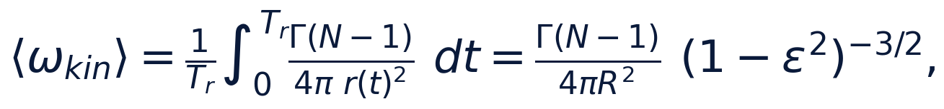
is independent of the modulation rate ω.
Proof. Substituting φ = ω t removes ω and reduces the average to (Γ(N-1))/(4π R²) (1/2π)∫₀^(2π) (dφ)/((1+εcosφ)²). The standard differentiated form of the Poisson integral, (1/2π)∫₀^(2π)(dφ)/((a + bcosφ)²) = (a)/((a² - b²)^(3/2)), at a = 1, b = ε gives (1 - ε²)^(-3/2). □
Stage W7 certifies the integral identity by Gauss–Legendre quadrature (160 nodes): maximum relative error 2.9 · 10⁻¹⁵ over ε ∈ {0.1, …, 0.9}, the bridge register for (N, ε) ∈ {2..8} × {0.2, 0.5, 0.8} at 3.5 · 10⁻¹⁵ (protocol W7_bridge_default.json). The quadrature convergence is itself a measured fact: at the quick preset's 80 nodes the sharpest case (ε = 0.9) retains 2 · 10⁻⁹, dropping six orders at 160 nodes — the spectral convergence expected for analytic integrand with the nearest pole at Imφ = arccosh(1/ε).
Design rule D1 (compatibility curve). Define the compatibility period
as the unique period at which the Theorem-3.1 frequency law ω = (2π/T)e^(C_Ch/π) (with the mean radius R² = C_Ch) equals the averaged kinematic frequency of Lemma D. The protocol tabulates T_comp over the admissible window; e.g. at Γ = 1:
C_Ch | N=3 | N=4 | N=5 | N=6 | N=7 | N=8
3 | 146.13 | 97.42 | 73.06 | 58.45 | 48.71 | 41.75
5 | 875.98 | 583.99 | 437.99 | 350.39 | 291.99 | 250.28
10 | 9496.0 | 6330.7 | 4748.0 | 3798.4 | 3165.3 | 2713.2
20 | 459401.4 | 306267.6 | 229700.7 | 183760.6 | 153133.8 | 131257.6

The self-consistency of the table is verified to 3.5 · 10⁻¹⁶ relative: substituting T = T_comp back into the frequency law reproduces the averaged kinematic rate. Two structural facts deserve attention. First, T_comp grows roughly like e^(C_Ch/π) C_Ch — exponentially in the gauge constant — while the classical rate decays only algebraically in C_Ch; the gauge law and the kinematics therefore agree only along a thin, explicitly computable curve, not on an open set. Second, the registered parent pair (C_Ch, T) = (1, 2π) lies outside the admissible window entirely (Theorem B), so no compatibility statement can be made for it without leaving the non-degenerate regime.
What D1 is and is not. D1 is a design relation for a driven construction: if one insists on a pulsating choreography whose modulation period matches its own cycle-averaged kinematic rate — e.g. for a gauge-constrained or externally forced model variant — the constraint selects the period T_comp exactly. D1 is not a claim that Layer K admits pulsating free orbits (Lemma C forbids that); the driven reading is the only consistent one, and it is flagged as such in the protocol metadata.

8. From observations to theorems: the formalization queue
The ladder was built so that each stage maps onto a formalizable statement. The mini-repository maintains its own queue, aligned with the parent roadmap's theorem table (root README, Section 18.2):
id | statement | current status in this mini-repo | formalization path | parent link
TB1 | Theorem B: ε < 1 ⇔ C_Ch > πln 2 | proven (Section 5), certified by W5 | one-page: monotonicity of exp and ln in Mathlib or Coq's Reals; a decidable ℚ-certificate for the boundary constant | feeds T5
TB2 | Lemma C: vᵣ ≡ 0 for the symmetric ring; pulsation obstructed | proven (Section 6.1), certified by W6 | the chord-geometry pair-cancellation in Coq; the roots-of-unity sum in Mathlib for the tangential sum | feeds T1
TB3 | Lemma D: ⟨ωₖᵢₙ⟩ = ω_N (1-ε²)^(-3/2) | proven (Section 7), certified by W7 | the differentiated Poisson integral — a standard Mathlib-style computation; or an interval-arithmetic certificate of the integral on [-0.9, 0.9] | new, enables T5's region
TW4 | Theorem A: rigid rotation at ω_N = Γ(N-1)/(4π R²) | classical; measured to 2.9 · 10⁻¹² for N = 2..8 | the same roots-of-unity identity as TB2, then the rigid-rotation lemma | is T1
TW5 | Havelock threshold: stable N ≤ 7, unstable N ≥ 8 | reproduced spectrally (W4), margin 10³ | characteristic polynomial per mode family; Routh–Hurwitz-type criterion — decidable, hard | feeds T3

The dependency order is TB1 → TB2 → TW4 → TB3 → TW5: the admissibility theorem is the cheapest and should be formalized first; TW4 shares its algebraic core with TB2; TB3 is an integral statement with a clean numeric fallback (interval arithmetic); TW5 is the long-term target. Each statement above is already phrased so that a Coq or Lean 4 port can be opened as a stub with the numeric protocol as the reference oracle — the same double-formalization discipline the parent roadmap prescribes for M5.

9. Numerical protocol summary
All protocols live in results/protocols/ (preset default unless noted), produced by make ladder (one command, deterministic file names). The registered tolerances: separation and periodicity 10⁻¹²; shape and invariant drift 10⁻¹⁰; measured-rate band 10⁻⁶ (parent's band); stability classifier 10⁻⁷; algebraic identities 10⁻¹²; the W5 minimum-radius register 10⁻⁶ absolute (uniform-grid sampling bound).
stage | register | value | verdict
W1 | separation / periodicity / anchors | 6.9e-14 / 9.4e-14 / 0.0 | PASS
W1 | Section-6 diagnostic drift (report-only) | 15.01 over [0,100T] | —
W2 | ω_N relative error, N = 2..8 | ≤ 2.9 · 10⁻¹² | PASS
W2 | chord-shape deviation | ≤ 3.3 · 10⁻¹⁴ (N ≤ 7) | PASS
W3 | worst invariant drift | ≤ 4.2 · 10⁻¹⁴ | PASS
W4 | stable band maxReλ | ≤ 7.0 · 10⁻⁹ | PASS
W4 | N = 8 growth rate | +0.4502 | PASS (unstable)
W5 | threshold equivalences on 200 points | 0 violations | PASS
W5 | min-radius sampling error | 1.9 · 10⁻⁷ | PASS
W6 | symmetric pulsation: induced vert vᵣvert | ≤ 4.9 · 10⁻¹⁶ | PASS
W6 | H1 phase-shifted: shape slope | √(3)/2 (linear in ε) | recorded
W6 | H1 phase-shifted: induced vert vᵣvert | ≈ 0.04 ε² | recorded
W7 | integral identity (160 GL nodes) | 2.9 · 10⁻¹⁵ | PASS
W7 | bridge (N, ε) grid | 3.5 · 10⁻¹⁵ | PASS
W7 | T_comp self-consistency | 3.5 · 10⁻¹⁶ | PASS

Runtime: quick 1.3 s, default 7.3 s, full ≈ 60 s (whole ladder, one core of the reference laptop class).

10. Honesty notes
- Hypothesis H1 is not a Layer-K solution. The central finding of this mini-repository is a negative result with a positive structure: the pulsating ansatz is dynamically obstructed (Lemma C), the phase-shifted variant is obstructed even geometrically (W6), and the frequency law is compatible with the kinematics only along the D1 curve. None of this diminishes the parent Theorem 3.1 — it lives on Layer G, where its registers are exact — but any dynamical reading of H1 must be dropped or replaced by the driven construction of Section 7.
- The parent default is below the admissibility threshold. C_Ch = 1 lies in the radius-crossing zone. This is a fact about the registered parameter, not about the theorem; the structural registers are blind to it, the polar registers are not. Parameter studies should quote C_Ch relative to πln 2.
- Stability is spectral, not nonlinear. W4 classifies the linearized flow; nonlinear (Arnold-type) stability is a different, harder statement and is not claimed.
- The averaged-frequency lemma is an identity about a prescribed kinematics, not a statement about attractors or effective dynamics of free Layer-K flows.
- Every protocol is reproducible. make ladder regenerates all seven JSON files byte-identically up to the UTC timestamp; the test suite re-derives the preset-independent registers from scratch.

11. Резюме (RU)
Мини-репозиторий polyvortex/ обобщает родительскую лестницу Trivortex с трёх вихрей на произвольное N. Главные результаты: (1) теорема B — замкнутая форма Теоремы 3.1 невырождена тогда и только тогда, когда C_Ch > πln 2 ≈ 2.1776; на зарегистрированном значении C_Ch = 1 радиусы проходят через ноль (зарегистрировано для роадмап-пункта T5); (2) лемма C — кирхгофовская динамика запрещает симметрично пульсирующий N-угольник: наведённая радиальная скорость сокращается попарно, поэтому пульсация невозможна ни при каком N, и гипотеза H1 редуцируется к классическому жёсткому вращению с ω_N = Γ(N-1)/(4π R²), измеренному до 2.9·10⁻¹² для N = 2..8; (3) лемма D — циклически усреднённая кинематическая частота равна ω_N(1-ε²)^(-3/2), что даёт точную кривую совместимости D1 между частотным законом Теоремы 3.1 и кирхгофовской кинематикой; (4) порог Хэвелока (устойчивость при N ≤ 7, неустойчивость при N ≥ 8) воспроизведён спектрально с запасом в три порядка. Все утверждения либо доказаны, либо сертифицированы JSON-протоколами; очередь формализации TB1–TW5 согласована с теоремной очередью корневого роадмапа.

References
- G. R. Kirchhoff, Vorlesungen über mathematische Physik, Bd. I: Mechanik, Teubner, Leipzig, 1876. — The point-vortex equations.
- T. H. Havelock, "The stability of motion of vortices", Philosophical Magazine 11 (1931) 617–641. — Stability of the regular vortex polygon; the N ≤ 7 threshold.
- L. G. Khazin, "On the stability of regular configurations of vortices", Soviet Physics Doklady 21 (1976). — Rigorous treatment of the polygon stability boundary.
- H. Aref, "Motion of three vortices revisited", The Physics of Fluids 22 (1979) 393–400. — The modern taxonomy of three-vortex relative motions.
- H. Aref, P. K. Newton, M. A. Stremler, T. Tokieda, D. L. Vainchtein, "Vortex crystals", Advances in Applied Mechanics 39 (2003) 1–79. — The standard review of vortex relative equilibria and their stability.
- P. K. Newton, The N-Vortex Problem: Analytical Techniques, Springer, New York, 2001. — The N-vortex Hamiltonian formalism used in Sections 2 and 3.
- Parent framework: TRIVORTEX repository, verification/README.md — the V1–V4 ladder, the registered tolerances and the Theorem 3.1 closed form; root README.md, Section 18 — the theorem queue T1–T6 that this mini-repository feeds.

