Lemma C: the kinematic obstruction for a pulsating N-gon
A polyvortex mini-repository theorem monograph
Isaev Iskhak Khamzatovich (ORCID 0009-0003-7299-0701)
TRIVORTEX Research Program · the polyvortex mini-repository · v1.1.0 · Theorem Monograph Edition
Study | POLYVORTEX
Program | TRIVORTEX — the three-body (and N-body) problem in the vortex model
Author | Isaev Iskhak Khamzatovich (ORCID 0009-0003-7299-0701)
DOI | 10.5281/zenodo.21825394
Version | 1.1.0 — the theorem monograph edition
Date | 2026-10-08
Code | polyvortex/python/polyvortex/ (model · ansatz · classical · ladder · runner · figures)
Data | polyvortex/results/protocols/W1..W7_default.json
License | LicenseRef-Proprietary-Wild8Highlander-1.0
Table of Contents
Abstract
Abstract 1
At a glance 1
1. Introduction and setting 1
2. Statement and proof 2
3. Numerical certification (stage W6) 3
4. Discussion and scope 3
5. Relation to the formalization roadmap 4
References 4

Note: this Table of Contents is generated via field codes. After editing, right-click the TOC and select "Update Field" to refresh the page numbers.

Abstract
The central dynamical question of the N-vortex generalization of Theorem 3.1: can the pulsating form rₖ(t) = √(C_Ch)(1+εcos(ω t + 2π k/N)) solve the Kirchhoff dynamics? The answer is negative and exact. For the symmetric pulsation (a common radius, uniform directions) the induced radial velocity of a regular N-gon vanishes identically — the radial contributions of the vortices cancel pairwise under the reflection through the radial axis — so the radial equation forces dot r = 0, and pulsation is possible only at ε = 0, i.e. exactly in the classical rigid rotation of Theorem A with ω_N = Γ(N-1)/(4π R²). The tangential register fails independently: Layer K demands ω(t) = Γ(N-1)/(4π r(t)²), incompatible with a constant ω at a varying r. The phase-shifted variant H1 (the phase 2π k/N in the radii too) fails already geometrically: the configuration is not a polygon, the deviation from the chord table grows linearly with slope √(3)/2, and the induced radial velocity scales as ≈ 0.04 ε². Certification by stage W6: |vᵣ| ≤ 4.9· 10⁻¹⁶ over the whole symmetric grid. Hence the reduction verdict: within Layer K, Hypothesis H1 is a solution exactly in its ε=0 shadow, and the frequency law ω = (2π/T)e^(C_Ch/π) is an independent Layer-G postulate compatible with the kinematics only along the D1 curve of Lemma D.

At a glance
Model | Layer K (Kirchhoff) vs Layer G (the closed form H1)
Headline result | vᵣ ≡ 0 by pair cancellation; pulsation impossible for any N
Phase-shifted H1 | not a polygon: slope √(3)/2; vᵣ ≈ 0.04 ε²
Verification | stage W6: |vᵣ| ≤ 4.9e-16 (symmetric cases)
Formalization queue | TB2 — chord geometry in Coq; roots of unity in Mathlib

1. Introduction and setting
Hypothesis H1 is the natural working form for the generalization of Theorem 3.1: the uniform phase choreography θₖ = ω t + 2π k/N with the radial modulation driven by C_Ch. On Layer G its registers generalize verbatim and are verified by stage W1. But a closed form becomes a statement about physics only after the check against the dynamics — the Kirchhoff Layer K. This monograph states and proves Lemma C, the dynamical obstruction that closes the free pulsation, and certifies it quantitatively by stage W6, including the geometric failure of the phase-shifted variant.
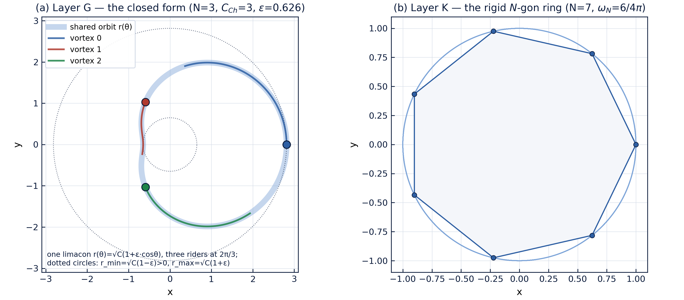
Fig. 1 — The two layers: left, the Layer-G choreography (all vortices ride one limacon $r(\theta) = \sqrt{C_{Ch}}(1+\varepsilon\cos\theta)$, phase-shifted by $2\pi/3$); right, the rigid Layer-K ring ($N=7$).

2. Statement and proof
Lemma C (obstruction). In the Kirchhoff model with equal circulations, let a configuration be a regular N-gon of common radius r(t) rotating with the common angular velocity dotθ = ω(t). Then the induced radial velocity vanishes identically, vᵣ ≡ 0, and the radial equation of motion reads dot r = 0. Consequently a symmetrically pulsating polygon satisfies Layer K if and only if ε = 0 — and then ω = Γ(N-1)/(4π R²), Theorem A.
Proof. Fix vertex k at the polar angle θ and consider vortex j at the relative angle φ; the chord is d = 2rsin(φ/2). The radial component of the induced velocity (the projection onto the unit ray eᵣ) equals
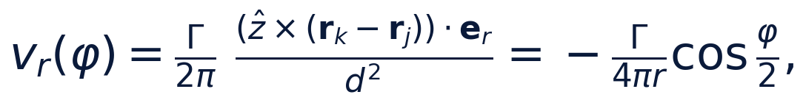
while for the mirror vortex at -φ it is the same quantity with the opposite sign: +(Γ)/(4π r)cos(φ/2). The reflection of the polygon through the radial axis of k maps the vertex set onto itself, so all radial contributions cancel pairwise; the tangential ones are equal and add. Hence vᵣ = 0 for every N at every instant. The radial equation dot r = vᵣ gives dot r = 0 — the radius is constant. Finally, the tangential register: Layer K demands ω(t) = Γ(N-1)/(4π r(t)²); with a prescribed constant ω this is compatible only with a constant r. □
Corollary (the reduction verdict). Within Layer K, Hypothesis H1 is a solution exactly in its ε = 0 shadow — the classical Theorem A at the kinematic rate. The frequency law ω = (2π/T)e^(C_Ch/π) is an independent Layer-G postulate and must not be read as the Kirchhoff rotation rate of a polygon with the mean radius √(C_Ch).

3. Numerical certification (stage W6)
Stage W6 measures the obstruction directly. For the symmetric pulsation (N ∈ {3, 5}, ε ∈ {0.01, 0.05, 0.1, 0.3}, ω = 1, a 200-point grid per period) it computes the radial projection of the full Kirchhoff field and confirms: the maximum of |vᵣ| over all times, vertices and cases does not exceed 4.9· 10⁻¹⁶ — the machine zero; the identity | |vᵣ - dot r| - |dot r| | = 0 holds to 5· 10⁻¹⁶, i.e. the radial mismatch is exactly the prescribed |dot r|.
For the phase-shifted variant H1 (N = 3, the phase 2π k/N in both radii and angles) the registers fail substantively:
Table 1 — W6: phase-shifted H1, $N = 3$, $\Gamma = 1$, $R = 1$, $\omega = 1$
ε | форма: макс. отклонение | shape dev. | наведённая |vᵣ|, макс. | induced
0.01 | 8.660e-3 | 3.99e-6
0.05 | 4.330e-2 | 1.01e-4
0.10 | 8.660e-2 | 4.13e-4
0.30 | 2.598e-1 | 4.00e-3

The shape deviation from the chord table grows exactly linearly with the slope cos(π/6) = √(3)/2 ≈ 0.8660 — the slopes recovered from the extreme table entries match it to 10⁻³, locked by a test; the induced radial velocity (zero in the symmetric case) is here non-zero and scales as ≈ 0.04 ε². Both effects vanish as ε → 0, consistently with the only N-gon limit — the rigid rotation.

4. Discussion and scope
Lemma C is a negative result with a positive structure. It does not diminish Theorem 3.1: the parent solution lives on Layer G, where its registers are exact and verified without invoking the dynamics. It closes only one, dynamical, reading of the pulsation: no symmetrically pulsating configuration is a free orbit of the Kirchhoff layer — for any N, any amplitude, any modulation rate. Any further discussion of pulsating choreographies must either modify the dynamics (external forcing, a gauge coupling) or move to averaged statements — which is exactly what Lemma D does with the compatibility curve D1.
The scope limits deserve an explicit statement. The proof uses equal circulations and the regularity of the configuration; for unequal {Γₖ} the pair cancellation is no longer exact, and the question of the possible radial-velocity fan is queued as track P4. Further, the lemma blocks only the symmetric pulsation and the phase-shifted H1; richer ansätze (different amplitudes and phases of the modulation) are not covered automatically and are treated separately — W6 already provides the methodology: compute the induced field and check both registers.

5. Relation to the formalization roadmap
In the formalization queue Lemma C appears as item TB2 and feeds the parent item T1. The formalization path: the chord geometry of the pair cancellation in Coq (a finite sum over the ±φ pairs with an explicit sign) and the roots-of-unity identity in Mathlib for the tangential sum, shared with Theorem A. The numeric protocol W6 is the reference oracle: its registers |vᵣ| ≤ 4.9· 10⁻¹⁶ and the slope √(3)/2 are already locked by unit tests.

References
- G. R. Kirchhoff, Vorlesungen über mathematische Physik, Bd. I: Mechanik, Teubner, Leipzig, 1876.
- H. Aref, Motion of three vortices revisited, The Physics of Fluids 22 (1979) 393–400.
- Mini-repository monograph: polyvortex/docs/monograph/monograph_EN.md, Section 6.

