Lemma D: the averaged-frequency bridge and the compatibility curve D1
A polyvortex mini-repository theorem monograph
Isaev Iskhak Khamzatovich (ORCID 0009-0003-7299-0701)
TRIVORTEX Research Program · the polyvortex mini-repository · v1.1.0 · Theorem Monograph Edition
Study | POLYVORTEX
Program | TRIVORTEX — the three-body (and N-body) problem in the vortex model
Author | Isaev Iskhak Khamzatovich (ORCID 0009-0003-7299-0701)
DOI | 10.5281/zenodo.21825394
Version | 1.1.0 — the theorem monograph edition
Date | 2026-10-08
Code | polyvortex/python/polyvortex/ (model · ansatz · classical · ladder · runner · figures)
Data | polyvortex/results/protocols/W1..W7_default.json
License | LicenseRef-Proprietary-Wild8Highlander-1.0
Table of Contents
Abstract
Abstract 1
At a glance 1
1. Introduction and setting 1
2. Statement and proof 2
3. Numerical certification and the D1 rule 2
4. Discussion: what D1 is and is not 3
5. Relation to the formalization roadmap 3
References 4

Note: this Table of Contents is generated via field codes. After editing, right-click the TOC and select "Update Field" to refresh the page numbers.

Abstract
If the free pulsation of the N-gon is dynamically obstructed (Lemma C), the next natural question is the averaged compatibility: at what rate would the "instantaneous kinematics" of a pulsating ring rotate over a full modulation cycle? The answer is exact and independent of the modulation rate: for r(t) = R(1 + εcosω t) with |ε| < 1 the cycle-averaged Kirchhoff rate equals ⟨ωₖᵢₙ⟩ = ω_N (1-ε²)^(-3/2) with ω_N = Γ(N-1)/(4π R²); the proof is the substitution φ = ω t and the differentiated Poisson integral (1/2π)∫₀^(2π)(dφ)/((a+bcosφ)²) = (a)/((a²-b²)^(3/2)). Certification by stage W7: the identity to a maximum relative error of 2.9· 10⁻¹⁵ (Gauss–Legendre quadrature, 160 nodes), the bridge register over (N, ε) ∈ {2..8}×{0.2, 0.5, 0.8} — 3.5· 10⁻¹⁵. The applied output is the design rule D1: the exact compatibility period T_comp(N, C_Ch) = 2π e^(C_Ch/π) 4π C_Ch(1-ε²)^(3/2)/(Γ(N-1)) at which the Theorem-3.1 frequency law meets the averaged kinematics (table self-consistency 3.5· 10⁻¹⁶). What D1 is (a constraint for a driven construction) and is not (not a claim about free Layer-K orbits) is stated separately.

At a glance
Model | the averaged kinematics of a pulsating ring (Layer K)
Headline result | ⟨ωₖᵢₙ⟩ = ω_N (1-ε²)^(-3/2), independent of ω
Verification | stage W7: identity 2.9e-15, bridge 3.5e-15, T_comp 3.5e-16
Applied output | the design rule D1: the table T_comp(N, C_Ch)
Formalization queue | TB3 — the Poisson integral (Mathlib) or an interval certificate

1. Introduction and setting
Lemma C closes the free pulsation: the Kirchhoff dynamics carries no symmetrically pulsating ring for any N. But between "forbidden as a free orbit" and "meaningless altogether" lies a wide gap. For driven or gauge-coupled variants of the model (external shape keeping, forced modulation) the natural characteristic is the cycle-averaged kinematic rate: at what frequency would the configuration rotate on average if at every instant its angular velocity were given by the instantaneous Kirchhoff rule Γ(N-1)/(4π r(t)²)? Lemma D answers exactly and surprisingly smoothly — the average does not depend on the modulation rate.

2. Statement and proof
Lemma D (averaged frequency). For the symmetric pulsation r(t) = R(1 + εcosω t) with |ε| < 1 the cycle-averaged Kirchhoff rate
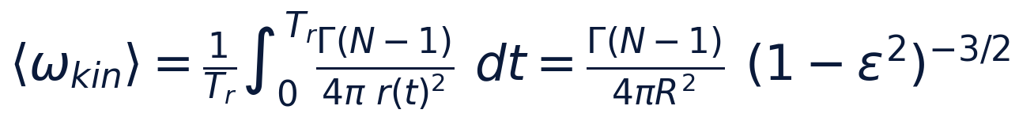
is independent of the modulation frequency ω.
Proof. The substitution φ = ω t (with Tᵣ = 2π/ω) removes ω and reduces the average to (Γ(N-1))/(4π R²) (1/2π)∫₀^(2π)(dφ)/((1+εcosφ)²). The standard differentiated form of the Poisson integral
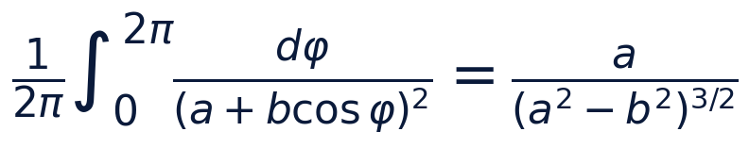
at a = 1, b = ε gives exactly (1 - ε²)^(-3/2). □
Note the analytic structure in passing: the pole of the integrand nearest to the real axis sits at Imφ = arccosh(1/ε), hence the spectral quadrature convergence; as ε → 1⁻ the averaged rate grows like (1-ε²)^(-3/2) — the modulation sharply accelerates the mean rotation near the admissibility threshold of Theorem B.

3. Numerical certification and the D1 rule
Stage W7 certifies three registers. The identity: Gauss–Legendre quadrature at 160 nodes reproduces (1-ε²)^(-3/2) with the maximum relative error 2.9· 10⁻¹⁵ over ε ∈ {0.1,…,0.9}; at the 80 nodes of the quick preset the sharpest case ε = 0.9 retains 2· 10⁻⁹ — a measured spectral convergence dropping six orders when the nodes double. The bridge: for (N, ε) ∈ {2..8}×{0.2, 0.5, 0.8} the numeric average of the instantaneous rule matches the formula to 3.5· 10⁻¹⁵.
The applied output is the design rule D1. Equating the Theorem-3.1 frequency law ω = (2π/T)e^(C_Ch/π) (with the mean radius R² = C_Ch) to the averaged kinematic rate yields the unique compatibility period
whose self-consistency (substituting T = T_comp back into the frequency law) is verified to 3.5· 10⁻¹⁶. The table of the W7_bridge_default.json protocol at Γ = 1:
Table 1 — D1: the compatibility periods $T_{comp}(N, C_{Ch})$
C_Ch | N=3 | N=4 | N=5 | N=6 | N=7 | N=8
3 | 146.13 | 97.42 | 73.06 | 58.45 | 48.71 | 41.75
5 | 875.98 | 583.99 | 437.99 | 350.39 | 291.99 | 250.28
10 | 9496.0 | 6330.7 | 4748.0 | 3798.4 | 3165.3 | 2713.2
20 | 459401.4 | 306267.6 | 229700.7 | 183760.6 | 153133.8 | 131257.6

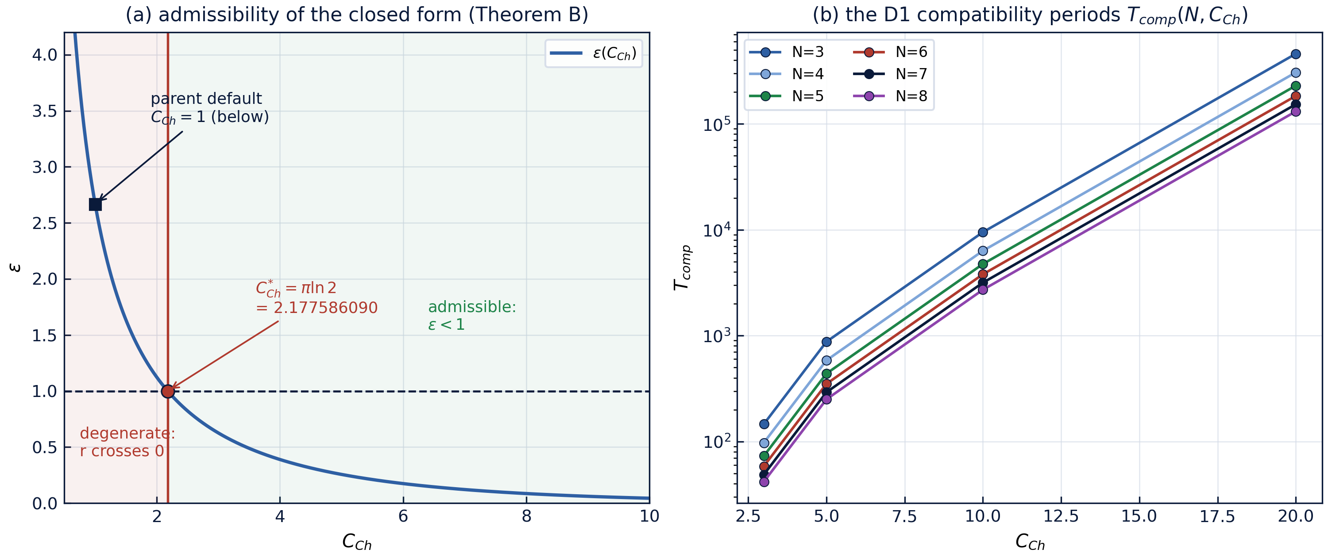
Fig. 1 — Left: the amplitude law and the admissibility threshold (Theorem B). Right: the D1 compatibility periods $T_{comp}(N, C_{Ch})$ from the W7 protocol (log scale).

4. Discussion: what D1 is and is not
Two structural facts. First, T_comp grows roughly like e^(C_Ch/π) C_Ch — exponentially in the gauge constant — while the classical rate ω_N decays only algebraically in C_Ch; the gauge law and the kinematics therefore agree only along a thin, explicitly computable curve, not on an open parameter set. Second, the registered parent pair (C_Ch, T) = (1, 2π) lies entirely outside the admissible window (Theorem B), so no compatibility statement can be made for it without leaving the non-degenerate regime.
The reading discipline: D1 is a design relation for a driven construction. If one insists on a pulsating choreography whose modulation matches its own cycle-averaged kinematics, the constraint selects the period T_comp exactly, and the table delivers it for any (N, C_Ch). D1 is not a claim that Layer K admits free pulsating orbits: Lemma C forbids that. The driven reading is the only consistent one and is flagged as such in the W7 protocol metadata.

5. Relation to the formalization roadmap
In the formalization queue Lemma D appears as item TB3. The formalization path: the differentiated Poisson integral — a standard Mathlib-style computation (parametric differentiation of ∫ dφ/(a + bcosφ) in a); an alternative numeric route is an interval-arithmetic certificate of the integral on [-0.9, 0.9] with rational bounds. The lemma opens the T5 region of the parent: with it, the admissible region of the closed form receives not only its boundary (Theorem B) but also an internal metric of kinematic compatibility. The numeric protocol W7 is the reference oracle.

References
- G. M. Fikhtengol'ts, Course of Differential and Integral Calculus, vol. II — parameter-dependent integrals.
- H. Aref, P. K. Newton, M. A. Stremler, T. Tokieda, D. L. Vainchtein, Vortex crystals, Advances in Applied Mechanics 39 (2003) 1–79.
- Mini-repository monograph: polyvortex/docs/monograph/monograph_EN.md, Section 7.

