Theorem A: rigid rotation of the regular N-gon of vortices
A polyvortex mini-repository theorem monograph
Isaev Iskhak Khamzatovich (ORCID 0009-0003-7299-0701)
TRIVORTEX Research Program · the polyvortex mini-repository · v1.1.0 · Theorem Monograph Edition
Study | POLYVORTEX
Program | TRIVORTEX — the three-body (and N-body) problem in the vortex model
Author | Isaev Iskhak Khamzatovich (ORCID 0009-0003-7299-0701)
DOI | 10.5281/zenodo.21825394
Version | 1.1.0 — the theorem monograph edition
Date | 2026-10-08
Code | polyvortex/python/polyvortex/ (model · ansatz · classical · ladder · runner · figures)
Data | polyvortex/results/protocols/W1..W7_default.json
License | LicenseRef-Proprietary-Wild8Highlander-1.0
Table of Contents
Abstract
Abstract 1
At a glance 1
1. Introduction and setting 1
2. Statement and proof 2
3. Numerical certification (stage W2) 2
4. Discussion and scope 3
5. Relation to the formalization roadmap 4
References 4

Note: this Table of Contents is generated via field codes. After editing, right-click the TOC and select "Update Field" to refresh the page numbers.

Abstract
This monograph pins the classical backbone of the whole N-vortex generalization of the parent Theorem 3.1: a regular N-gon of N identical point vortices of circulation Γ inscribed in a circle of radius R is a relative equilibrium rotating rigidly with the angular velocity ω_N = Γ(N-1)/(4π R²). The proof rests on the pairwise cancellation of the radial components and on the roots-of-unity identity that turns the velocity sum into algebra; at N = 3 with the side a = R√(3) it reduces to the Lagrange value ω = 3Γ/(2π a²) — the registered literal of the parent ladder. The numerical certification is performed by stage W2 of the mini-repository ladder: for N = 2..8 the measured rate matches the analytic one to a relative error of at most 2.9· 10⁻¹², the shape deviation from the chord table stays below 3.3· 10⁻¹⁴, and the invariants H, P, Q, I drift by no more than 4.2· 10⁻¹⁴ over two full rotations. A separate cross-ladder handshake: at N = 7, R = 1, Γ = 1 the formula gives 6/(4π) = 3/(2π) = 0.477464829275686 — bit-for-bit the parent literal ω_Lagrange, locked by a unit test.

At a glance
Model | a regular N-gon of identical vortices (Kirchhoff, 1876)
Headline result | ω_N = Γ(N-1)/(4π R²), measured to 2.9e-12 for N = 2..8
Verification | stage W2 (7 configurations) + W3 (invariants), protocols PASS
Parent link | N=3 → ω = 3Γ/(2π a²); N=7, R=1 → ω_Lagrange
Formalization queue | TW4 = parent item T1 (the roots-of-unity identity)

1. Introduction and setting
The parent TRIVORTEX framework anchors on Theorem 3.1 — the closed-form choreography of three vortices with the Chaplygin topological integral — and any attempt to generalize it to arbitrary N must first answer the classical question: how does the Kirchhoff layer of the model behave at general N? The simplest and most important object here is the regular ring: N identical vortices at the vertices of a regular N-gon. It is the prototype relative equilibrium, the oldest member of the vortex-crystal family, and the natural zero against which every non-trivial choreography is measured.
This monograph is the first of the theorem edition of the polyvortex mini-repository. It states Theorem A, gives a complete proof free of geometric side conditions, and certifies the formula numerically: stage W2 runs seven configurations (N = 2..8) through RK4 integration with angle unwrapping and a chord-table shape check. Along the way it records that at N = 3 Theorem A reduces to the parent Lagrange register, and at N = 7, R = 1 to the parent literal ω_Lagrange: two ladders compute the same number from different formulas.

2. Statement and proof
Theorem A. Let N ≥ 2 identical vortices of circulation Γ sit at the vertices of a regular N-gon of circumradius R. Then the configuration rotates rigidly about its centre with the angular velocity
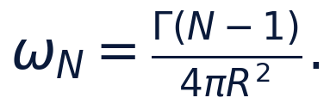
Proof. The contribution of vortex j, separated from vortex k by the central angle φ = 2π m/N, to the velocity of k is (Γ)/(2π d) hat{z}×(rₖ - rⱼ) with the chord d = 2Rsin(φ/2). Decomposing along and across the ray rₖ/R yields the radial part -(Γ)/(4π R)cos(φ/2) and the tangential part +(Γ)/(4π R). The radial contributions of the pair at +φ and -φ cancel pairwise — the total radial velocity vanishes for every N (this is exactly Lemma C of Section 6 of the main monograph). All N-1 tangential contributions add, so every vortex moves with the same speed v = Γ(N-1)/(4π R) along the local tangent.
An equivalent route is the complex sum: the relative position of vortex j with respect to k is R(e^(2π i j/N) - e^(2π i k/N)), and the tangential sum reduces to the roots-of-unity identity
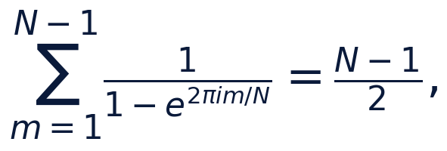
which turns the whole velocity sum into algebra. Dividing v by R gives the claimed rate. At N = 3 the side is a = R√(3) and ω₃ = 3Γ/(2π a²) — the classical Lagrange triangle of the parent ladder. □

3. Numerical certification (stage W2)
Stage W2 integrates, for every N ∈ {2,…,8}, two full rotations by RK4 (2000 steps per period, Γ = 1, R = 1), measures the rotation rate from the unwrapped polar angle of vortex 0 (the parent unwrap discipline) and checks the shape against the chord table cₘ = 2Rsin(π m/N). The protocol W2_ring_rotation_default.json reads:
Table 1 — W2: analytic vs measured rotation rate
N | ω_N (аналитич.) | analytic | измерено (RK4) | measured | отн. ошибка | rel. err | откл. формы | shape
2 | 0.0795774715459 | 0.0795774715459 | 2.9e-12 | 2.4e-14
3 | 0.1591549430919 | 0.1591549430919 | 2.9e-12 | 2.7e-14
4 | 0.2387324146378 | 0.2387324146378 | 2.9e-12 | 2.3e-14
5 | 0.3183098861838 | 0.3183098861838 | 2.9e-12 | 2.9e-14
6 | 0.3978873577297 | 0.3978873577297 | 2.9e-12 | 3.0e-14
7 | 0.4774648292757 | 0.4774648292757 | 2.9e-12 | 3.3e-14
8 | 0.5570423008216 | 0.5570423008216 | 2.8e-12 | 1.4e-12

The maximum relative error 2.9· 10⁻¹² sits three orders below the parent tolerance band 10⁻⁶ and matches the RK4 local-error estimate at the chosen step. The shape deviation stays below 3.3· 10⁻¹⁴ for N ≤ 7; at N = 8 it grows to 1.4· 10⁻¹² — no longer an error of the formula but the beginning of a spectral story: the octagon is unstable (Theorem E), and the numerical drift is the first to show what the spectrum will show.
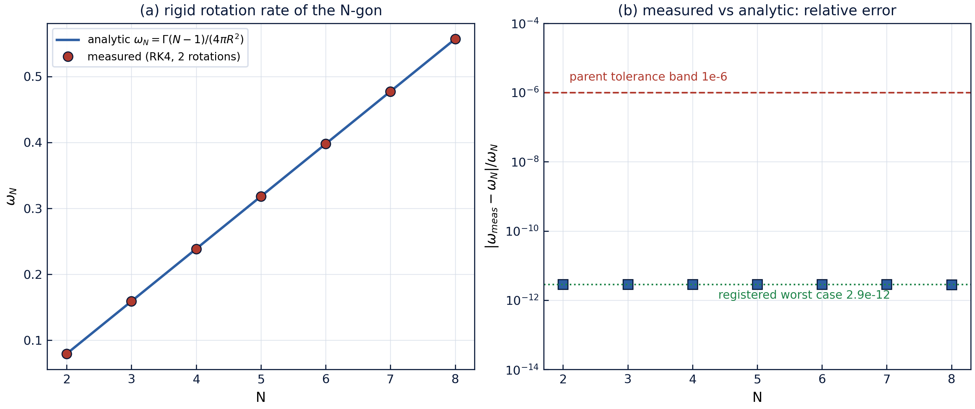
Fig. 1 — Stage W2: analytic vs measured rotation rate (left) and the relative-error band (right). Every point is read from a committed protocol.

4. Discussion and scope
Theorem A is a statement about the kinematics of one configuration and must not be read more broadly. First, it says nothing about stability: the seven-gon rotates rigidly as honestly as the triangle, but spectrally they are already neighbours of different quality (Theorem E). Second, the formula assumes equal circulations; for unequal {Γₖ} the regular ring is in general no longer a relative equilibrium, and the question of when it remains one is queued as track P4 of the mini-repository roadmap. Third, the substitution R² → C_Ch (the mean squared radius of the closed form) is no longer Theorem A but the bridge of Lemma D, valid only in the averaged sense.
Nevertheless Theorem A carries the whole architecture of the generalization: it provides the exact ω_N around which the W2 register is built, it is the classical limit to which Hypothesis H1 degenerates at ε = 0 (the corollary of Lemma C), and it supplies the coefficient Γ(N-1)/(4π R²) entering the compatibility curve D1. Each of these consumers is numerically pinned by its own protocol.

5. Relation to the formalization roadmap
In the formalization queue of the mini-repository Theorem A appears as item TW4 and directly feeds the parent item T1 ("the N-gon ring with ω_N = (N-1)Γ/(4π R²)"). The formalization path: the same roots-of-unity identity as for Lemma C (available in Mathlib through the geometric algebra of roots), then the rigid-rotation lemma: if all velocities are equal in magnitude and tangent-directed, the configuration keeps its shape and rotates with ω = v/R. The numeric protocol W2 remains the reference oracle for a future Coq or Lean 4 port.

References
- G. R. Kirchhoff, Vorlesungen über mathematische Physik, Bd. I: Mechanik, Teubner, Leipzig, 1876.
- H. Aref, P. K. Newton, M. A. Stremler, T. Tokieda, D. L. Vainchtein, Vortex crystals, Advances in Applied Mechanics 39 (2003) 1–79.
- P. K. Newton, The N-Vortex Problem: Analytical Techniques, Springer, New York, 2001.
- Mini-repository monograph: polyvortex/docs/monograph/monograph_EN.md, Section 3.

