Theorem B: the exact admissibility threshold of the closed form
A polyvortex mini-repository theorem monograph
Isaev Iskhak Khamzatovich (ORCID 0009-0003-7299-0701)
TRIVORTEX Research Program · the polyvortex mini-repository · v1.1.0 · Theorem Monograph Edition
Study | POLYVORTEX
Program | TRIVORTEX — the three-body (and N-body) problem in the vortex model
Author | Isaev Iskhak Khamzatovich (ORCID 0009-0003-7299-0701)
DOI | 10.5281/zenodo.21825394
Version | 1.1.0 — the theorem monograph edition
Date | 2026-10-08
Code | polyvortex/python/polyvortex/ (model · ansatz · classical · ladder · runner · figures)
Data | polyvortex/results/protocols/W1..W7_default.json
License | LicenseRef-Proprietary-Wild8Highlander-1.0
Table of Contents
Abstract
Abstract 1
At a glance 1
1. Introduction and setting 1
2. Statement and proof 2
3. Numerical certification (stage W5) 2
4. A registered fact about the parent default 3
5. Relation to the formalization roadmap 3
References 4

Note: this Table of Contents is generated via field codes. After editing, right-click the TOC and select "Update Field" to refresh the page numbers.

Abstract
The closed form of Theorem 3.1 — rₖ(t) = √(C_Ch)(1 + εcos(ω t + 2π k/N)) with the laws ω = (2π/T)e^(C_Ch/π) and ε = 1/(e^(C_Ch/π) - 1) — describes a rotating configuration with positive radii not for all values of the topological invariant. This monograph proves the exact boundary: the radii are strictly positive at all times for all vortices if and only if C_Ch > πln 2 = 2.177586090303602…; at the threshold the amplitude equals exactly ε = 1 and each radius touches zero once per period; below it the radii change sign twice per period while the complex trajectory stays continuous. The proof is a chain of exact real-algebra equivalences. Certification by stage W5: on a grid of 200 values of C_Ch ∈ [0.5, 10] the equivalence has zero violations, the amplitude at the threshold equals one to machine precision (error 0.0), and the sampled minimum radius matches the analytic √(C_Ch)(1-ε) to 1.9· 10⁻⁷. A registered conclusion for the parent framework: the pair (C_Ch, T) = (1, 2π) lies below the threshold — the structural registers of Theorem 3.1 are blind to it, the polar ones are not; parameter studies of Layer G should quote C_Ch relative to C^(*)_Ch = πln 2.

At a glance
Model | the closed form of Theorem 3.1 at arbitrary N (Layer G)
Headline result | ε < 1 ⇔ C_Ch > πln 2 = 2.177586090303602
Verification | stage W5: 200 grid points, 0 violations; min radius 1.9e-7
Registered fact | the parent default (C_Ch, T) = (1, 2π) is below the threshold
Formalization queue | TB1 — the cheapest candidate (Mathlib / Coq Reals)

1. Introduction and setting
The topological invariant C_Ch enters the closed form of Theorem 3.1 twice: as the radius scale √(C_Ch) and — through the amplitude law ε(C_Ch) = 1/(e^(C_Ch/π) - 1) — as the depth of the radial modulation. As C_Ch grows, the amplitude decreases monotonically from +∞ to zero, so the question of for which C_Ch the polar picture of the solution remains physically meaningful reduces to one exact inequality. The polar registers — radius positivity, the regular-N-gon picture, the gauge combination with Atheta = 1/r — are sensitive to the sign of the radius; the structural registers (the 2π/N separation, periodicity, pinned literals) are not. This monograph delivers the boundary between these two worlds in closed form, with a numerical certificate attached.

2. Statement and proof
Theorem B (admissibility). The closed form of Theorem 3.1 (and of Hypothesis H1 at any N) has strictly positive radii for all times and all vortices if and only if
At $C_{Ch} = C^_{Ch}the amplitude equals exactly\varepsilon = 1and each radius touches zero once per period; below the threshold each radius changes sign twice per period — on the complex plane the trajectory is continuous (z_k = r_k e^{i\theta_k}is insensitive to the phase flip\pi$), but the polar registers degenerate.*
Proof. The minimum of 1 + εcosφ over a period equals 1 - ε, so the positivity of all radii at all times is equivalent to ε < 1. The chain of exact equivalences follows:
using the strict monotonicity of exp and the mutual monotonicity of exp and ln on the positive half-axis. At ε = 1 the minimum of 1+cosφ is attained at the single point φ = π — the radius touches zero once per period; at ε > 1 the cosine crosses the level -1/ε twice per period — the radius changes sign twice. □

3. Numerical certification (stage W5)
Stage W5 verifies the theorem on a uniform grid of 200 values C_Ch ∈ [0.5, 10] through three independent registers. First, the pointwise equivalence (C_Ch > C^(*)_Ch) ⇔ (ε < 1) — zero violations over the whole grid. Second, the amplitude at the threshold: ε(πln 2) = 1 with error 0.0 — a consequence of the exact identity e^(ln 2) = 2. Third, the minimum radius: for all admissible grid points the sampled minimum of rₖ(t) over a 4096-node grid matches the analytic √(C_Ch)(1 - ε) with the maximum absolute error 1.9· 10⁻⁷ — the uniform-grid resolution bound (quadratic in 1/4096), not a model error.
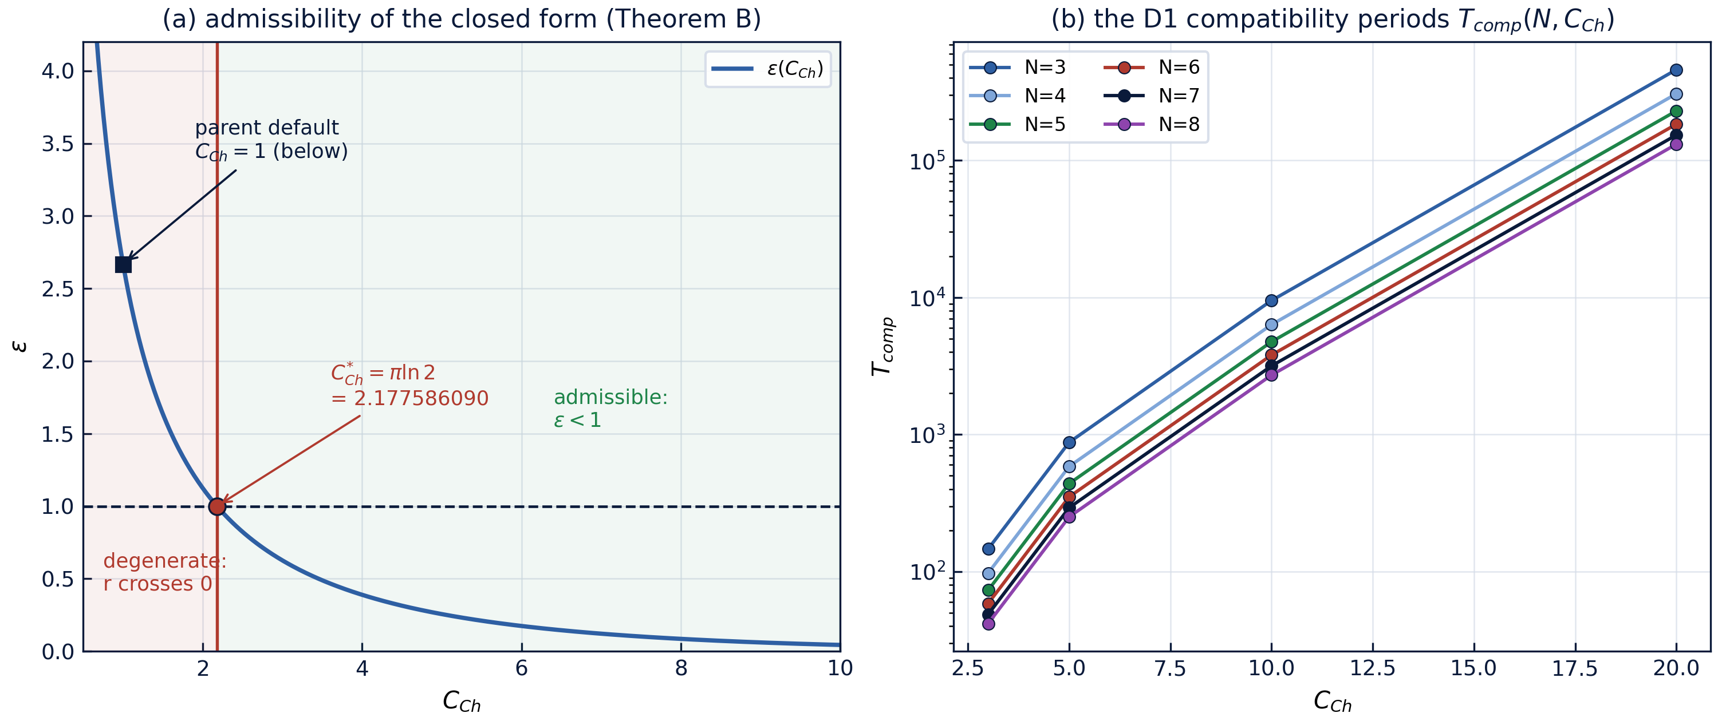
Fig. 1 — Left: the amplitude law $\varepsilon(C_{Ch})$ with the exact boundary $\pi\ln 2$, the degenerate and admissible zones and the parent default $C_{Ch}=1$. Right: the D1 compatibility periods (Lemma D).

4. A registered fact about the parent default
The registered pair of the parent ladder, (C_Ch, T) = (1, 2π), lies below the threshold: ε(1) ≈ 2.668 > 1. The conclusion is careful but important: in this zone the closed form remains a perfectly well-defined complex choreography — the 2π/N separation, the periodicity and the literals ω = e^(1/π) hold bit-for-bit (stage W1) — but the polar picture "an N-gon of radius √(C_Ch)(1 + εcos)" is degenerate, the radii sweep through zero. The Section-6 diagnostic C_Ch(t) = r²(dotθ - q/r) degenerates at the crossing instants, which is why in the parent ladder it is report-only rather than pass/fail — this mini-repository reproduces the same honesty convention (diagnostic drift 15.01 over [0, 100 T] at the default).
The practical reading for Layer-G parameter studies: the non-degenerate regime opens at C_Ch > πln 2, and C_Ch should be quoted relative to C^(*)_Ch. This makes Theorem B an exact, decidable delivery to the parent roadmap item T5, "the admissible region of the closed form".

5. Relation to the formalization roadmap
In the formalization queue Theorem B appears as item TB1 and feeds the parent item T5. It is the cheapest formalization candidate: the statement is one inequality, the proof is the monotonicity of exp and ln, available both in Mathlib and in Coq Reals; the boundary constant πln 2 admits a decidable rational certificate (e.g. the interval [2.1775, 2.1776] ni πln 2 with rational endpoints). The numeric protocol W5 is the reference oracle of a future port; the grid equivalence is already verified by a test of the suite.

References
- TRIVORTEX, verification/README.md — the V1–V4 ladder and the Theorem 3.1 registers.
- H. Aref, P. K. Newton, M. A. Stremler, T. Tokieda, D. L. Vainchtein, Vortex crystals, Advances in Applied Mechanics 39 (2003) 1–79.
- Mini-repository monograph: polyvortex/docs/monograph/monograph_EN.md, Section 5.

