Theorem E: the spectral stability threshold of the N-vortex ring
A polyvortex mini-repository theorem monograph
Isaev Iskhak Khamzatovich (ORCID 0009-0003-7299-0701)
TRIVORTEX Research Program · the polyvortex mini-repository · v1.1.0 · Theorem Monograph Edition
Study | POLYVORTEX
Program | TRIVORTEX — the three-body (and N-body) problem in the vortex model
Author | Isaev Iskhak Khamzatovich (ORCID 0009-0003-7299-0701)
DOI | 10.5281/zenodo.21825394
Version | 1.1.0 — the theorem monograph edition
Date | 2026-10-08
Code | polyvortex/python/polyvortex/ (model · ansatz · classical · ladder · runner · figures)
Data | polyvortex/results/protocols/W1..W7_default.json
License | LicenseRef-Proprietary-Wild8Highlander-1.0
Table of Contents
Abstract
Abstract 1
At a glance 1
1. Introduction and setting 1
2. The eigenvalue problem 2
3. Numerical certification (stage W4) 2
4. The defective zero and the scope 3
5. Relation to the formalization roadmap 3
References 4

Note: this Table of Contents is generated via field codes. After editing, right-click the TOC and select "Update Field" to refresh the page numbers.

Abstract
A regular ring of N identical vortices rotates rigidly for every N (Theorem A), but the spectral quality of that rotation changes by a jump: the co-rotating spectrum of the linearization is purely imaginary for N ≤ 7 and owns a real growing pair for N ≥ 8. This monograph states the Havelock (1931) classification with the later rigorous treatment by Khazin (1976), describes the numerical implementation — the analytic Jacobian A of the Kirchhoff field plus the transport generator ω_N S — and certifies the threshold by stage W4: for N = 2..7 the maximum max Re λ ≤ 7.0· 10⁻⁹ (the defective-double-zero floor), for N = 8 the growth rate max Re λ = +0.4502 — a three-order margin on both sides of the 10⁻⁷ classifier. A separate numerical remark concerns the defective zero of the co-rotating Jacobian (algebraic multiplicity two, geometric one): rounding splits it into a ±-pair of size √(ε_mach|J|)∼ 10⁻⁹, which explains the noise floor of the stable cases. The threshold is the numerical prototype of the parent roadmap item T3; only the spectral (linear) classification is claimed, no nonlinear stability is asserted.

At a glance
Model | Layer-K linearization in the co-rotating frame of the ring
Headline result | stable N ≤ 7 (≤ 7.0e-9), unstable N ≥ 8 (+0.4502)
Verification | stage W4: analytic Jacobian + transport, the 10⁻⁷ classifier
Subtlety | the defective double zero: floor √(ε_mach|J|)∼ 10⁻⁹
Formalization queue | TW5 — per-mode characteristic polynomial; Routh–Hurwitz

1. Introduction and setting
Theorem A guarantees the ring a rigid rotation for every N, but says nothing about what happens to the configuration under a small perturbation. The linear analysis answers: linearizing the Kirchhoff flow around the rotating ring in the co-rotating frame yields an eigenvalue problem whose spectrum is the complete linear verdict. The classical classification goes back to Havelock (1931): the heptagon is the last stable member of the family, the octagon is already unstable. This is one of the most cited facts of vortex dynamics, and the parent roadmap queues its reproduction as item T3. This monograph pins the numerical implementation of the threshold in the mini-repository: an analytic Jacobian (no finite differences), the transport term, a classifier with an explicit tolerance, and the W4 protocol with full spectra.

2. The eigenvalue problem
Let {zₖ} be the vortex positions of the ring (Theorem A) and ω_N = Γ(N-1)/(4π R²). The linearization of Layer K in the fixed frame gives the Jacobian A = d rhs/d state; the passage to the frame rotating with ω_N adds a transport term: a perturbation w obeys dot w = (A + ω_N S) w with the block-diagonal rotation generator
The relative equilibrium is spectrally stable iff the whole spectrum of J = A + ω_N S is purely imaginary (the Havelock criterion). The analytic Jacobian is written in model.py as pairwise blocks ∂(vₓⁱ, v_yⁱ)/∂(x^(j), y^(j)) and validated against central finite differences in the test suite — the numerical implementation is free of differentiation noise.

3. Numerical certification (stage W4)
The W4_stability_default.json protocol (Γ = 1, R = 1):
Table 1 — W4: the maximum real part of the spectrum across $N$
N | max Re λ | вердикт | verdict | Хэвелок | Havelock
2 | 6.9e-10 | устойчиво | stable | устойчиво | stable
3 | 0.0 | устойчиво | stable | устойчиво | stable
4 | 3.8e-9 | устойчиво | stable | устойчиво | stable
5 | 0.0 | устойчиво | stable | устойчиво | stable
6 | 0.0 | устойчиво | stable | устойчиво | stable
7 | 7.0e-9 | устойчиво | stable | устойчиво | stable
8 | +0.4502 | неустойчиво | unstable | неустойчиво | unstable

The classifier runs at the tolerance 10⁻⁷ — three orders above the noise floor and three below the octagon growth rate. The stage verdicts match the Havelock classification at every N ∈ {2,…,8}; the full spectra (the pairs (Reλ, Imλ)) are recorded in the protocol. The picture of the threshold:
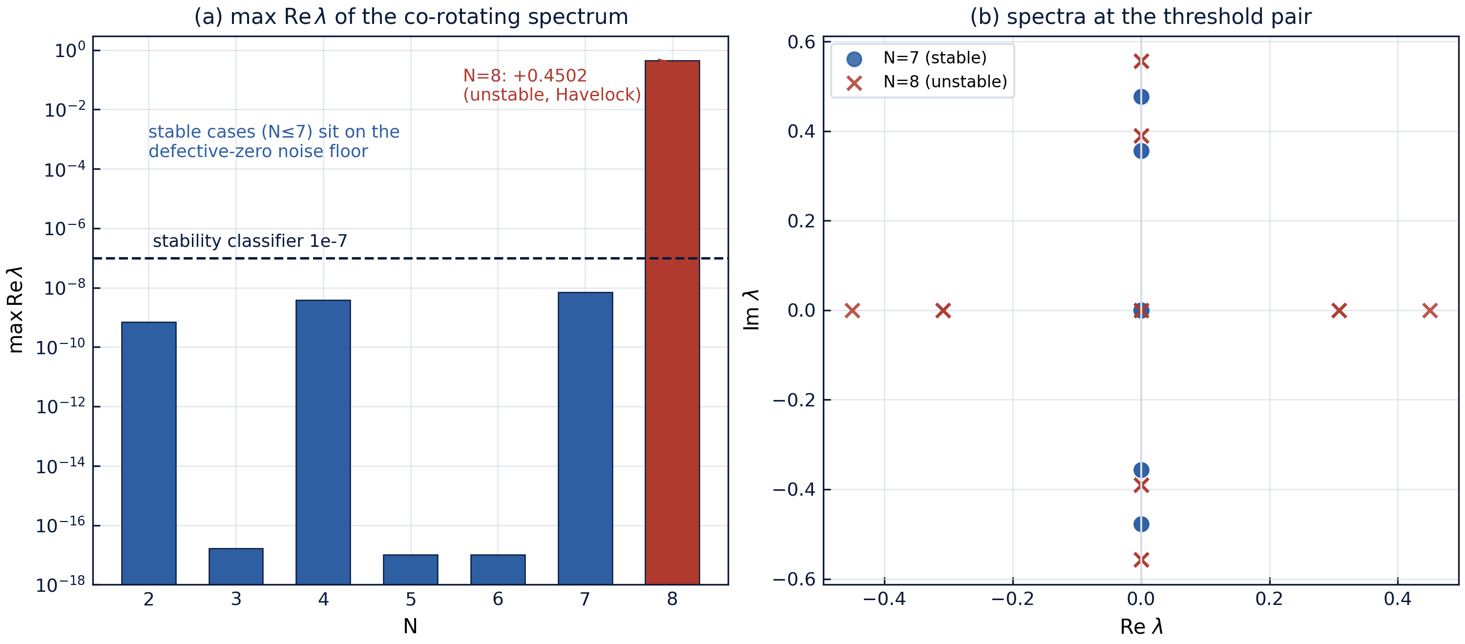
Fig. 1 — Stage W4: left, the maximum $\mathrm{Re}\,\lambda$ across $N$ with the $10^{-7}$ classifier; right, the spectra of the threshold pair $N = 7$ (stable) and $N = 8$ (unstable, the real pair $\pm 0.4502$).

4. The defective zero and the scope
The co-rotating Jacobian of the ring owns a zero eigenvalue of algebraic multiplicity two and geometric multiplicity one: the continuum of rotated polygons is a one-parameter family of equilibria, and along it the linearization must have a zero. Numerically such a defective double zero is split by rounding into a ±-real pair of size √(ε_mach |J|) ∼ 10⁻⁹ — exactly the noise floor of the stable table entries (6.9· 10⁻¹⁰ at N=2, 3.8· 10⁻⁹ at N=4, 7.0· 10⁻⁹ at N=7; at N = 3, 5, 6 the splitting did not show at all). Hence the classifier tolerance: too low is impossible, too high is dangerous; 10⁻⁷ sits in the logarithmic middle.
The scope limits are stated in the honesty notes of the mini-repository. The claim is spectral, i.e. linear, stability; nonlinear (Arnold-style) stability is a different, harder statement not made here. The family N = 2..8 is verified; for N ≥ 9 the instability is expected to persist (the Havelock classification), and the ladder extends to larger N without code changes. Finally, the stability is studied for the ring of the free Layer K; the behavior of a perturbed ring under external shape keeping is a separate problem and does not enter the protocols.

5. Relation to the formalization roadmap
In the formalization queue the threshold appears as item TW5 and feeds the parent item T3. It is the hardest target of the queue: formalization requires the characteristic polynomial over the Fourier mode families (perturbations of the form wₖ = u e^(iμθₖ) reduce the spectrum to a finite set of polynomials) and a Routh–Hurwitz-type criterion for the negativity of the real parts; both objects are decidable but laborious. An intermediate milestone is the formalization of the defective zero and its splitting, which delivers an honest numerical boundary between "stable" and "noise floor". The W4 protocol with full spectra is the reference oracle of a future port.

References
- T. H. Havelock, The stability of motion of vortices, Philosophical Magazine 11 (1931) 617–641.
- L. G. Khazin, On the stability of regular configurations of vortices, Soviet Physics Doklady 21 (1976).
- H. Aref, P. K. Newton, M. A. Stremler, T. Tokieda, D. L. Vainchtein, Vortex crystals, Advances in Applied Mechanics 39 (2003) 1–79.
- Mini-repository monograph: polyvortex/docs/monograph/monograph_EN.md, Sections 3 and 6.3.

