CYCLORING: Gamma-periods, the defect chain, and the synchronous breathing of a vortex ring
A self-contained numerical-analytical study
Isaev Iskhak Khamzatovich (ORCID 0009-0003-7299-0701)
The cycloring research program · v1.0.0 · Theorem Monograph Edition
Study | CYCLORING
Study | CYCLORING — the Gamma-periods, the defect chain, and the synchronous breathing of a vortex ring
Author | Isaev Iskhak Khamzatovich (ORCID 0009-0003-7299-0701)
Version | 1.0.0 — the theorem monograph edition
Date | 2026-10-08
Code | cycloring/python/cycloring/ (periods · chain · ring · dynamics · ladder · runner · figures)
Data | cycloring/results/protocols/W1..W7_default.json
License | LicenseRef-Proprietary-Wild8Highlander-1.0
Table of Contents
1. Setting: from the rigid ring to the periodic modulation
1. Setting: from the rigid ring to the periodic modulation 1
2. The model and the basic objects 2
3. Theorem 1 — the root system of the ring 3
4. Theorem 2 — the periods of the level and the algebraic boundary 5
5. Theorem 3 — the period transducer 6
6. Theorem 4 — the synchronous breathing and the closure 8
7. Theorem 5 — the dichotomy of the invariants 9
8. The verification ladder W1–W7 10
9. The numerical experiments and the figures 11
10. The honest limitations 13
11. Summary 13

Note: this Table of Contents is generated via field codes. After editing, right-click the TOC and select "Update Field" to refresh the page numbers.

1. Setting: from the rigid ring to the periodic modulation
The regular N-gon of equal point vortices is the most economical laboratory of collective vortex motion. The configuration is specified by one radius and one angle: the vortices occupy the vertices of a polygon and rotate as a whole at a constant angular rate. The entire kinematics here is algebraic in nature: the angular positions are the roots of unity ζ_Nᵏ = e^(2π i k/N), and any relation between the vortices reduces to the arithmetic of the cyclotomic lattice. The present study takes this observation to its conclusion: we show that not only the angular but also the radial dynamics of the ring can be read off a finite set of transcendental constants — the Gamma-periods of the level.
The program splits into four registers. The first register is the algebraization: the ring is the root system of a single binomial z^(N) = σ(t), and every instantaneous relation between the vortices is expressed by the roots-of-unity filter. The second register is the periodic one: for the level N we introduce the functional Ω_a,b = Γ(a/N)Γ(b/N)/Γ((a+b)/N), its boundary turns out to be algebraic, and its diagonal sums produce the period witness W_N. The third register is the defect chain: from the triple (N, B, λ₀) a finite chain δ → γ → δ_eff → Δ_Ch is built, which converts the periods of the level into the amplitude and the frequency of the modulation. The fourth register is dynamical: the synchronous breathing at the transducer-prescribed frequency closes exactly, and every rosette returns to its start after T_c = 2π/ν.
All statements of the program split into two sorts. Theorems 1–5, proved here, are clean statements: the binomial identity, the roots-of-unity filter, the algebraicity of the boundary, the mean-transport identity, the closed form of the Hamiltonian. Each carries a full proof and a numerical certificate from the ladder W1–W7. The numerical laws — for instance the stiffness power law Δ_Ch(N) — are reported honestly as numerical approximations with their scan range. This standard — "a theorem with a proof plus a protocol with a tolerance" — is maintained throughout.

2. The model and the basic objects
Point vortices with circulations Γₖ in the complex plane obey
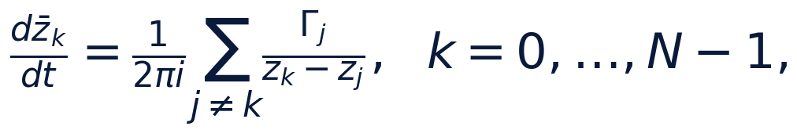
with the classical integrals — the Hamiltonian, the impulse and the moment:
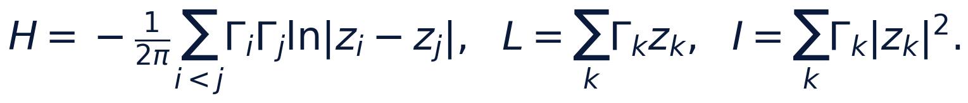
We work in the natural units Γ = R₀ = 1, where R₀ is the base radius of the ring. The rigid ring is the configuration zₖ = Rζ_Nᵏ; the key elementary fact about it is the pair cancellation. For a pair of vertices zₖ - zⱼ = Re^(iθₖ)(1 - e^(i(θⱼ - θₖ))), and the sum over all neighbors splits into a real half and an antisymmetric cotangent tail:
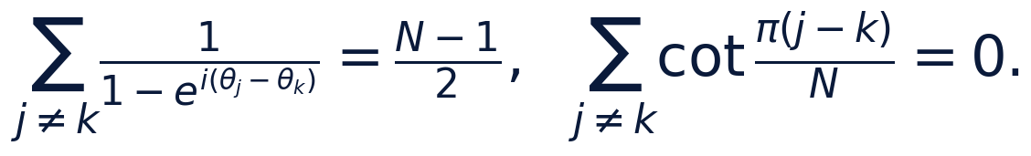
Hence the rigid-rotation theorem: the frozen polygon rotates as a whole at
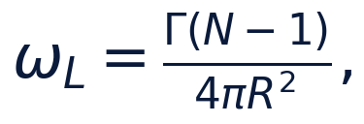
and the radial velocity component of every vortex vanishes identically. This is an exact statement, not an approximation: it follows from the antisymmetry of the cotangent sum and is re-checked numerically at stage W4 with the relative error 1.1 · 10⁻¹⁰ (RK4, two turns, N = 7). The consequence for the whole program: any breathing of the ring is a radial program the kinematical flow does not sustain by itself; the angular transport of the ring under an arbitrary radius program r(t), however, follows the frozen law with the adiabatic invariant
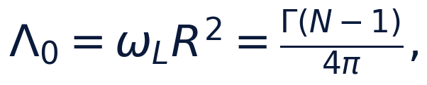
which is free of the radius. The invariance of the polygon in the flow and the supporting role of the radial drive are discussed in Section 6 and pinned in the honesty notes.
The level triple that launches the whole chain is now natural: N is the order of the cyclotomic lattice, B = NΓ R₀² is the angular impulse of the frozen ring, λ₀ = Γ(N-1)/(4π R₀²) is its frozen frequency. Both are exact integral registers of the ring, and their product Bλ₀/Γ² = N(N-1)/(4π) is dimensionless.

3. Theorem 1 — the root system of the ring
The first register of the program is the complete algebraization of the configuration. Let
be the kinematic program of the ring with the common radius r(t) and the common angular rate ν. The following theorem holds.
Theorem 1 (root system). For every time t the polynomial Fₜ(z) = ∏ₖ (z - zₖ(t)) is the binomial
that is, the ring is exactly the full set of roots of z^(N) = σ(t). Moreover, the power sums satisfy the roots-of-unity filter Sₘ(t) = Σₖ zₖᵐ = 0 for 1 ≤ m ≤ N-1 and S_N(t) = Nσ(t), the linear impulse L = ΓΣₖ zₖ vanishes identically, and the Galois group Gal(ℚ(ζ_N)/ℚ) cong (ℤ/N)times acts on the ring by relabeling the vortices: σₐ: ζ_Nᵏ ↦ ζ_Nᵃᵏ.
Proof. The set {r e^(iν t)ζ_Nᵏ} is the full root set of the binomial z^(N) = r^(N) e^(iNν t): the N-th power erases the factor ζ_Nᵏ since ζ_N^(Nk) = 1, and all N vortices land on the same value σ(t) = r^(N) e^(iNν t). Since the binomial z^(N) - σ has exactly N roots and all are listed, the identity Fₜ(z) = z^(N) - σ(t) is proved. For the power sums expand zₖᵐ = rᵐ e^(imν t)ζ_Nᵐᵏ: the sum becomes the geometric sum Σₖ ζ_Nᵐᵏ, equal to N when N vert m and to zero otherwise; for 1 ≤ m ≤ N-1 there is no divisibility, hence Sₘ = 0, and for m = N every summand equals r^(N) e^(iNν t), so S_N = Nσ. The vanishing impulse is the case m = 1. Finally, the automorphism σₐ of ℚ(ζ_N) sends ζ_Nᵏ ↦ ζ_Nᵃᵏ for gcd(a, N) = 1 and therefore permutes the roots of the binomial: the Galois action on the ring is exactly the vortex permutation k ↦ ak mod N. The theorem is proved. ∎
The practical corollary is the character decomposition of the deformations. Perturb the ring, zₖ = zₖ⁽⁰⁾ + ηₖ; the coefficients
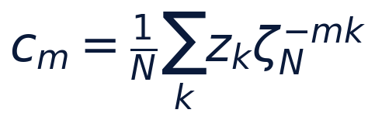
are exactly the projections of the perturbation onto the characters of the lattice μ_N: the ideal ring populates only the master mode m = 1 (c₁ = re^(iν t), the rest are zeros to 10⁻¹⁰ — a test register), and any deformation appears as the population of the senior modes. The roots-of-unity filter is the discrete Fourier transform on the cyclotomic lattice, and the entire "algebraization" of the first register is precisely it. The numerical certificate is stage W3: the binomial identity holds with the normalized residual 6.4 · 10⁻¹¹, the power sums with 2.9 · 10⁻¹⁴, the impulse with 1.9 · 10⁻¹⁵.

4. Theorem 2 — the periods of the level and the algebraic boundary
The second register introduces the periodic functional of the level. For integers a, b ≥ 1 set
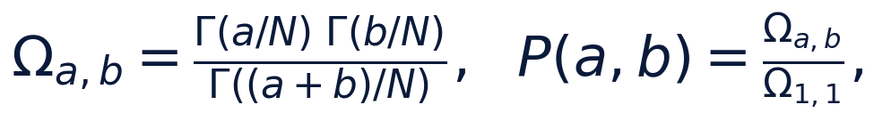
call the normalized periods P(a,b) the periodic coordinates of the pair (a,b), and the period witness of the level —
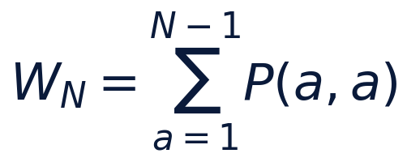
— its diagonal sum. The functional is symmetric: Ω_a,b = Ω_b,a.
Theorem 2 (the algebraic boundary). For 1 ≤ a ≤ N-1 the boundary period equals
that is, it lies in π · ℚ(ζ_N)times — an algebraic multiple of π. Moreover, the sine product
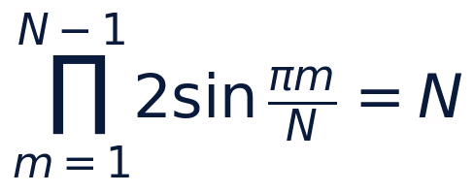
is exact, and therefore the product of all boundary periods equals π^(N-1) 2^(N-1)/N.
Proof. The reflection identity Γ(z)Γ(1-z) = π/sin(π z) at z = a/N gives the first part immediately: the denominator Γ(1) is one, and sin(π a/N) is an algebraic number generated by ζ_N. For the sine product consider (z^(N) - 1)/(z - 1) = ∏ₘ₌₁^(N-1)(z - ζ_Nᵐ) and substitute z = 1: the left side is N, the right side is ∏ₘ (1 - ζ_Nᵐ). Passing to the moduli gives ∏ₘ |1 - ζ_Nᵐ| = N, and |1 - e^(iφ)| = 2sin(φ/2) completes the proof. The product of the boundary periods follows directly: ∏ₐ π/sin(π a/N) = π^(N-1) · 2^(N-1)/N. ∎
The dichotomy "the boundary is algebraic, the interior is Gamma-transcendental" is the main periodic fact of the program. At small levels the boundary values are elementary: Ω_1,2 = 2π/√(3) at N = 3, Ω_1,3 = π√(2) and Ω_2,2 = π at N = 4, Ω_3,3 = π at N = 6. The interior periods — for instance P(2,2) ≈ 0.411 at N = 7 — admit no known algebraic reductions, and the program never consumes them as algebraic: the chain takes only the diagonal sums W_N (as the numerical constants of the level) and the boundary values. The certificates are stages W1 and W2: the reflection identity holds with the residual 5.1 · 10⁻⁴⁹, the sine product with 5.1 · 10⁻⁴⁹ (mpmath, 50 working digits); the float versions of the registers hold 10⁻¹².

5. Theorem 3 — the period transducer
The third register connects the two previous ones: the defect chain converts the arithmetic of the level into the modulation program of the ring. The input is the triple (N, B, λ₀) of Section 2; the output is the triple (ε, ν, C_N): the amplitude, the frequency and the log-stiffness of the breathing.
Theorem 3 (the transducer). Set successively
Then the map
is well defined for Δ_Ch > 0, bijective, and its frequency branch is identical to the synchronous law ν = ω_L(1-ε²)^(-3/2). Moreover: (i) γ(N) strictly decreases in N from N = 4 on; (ii) the classical limit Δ_Ch → 0 gives ε → 0, ν → ω_L, C_N → ∞ — the rigid ring.
Proof. Well-definedness: Δ_Ch > 0 as a product of the positive γ and W_N; the map ε = Δ/(1+Δ) is a fractional-linear isomorphism (0,∞) → (0,1) with the inverse Δ = ε/(1-ε). The branch identity: from ε = Δ/(1+Δ) we get 1 - ε² = ((1+Δ)² - Δ²)/((1+Δ)²) = (1+2Δ)/((1+Δ)²), whence (1-ε²)^(-3/2) = ((1+Δ)³)/((1+2Δ)^(3/2)) — the frequency branches coincide. Monotonicity: δ⁴ = π⁴/N⁴ strictly decreases, while k = lceil N(N-1)/(4π)rceil is non-decreasing and strictly increases for N ≥ 4 (the step 2N/(4π) > 1), hence γ = δ⁴/k strictly decreases. The limit: as Δ → 0 the fractional-linear isomorphism gives ε → 0, the expansion (1-ε²)^(-3/2) = 1 + (3/2)ε² + O(ε⁴) gives ν → ω_L, and C_N = -lnε → ∞. ∎
The numerical shape of the transducer is pinned by stage W7; the registered table of the four levels is given in Section 8. On the scan range N = 3..30 the discriminant follows the power law Δ_Ch(N) ≈ 1.7 · 10³ · N^(-6.7) — a numerical approximation, not an asymptotic theorem; only the monotonicity is proved. The economical meaning of the chain: only one number of the level grows with N — the period witness W_N ≈ ln N + O(1), slowly, while the defects γ ∼ δ⁴/k fall fast; their product creates the observed stiffness of the high levels.

6. Theorem 4 — the synchronous breathing and the closure
The fourth register is the dynamical content of the program. Let the ring be driven by the radial breathing program
with the amplitude ε = ε_N from the transducer. The pair cancellations of Section 2 guarantee: in the Kirchhoff field such a configuration has no radial velocity of its own, so the radial drive must be supplied by a pump; the angular transport of the ring, however, is not prescribed — it follows the frozen law with the instantaneous rate Λ₀/r(t)².
Theorem 4 (synchronous breathing). The mean-transport identity holds:
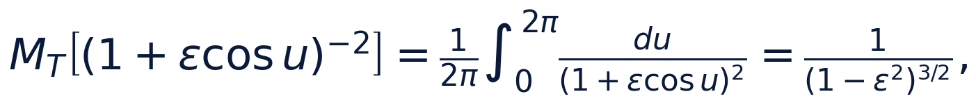
and therefore the phase accumulated by the ring over one breathing cycle at the frequency
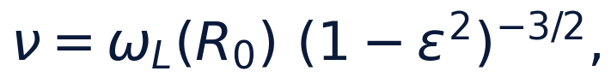
equals exactly 2π: every rosette zₖ(t) = r(t)e^(i(ν t + 2π k/N)) is closed, and the whole configuration returns to its start at T_c = 2π/ν.
Proof. The integral reduces by t = tan(u/2) to a rational one; the standard computation gives ∫₀^(2π)(du)/(a + bcos u) = (2π)/(√(a² - b²)) for a > |b|, and the differentiation in the parameter a gives ∫₀^(2π)(du)/((a + bcos u)²) = (2π a)/((a² - b²)^(3/2)); at a = 1, b = ε we obtain the identity. The phase over a cycle: ∫₀^(T_c)(Λ₀ dt)/(r(t)²) = (Λ₀)/(ν R₀²)∫₀^(2π)(du)/((1+εcos u)²) = (Λ₀)/(ν R₀²) · (2π)/((1-ε²)^(3/2)); at the synchronous choice ν = (Λ₀/R₀²)(1-ε²)^(-3/2) this product equals 2π exactly. The closure of the configuration: at t = T_c the phase of every vortex is shifted by exactly 2π, the radius program is periodic, and zₖ(T_c) = zₖ(0). ∎
It is essential that both parts of the theorem are exact statements, not approximations: the transport identity is an integral identity, and the closure is a consequence of periodicity. The numerical certificates: stage W5 holds the mpmath residual of the identity at 10⁻³⁰ over the grid ε ∈ [0.05, 0.6] and confirms the exact 2π phase advance with the error 3.6 · 10⁻¹³; stage W6 pins the closure of the level rosettes (N = 7, ε = ε₇) with the residual 10⁻¹⁵ and the shape rigidity along the program — all |zₖ| coincide to 10⁻¹⁶. The geometry of the program is illustrated by fig03: at the raised amplitude ε = 0.25 every vortex rides the limacon r(θ) = R₀(1 + εcos(θ - 2π k/N)), and the family of seven rosettes closes over three periods.

7. Theorem 5 — the dichotomy of the invariants
The fifth register answers which of the classical invariants of the ring are algebraic and which carry a transcendental shell.
Theorem 5 (the dichotomy). For the frozen regular N-gon of radius R:
(i) the pair-distance product is algebraic in R:
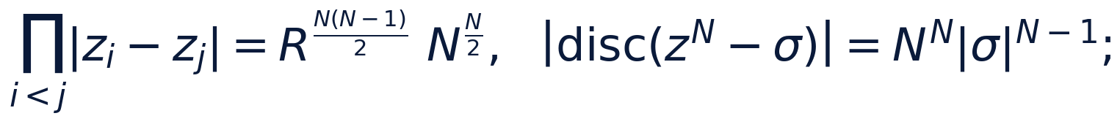
(ii) the Hamiltonian has the closed form
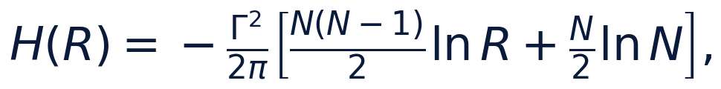
that is, it splits into an R-algebraic part and a transcendental ln-shell;
(iii) the impulses L = 0, the moment I = NΓ R² are algebraic, and the power sums Sₘ are cyclotomic.
Proof. (i) The distance between the vertices is R|1 - ζ_N^(j-i)|, and the product over the pairs splits into R^(N(N-1)/2) and the chord product ∏ₘ |1-ζ_Nᵐ|^(N/2) = N^(N/2) — by Theorem 2. The discriminant of the binomial z^(N) - σ equals (-1)^(N(N-1)/2) N^(N) σ^(N-1) — the standard formula for xⁿ - a; its modulus gives the second register, and the root system of Theorem 1 links the discriminant to the squared product of the root differences. (ii) The logarithm of the product from (i) is exactly the sum Σ_i<jln|zᵢ - zⱼ|, and the substitution into the definition of H gives the closed form; the term (N/2)ln N is the constant of the level, the term with ln R is the only transcendental shell. (iii) The impulse is Theorem 1; the moment is the direct computation Σₖ |zₖ|² = NR². ∎
The dichotomy agrees with the periodic register: the boundary periods (the algebraic multiples of π) serve the algebraic registers of the ring — the chords, the discriminant, the moment; the interior Gamma-periods serve the modulation — the amplitude and the frequency of the breathing through W_N. The numerical certificate is stage W4: the closed form of H matches the direct pairwise summation with the error 10⁻¹⁶, the distance product with 1.3 · 10⁻¹⁶; the picture is fig05.

8. The verification ladder W1–W7
The ladder consists of seven stages; each is a deterministic JSON protocol in results/protocols/ bound to a run. The presets: quick (smoke), default (registration), full (long integration).
stage | register | tolerance | result
W1 | reflection identity + P(1,1) = 1 + symmetry | 1e−30 | 5.1e−49
W2 | the algebraic boundary + the sine product | 1e−30 | 5.1e−49
W3 | the binomial z^N − σ + moments + impulse | 1e−10 / 1e−12 | 6.4e−11 / 2.9e−14
W4 | rigid rotation, shape, invariants, the H form | 1e−9 / 1e−12 | 1.1e−10 / 2.0e−12
W5 | the mean-transport identity + the 2π advance | 1e−30 / 1e−12 | 1.0e−30 / 3.6e−13
W6 | the rosette closure + the shape rigidity | 1e−9 | 1.5e−15
W7 | the transducer table + the stiffness order + the round trip | 1e−15 | 1.2e−16

The registered table of the levels (the default preset):
N | k | W_N | Δ_Ch | ε_N | ν/ω_L | C_N
7 | 4 | 2.175444 | 3.677e−03 | 3.664e−03 | 1.0000201 | 5.609
9 | 6 | 2.416543 | 7.474e−04 | 7.469e−04 | 1.0000042 | 7.200
15 | 17 | 2.915447 | 2.357e−05 | 2.357e−05 | 1.0000000 | 10.656
30 | 70 | 3.603649 | 2.135e−07 | 2.135e−07 | 1.0000000 | 15.360

The test guard of the mini-research is 37 tests; together with the parent package the full guard is 126 tests and keeps every number of the tables bound to the protocols.

9. The numerical experiments and the figures
The figure factory reads the registers from the committed protocols and never invents numbers; the trajectory panels are pictures of the program recomputed from the modules. fig01 shows the period field of the level N = 15 and the algebraic boundary: the residual of the reflection identity is 5.1 · 10⁻⁴⁹ on all fourteen boundary pairs. fig02 — the defect chain: the discriminant Δ_Ch(N) on the grid N = 3..30 with the power approximation 1.7 · 10³ · N^(-6.7) and the mark of the four registered levels; the right panel contrasts the amplitude ε_N and the stiffness C_N.
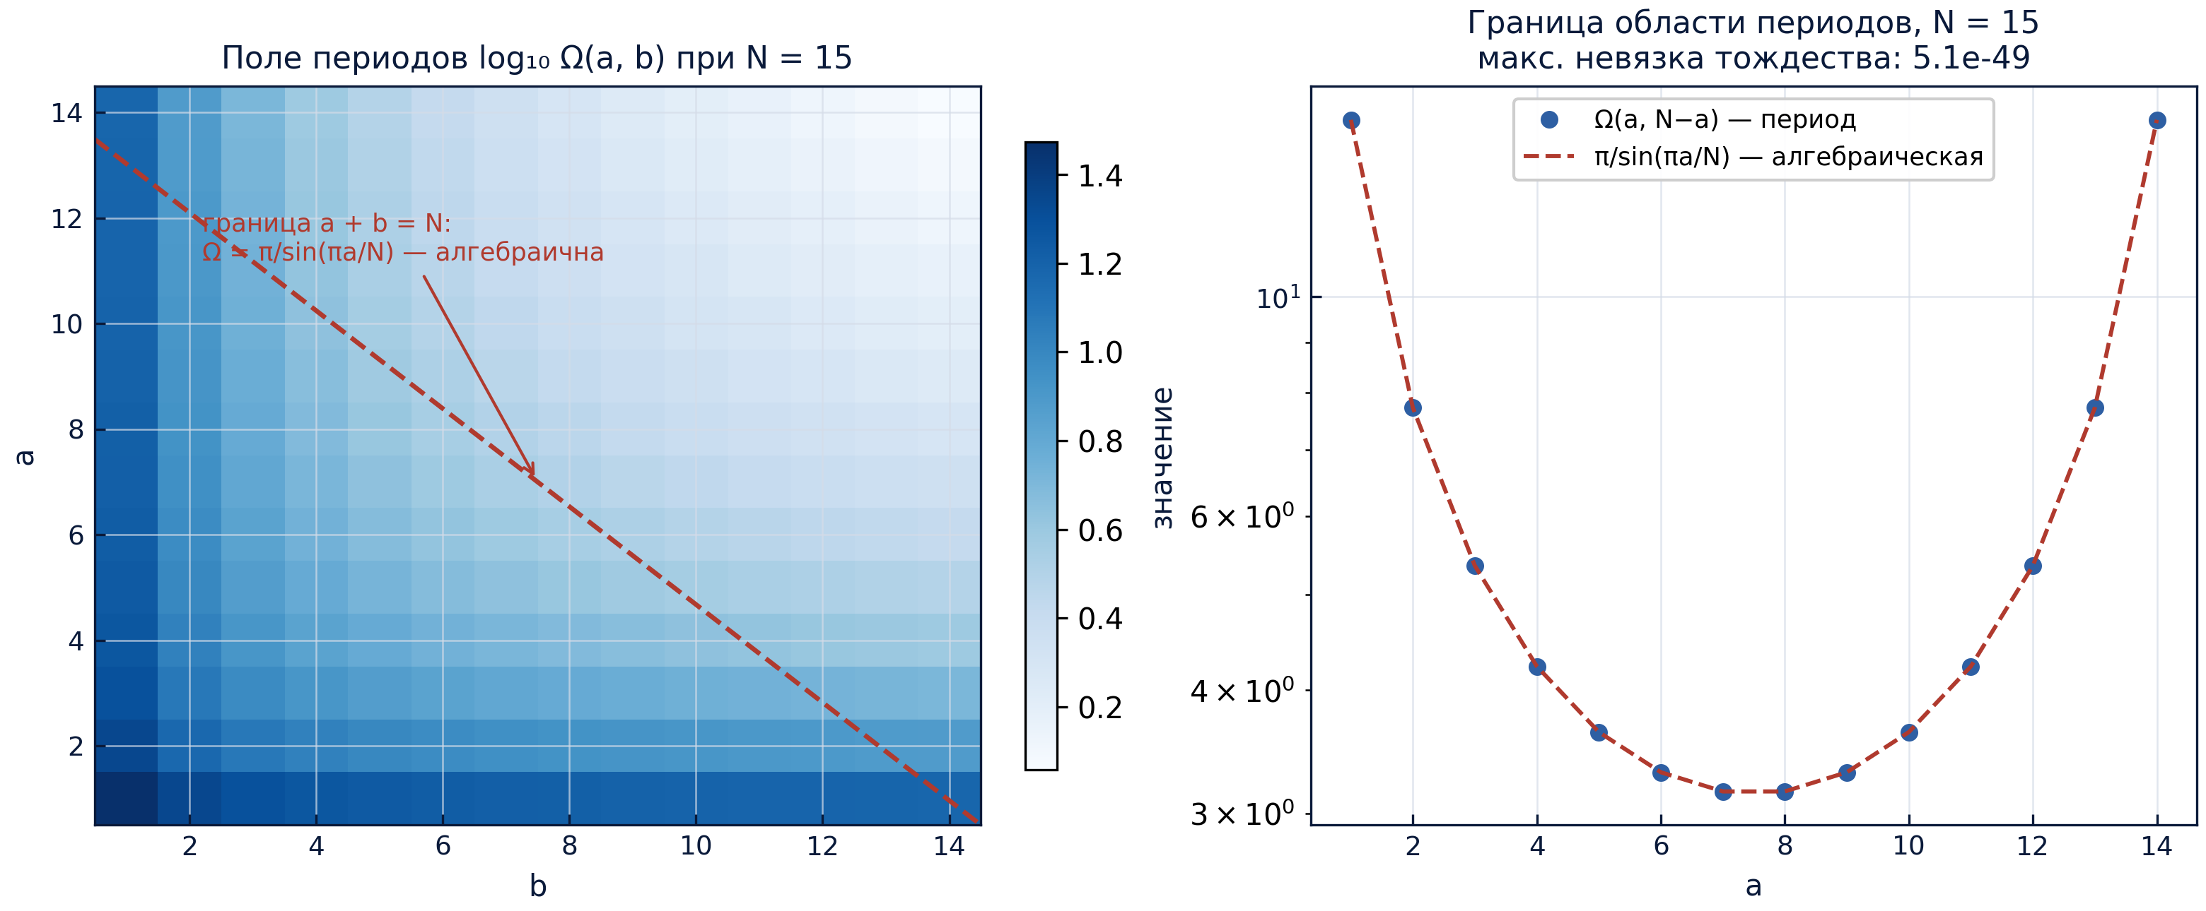
Fig. 1 — The period field of the level N = 15 and the algebraic boundary (protocol W2).
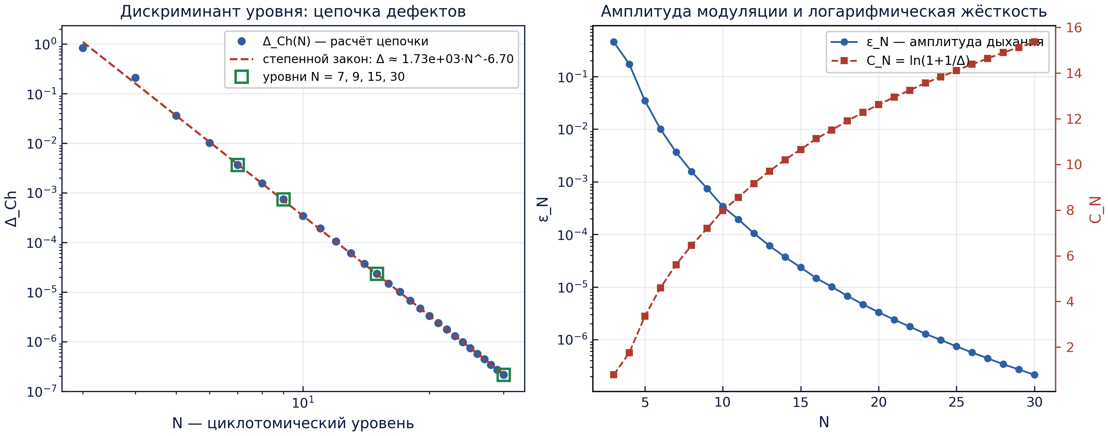
Fig. 2 — The defect chain: the level discriminant and the modulation map (protocol W7).
The synchronous breathing is shown on fig03: the rosettes of the seven vortices over three closure periods at the illustrative amplitude ε = 0.25 (the level value ε₇ = 3.664 · 10⁻³ is far smaller — a stiff ring). fig04 — the mean-transport identity: the quadrature mean and the closed form (1-ε²)^(-3/2) merge over the whole grid, the residual of the inset is at the machine level. fig05 — the dichotomy: on the left, the boundary (algebraic) and the diagonal (Gamma-period) values of the level N = 7; on the right, the closed form of the Hamiltonian against the direct pairwise summation.
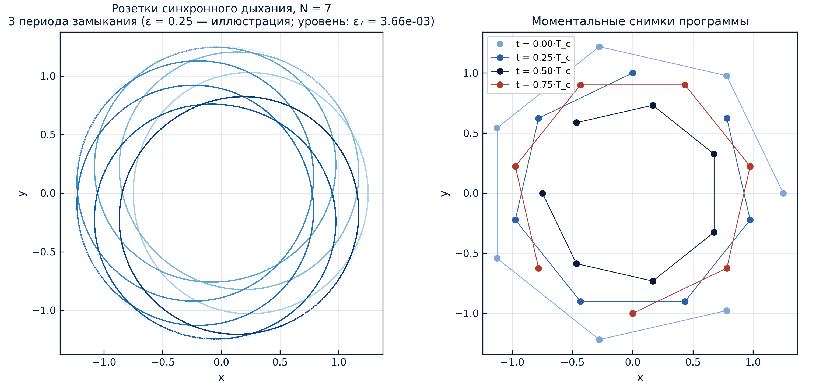
Fig. 3 — The rosettes and the snapshots of the synchronous program (protocol W6).
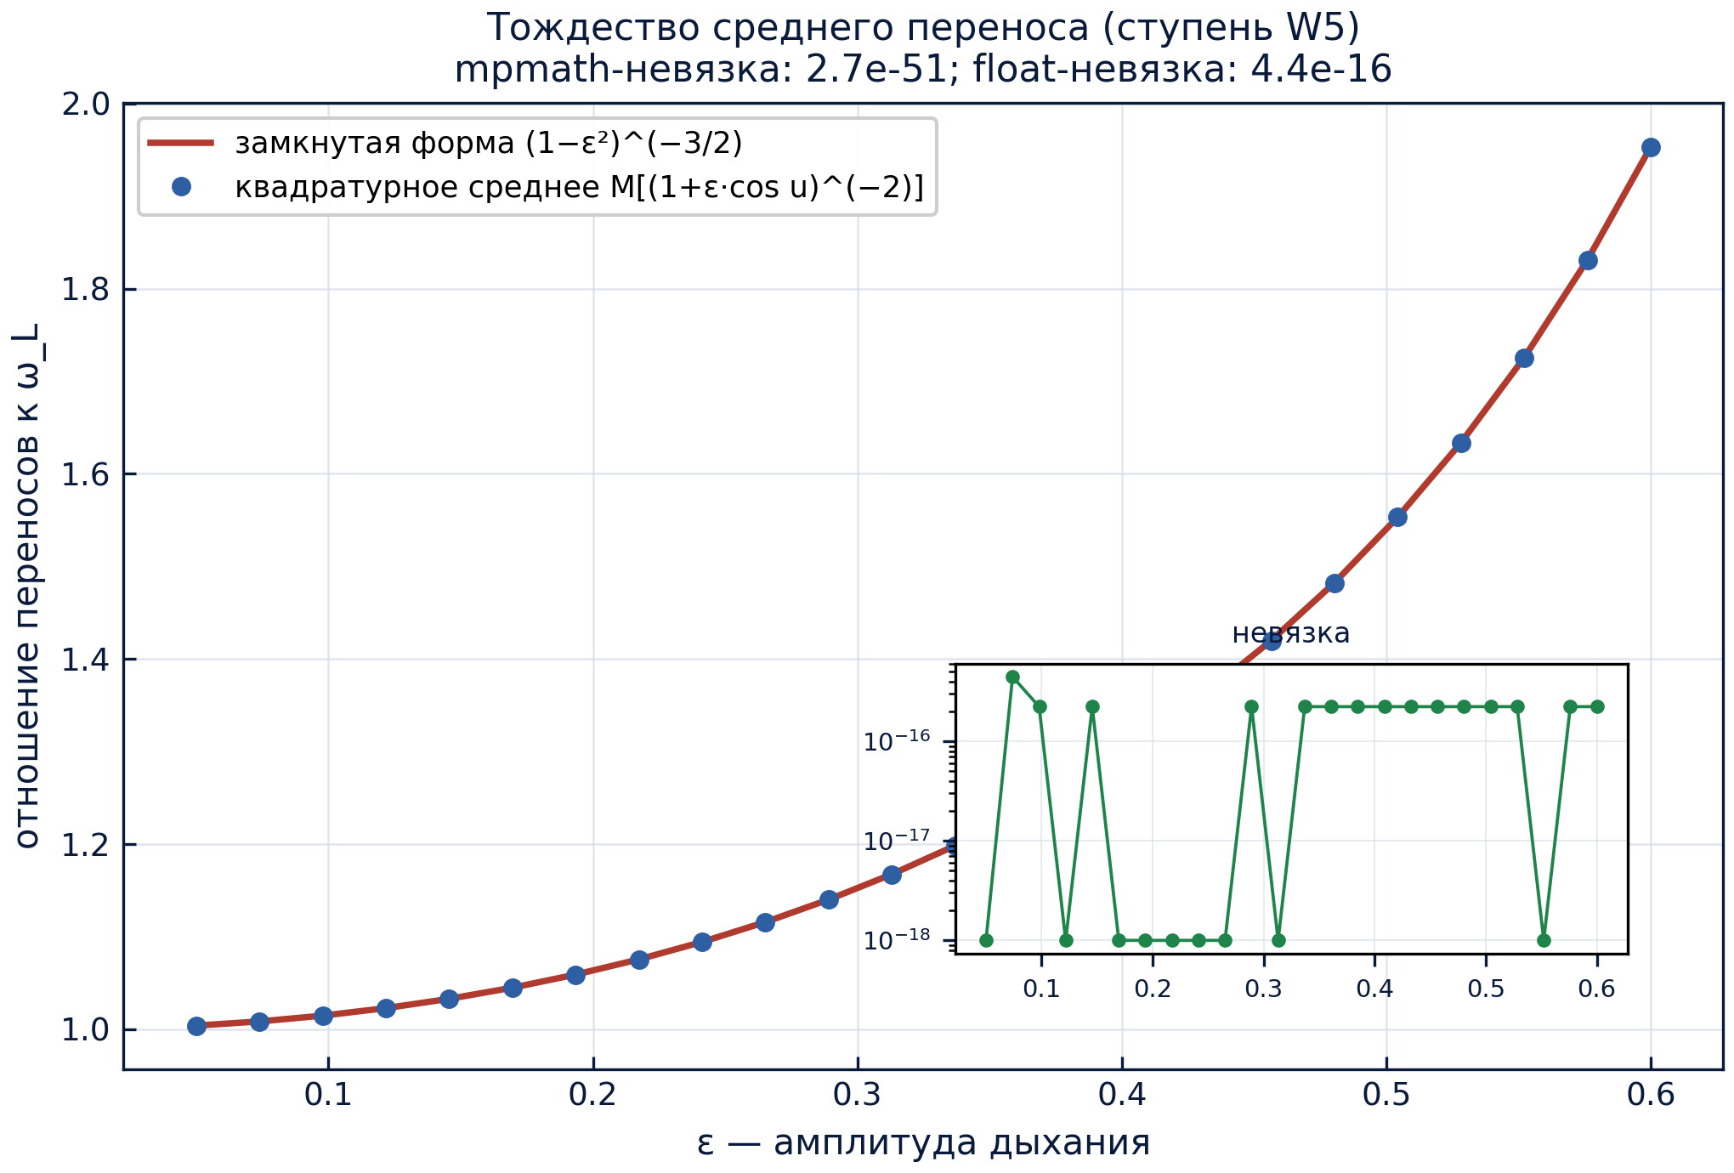
Fig. 4 — The mean-transport identity: the quadrature against the closed form (protocol W5).
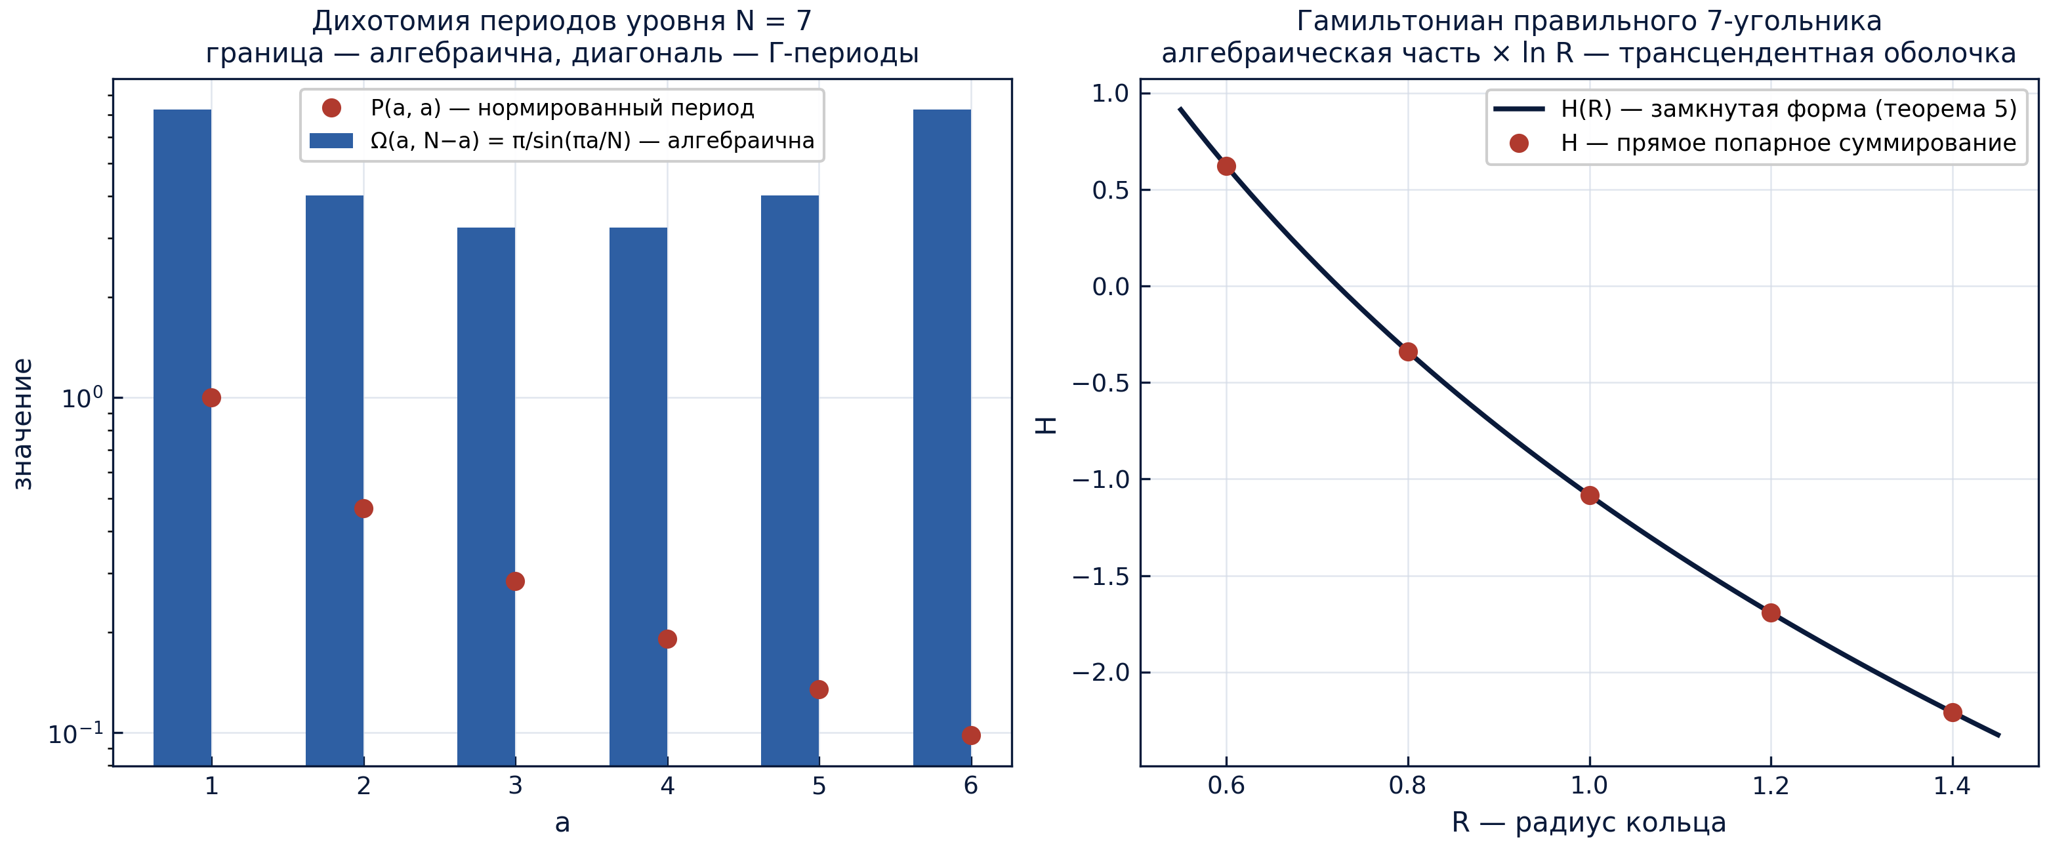
Fig. 5 — The dichotomy of the periods and the closed form of the Hamiltonian (protocols W2/W4).

10. The honest limitations
The breathing program is kinematic: the Kirchhoff flow does not sustain the radial velocity of the polygon, so the radial drive is an external pump. The angular transport, however, is not prescribed — it follows the frozen law Λ₀/r(t)², and that is why the transport identity and the closure are exact; but the direct integration of the free ring from the modulated initial condition yields the rigid rotation at the radius R₀(1+ε) — the ring will not breathe by itself. The stiffness power law is a numerical approximation on a finite range; only the defect monotonicity is proved. The interior periods are treated as transcendental constants of Gamma type with no algebraic claims; no reduction is used anywhere. The spectral registers of the Jacobian serve as diagnostics; the ladder claims no stability results. Finally, all tolerances of the ladder are machine tolerances, not mathematically strict bounds; the formalization queue C1–C3 of the roadmap addresses this.

11. Summary
A self-contained study has been assembled that translates the vortex ring into the language of algebra and periods. The ring is the root system of a binomial; its deformations live on the character lattice; the boundary of the period domain of the level is algebraic; a finite defect chain converts the Gamma-periods into the modulation program; the synchronous breathing at the transducer frequency closes exactly; the invariants of the ring split into an algebraic part and a transcendental ln-shell. Every register is held by a theorem with a proof and a protocol with a tolerance; the ladder W1–W7, the table of the levels 7/9/15/30, five figures and thirty-seven tests form a reproducible circuit. The roadmap C1–C4 leads from the numerical certificates to formalization and extensions — unequal circulations, two-frequency programs, and the senior-mode experiments.

