Theorem 1. The root system of the vortex ring
The ring as the full root set of the binomial z^N = sigma(t) and the character lattice mu_N
Isaev Iskhak Khamzatovich (ORCID 0009-0003-7299-0701)
The cycloring research program · v1.0.0 · Theorem Monograph Edition
Study | CYCLORING
Study | CYCLORING — the Gamma-periods, the defect chain, and the synchronous breathing of a vortex ring
Author | Isaev Iskhak Khamzatovich (ORCID 0009-0003-7299-0701)
Version | 1.0.0 — the theorem monograph edition
Date | 2026-10-08
Code | cycloring/python/cycloring/ (periods · chain · ring · dynamics · ladder · runner · figures)
Data | cycloring/results/protocols/W1..W7_default.json
License | LicenseRef-Proprietary-Wild8Highlander-1.0
Table of Contents
Abstract
Abstract 1
At a glance 1
1. Setting and the statement 1
2. Proof 2
3. The character decomposition of the deformations 2
4. The numerical certificate 2

Note: this Table of Contents is generated via field codes. After editing, right-click the TOC and select "Update Field" to refresh the page numbers.

Abstract
The monograph proves that the regular N-vortex ring with a common radius program r(t) and a common angular rate nu is exactly the full root set of a single binomial z^N = sigma(t) with the master coefficient sigma(t) = r(t)^N e^{iN nu t}. The entire instantaneous algebra of the ring collapses to one scalar.
The corollaries are written out in full: the roots-of-unity filter gives the vanishing power sums S_m = 0 for m < N and S_N = N sigma; the linear impulse vanishes identically; the Galois group of the cyclotomic field acts on the ring by relabeling the vortices, and the character decomposition c_m = (1/N) sum z_k zeta_N^{-mk} isolates the master mode m = 1 and turns any deformation into the population of senior modes.
All registers are certified numerically: the binomial identity holds with the normalized residual 6.4e-11, the power sums with 2.9e-14, the impulse with 1.9e-15 (stage W3 of the ladder).

At a glance
Object | the ring z_k = r(t) zeta_N^k e^{i nu t}, k = 0..N-1
Master coefficient | sigma(t) = r(t)^N e^{iN nu t}
Ring polynomial | F_t(z) = z^N - sigma(t)
Roots-of-unity filter | S_m = 0 (m < N); S_N = N sigma
Galois action | sigma_a: zeta_N^k -> zeta_N^{ak} — vortex relabeling
Numerical certificate | stage W3: 6.4e-11 / 2.9e-14 / 1.9e-15

1. Setting and the statement
Let the ring be the kinematic program zₖ(t) = r(t) ζ_Nᵏ e^(iν t) with the common radius r(t) and the common angular rate ν. The theorem states three identities and one action: the ring polynomial is Fₜ(z) = z^(N) - σ(t); the power sums obey the roots-of-unity filter; the impulse vanishes; the Galois group permutes the vortices.
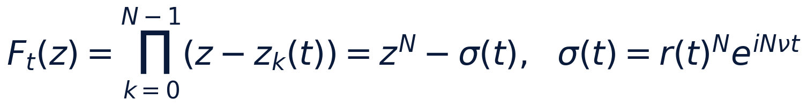

2. Proof
The set {r e^(iν t)ζ_Nᵏ} is the full root set of z^(N) = r^(N) e^(iNν t): the N-th power erases ζ_Nᵏ since ζ_N^(Nk) = 1. The binomial has exactly N roots, all listed — the identity is proved. For the power sums expand zₖᵐ = rᵐ e^(imν t)ζ_Nᵐᵏ: the sum is geometric, Σₖ ζ_Nᵐᵏ equals N when N vert m and zero otherwise; for 1 ≤ m ≤ N-1 there is no divisibility, hence Sₘ = 0; at m = N all summands equal σ(t) and S_N = Nσ. The impulse is the case m = 1. The automorphism ζ_N ↦ ζ_Nᵃ for gcd(a, N) = 1 sends the root zₖ to the root z_ak mod N — the Galois action is the relabeling.
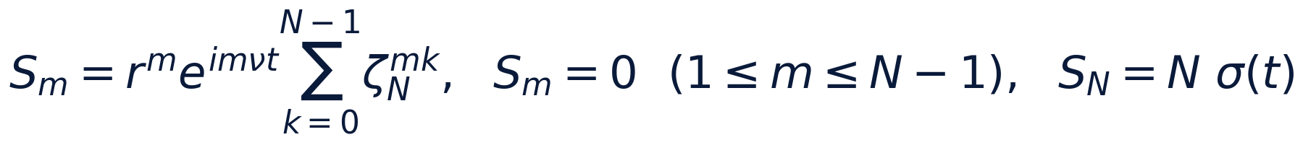

3. The character decomposition of the deformations
The coefficients cₘ = (1/N)Σₖ zₖ ζ_N⁻ᵐᵏ are the projections of the configuration onto the characters of the lattice μ_N. The ideal ring populates only the master mode m = 1: c₁ = r e^(iν t), the rest are zeros (the 10⁻¹⁰ register). Any perturbation ηₖ spreads over the senior modes, and the roots-of-unity filter acts as the discrete Fourier transform on the cyclotomic lattice. The algebraization thus becomes computable: to watch the ring is to watch the N complex numbers cₘ.
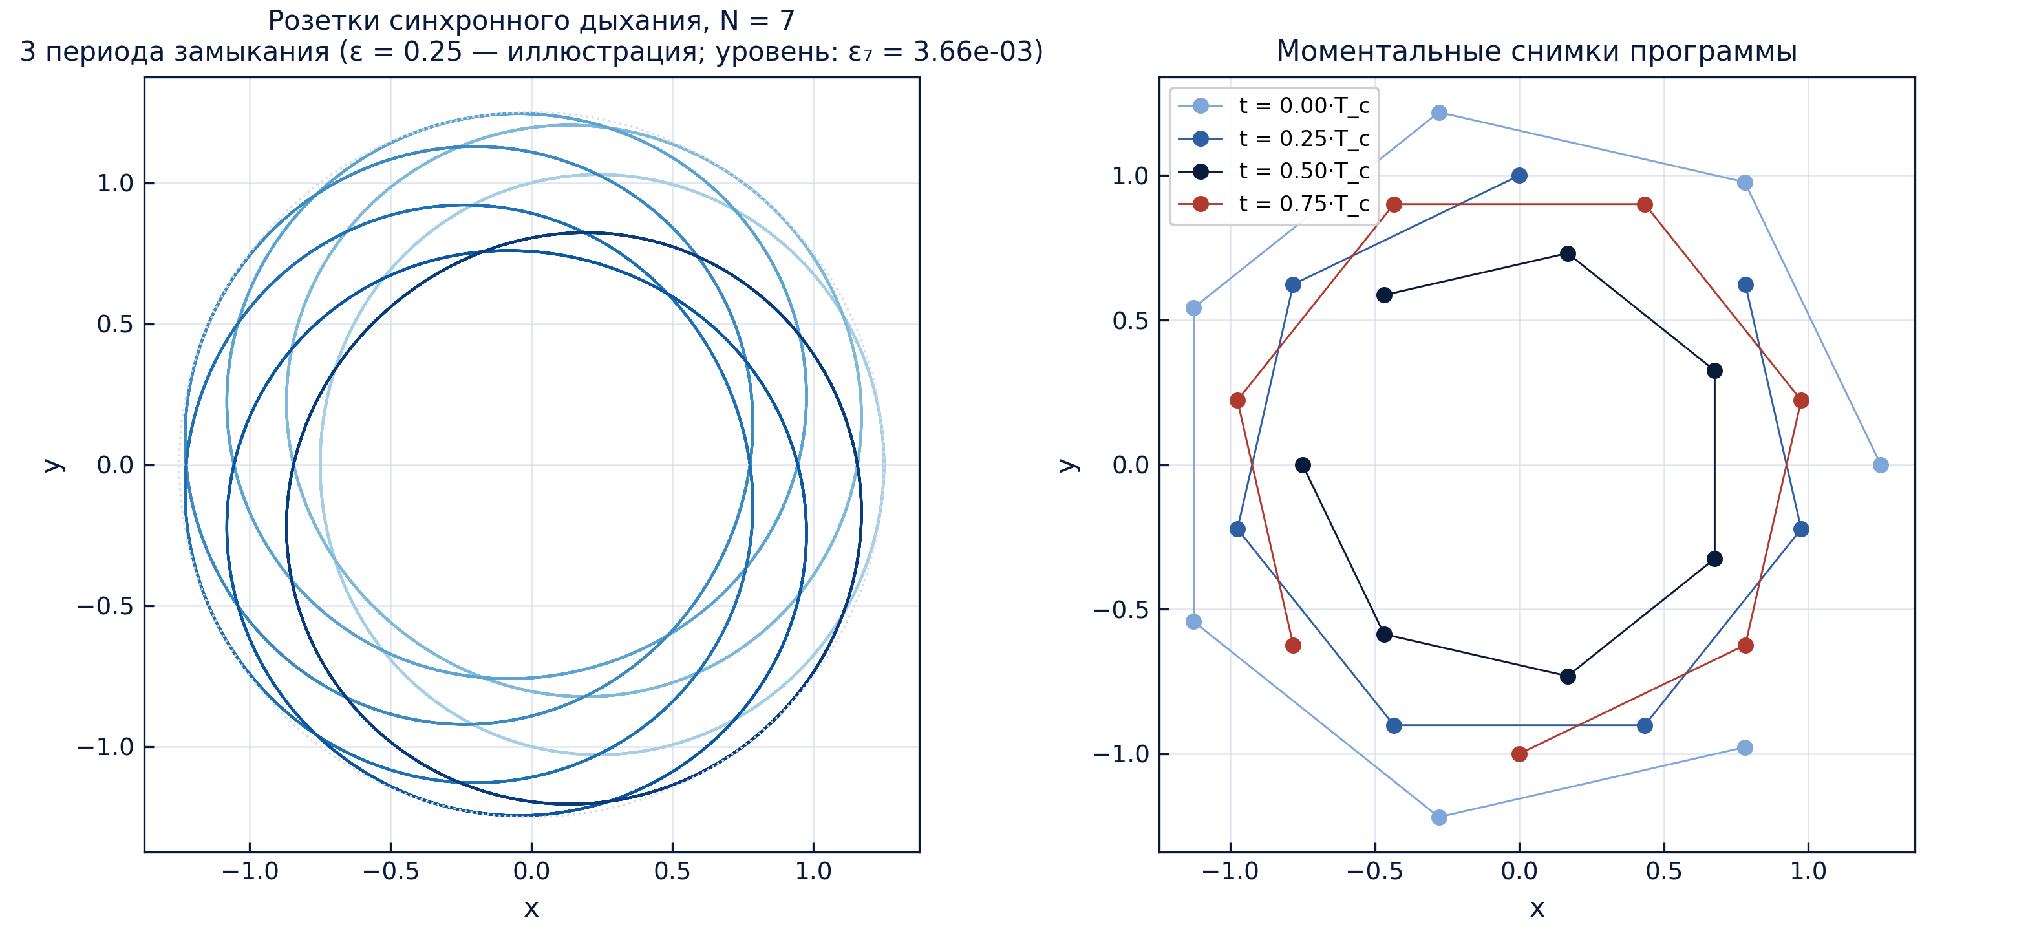
The rosettes of the synchronous program (illustrative amplitude): the trajectory realization of the root system.

4. The numerical certificate
Stage W3 of the ladder checks the identities at the levels N = 7, 9, 15 with the rotated phase θ₀ = 0.3: the normalized residual of the binomial is 6.4 · 10⁻¹¹, of the power sums 2.9 · 10⁻¹⁴, of the senior sum 1.9 · 10⁻¹⁵, of the impulse 1.9 · 10⁻¹⁵. The stage tolerances are 10⁻¹⁰ and 10⁻¹²; the protocol is W3_root_system_default.json.
The registers of stage W3 (default preset)
register | tolerance | result
binomial z^N - sigma | 1e-10 | 6.4e-11
sums S_m, m < N | 1e-12 | 2.9e-14
S_N = N sigma | 1e-12 | 1.9e-15
impulse L | 1e-12 | 1.9e-15

