Theorem 2. The algebraic boundary of the period domain
Omega(a, N-a) = pi/sin(pi a/N), the sine product, and the period witness W_N
Isaev Iskhak Khamzatovich (ORCID 0009-0003-7299-0701)
The cycloring research program · v1.0.0 · Theorem Monograph Edition
Study | CYCLORING
Study | CYCLORING — the Gamma-periods, the defect chain, and the synchronous breathing of a vortex ring
Author | Isaev Iskhak Khamzatovich (ORCID 0009-0003-7299-0701)
Version | 1.0.0 — the theorem monograph edition
Date | 2026-10-08
Code | cycloring/python/cycloring/ (periods · chain · ring · dynamics · ladder · runner · figures)
Data | cycloring/results/protocols/W1..W7_default.json
License | LicenseRef-Proprietary-Wild8Highlander-1.0
Table of Contents
Abstract
Abstract 1
At a glance 1
1. The period functional of the level 1
2. The algebraicity of the boundary 2
3. The sine product 2
4. Certificates and exact values 2

Note: this Table of Contents is generated via field codes. After editing, right-click the TOC and select "Update Field" to refresh the page numbers.

Abstract
The monograph introduces the period functional of the level Omega(a,b) = Gamma(a/N)Gamma(b/N)/Gamma((a+b)/N) and proves that its boundary is algebraic: Omega(a, N-a) = pi/sin(pi a/N) — an algebraic multiple of pi lying in pi Q(zeta_N). The interior periods are genuine Gamma-transcendentals, and the program never uses them algebraically.
The algebraic backbone is the sine product of 2 sin(pi m/N) = N, which yields the closed form of the product of all boundary periods pi^{N-1} 2^{N-1}/N. The diagonal normalized sums P(a,a) generate the period witness W_N — the only periodic number of the level entering the defect chain.
Certificates: stage W1 — the reflection identity with the residual 5.1e-49 (mpmath, 50 digits) at all levels 7, 9, 15, 30; stage W2 — the sine product with the same residual; the float versions hold 1e-12.

At a glance
Functional | Omega(a,b) = Gamma(a/N)Gamma(b/N)/Gamma((a+b)/N)
Normalization | P(a,b) = Omega(a,b)/Omega(1,1); P(1,1) = 1
Boundary | Omega(a, N-a) = pi/sin(pi a/N) in pi Q(zeta_N)
Sine product | of 2 sin(pi m/N) = N
Boundary product | pi^{N-1} 2^{N-1}/N
Period witness | W_N = sum_{a=1}^{N-1} P(a,a)

1. The period functional of the level
For integers a, b ≥ 1 set Ω_a,b = (Γ(a/N)Γ(b/N))/(Γ((a+b)/N)) and P(a,b) = Ω_a,b/Ω_1,1. The functional is symmetric, positive, and the normalization is canonical: P(1,1) = 1 exactly. The period witness of the level is the diagonal sum W_N = Σₐ₌₁^(N-1) P(a,a).
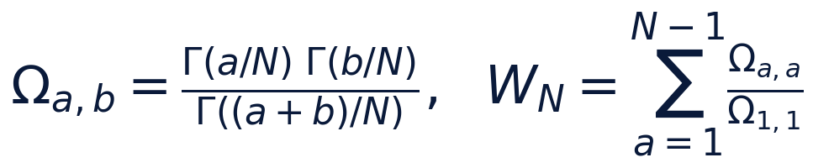

2. The algebraicity of the boundary
The reflection identity Γ(z)Γ(1-z) = π/sin(π z) at z = a/N gives Ω_a, N-a = Γ(a/N)Γ(1-a/N) = π/sin(π a/N), since Γ(1) = 1. The number sin(π a/N) is algebraic — it is expressed through ζ_N; hence the boundary period is an algebraic multiple of pi. The interior pairs a + b ≠ N admit no such reduction: they are treated as Gamma-transcendentals.
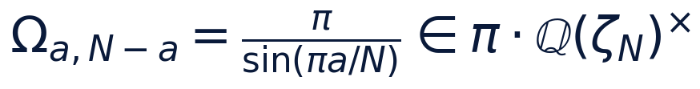

3. The sine product
The polynomial (z^(N) - 1)/(z - 1) = ∏ₘ₌₁^(N-1)(z - ζ_Nᵐ) at z = 1 gives ∏ₘ (1 - ζ_Nᵐ) = N; passing to the moduli and the identity |1 - e^(iφ)| = 2sin(φ/2) complete the argument: ∏ₘ 2sin(π m/N) = N. Corollary: the product of all boundary periods equals π^(N-1) 2^(N-1)/N — a closed arithmetic register of the level.
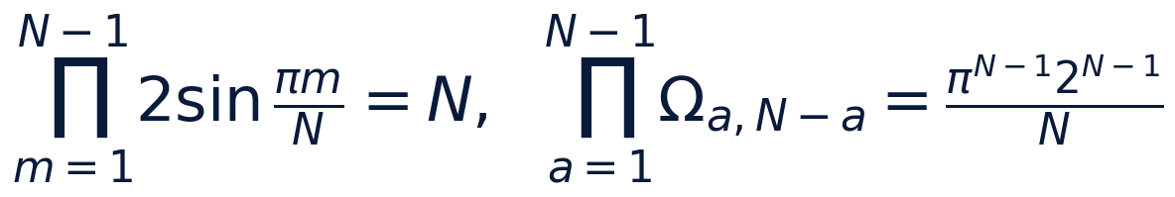

4. Certificates and exact values
Stages W1–W2 hold the mpmath residuals 5.1 · 10⁻⁴⁹ at the levels 7, 9, 15, 30 (all boundary pairs). Exact values at small levels: Ω_1,2 = 2π/√(3) at N = 3; Ω_1,3 = π√(2) and Ω_2,2 = π at N = 4; Ω_3,3 = π at N = 6. The witnesses of the four registered levels are tabulated below.
The period witness W_N (protocol W7, default preset)
N | W_N | N | W_N
7 | 2.175444 | 15 | 2.915447
9 | 2.416543 | 30 | 3.603649

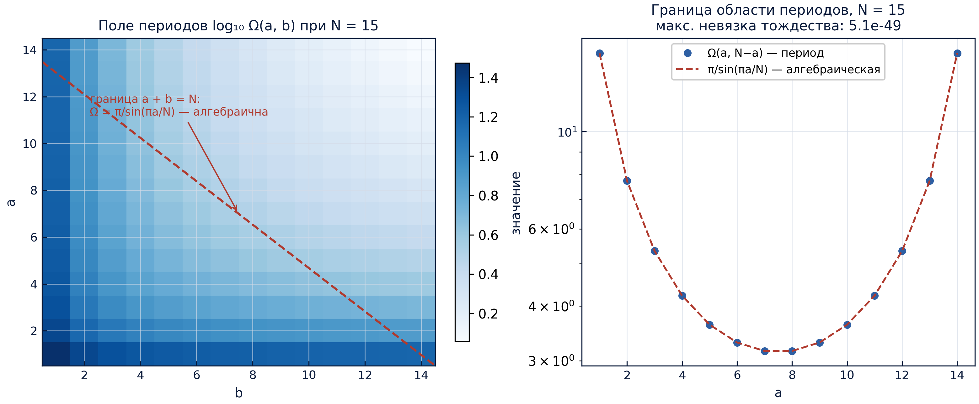
The period field of the level and the algebraic boundary (protocol W2).

