Theorem 3. The period transducer
The defect chain delta -> gamma -> delta_eff -> Delta_Ch and the modulation map (eps, nu, C_N)
Isaev Iskhak Khamzatovich (ORCID 0009-0003-7299-0701)
The cycloring research program · v1.0.0 · Theorem Monograph Edition
Study | CYCLORING
Study | CYCLORING — the Gamma-periods, the defect chain, and the synchronous breathing of a vortex ring
Author | Isaev Iskhak Khamzatovich (ORCID 0009-0003-7299-0701)
Version | 1.0.0 — the theorem monograph edition
Date | 2026-10-08
Code | cycloring/python/cycloring/ (periods · chain · ring · dynamics · ladder · runner · figures)
Data | cycloring/results/protocols/W1..W7_default.json
License | LicenseRef-Proprietary-Wild8Highlander-1.0
Table of Contents
Abstract
Abstract 1
At a glance 1
1. The defect chain 1
2. The modulation map 2
3. Monotonicity and the limit 2
4. The stiffness power law 2

Note: this Table of Contents is generated via field codes. After editing, right-click the TOC and select "Update Field" to refresh the page numbers.

Abstract
The monograph builds a finite chain converting the arithmetic of the cyclotomic level into the modulation program of the ring. The input is the triple (N, B, lambda_0): the lattice order, the angular impulse of the frozen ring B = N Gamma R0^2, and its frozen frequency lambda_0 = Gamma(N-1)/(4 pi R0^2). The chain: delta = pi/N, k = ceil(B lambda_0/Gamma^2), gamma = delta^4/k, delta_eff = delta^5/k, Delta_Ch = gamma W_N/(N-1).
The transducer converts the discriminant Delta_Ch into the breathing program: eps = Delta/(1+Delta), nu = omega_L (1+Delta)^3/(1+2 Delta)^{3/2} = omega_L (1-eps^2)^{-3/2}, C_N = ln(1+1/Delta) = -ln eps. Well-definedness, bijectivity, the frequency-branch identity, the strict monotonicity of the defect gamma(N), and the classical limit are proved: Delta -> 0 recovers the rigid ring.
The registered table of the four levels (7, 9, 15, 30): the breathing amplitude falls from 3.664e-3 to 2.135e-7 — the high levels are stiff. On the grid N = 3..30 the discriminant follows the power law Delta_Ch(N) of about 1.7e3 N^{-6.7} (a numerical approximation).

At a glance
Input | the triple (N, B, lambda_0) = (level, N Gamma R0^2, Gamma(N-1)/(4 pi R0^2))
Stiffness index | k = ceil(B lambda_0/Gamma^2) = ceil(N(N-1)/(4 pi))
Chain | delta = pi/N; gamma = delta^4/k; delta_eff = delta^5/k; Delta_Ch = gamma W_N/(N-1)
Amplitude | eps = Delta/(1+Delta) in (0,1); the inverse Delta = eps/(1-eps)
Frequency | nu = omega_L (1+Delta)^3/(1+2 Delta)^{3/2} = omega_L (1-eps^2)^{-3/2}
Stiffness | C_N = ln(1+1/Delta) = -ln eps

1. The defect chain
The level triple consists of the exact integral registers of the ring: B = NΓ R₀² — the angular impulse, λ₀ = Γ(N-1)/(4π R₀²) — the frozen frequency. Their product is dimensionless and defines the stiffness index k = lceil Bλ₀/Γ²rceil; the defects then cascade: γ = δ⁴/k, δ_eff = δ⁵/k = δγ, and the periodic completion is Δ_Ch = γ W_N/(N-1).

2. The modulation map
The transducer is three formulas: ε = Δ/(1+Δ); ν = ω_L((1+Δ)³)/((1+2Δ)^(3/2)); C_N = ln(1+1/Δ). The frequency-branch identity is the core of the theorem: from ε = Δ/(1+Δ) follows 1 - ε² = (1+2Δ)/((1+Δ)²), hence ν = ω_L(1-ε²)^(-3/2) — the transducer output coincides with the synchronous law of Theorem 4.

3. Monotonicity and the limit
The defect γ = δ⁴/k strictly decreases in N: the numerator π⁴/N⁴ falls, the denominator k = lceil N(N-1)/(4π)rceil strictly grows for N ≥ 4 (the step 2N/(4π) > 1). The classical limit: Δ → 0 gives ε → 0, ν → ω_L (the expansion (1-ε²)^(-3/2) = 1 + (3/2)ε² + O(ε⁴)) and C_N → ∞ — in the limit the transducer switches the breathing off, restoring the rigid ring.
The registered table of the levels (protocol W7, default)
N | k | W_N | Delta_Ch | eps_N | nu/omega_L | C_N
7 | 4 | 2.175444 | 3.677e-03 | 3.664e-03 | 1.0000201 | 5.609
9 | 6 | 2.416543 | 7.474e-04 | 7.469e-04 | 1.0000042 | 7.200
15 | 17 | 2.915447 | 2.357e-05 | 2.357e-05 | 1.0000000 | 10.656
30 | 70 | 3.603649 | 2.135e-07 | 2.135e-07 | 1.0000000 | 15.360

4. The stiffness power law
On the grid N = 3..30 the discriminant is approximated by the power law Δ_Ch(N) ≈ 1.7 · 10³ · N^(-6.7). The honest caveat: this is a numerical approximation, not an asymptotic theorem — only the monotonicity of the defect is proved. The economical mechanism of the observed stiffness: W_N ≈ ln N + O(1) grows slowly, γ ∼ δ⁴/k falls fast, and their product decays like a power.
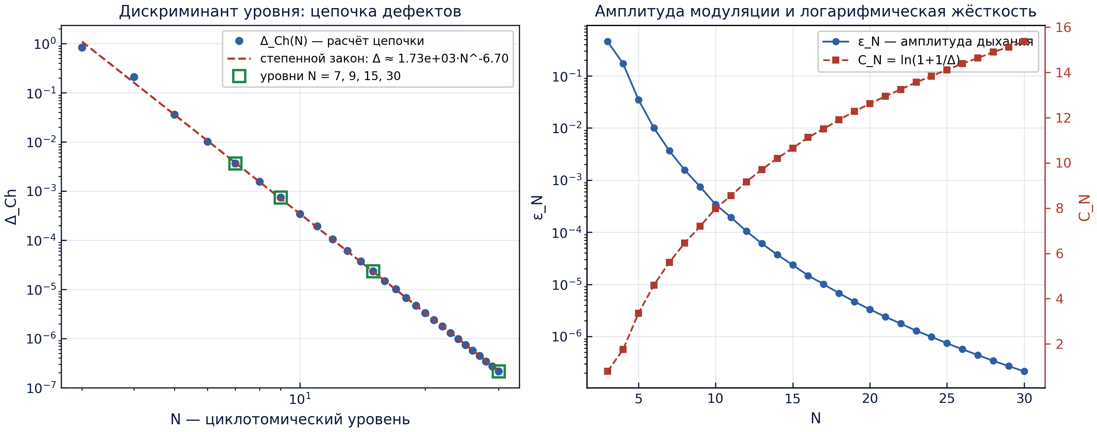
The level discriminant, the amplitude, and the stiffness (protocol W7).

