Theorem 4. The synchronous breathing of the ring
The mean-transport identity and the exact closure of the rosettes T_c = 2 pi / nu
Isaev Iskhak Khamzatovich (ORCID 0009-0003-7299-0701)
The cycloring research program · v1.0.0 · Theorem Monograph Edition
Study | CYCLORING
Study | CYCLORING — the Gamma-periods, the defect chain, and the synchronous breathing of a vortex ring
Author | Isaev Iskhak Khamzatovich (ORCID 0009-0003-7299-0701)
Version | 1.0.0 — the theorem monograph edition
Date | 2026-10-08
Code | cycloring/python/cycloring/ (periods · chain · ring · dynamics · ladder · runner · figures)
Data | cycloring/results/protocols/W1..W7_default.json
License | LicenseRef-Proprietary-Wild8Highlander-1.0
Table of Contents
Abstract
Abstract 1
At a glance 1
1. The polygon invariance and the role of the pump 1
2. The mean-transport identity 2
3. The synchronous frequency and the closure 2
4. The numerical certificates 2

Note: this Table of Contents is generated via field codes. After editing, right-click the TOC and select "Update Field" to refresh the page numbers.

Abstract
The monograph proves the central dynamical statement of the program. The radial breathing program r(t) = R0(1 + eps cos nu t) with the rigid 2 pi/N choreography is not an orbit of the Kirchhoff flow — the polygon has no radial velocity of its own (the pair cancellations); the radial drive is supplied by a pump. The angular transport of the ring, however, is not prescribed: it follows the frozen law Lambda_0/r(t)^2 with the adiabatic invariant Lambda_0 = Gamma(N-1)/(4 pi).
The core of the theorem is the integral mean-transport identity: the cycle mean of (1 + eps cos u)^{-2} equals (1 - eps^2)^{-3/2}. The synchronous choice of the frequency nu = omega_L(R0)(1-eps^2)^{-3/2} makes the phase accumulated over a cycle exactly 2 pi: every rosette z_k(t) = r(t)e^{i(nu t + 2 pi k/N)} is closed, and the configuration returns at T_c = 2 pi/nu. Both statements are exact, not approximations.
Certificates: W5 — the mpmath residual of the identity 1.0e-30 over the grid eps in [0.05, 0.6], the 2 pi phase advance with the error 3.6e-13; W6 — the closure of the level rosettes N = 7 (eps = eps_7) with the residual 1.5e-15 and the shape rigidity 1e-16.

At a glance
Breathing program | r(t) = R0(1 + eps cos nu t), theta_k = nu t + 2 pi k/N
Adiabatic invariant | Lambda_0 = omega_L R^2 = Gamma(N-1)/(4 pi) — radius-free
Transport identity | M[(1+eps cos u)^{-2}] = (1-eps^2)^{-3/2}
Synchronous frequency | nu = omega_L(R0)(1-eps^2)^{-3/2}
Phase advance per cycle | exactly 2 pi
Closure | T_c = 2 pi/nu; z_k(T_c) = z_k(0)

1. The polygon invariance and the role of the pump
The pair cancellations of the Kirchhoff field on the regular polygon give: the total velocity of every vortex is tangential, dot zₖ = iω_L(r) zₖ, and the radial component vanishes identically. Hence the family of frozen polygons is invariant in the flow — the free ring started from the modulated initial condition rotates rigidly at the radius R₀(1+ε) and does not breathe. The breathing is an external radial program; its kinematic honesty is that the angular transport is not assigned but computed: dotφ(t) = Λ₀/r(t)².
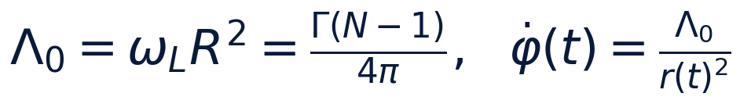

2. The mean-transport identity
The integral ∫₀^(2π)(du)/((1+εcos u)²) is computed by t = tan(u/2): the base integral ∫₀^(2π)(du)/(a + bcos u) = (2π)/(√(a²-b²)) for a > |b|, and the differentiation in a gives ∫₀^(2π)(du)/((a+bcos u)²) = (2π a)/((a²-b²)^(3/2)). At a = 1, b = ε we obtain the identity.
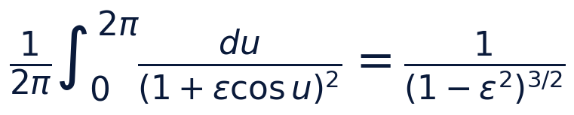

3. The synchronous frequency and the closure
The phase over a cycle: ∫₀^(T_c)(Λ₀ dt)/(r(t)²) = (Λ₀)/(ν R₀²)·(2π)/((1-ε²)^(3/2)). The synchronous choice ν = (Λ₀/R₀²)(1-ε²)^(-3/2) = ω_L(R₀)(1-ε²)^(-3/2) cancels the fraction: the accumulated phase equals 2π exactly. Then zₖ(T_c) = zₖ(0) for all k: the rosettes are closed, the configuration returns, and on the way every vortex rides the limason r(θ) = R₀(1+εcos(θ - 2π k/N)). The closure is a consequence of periodicity, not of the smallness of eps.
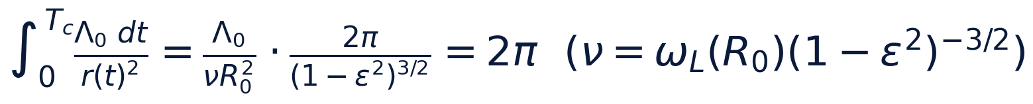
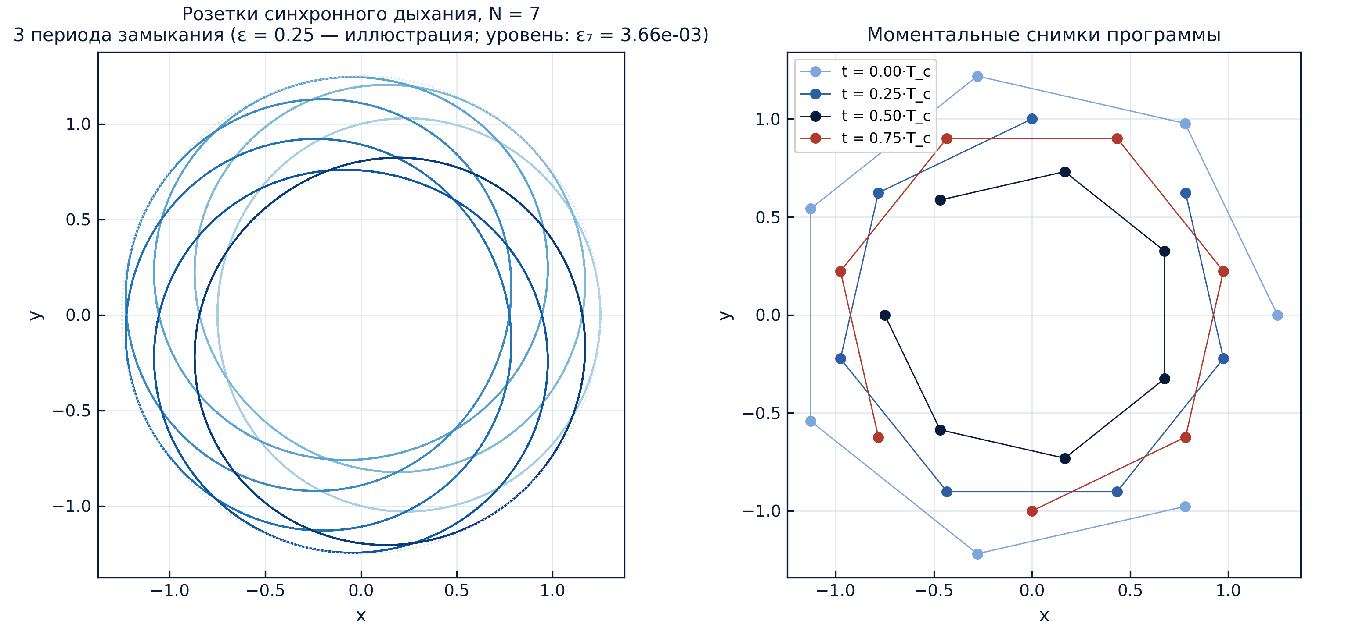
The rosettes and the snapshots of the synchronous program (protocol W6).

4. The numerical certificates
Stage W5: the mpmath residual of the identity 1.0 · 10⁻³⁰ over the grid of 16 values ε ∈ [0.05, 0.6], the float residual 10⁻¹⁴, the phase-advance error 3.6 · 10⁻¹³. Stage W6: the closure of the level rosettes N = 7 at ε = ε₇ = 3.664 · 10⁻³ — the residual 1.5 · 10⁻¹⁵; the shape rigidity along the program — 10⁻¹⁶; the radial excursion 2R₀ε is nonzero, the breathing is real.
The registers of stages W5–W6 (default preset)
register | tolerance | result
mpmath residual of the identity | 1e-30 | 1.0e-30
float residual of the scan | 1e-12 | <=1e-14
the 2 pi phase advance | 1e-12 | 3.6e-13
rosette closure (N=7) | 1e-9 | 1.5e-15
shape rigidity | 1e-9 | 1e-16

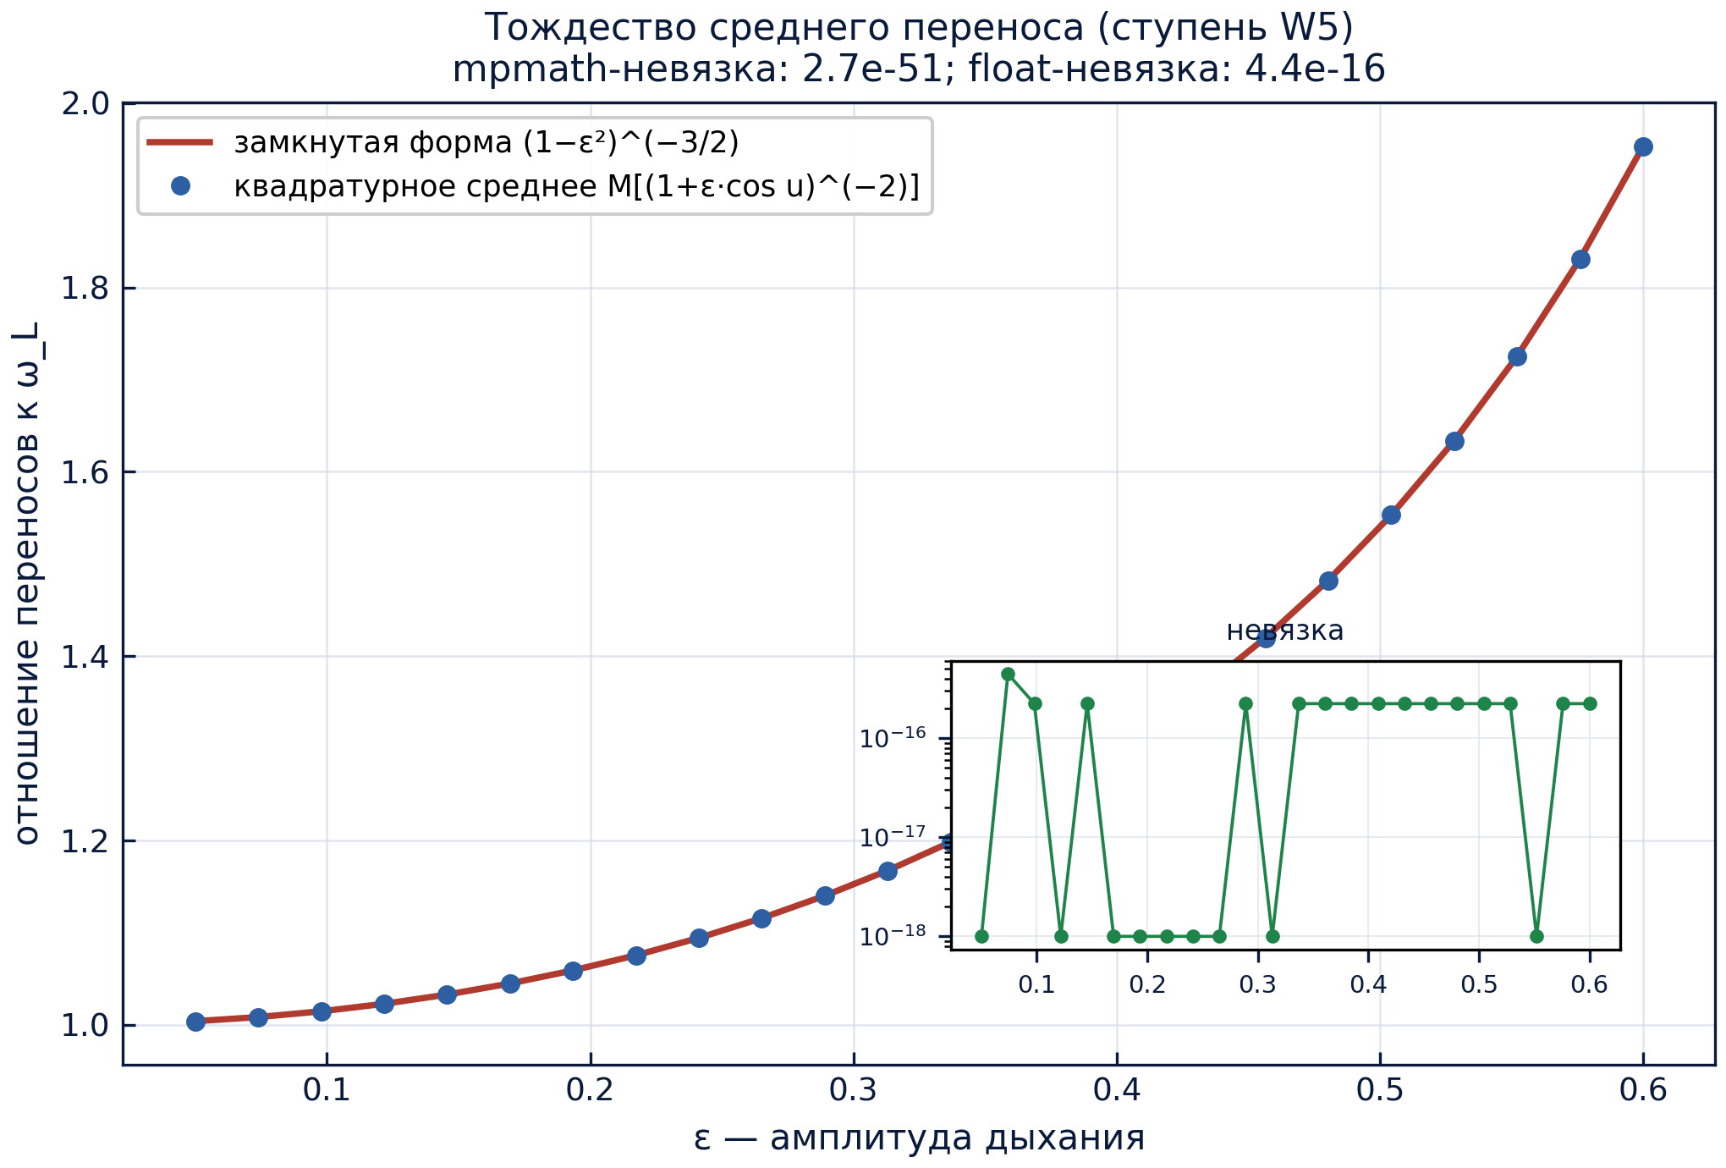
The quadrature against the closed form over the whole eps grid (protocol W5).

