Theorem 5. The dichotomy of the ring invariants
The algebraic registers (chords, discriminant, moment) against the transcendental ln-shell of the Hamiltonian
Isaev Iskhak Khamzatovich (ORCID 0009-0003-7299-0701)
The cycloring research program · v1.0.0 · Theorem Monograph Edition
Study | CYCLORING
Study | CYCLORING — the Gamma-periods, the defect chain, and the synchronous breathing of a vortex ring
Author | Isaev Iskhak Khamzatovich (ORCID 0009-0003-7299-0701)
Version | 1.0.0 — the theorem monograph edition
Date | 2026-10-08
Code | cycloring/python/cycloring/ (periods · chain · ring · dynamics · ladder · runner · figures)
Data | cycloring/results/protocols/W1..W7_default.json
License | LicenseRef-Proprietary-Wild8Highlander-1.0
Table of Contents
Abstract
Abstract 1
At a glance 1
1. The algebraic registers 1
2. The closed form of the Hamiltonian 2
3. The agreement with the periodic register 2
4. The numerical certificate 2

Note: this Table of Contents is generated via field codes. After editing, right-click the TOC and select "Update Field" to refresh the page numbers.

Abstract
The monograph arranges the classical invariants of the regular N-gon on the algebraic-transcendental scale. The pair-distance product is algebraic: the product of |z_i - z_j| equals R^{N(N-1)/2} N^{N/2}, and the modulus of the discriminant of the binomial z^N - sigma equals N^N|sigma|^{N-1} — both registers are algebraic functions of the radius. The impulse L = 0 and the moment I = N Gamma R^2 are algebraic; the power sums are cyclotomic.
The Hamiltonian is the only invariant with a transcendental shell: H(R) = -(Gamma^2/2 pi)[(N(N-1)/2) ln R + (N/2) ln N]. The closed form follows from the sine product of Theorem 2 and is checked against the direct pairwise summation with the error 1e-16. The dichotomy agrees with the periodic register: the boundary algebraic periods serve the algebraic registers, the interior Gamma-periods serve the modulation.
Certificates: W4 — the closed form of H against the direct summation 1e-16, the distance product 1.3e-16; W4 also holds the rigid rotation (1.1e-10) and the invariant drifts 2.0e-12.

At a glance
Distance product | the product of |z_i-z_j| = R^{N(N-1)/2} N^{N/2}
Discriminant | |disc(z^N - sigma)| = N^N |sigma|^{N-1}
Impulse and moment | L = 0; I = N Gamma R^2 — algebraic
Hamiltonian | H(R) = -(Gamma^2/2 pi)[(N(N-1)/2) ln R + (N/2) ln N]
The shell | the only transcendence — ln R
Certificate | W4: 1e-16 (the H form), 1.3e-16 (the product)

1. The algebraic registers
The distance between the vertices is R|1 - ζ_N^(j-i)|, so the product over the pairs splits into the radius power and the chord product: ∏_i<j|zᵢ - zⱼ| = R^(N(N-1)/2)∏ₘ|1-ζ_Nᵐ|^(N/2). By the sine product of Theorem 2 the second factor equals N^(N/2) — the register is algebraic in R. The discriminant of the binomial z^(N) - σ equals (-1)^(N(N-1)/2)N^(N)σ^(N-1); the root system of Theorem 1 links it to the squared product of the root differences.
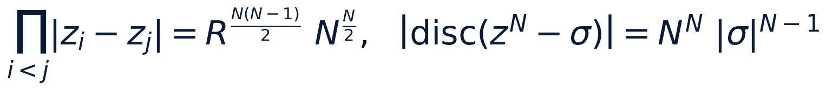

2. The closed form of the Hamiltonian
The logarithm of the product from item 1 is exactly Σ_i<jln|zᵢ - zⱼ|. The substitution into H = -(1/2π)Σ_i<jΓᵢΓⱼln|zᵢ - zⱼ| gives the closed form: the term (N/2)ln N is the constant of the level (the algebraic part inside the shell), and the term with ln R is the only transcendence. The impulse L = 0 is Theorem 1; the moment I = ΣₖΓ|zₖ|² = NΓ R² is a direct computation.
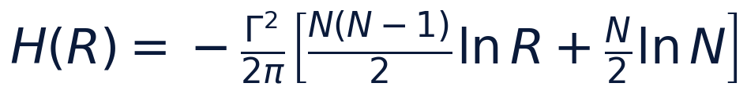

3. The agreement with the periodic register
The dichotomy of the invariants mirrors the dichotomy of the periods: the boundary algebraic multiples of pi (Theorem 2) serve the chords, the discriminant and the moment; the interior Gamma-periods through the witness W_N serve the modulation — the amplitude and the frequency of the breathing (Theorem 3). At the levels N = 7, 9, 15, 30 the transducer table ties the two sides together: the higher the level, the stiffer the ring and the closer its invariants stay to the algebraic branch.
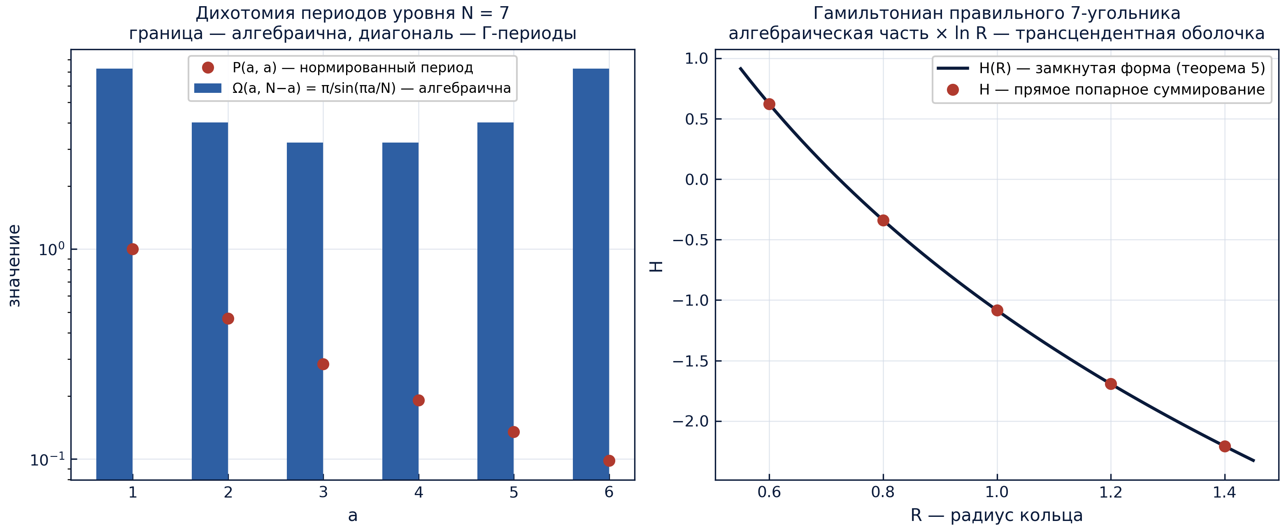
The periods and the Hamiltonian: the algebraic part and the transcendental shell.

4. The numerical certificate
Stage W4 (N = 7, RK4, two turns): the closed form of H matches the direct pairwise summation with the relative error 10⁻¹⁶; the distance product — with 1.3 · 10⁻¹⁶; the measured rotation rate is 1.1 · 10⁻¹⁰ off the formula; the drifts of H, P, Q, I stay within 2.0 · 10⁻¹². The protocol is W4_polygon_flow_default.json.
The registers of stage W4 (default preset)
register | tolerance | result
rotation rate omega_L | 1e-9 | 1.1e-10
radius drift (shape) | 1e-10 | 6.5e-13
drifts of H, P, Q, I | 1e-12 | 2.0e-12
the closed form of H | 1e-12 | 1e-16
the distance product | 1e-12 | 1.3e-16

