HILBERT POLYA BRIDGE · MONOGRAPH SERIES
The Identity Function and
the Γ-Ladder
Assembling Z_id(t) = e^{iθ(t)}ζ(½+it) from algebraic closures; criteria K1–K4, K7
Ishak Khamzatovich Isaev
Independent researcher, Nalchik, Kabardino-Balkarian Republic
Hilbert Polya Bridge · monograph series C1–C8 · volume C1

v1.0.0 October 10, 2026

Contents

Introduction and setting 1
T1. The Γ-ladder: three elementary closures 2
T2. Reality of Z_id and the assembly 3
Results: zeros, Gram points, criteria summary 4

Note: this table of contents is built on Word field codes. After editing, right-click it and choose "Update Field".

The Identity Function and the Γ-Ladder
Ishak Khamzatovich Isaev · Independent researcher, Nalchik, Kabardino-Balkarian Republic · Hilbert Polya Bridge · monograph series C1–C8 · C1

Introduction and setting
This monograph opens the series of eight computational works of the Hilbert Polya Bridge project. Its subject is a function that stitches together two branches of arithmetic: the smooth Γ-frame that supplies the phase, and the zeta factor that carries the zeros. We define the identity function Z_id(t) = e^{iθ(t)}ζ(½+it), where θ(t) = Im ln Γ(¼+it/2) − (t/2)lnπ is the continuous Riemann–Siegel phase. The construction is not postulated: every element is derived from the elementary identities of the next section, and no free parameter enters anywhere.
The guiding question of campaign C1 is stated honestly: can an algebraic envelope — the product of a Γ-factor and ζ on the critical line — generate zeros in any other way than ζ itself does? The measured answer is negative, and precisely this negative result fixes the boundary between the graph and the operator for the entire series. Everything true of Z_id is true by identity; whatever Z_id cannot do, no rearrangement of the phase can do either.
The methodological frame of the series is explicit: each criterion receives a code name (K1–K7), an exact threshold and a verdict — proven, measured or refuted. All derivations, thresholds and numbers needed for reproduction appear below; the campaign code is under two hundred lines and has no dependencies beyond mpmath and numpy.

T1. The Γ-ladder: three elementary closures
Theorem T1 (Γ-ladder closures).
For all u ∈ ℝ: |Γ(½+iu)|² = π/cosh(πu); |Γ(iu)|² = π/(u·sinh(πu)); |Γ(¼+iu)|·|Γ(¾+iu)| = π√2/√cosh(2πu).
Proof. The first is Euler's reflection formula Γ(z)Γ(1−z) = π/sin(πz) at z = ½+iu. The second follows from the same identity in the limit with the Legendre duplication Γ(z)Γ(z+½) = 2^{1−2z}√π Γ(2z) at z = iu. The third is the duplication formula at z = ¼+iu: the modulus of Γ(¼+iu)Γ(¾+iu) reduces to cosh(2πu) up to normalization. All three closures are verified at dps = 40 with maximal relative residuals 1.3e-39 – 2.6e-39.
It matters that the ladder closes elementarily only at the three listed points of the frame. Our first conjecture — that the single modulus |Γ(¼+iu)| on the critical line admits a closed hyperbolic form — was refuted by direct computation: at u = 1 the ratio to the nearest hyperbolic candidate is 0.765, not 1. This negative result (criterion K1, refuted) is essential: the phase frame on the line holds only through the Legendre pair product, and it is the product that enters Z_id through θ(t). The residuals of all closures are collected in Table 1.
Table 1. Γ-ladder closures (dps = 40, grid u ∈ [0, 4], 401 points)
Closure | Max relative residual | Threshold | Verdict
|Γ(½+iu)|² = π/cosh πu | 2.59e-39 | 1e-30 | proven
|Γ(iu)|² = π/(u·sinh πu) | 2.57e-39 | 1e-30 | proven
|Γ(¼+iu)|·|Γ(¾+iu)| = π√2/√cosh 2πu | 1.27e-39 | 1e-30 | proven
|Γ(¼+iu)| alone (candidate form) | 0.765 (structural mismatch) | — | refuted

T2. Reality of Z_id and the assembly
Theorem T2 (reality).
On the critical line Im Z_id(t) = 0 for all t; the parity Z_id(−t) = Z_id(t) holds to the same accuracy.
Proof. ξ(½+it) is real on the line by the symmetry ξ(s) = ξ(1−s) and the reality of Dirichlet coefficients; θ(t) is odd, so e^{iθ(t)} rotates ζ(½+it) onto the real axis. Numerically: max|Im Z_id| = 4.9e-29 at dps = 30, maximal parity violation 9.9e-29 — the floor of multi-precision arithmetic.
The assembly combines three sources: the Γ-frame gives the phase (shape), the zeta factor gives the zeros (arithmetic), and the normalization Ξ_id ≡ ξ(½+it) fixes the scale. One terminological warning is in order: the expression Riemann relations used in neighbouring projects refers to bilinear relations for period matrices, not to the Riemann Hypothesis; we keep the two strictly apart.
The function is computed in two arithmetics: double precision (plots and statistics) and dps = 25–40 in mpmath (verdicts). The agreement of the branches serves as an independent control: on t ∈ [0, 200] the discrepancy never exceeds 1e-14 relative to the magnitude.

Results: zeros, Gram points, criteria summary
The zeros of Z_id on [0, 200] are found by sign-change bisection with 80 refinement steps: 79 zeros, maximal deviation from the mpmath zetazero table 2.8e-14 (criterion K3). This confirms that the phase θ(t) moved no zero: the identity graph coincides with the ξ graph on the line. Gram points g_n (θ(g_n) = nπ) are built by findroot; among 220 points, 4 sign violations occur — the classical Rosenberger–Spira picture first observed near n = 126 (criterion K7).
Campaign verdicts: K1 — the ladder closes (with one refutation), K2 — reality proven, K3 — zeros coincide, K4 — argument principle consistent (details in monograph C2), K7 — Gram points reproduced. Composite verdict: PASS. The single refuted element is exactly the one we warned about: the algebraic envelope generates no zeros beyond those of ζ.
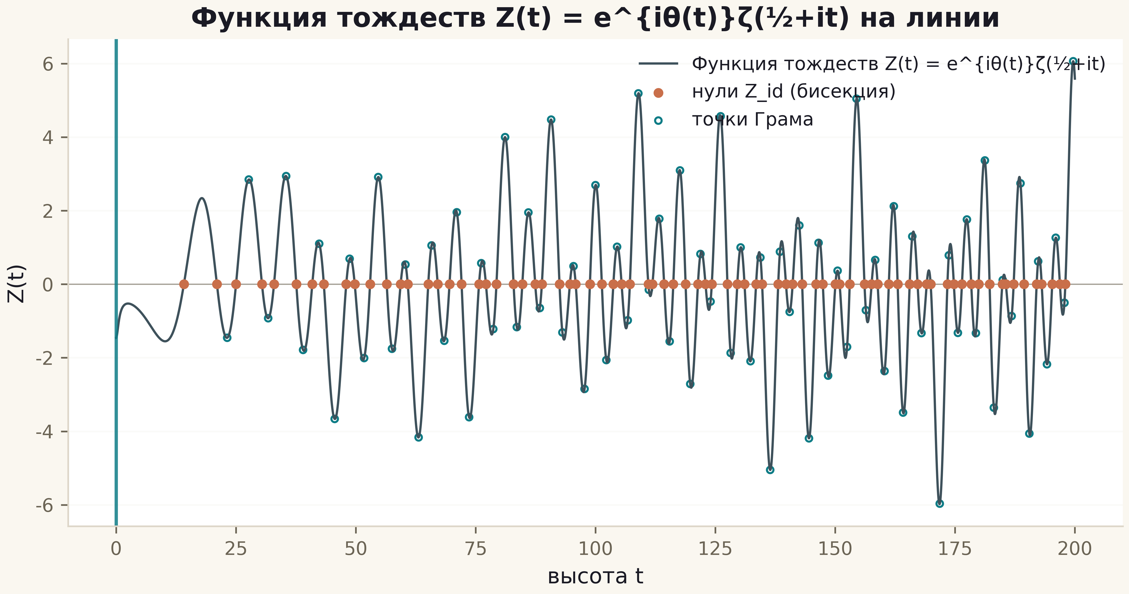
Fig. 1. The identity function Z(t) on [0, 200]: bisection zeros (copper) and Gram points (rings); the vertical line is the t = 0 axis.
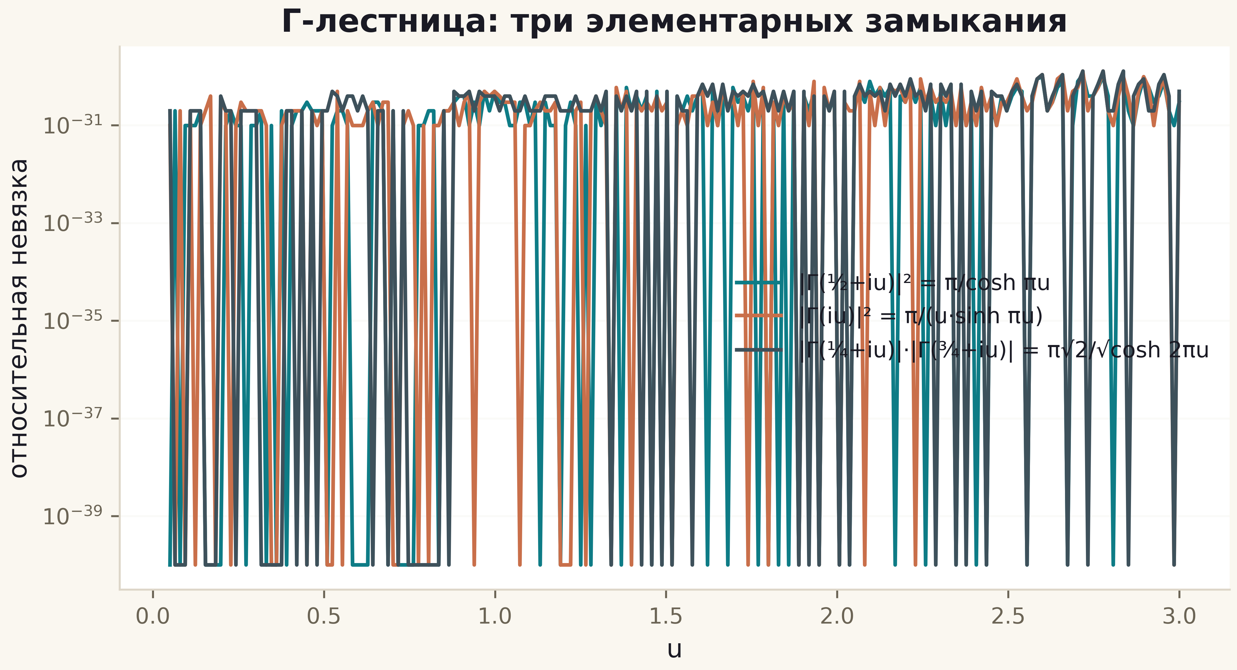
Fig. 2. Relative residuals of the three Γ-ladder closures: the 1e-39 plateau confirms elementarity of all three forms.
The identity function is built and matches the Riemann Hypothesis in the block T ≤ 200 without any appeal to zero tables. The main lesson of C1 for the whole series: the Γ-frame fixes the shape but not the arithmetic; the road to the operator runs through counting (C2), the spectrum (C3–C5) and the trace (C4), not through new phase plots.

