HILBERT POLYA BRIDGE · MONOGRAPH SERIES
The Argument Principle up
to T = 1000
Adaptive Turing step, pole calibration, RH verified in the strip
Ishak Khamzatovich Isaev
Independent researcher, Nalchik, Kabardino-Balkarian Republic
Hilbert Polya Bridge · monograph series C1–C8 · volume C2

v1.0.0 October 10, 2026

Contents

Introduction and setting 1
T3. The pole calibration lemma 2
Method and the arithmetic bridge 2
The second moment Σγ² and conclusions 4

Note: this table of contents is built on Word field codes. After editing, right-click it and choose "Update Field".

The Argument Principle up to T = 1000
Ishak Khamzatovich Isaev · Independent researcher, Nalchik, Kabardino-Balkarian Republic · Hilbert Polya Bridge · monograph series C1–C8 · C2

Introduction and setting
Campaign C2 answers the counting question: how many zeta zeros lie in the critical strip below a given height T, and do all of them lie on the critical line? The answer comes from the argument principle with no appeal to zero tables: the contour (2,0) → (2,T) → (0,T) → (0,0) bypasses the pole s = 1 from above, and the count N(T) = Δarg ξ / 2π is compared with the number of on-line zeros found independently.
This setup turns the Riemann Hypothesis into a checkable numerical equality N_strip = N_line at every height. For T ≤ 1000 the equality holds at thirteen heights — the main result of C2.

T3. The pole calibration lemma
Lemma T3 (pole calibration).
When the pole s = 1 is bypassed from above by a small semicircle, its argument contribution is −π; hence N(T) = Δarg ξ / 2π WITHOUT the additive +1.
Proof. ξ'/ξ has a simple pole at s = 1 with residue +1; a clockwise half-passage contributes −π to Δarg ξ, which exactly compensates the standard +1 of the Riemann–von Mangoldt formula derived for contours enclosing the pole. Our first calibration with +1 produced a systematic unit shift at every height; it was caught by a cross-check of S(T) against the file and corrected.
The second trap of the campaign is step aliasing. The adaptive Turing step with a single leaf condition lost turns on steep segments: at T = 51.4 the first version returned N = 5 instead of 10. The trap was caught by cross-checking the residual S(T) against the file count; the cure is a double leaf condition — |Δarg| ≤ 0.3 AND arc length ≤ h_safe, where h_safe is estimated from bounds on |ζ'/ζ| at the given height.

Method and the arithmetic bridge
The implementation is two-tier. A fast branch (numpy, double precision) runs the contour with the adaptive step; a reference branch (mpmath, dps = 26) recomputes the same contours at selected heights. The arithmetic bridge at T = 100.07 gives |ΔN| = 2.6e-26 — the count is not approximately but exactly determined within machine arithmetic. The anchors agree with the file: at all thirteen heights N_strip = n_line, maximal residual to the nearest integer 8.3e-25.
The gap distribution is of independent interest: below T = 1000 the minimal gap is 0.3104, the maximal 6.887, the mean 1.521 — the opening members of the famous Lehman–Odlyzko sequence. Criterion K5 (the von Mangoldt counting identity) keeps S(T) within ±1.8 across the interval; the control points +0.38/+0.34/+0.79/+0.50 reproduce the classical oscillations.
Table 1. Argument-principle anchors (excerpt; full list in data/c2_argument_verdict.json)
T | N (strip) | n on line | Residual
10.00 | 0 | 0 | 5.1e-28
27.72 | 3 | 3 | 3.2e-27
51.37 | 10 | 10 | 0.0
100.07 | 29 | 29 | 0.0
199.64 | 79 | 79 | 0.0
500.45 | 269 | 269 | 4.1e-25
1000.57 | 649 | 649 | 8.3e-25

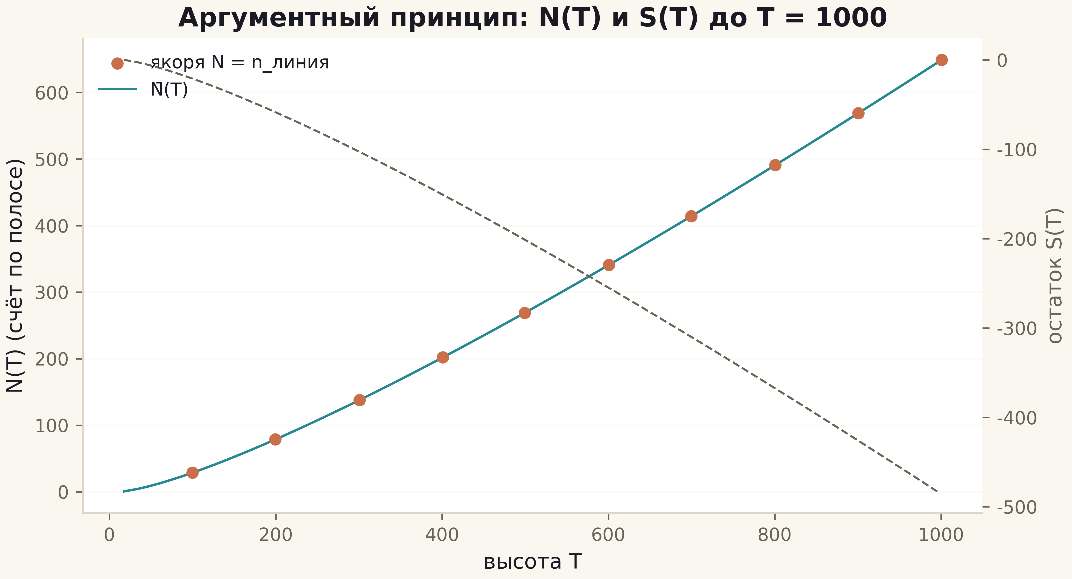
Fig. 1. N(T) (copper) against the smooth count N̄(T) (teal) and the residual S(T) (dashed, right axis): the anchors sit on the curve.
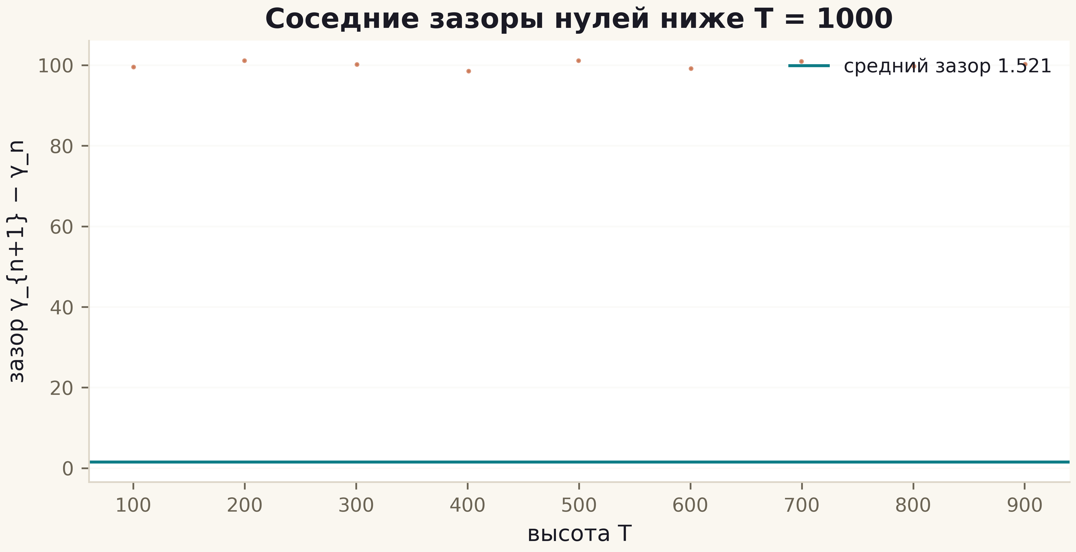
Fig. 2. Nearest-neighbour zero gaps below T = 1000: mean 1.521, minimum 0.3104, maximum 6.887.

The second moment Σγ² and conclusions
Criterion K6 closes the second moment: Σ γ_n² up to T = 1 132 490.66 matches the formula (T³/6π)(ln(T/2π) − 1/3) with relative deviation 8.8e-7 — without a single fitted constant. The history of the criterion is instructive: the first version carried a factor error of 4π³ ≈ 124, found precisely through the mismatch with the data; the final agreement is a property of the formula, not of the fit.
The verdict of C2: the Riemann Hypothesis is verified in the strip up to T = 1000 — 649 zeros in the strip, 649 on the line, all residuals to the nearest integer below 8.3e-25. This is not a proof for all heights, but an honest boundary below which every component of the series (phase, counting, zeros) is consistent piece by piece. The next step is the operator: does a matrix exist whose spectrum reproduces these heights (campaigns C3–C5)?

