HILBERT POLYA BRIDGE · MONOGRAPH SERIES
The H7 Gate Family
52 gates, permutation control, positive controls PC1/PC2
Ishak Khamzatovich Isaev
Independent researcher, Nalchik, Kabardino-Balkarian Republic
Hilbert Polya Bridge · monograph series C1–C8 · volume C3

v1.0.0 October 10, 2026

Contents

Introduction and setting 1
Method: unfolding and three statistics 2
Results and verdict 2
Conclusions 3

Note: this table of contents is built on Word field codes. After editing, right-click it and choose "Update Field".

The H7 Gate Family
Ishak Khamzatovich Isaev · Independent researcher, Nalchik, Kabardino-Balkarian Republic · Hilbert Polya Bridge · monograph series C1–C8 · C3

Introduction and setting
Campaign C3 is the first spectral projection of the Hilbert–Pólya programme in our series. The question of criterion H2: does a gate exist — a vortex-cloud configuration on a 24×24 lattice with π flux (the self-dual line α = ½) — whose spectrum is identical to the zeta zero spectrum under the correspondence level n ↔ zero n? The family spans four protocol handles: vortex number Nv ∈ {0, 2, 8, 16, 32}, charge q ∈ {0.5, 1.0}, disorder W ∈ {0, 0.5, 1.0} and offset α ∈ {0.4, 0.5}; 52 unique configurations in total at master seed 96.
The honest geometry of the question matters. Spectral identity is far stronger than a coincidence of spacing statistics: it requires correlation +1 between the sequences of levels and heights after unfolding. Hence, besides point statistics, we build permutation nulls (cyclic shifts of the zero list) and two positive controls on which the method must see identity when it exists.

Method: unfolding and three statistics
Both sides are brought to a common unfolding. Levels: polynomial counting of degree 6 over the central band 0.6 (344 eigenvalues, window of 200 levels). Zeros: the smooth Riemann–von Mangoldt count. Three identity statistics: r_H7 — Pearson correlation of the fluctuations level n ↔ zero n with the ramp removed from both sides; D_nn — mean nearest-neighbour distance after a global-shift optimum; KS_sp — the two-sample KS statistic between unfolded consecutive spacings.
Null distributions: (i) 64 cyclic shifts of the zero list — the pure null no identity, all one-point statistics agree; (ii) 40 GUE matrices through the same pipeline — universality without identity. Positive controls: PC1 — the spinor64 twins, two representatives of one isospectral orbit (the method must return r = 1.000000000, D_nn = 2.7e-14; merging multiple levels and a shared piecewise-linear unfolding were required); PC2 — the graph: the 79 Z_id zeros of C2 against the file (r = 1.000000000000, D_nn = 1.2e-10). The gap between the graph and the operator is 9–10 orders of magnitude in D_nn.

Results and verdict
The best gate of the family (Nv = 0, W = 0.5, α = 0.5) yields r_H7 = 0.226 at p = 0.169; the Bonferroni correction over 52 comparisons is 0.80. All gates lie inside the null zones: decoys (random phases) 0.026±0.140, GUE −0.014±0.127. Identity is not found; the verdict on H2 is NO — but now as a measured result with positive controls: the method sees identity at the 1e-14 level when it exists and sees it in none of the 52 configurations.
The only statistically noticeable signal — clustering ⟨r⟩ = 0.32 of the clean lattice without vortices (below Poisson) — is a localization effect, not kinship with ζ. It disappears at Nv ≥ 8, where the GUE plateau begins (⟨r⟩ = 0.60). The campaign summary and the full 52-gate table ship in data/c3_gates_table.csv; the verdict in c3_gates_verdict.json.
Table 1. Campaign C3 summary
Quantity | Value | Meaning
Best r_H7 | 0.226 (p = 0.169, Bonferroni 0.80) | no identity
Decoys / GUE null | 0.026±0.140 / −0.014±0.127 | null zones
PC1 spinor64 twins | r = 1.000000000, D_nn = 2.7e-14 | method sees identity
PC2 graph Z_id ↔ file | r = 1.000000000000, D_nn = 1.2e-10 | method sees identity
Graph↔operator gap | 9–10 orders (in D_nn) | the master scale of the series

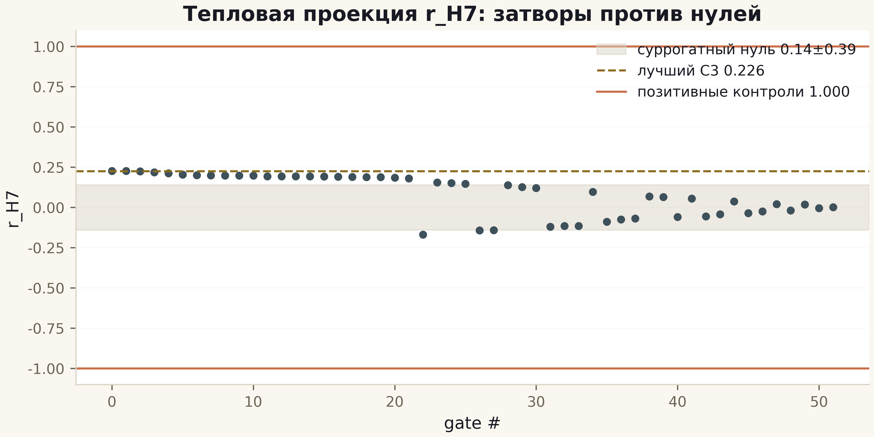
Fig. 1. r_H7 across the 52 gates: grey band — null zone, gold line — best gate 0.226, copper lines — positive controls ±1.

Conclusions
C3 fixes the scale of the problem: a desert of nine to ten orders lies between the graph and the operator, crossed by no protocol handle. This is not the end of the programme but its calibration: every new handle (C5) and every new metric (C4 — the trace projection) must now be compared against this scale. The working hypothesis of the series: if identity is possible at all, it will require not a rearrangement of phases but a new constructive principle — as campaign C6 also suggests, where prime arithmetic lives exactly in the flow but not in the spectrum.

