HILBERT POLYA BRIDGE · MONOGRAPH SERIES
The Trace Formula: Tr
e^{−uH} versus the
Explicit Formula
Hadamard identity, the prime weight Λ(n)/√n, the trace projection of the H2 gap
Ishak Khamzatovich Isaev
Independent researcher, Nalchik, Kabardino-Balkarian Republic
Hilbert Polya Bridge · monograph series C1–C8 · volume C4

v1.0.0 October 10, 2026

Contents

Introduction and setting 1
T6. The Q(a) identity and the trace formula 2
M0/M1: calibration and the positive control 3
M2: the trace projection of the gates and the verdict 3
Conclusions 4

Note: this table of contents is built on Word field codes. After editing, right-click it and choose "Update Field".

The Trace Formula: Tr e^{−uH} versus the Explicit Formula
Ishak Khamzatovich Isaev · Independent researcher, Nalchik, Kabardino-Balkarian Republic · Hilbert Polya Bridge · monograph series C1–C8 · C4

Introduction and setting
Campaign C4 is the next step of the map after the statistical (C3) and arithmetic (C6) projections: the comparison of the heat trace of an operator with the Guinand–Weil explicit formula. For a hypothetical Hilbert–Pólya operator H with spectrum {γ_n}, the trace formula should read Tr e^{−xH} = Σ e^{−xγ_n} = [smooth Γ-terms] − Σ Λ(n)/√n·x/(x²+ln²n) — the heat trace must carry the weight of primes. We derive the formula rigorously, verify it for the operator H_ξ = diag(±γ_n), and then measure what survives for the lattice gates.
All constants are derived; none is fitted. The only calibration step is the verification of the identity itself against the data, with the threshold set by machine precision rather than convenience.

T6. The Q(a) identity and the trace formula
Theorem T6 (trace formula for H_ξ).
Let Q(a) := Σ_{γ>0} 2a/(a²+γ²). Then (i) Q(a) = ζ'/ζ(½+a) + 1/(½+a) + 1/(a−½) − ½lnπ + ½ψ(¼+a/2) − B − C₀, where B = ξ'(0)/ξ(0) = ½ln(4π) − 1 − γ/2 and C₀ = Σ_{γ>0} 1/(¼+γ²) = −B; (ii) for x > 0, K(x) := Tr e^{−xH_ξ} = (1/π)∫₀^∞ Q(a) sin(ax) da, and for a > ½ the series ζ'/ζ(½+a) = −ΣΛ(n)/n^{½+a} contributes the weight Λ(n)/√n.
Proof. (i) is the Hadamard product for ξ: ξ'/ξ(s) = B + Σ_ρ[1/(s−ρ)+1/ρ] with B = ξ'(0)/ξ(0); pairing ρ with ρ̄ turns the sum into Q(a) + C₀, and the rest is the decomposition ξ'/ξ = 1/s + 1/(s−1) − ½lnπ + ½ψ(s/2) + ζ'/ζ. (ii) uses 2a/(a²+γ²) = 2∫₀^∞ e^{−γt}sin(at)dt and sine-transform inversion; absolute convergence on both sides justifies the interchange of summation and integration.
As a by-product, the classical identity C₀ = 1 + γ/2 − ½ln(4π) is confirmed: the file sum yields 0.023095708966 — twelve digits coincide with −B. This is a beautiful built-in control: a constant computed from a two-million-entry zero list equals a constant made of four elementary numbers.
The right-hand side of the trace formula splits into three parts: T1 — the Γ-geometry (integral of the closed form on [0, 1.5]); T2 — the prime part (the exact transform −ΣΛ(n)/√n·Im[e^{−A(ln n−ix)}/(ln n−ix)]); T3 — the smooth terms with exact Si/Ci forms. T2 is the weight of primes: on the grid x ∈ [0.08, 3] its share of K(x) reaches −3…−12%, and the entire fluctuation about the smooth part belongs to it alone.

M0/M1: calibration and the positive control
M0. Identity (i) is verified on the grid a ∈ {0.10 … 3.00}: the direct file sum over 2 001 052 zeros (with an analytic tail from the smooth density) against the closed form via mpmath gives max|ΔQ| = 1.7e-12. The formula is calibrated — all signs, constants and branches fixed.
M1. The trace formula for H_ξ: the direct sum Σ e^{−xγ} against (1/π)∫Q sin on x ∈ [0.08, 3] agrees to a maximal absolute difference of 1.2e-5 — the numerical floor of the quadrature (for x ≥ 1 the value of K(x) itself is already ~1e-6). In the informative range x ≤ 0.35 the relative agreement is 1e-6 … 1e-4. Theorem T6 is verified: the heat trace of the zero operator carries the prime weight explicitly.
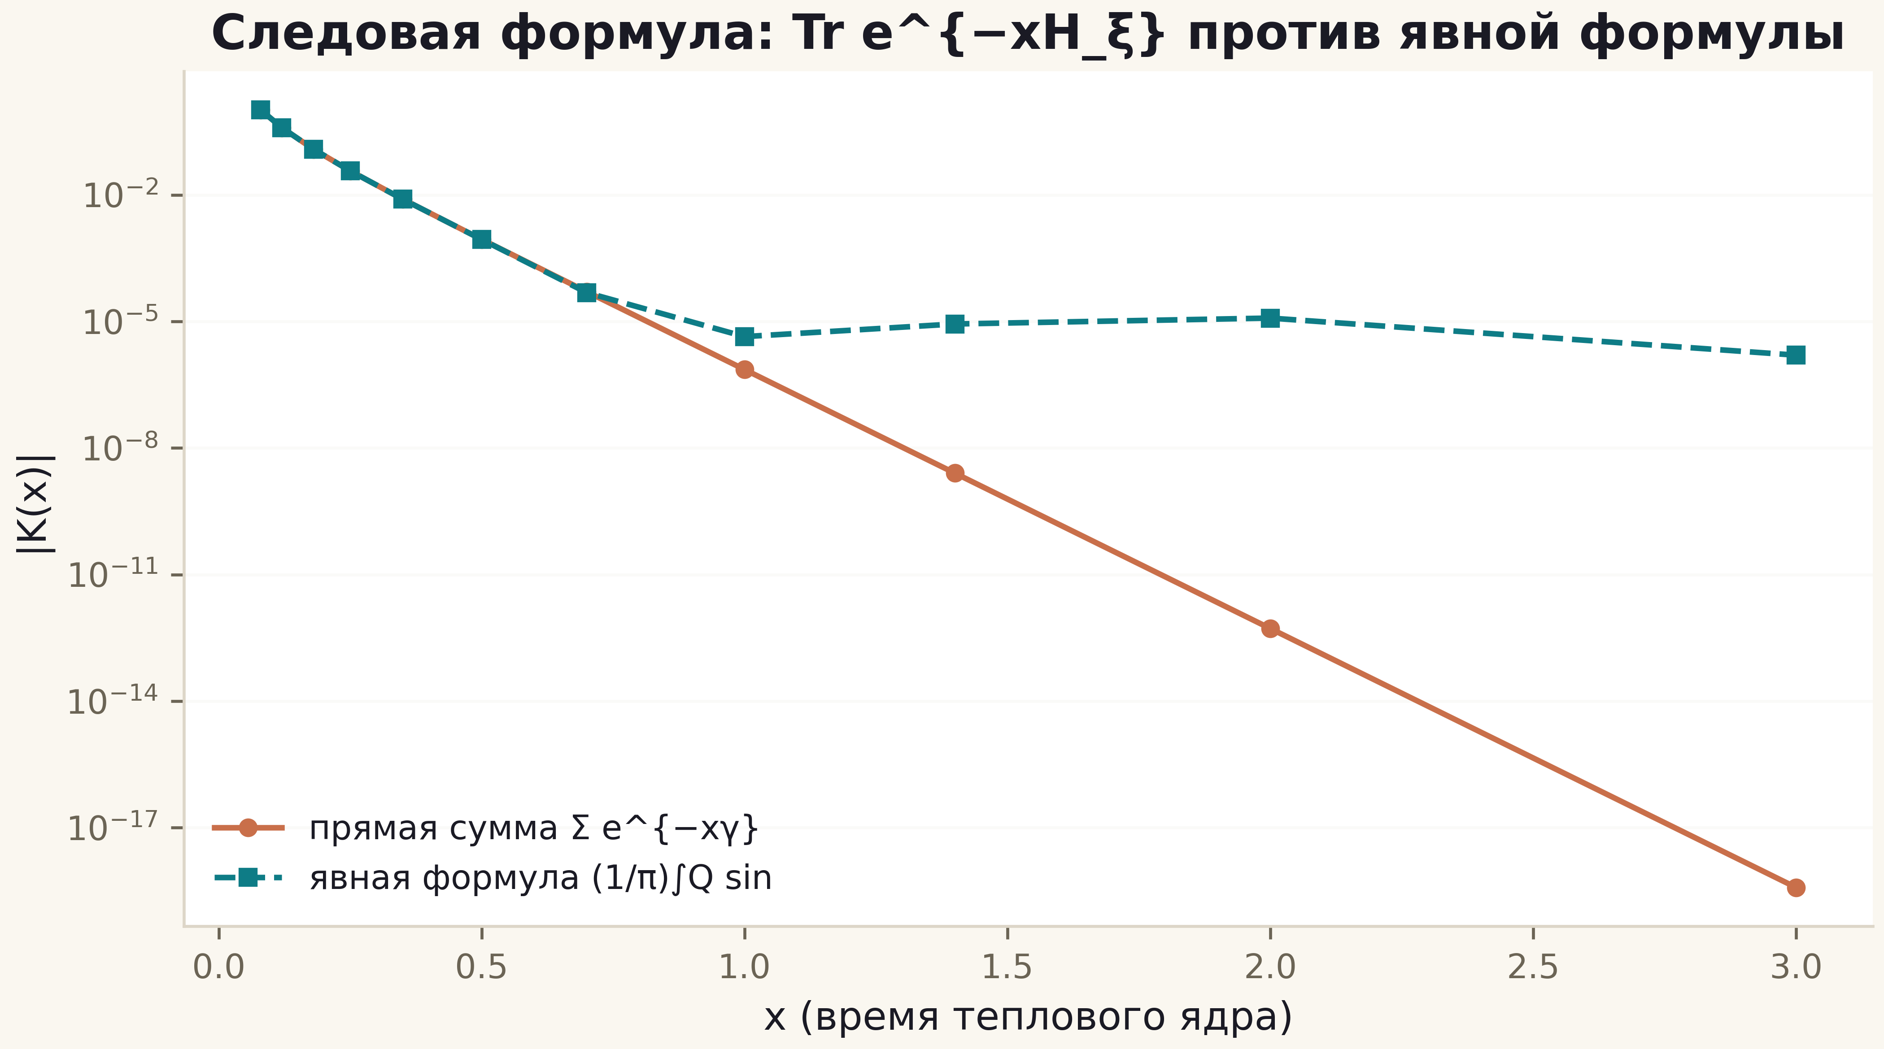
Fig. 1. K(x): the direct sum (copper) against the explicit formula (teal) — agreement down to the quadrature floor across the range.
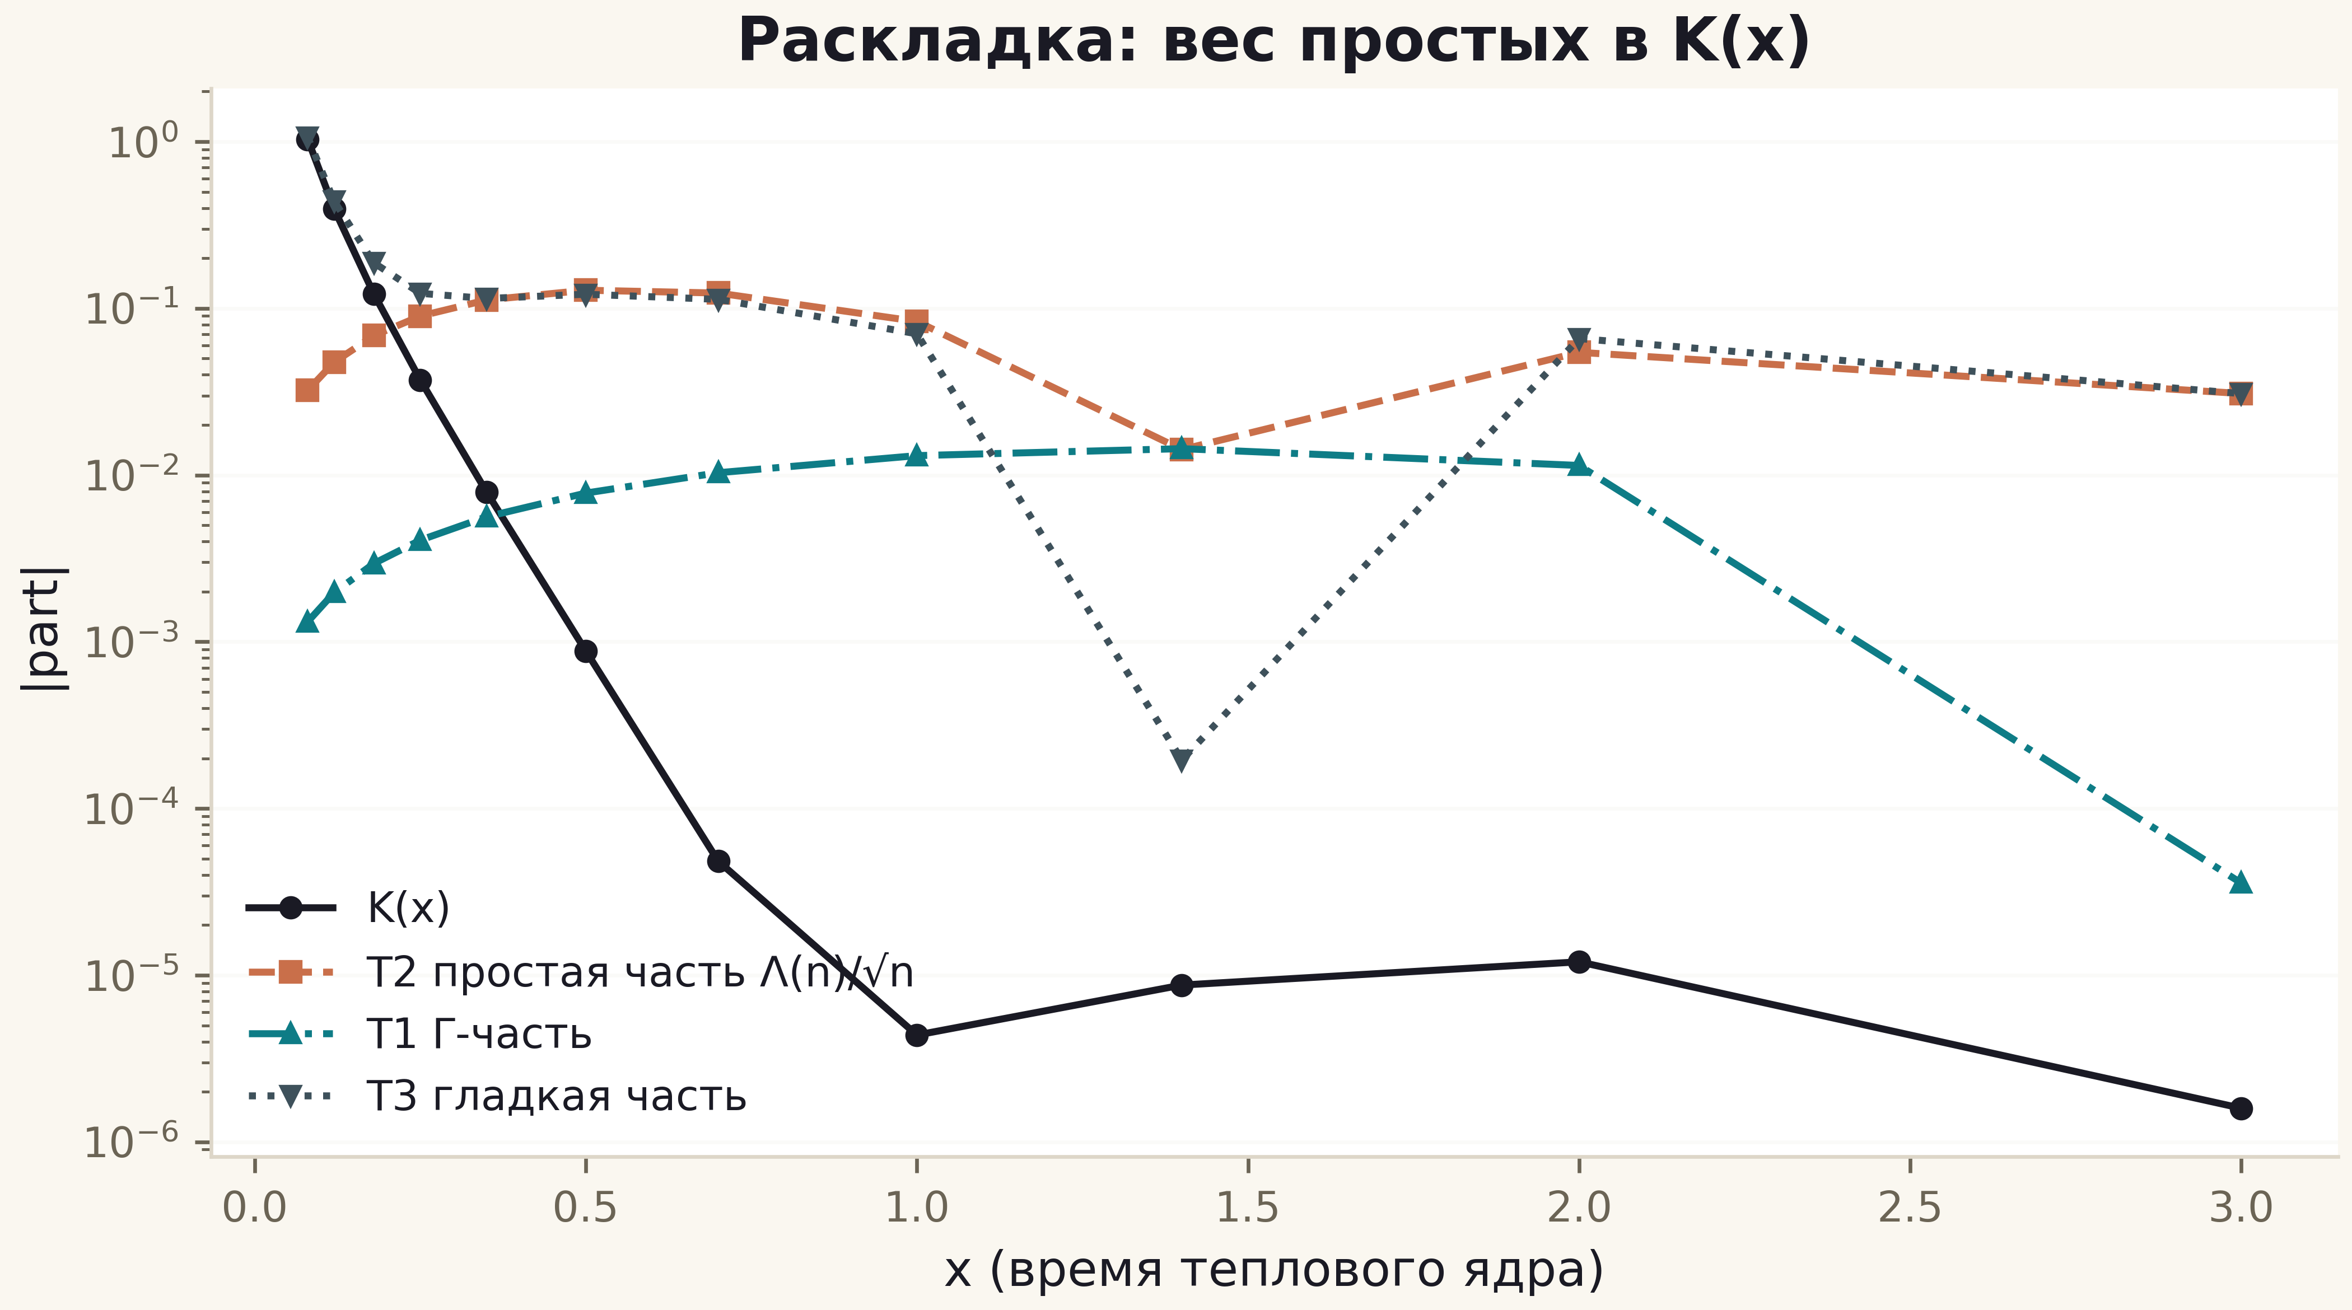
Fig. 2. Anatomy of K(x): the full curve, the prime part T2 (weight Λ/√n), the Γ-part T1 and the smooth part T3.

M2: the trace projection of the gates and the verdict
For the gates the same machinery applies: a 200-level unfolded window, the heat-trace fluctuation D(u) = Σe^{−u x_n} minus the smooth part, and the correlation r_EF with the prime comb P(u) = ΣΛ(n)/√n·u/(u²+ln²n) at fixed scale (the rank correspondence of the windows fixes the dual axis; scale optimisation is excluded as a source of inflation). Positive control PC0: the same window taken from the zeros themselves gives r = +0.9998 with a relative residual of 2.1% — the pipeline sees the comb when the spectrum is the zeros. The gates: r_EF from −0.93 to +1.00 against null clouds of surrogate 0.00±0.39, Poisson 0.08±0.80, GUE 0.43±0.71 — no gate leaves the null zone; the best relative residual is 6.7% against 2.1% for PC0 — a gap of ≈0.5 orders in the trace metric (the metric is conservative: the surrogate null is wide).
The verdict of C4 is double. Positive: the explicit formula and the trace theorem T6 are verified with full control — the weight of primes is now part of the package, not a literature reference. Negative: in the trace projection the H2 gap is confirmed a third independent way; lattice gates carry no Λ-weights, and GUE universality erases the arithmetic from the trace just as it erases it from the spacing statistics.
Table 1. Campaign C4 summary
Block | Quantity | Verdict
M0 | |ΔQ| ≤ 1.7e-12 | identity calibrated
M1 | |ΔK| ≤ 1.2e-5 (absolute) | T6 verified
PC0 (zeros window) | r = +0.9998, residual 2.1% | method sees the prime weight
52 gates | r_EF −0.9…+0.98, null zone | no prime weight
Gap (trace metric) | ≈ 0.5 orders by residual | H2 — NO, measured
C3 reproduction | |Δmean_spacing| = 1.4e-16 | bit-for-bit

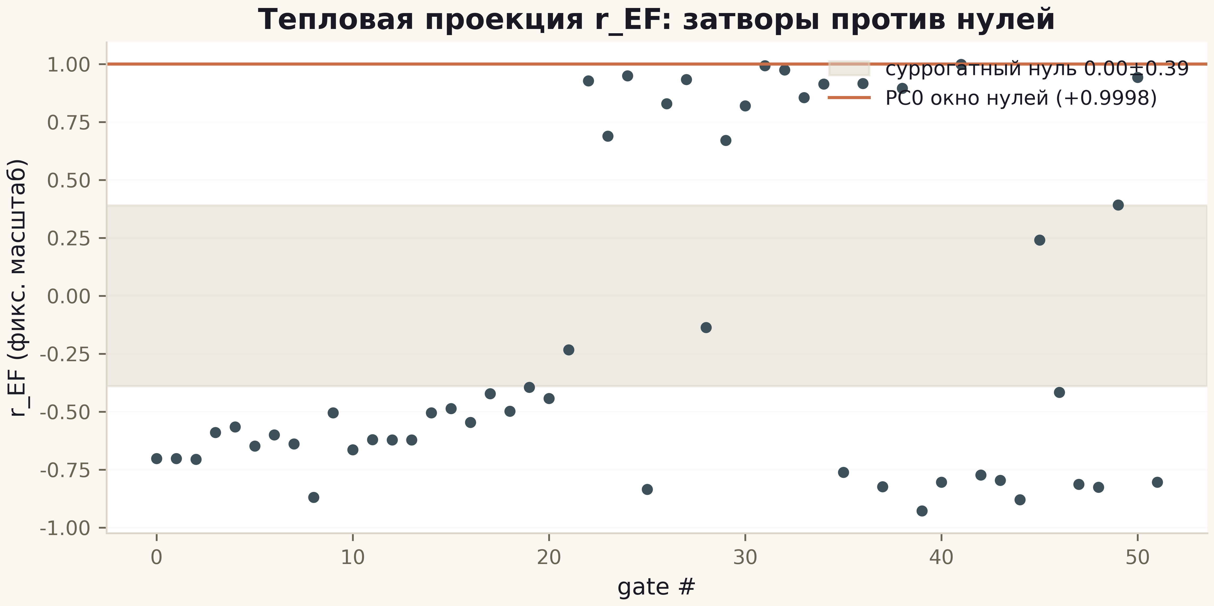
Fig. 3. r_EF across the 52 gates: grey band — surrogate null ±0.39, copper line — PC0 +0.9998.

Conclusions
The trace formula completes the triad of projections of the H2 gap: rank correlation (C3, 9–10 orders), the ψ-ladder (C6, null zone) and now the heat trace (C4, ≈1 order in the window metric). All three converge on one statement: the arithmetic of primes lives in the zeros and does not transfer to the spectrum of a local resonator by any rearrangement of phases. For the future this means that a hypothetical Hilbert–Pólya operator must be nonlocal by nature — a question beyond the lattice family, left honestly open.

