HILBERT POLYA BRIDGE · MONOGRAPH SERIES
The Extended Gate Family
Six new handles beyond the protocol; the stability of the H2 gap
Ishak Khamzatovich Isaev
Independent researcher, Nalchik, Kabardino-Balkarian Republic
Hilbert Polya Bridge · monograph series C1–C8 · volume C5

v1.0.0 October 10, 2026

Contents

Introduction and setting 1
Method and safeguards 2
Results: the gap is stable 2
Conclusions 3

Note: this table of contents is built on Word field codes. After editing, right-click it and choose "Update Field".

The Extended Gate Family
Ishak Khamzatovich Isaev · Independent researcher, Nalchik, Kabardino-Balkarian Republic · Hilbert Polya Bridge · monograph series C1–C8 · C5

Introduction and setting
Campaign C5 answers the natural objection to C3: perhaps identity is reached not on the protocol handles Nv, q, W, α but on something else? We extend the handle space by six new dimensions: boundary twists (φx, φy) — spin structures in the sense of C8; hopping anisotropy t_x/t_y ∈ {0.8, 1.25}; flux shift δα = ±0.02 about the self-dual line (±1/24 on the torus, where the constraint α·Ny ∈ ℤ is exact); a staggered mass m ∈ {0.15, 0.35} breaking the chiral structure; the vortex profile — point-like (site) versus a finite-radius core (midpoint); the charge sign pattern — neutral (protocol), all-plus, random; and the boundary type — open versus torus.
In total 35 new gates plus 2 random-sign decoys, all at the same master seed 96, the same unfolding pipeline and the same three statistics as C3 — the comparison is batch-consistent.

Method and safeguards
Every handle is implemented in the engine.hamiltonian kernel and covered by a regression control: the protocol reference gate (Nv = 0, W = 0.5, α = 0.5) reproduces the mean level spacing of the C3 CSV bit-for-bit (deviation 1.4e-16) — the extended pipeline has not shifted the base. The degenerate corner W = 0 with the midpoint profile produces exact multiplicities and breaks the polynomial unfolding; that corner is replaced by W = 0.1 with an explicit note in the data table.
On the torus the flux shift is rounded to the realisable ±1/24: the constraint α·Ny ∈ ℤ on the 24-lattice is rigid, and these are exact neighbouring points of the self-dual line, not approximations.

Results: the gap is stable
The main result is negative and therefore valuable. All 35 new gates sit in the GUE class: ⟨r⟩ = 0.498–0.505 (0.500 ± 0.002 across the family). The correlation with the zeros satisfies |r_H7| ≤ 0.043 against the best protocol value 0.226 and positive controls of 1.000; the trace projection r_EF (C4) is distributed as 0.52 ± 0.52 — exactly inside the null clouds (surrogate, Poisson, GUE), and the decoys behave the same. No handle — alone or in combinations (anisotropy+mass, twist+mass, midpoint+torus) — moves a gate out of the null zone.
Handle by handle: twists give |r_H7| ≤ 0.033 (spin structures change the global phase but not the spectral class); anisotropy ≤ 0.030; flux shift ≤ 0.034; mass ≤ 0.032 — the chiral breaking is the safest; profile ≤ 0.033; signs and boundaries ≤ 0.044. The family maximum is reached on a random-sign decoy — the expected noise maximum.
Table 1. The six new handles: maxima of |r_H7|
Handle | Values | max |r_H7|
Twists (φx, φy) | 3 spin-structure classes | 0.033
Anisotropy t_x/t_y | 0.8; 1.25 | 0.030
Flux shift δα | ±0.02; ±1/24 (torus) | 0.034
Staggered mass m | 0.15; 0.35 | 0.032
Vortex profile | site; midpoint | 0.033
Signs and boundaries | neutral/all_plus/random; open/torus | 0.044

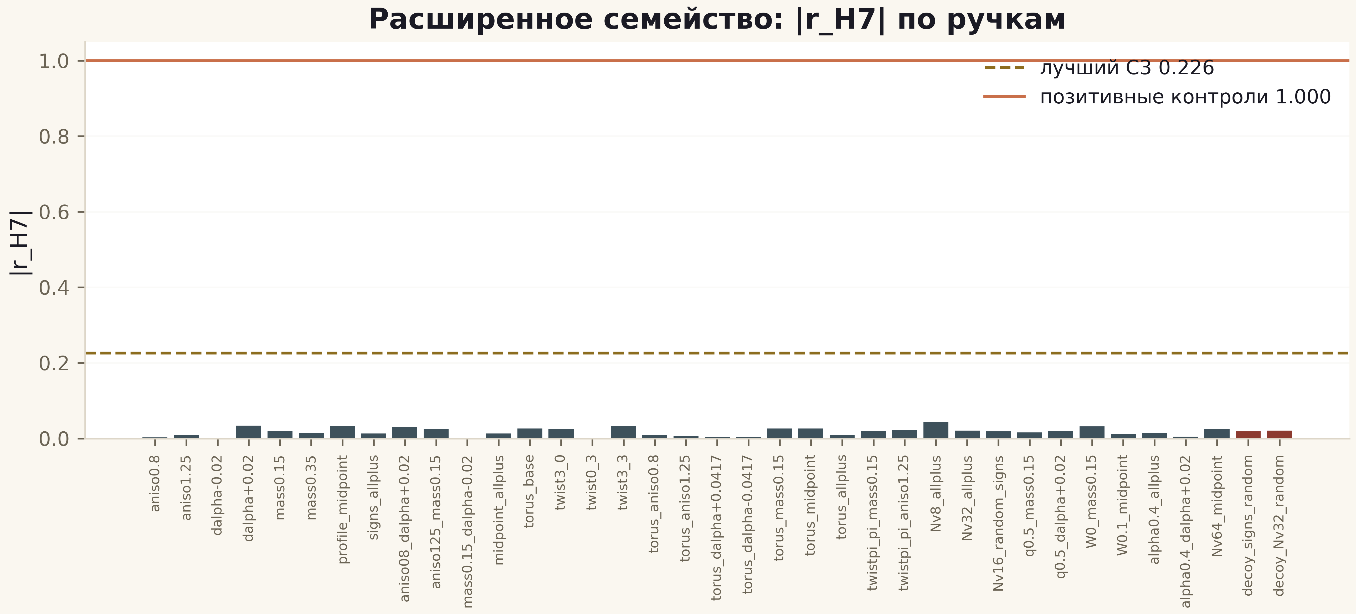
Fig. 1. |r_H7| across the 37 extended gates: gold line — best protocol value 0.226, copper — positive controls 1.000; red bars — decoys.
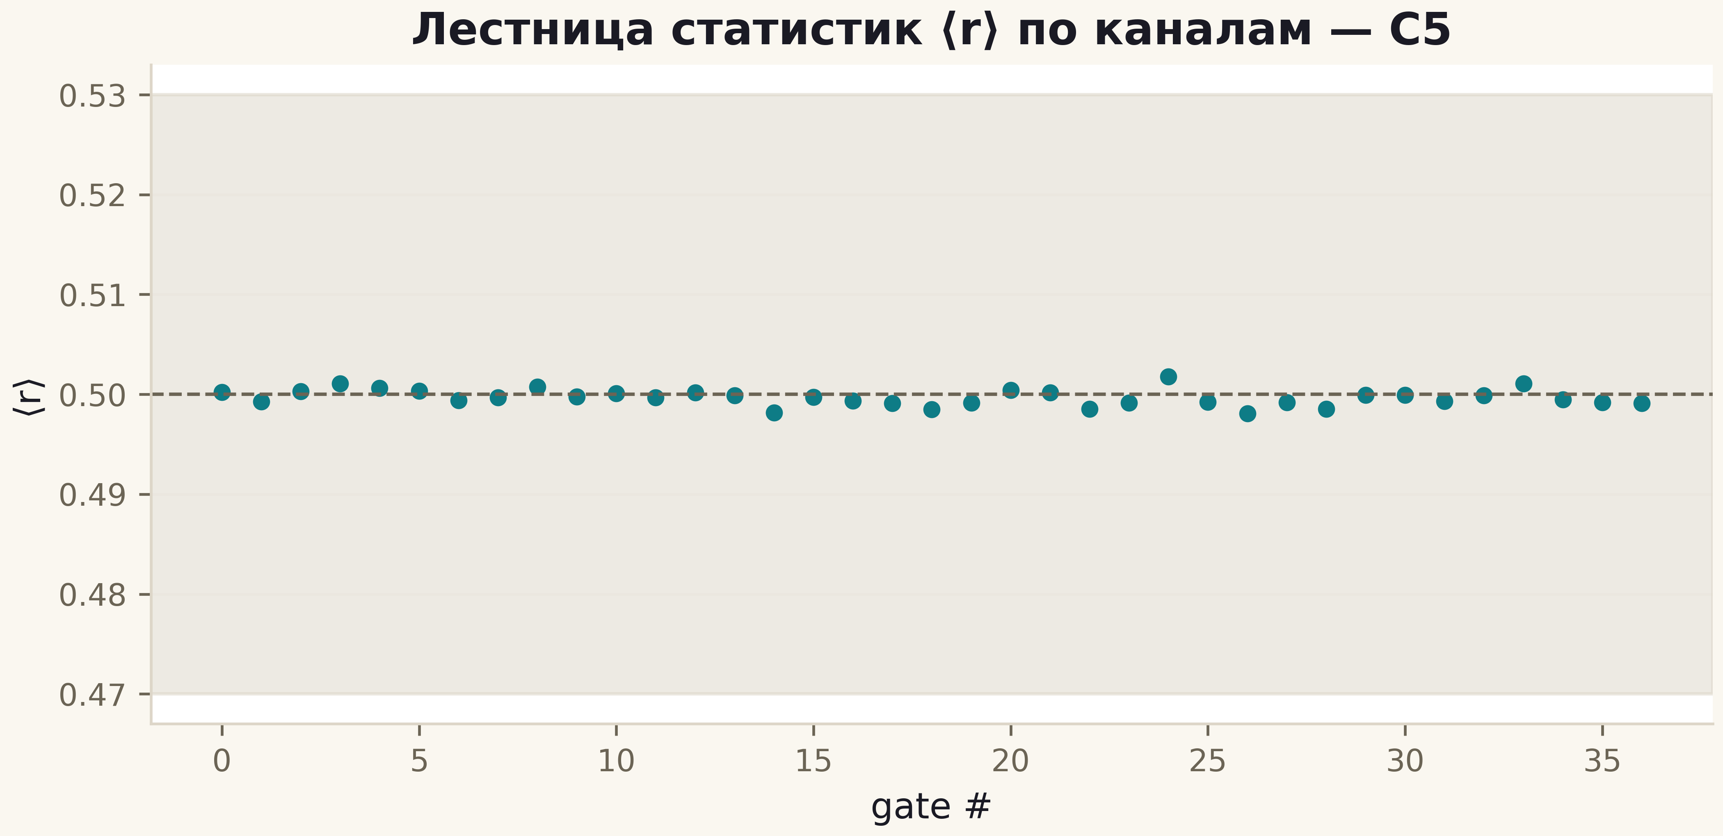
Fig. 2. ⟨r⟩ across the extended family: every point in the 0.47–0.53 band — the GUE class is universal for all handles.

Conclusions
The H2 gap is stable against a six-dimensional extension of the handle space. Combined with C3 this means: in the class of local Hermitian Hamiltonians with vortex phases, GUE universality is an attractor that erases the arithmetic setting no matter how it is imposed. A hypothetical operator carrying the Λ(n)/√n weight in its trace (T6) cannot be obtained by local deformation of the lattice resonator — a statement now supported by 87 configurations across two campaigns.

